RigBuilder : Generative AI–Powered Custom PC Configuration & Component Compatibility Advisor
Project Description:
RIG-Builder is a sophisticated, AI-powered platform designed to streamline the custom PC building process for gamers, professionals, and hardware enthusiasts. It significantly cuts down on the time and research typically required for component selection, allowing users to create optimal, personalized PC builds within minutes.
Key Technology and Integration:
The platform employs cutting-edge Generative AI, utilizing both Google's Gemini 2.0 Flash model and the Groq-powered LLaMA 3.3 model. This integration enables high-speed, intelligent component selection and precise extraction of user requirements through a natural language chatbot interface.
Crucially, RIG-Builder features an asynchronous web scraper for real-time market analysis, fetching current pricing and availability in the Indian market (INR) to ensure accurate, localized budgeting.
Architecture and Features:
Built on a robust, scalable architecture, RIG-Builder uses a Flask backend, a SQLAlchemy database (SQLite/PostgreSQL), and a lightweight HTML, CSS, and JavaScript frontend.
RIG-Builder automates essential PC building tasks, including:
- Personalized 8-Part Component Selection: Recommending the optimal CPU, GPU, Motherboard, RAM, Storage, PSU, Case, and Cooler tailored to the user's specific needs.
- Real-time Pricing and Budgeting: Providing accurate localized costs through real-time web scraping.
- AI-Generated Documentation: Delivering detailed build summaries and clear rationales for every component recommendation.
- Intuitive User Interaction: Utilizing a natural language Chatbot for easy requirement input.
- Export and Sharing: Generating automated PDF reports and direct PCPartPicker URLs for verification and sharing.
By merging Generative AI, real-time data, and modern web technologies, RIG-Builder empowers users to confidently assemble high-performance, cost-effective custom PCs.

Scenarios:
Scenario 1: First-time PC Builder Using the Chat Assistant
A beginner who wants to play specific games (like Cyberpunk 2077 or Valorant) needs a computer but doesn't know which parts to pick or how much they should spend. RIG-Builder generates: • Natural language extraction of their gaming requirements and budget • A complete, compatible 8-component build (CPU, GPU, RAM, etc.) • Beginner-friendly explanations (rationales) for why each part was chosen • Real-time Indian market (INR) pricing estimates This allows beginners to get a tailor-made, high-performing build without needing to do overwhelming technical research.

Scenario 2: Professional Content Creator Building a Workstation
A video editor or 3D artist requires a high-performance machine optimized for heavy workloads like 4K video rendering and 3D modeling software. RIG-Builder generates: • High-performance tier component selection focused on productivity • AI-generated summaries explaining why specific multi-core CPUs or high-VRAM GPUs are best for their software • Budget optimization ensuring bottleneck-free performance The generated build ensures that professional workstation software runs smoothly while keeping costs manageable.

Scenario 3: Hardware Enthusiast Sharing and Verifying a Build
A user wants to save their planned build, double-check the components, and share it with friends or an online forum before making a purchase. RIG-Builder provides: • Automated PDF report generation containing all component details, prices, and AI rationales • One-click integration to PCPartPicker to verify alternative parts • A saved build history in the database for tracking future upgrades This helps users confidently track, share, and purchase their chosen components with a professional summary.

Architecture Overview:
RIG-Builder follows a modular full-stack architecture consisting of a frontend, backend, and AI service layers.
Core Components:
Flask Backend Handles API routing, user authentication, database management (SQLAlchemy), AI model communication, asynchronous web scraping, and PDF report generation. Frontend (HTML + CSS + JavaScript) Provides a responsive and interactive user interface built with Jinja2 templates that communicate dynamically with backend APIs

AI Models Used:
- Primary Model: Google Gemini 2.0 Flash is utilized for its rapid, expert-level performance in PC component selection and extracting natural language requirements.
- High-Speed Fallback: Groq LLaMA 3.3 (70B Versatile) serves as a reliable, high-speed alternative for component generation and maintaining continuous, intelligent chatbot interactions.
Data Acquisition
- Web Scraper Engine: The system employs an asynchronous scraping module (scraper.py) to directly fetch real-time pricing and availability data from various Indian technology retailers.
Security & Configuration
- Environment Configuration: All sensitive data, including API keys, database URIs, and Flask secrets, is securely managed via .env files.

Pre-Requisites:
Accounts & API Keys
Google Gemini / Google AI Studio
https://aistudio.google.com/
Groq API Account
https://console.groq.com

Tools & Frameworks:
Python 3.8+
Flask (with Flask-SQLAlchemy & Flask-Login)
SQLite (Development) / PostgreSQL (Production)
FPDF (for PDF generation)
BeautifulSoup / Requests (for Web Scraping)
Visual Studio Code

Project Workflow:
Phase 1: Environment Setup
Activity 1.1: Install Python Environment & Dependencies (Flask, SQLAlchemy, etc.)
Activity 1.2: Configure Google Gemini API Access (Primary AI)
Activity 1.3: Configure Groq LLaMA 3.3 API Access (Fallback AI)
Activity 1.4: Set up SQLite database (Development) / PostgreSQL (Production)
Phase 2: Backend Development
Activity 2.1: Flask Project Structure & App Initialization (app.py)
Activity 2.2: User Authentication System (Flask-Login, Password Hashing)
Activity 2.3: Database Models Setup (Users, Saved Builds)
Activity 2.4: AI Service Integration (Prompt Engineering for JSON extraction)
Activity 2.5: Core PC Builder Generator Feature (Gemini/Groq integration)
Activity 2.6: Web Scraper Integration (scraper.py with ThreadPoolExecutor)
Activity 2.7: AI Chatbot Assistant (Natural language requirement extraction)
Activity 2.8: PDF Export Module (FPDF integration)
Activity 2.9: PCPartPicker URL Builder Module
Phase 3: Frontend Development
Activity 3.1: Create Base UI Framework (Templates and Layouts)
Activity 3.2: Implement PC Builder Interface (Budget, Use Case, Tier Selection)
Activity 3.3: Implement RIG Chatbot Chat View
Activity 3.4: Implement Build Results Dashboard & Component rendering
Activity 3.5: User Dashboard (Saved Build History)
Phase 4: Deployment
Activity 4.1: Local Deployment Setup
Phase 5: Testing
Activity 5.1: Functional Testing of Features

Technical Architecture:

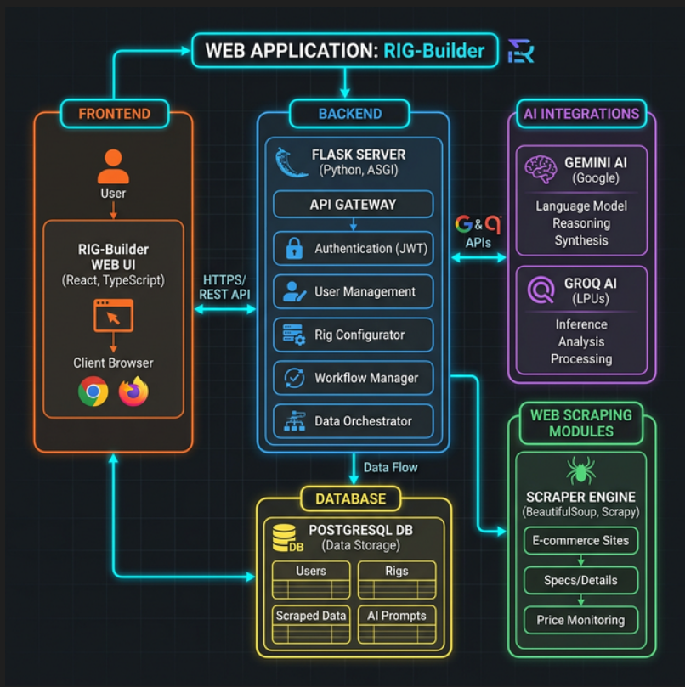

MILESTONE 1: Environment Setup & AI Model Configuration
This milestone establishes the core AI and web scraping environment for RIG-Builder by installing required dependencies and configuring access to the Google Gemini and Groq APIs. Completing this milestone ensures that the backend can communicate with AI models to generate PC builds and scrape real-time market pricing.
Activity 1.1: Install Python Environment & Dependencies
Install Python 3.10 or higher from the official website.
Create and activate a virtual environment.
For Windows :
Install Python 3.10+
Download from: https://www.python.org/downloads/
Create and activate virtual environment Windows:
python -m venv venv
.venv\Scripts\activate
Install core project dependencies:
pip install flask flask-sqlalchemy flask-login requests beautifulsoup4 fpdf2 python-dotenv google-generativeai groq
Verification:
python –version
pip list
If the environment is properly configured, the list will include flask, google-generativeai,
groq, and beautifulsoup4

Activity 1.2: Configure Google Gemini API (Primary AI)
RIG-Builder uses Google Gemini 2.0 Flash as its primary engine for generating optimized PC builds and handling natural language chat.
Steps:
- Create a Google AI Studio account Settings: https://aistudio.google.com/
- Generate API Key Dashboard → Get API key → Create API key
- Add the key to .env GEMINI_API_KEY="your_gemini_api_key"

Activity 1.3: Configure Groq API (Fallback System)
RIG-Builder uses Groq LLaMA 3.3 for high-speed fallback generation to ensure the application remains highly available if Gemini is rate-limited.
Steps:
- Create Groq Cloud account Settings: https://console.groq.com
- Generate API Key Dashboard → API Keys → Create Key
- Add the key to .env GROQ_API_KEY="your_groq_api_key"
Example code:
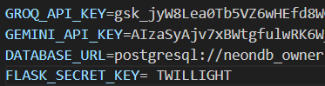
MILESTONE 2: Backend Development
This milestone focuses on building the Flask backend architecture that powers all PC building and AI features. The backend handles user input, communicates with the Gemini and Groq AI models, scrapes live market pricing, and returns formatted results to the frontend.

Activity 2.1 Flask Project Structure Setup
Create the project folder structure
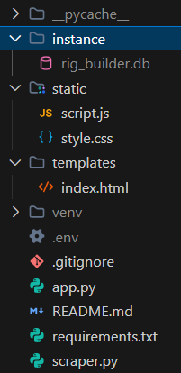

Create requirements.txt:
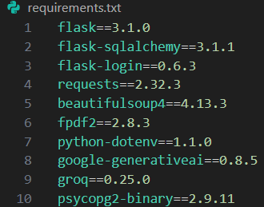

Open terminal/command prompt and run:
>> python -m venv venv
>> venv\Scripts\activate
>> pip install -r requirements.txt

Activity 2.2: Flask Application Initialization
Create the main Flask application in main.py.
The file performs
• Flask app creation
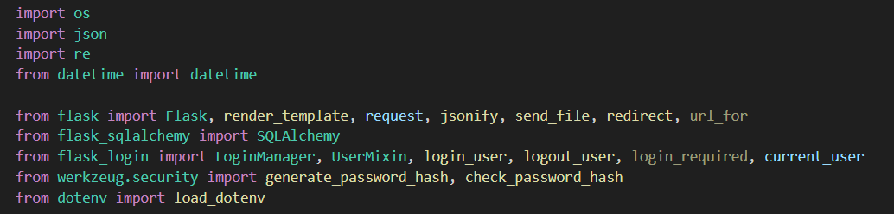
Activity 2.3 AI Service Integration
Integrate Groq LLaMA model for content generation.
File used:
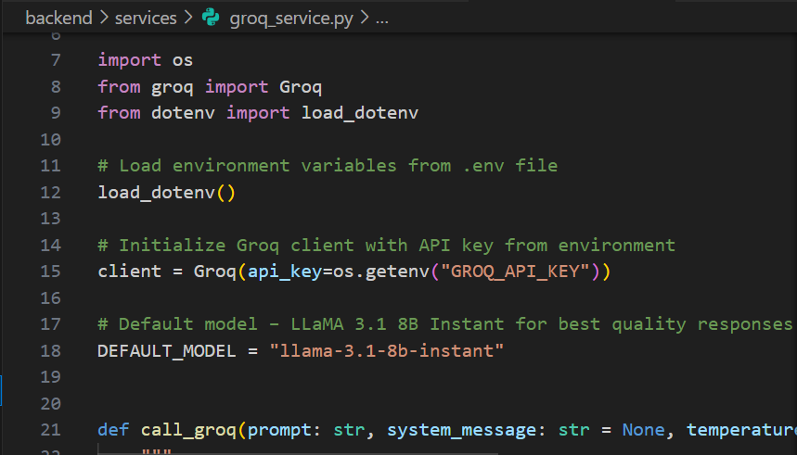
services/groq_service.py
Activity 2.4 AI engine with gemini model
API Endpoint
Input
• component type
• brand
• price
Output
• specific component
• brand name
• real time or estimated price
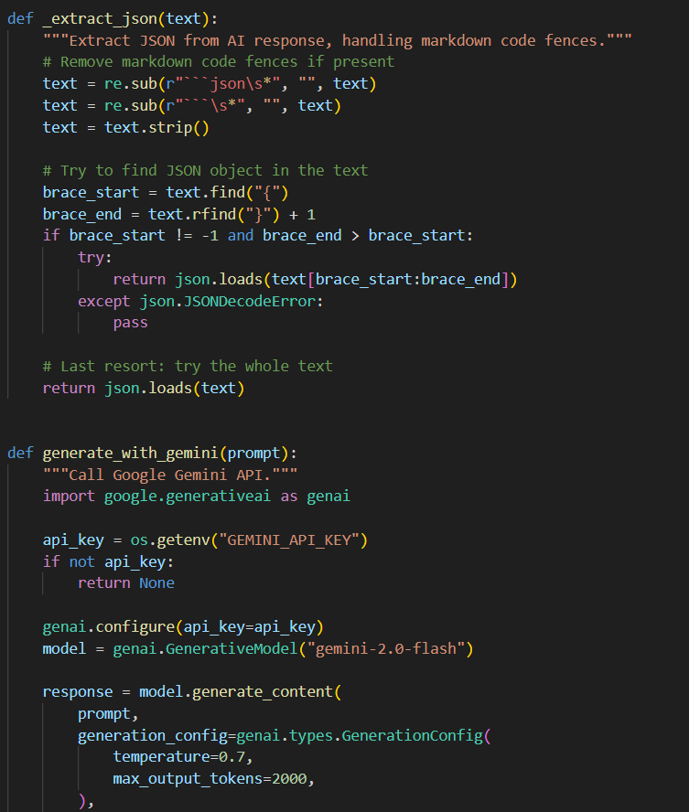

Activity 2.5 Groq api using LLAMA model
This api endpoint uses llama model from groq to generate the same results
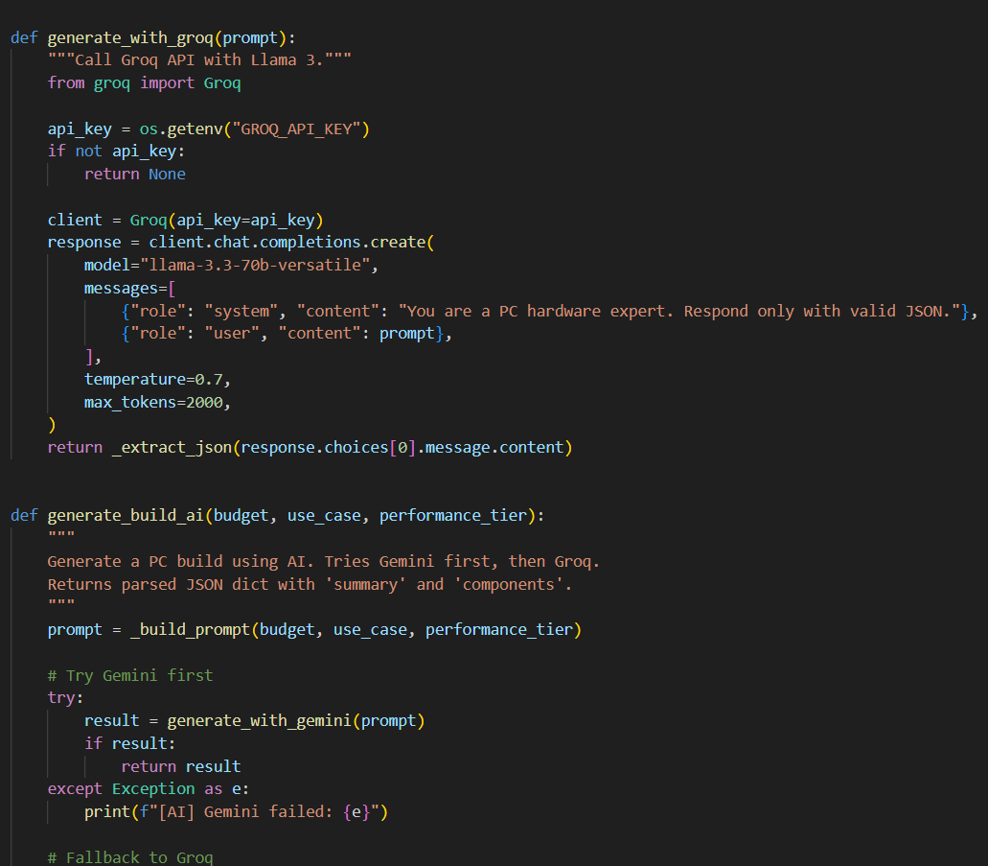

Activity 2.6 AI model fallback
API Endpoint
The program utilizes the Groq model as a fallback mechanism should the Gemini model's response time be excessive or if it encounters other issues.
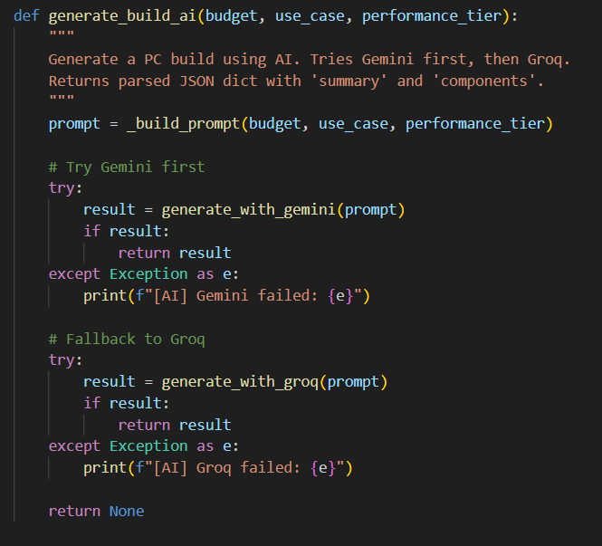
Activity 2.7 PDF generator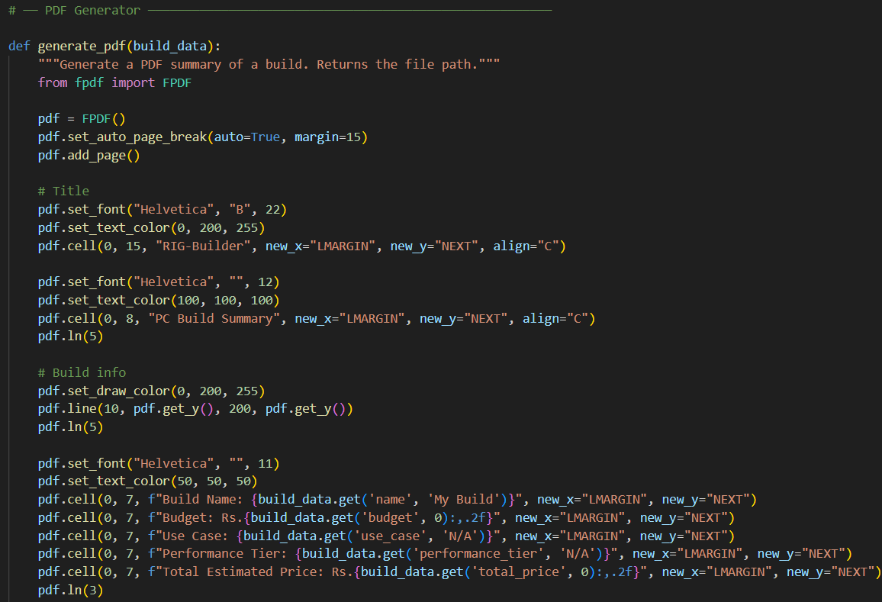

Activity 2.8 AI summary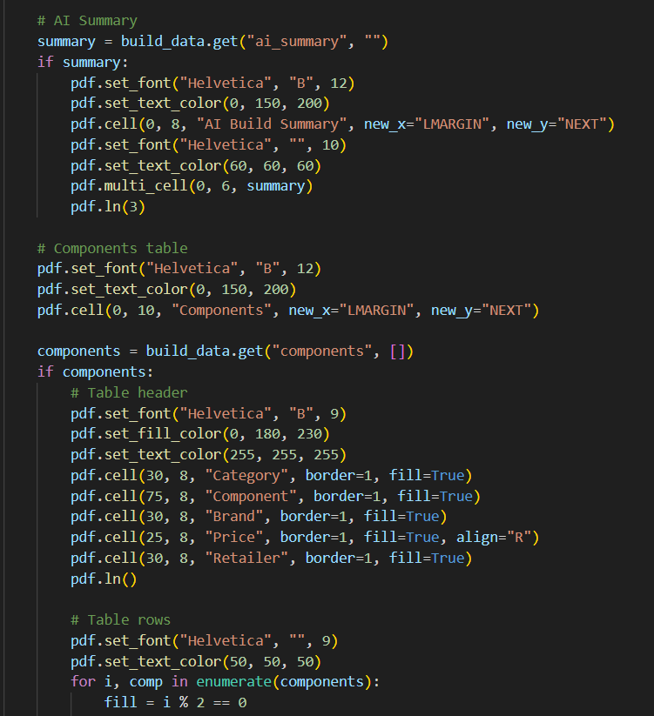

MILESTONE 3: Frontend Development
Frontend interface is built using HTML, CSS, and JavaScript.
Main files:
templates/index.html
static/style.css
static/script.js
Features:
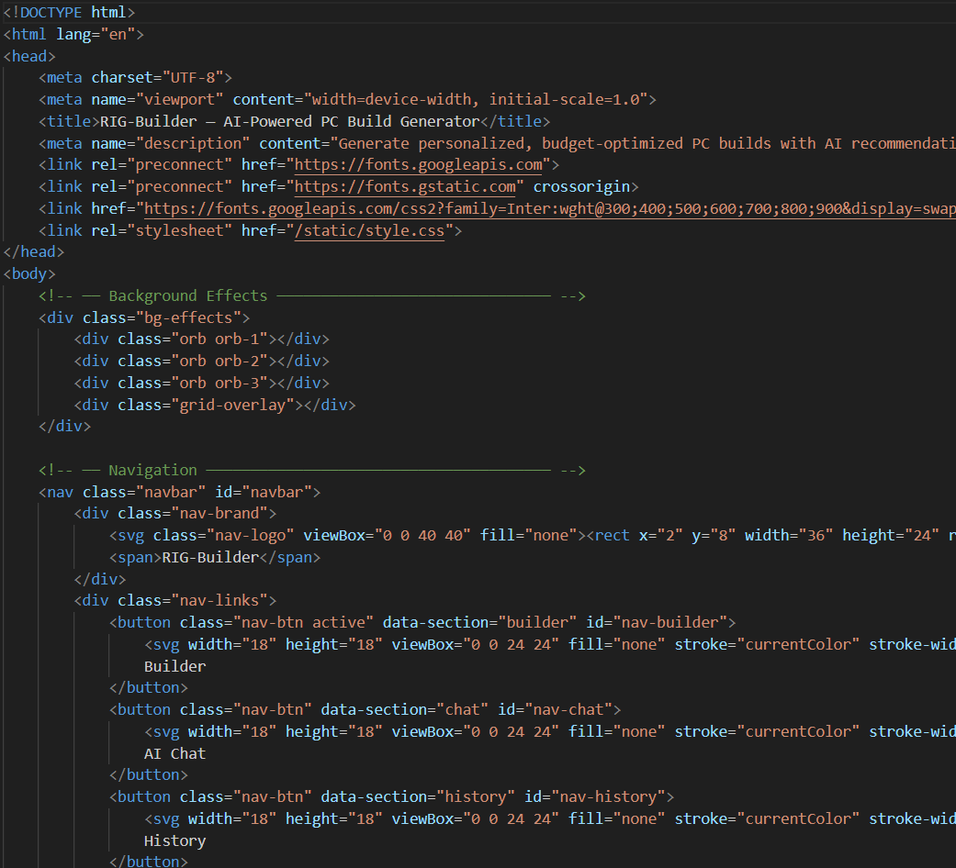

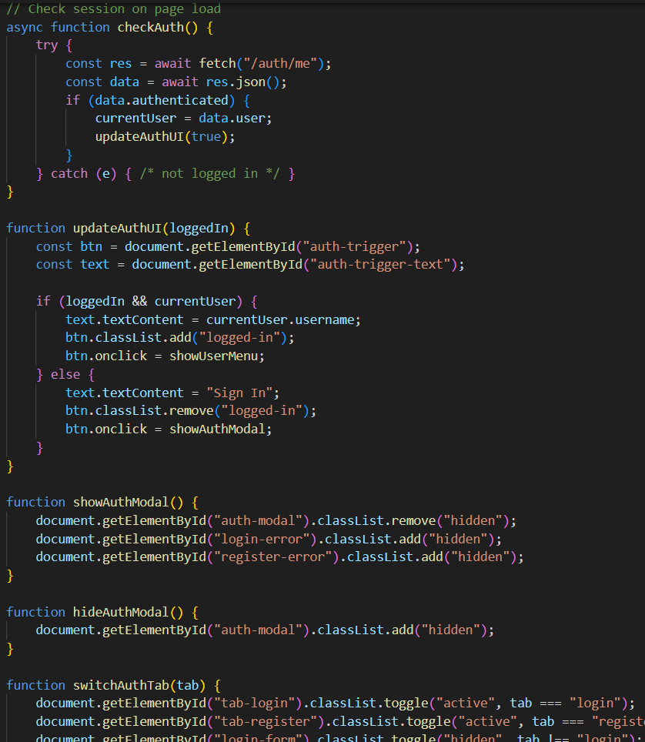
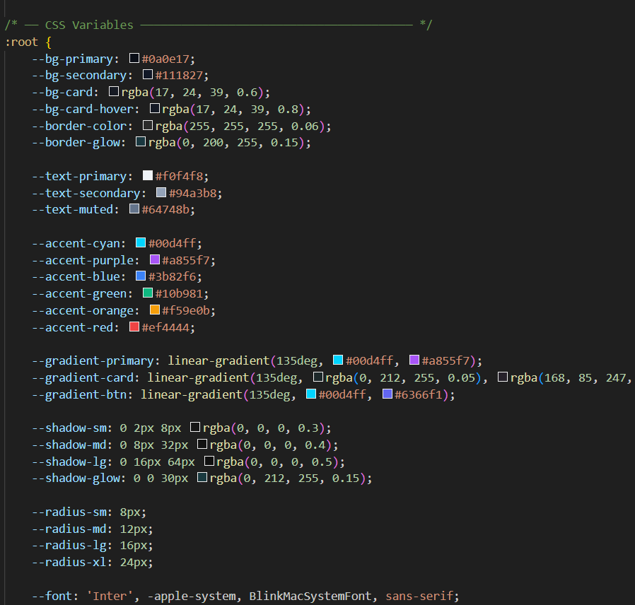

MILESTONE 4: Deployment
Run the application
Python app.py
Server runs at
http://127.0.0.1:5000
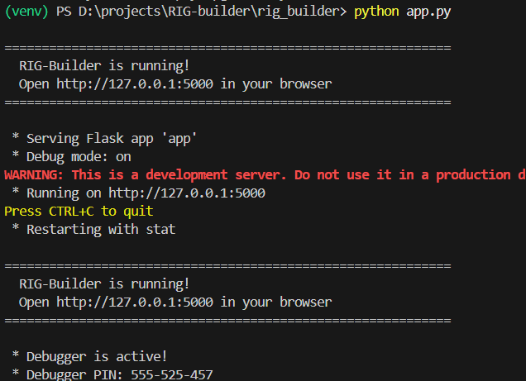

MILESTONE 5: Testing
Test 1: Home Page
Open application in browser.
Click Get Started
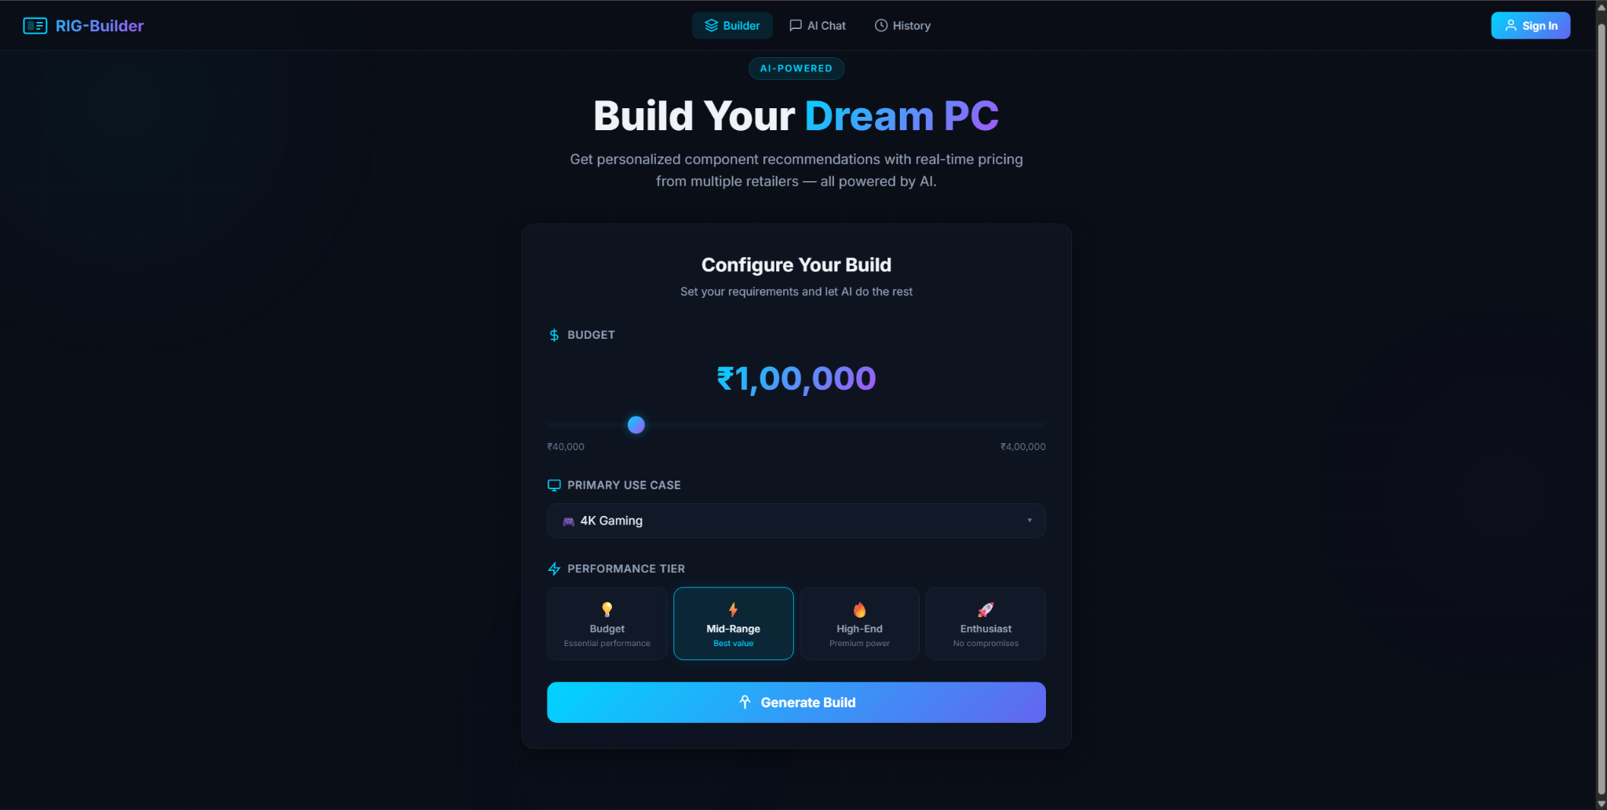

Test 2: login and sign-up
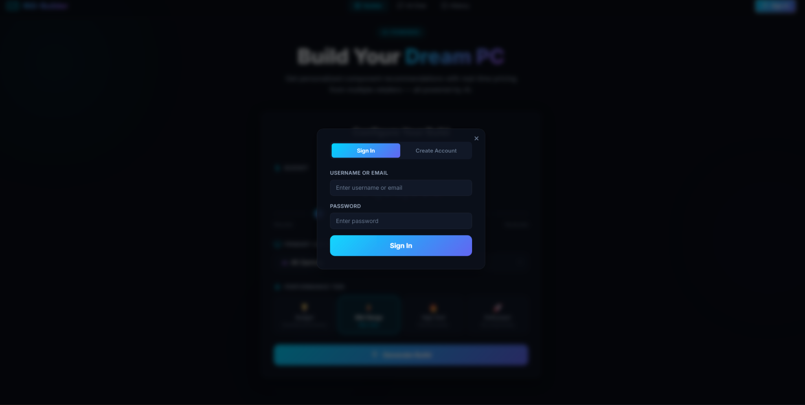

Test 3: choosing required details for the pc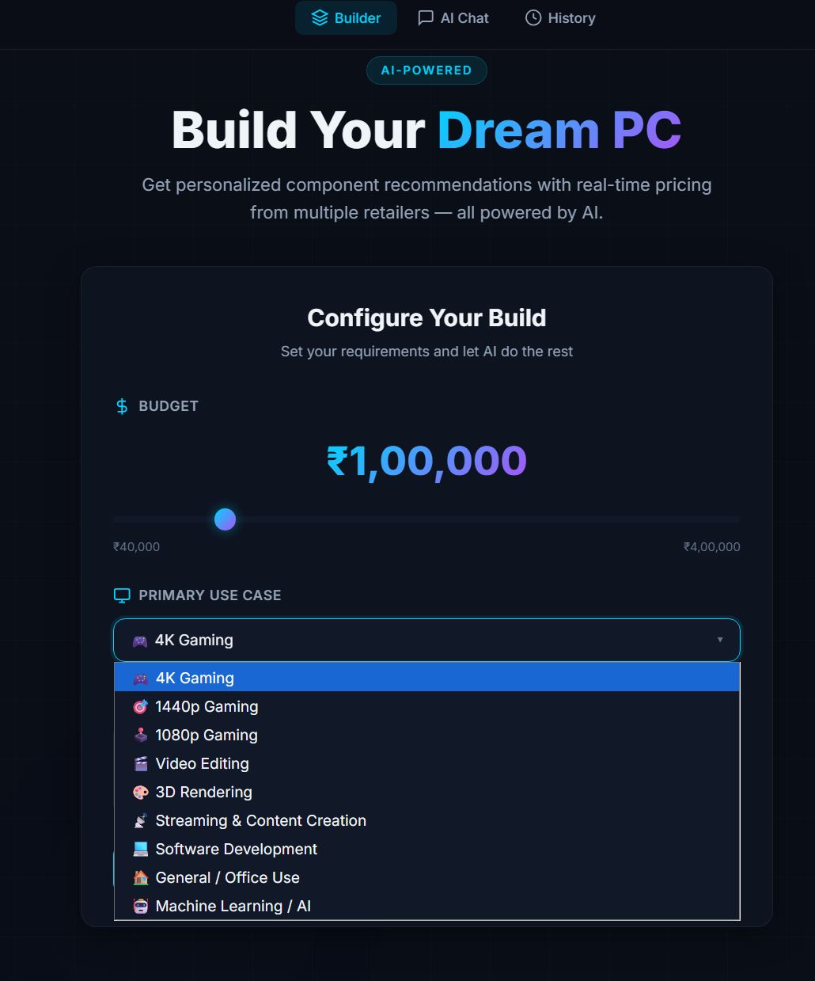
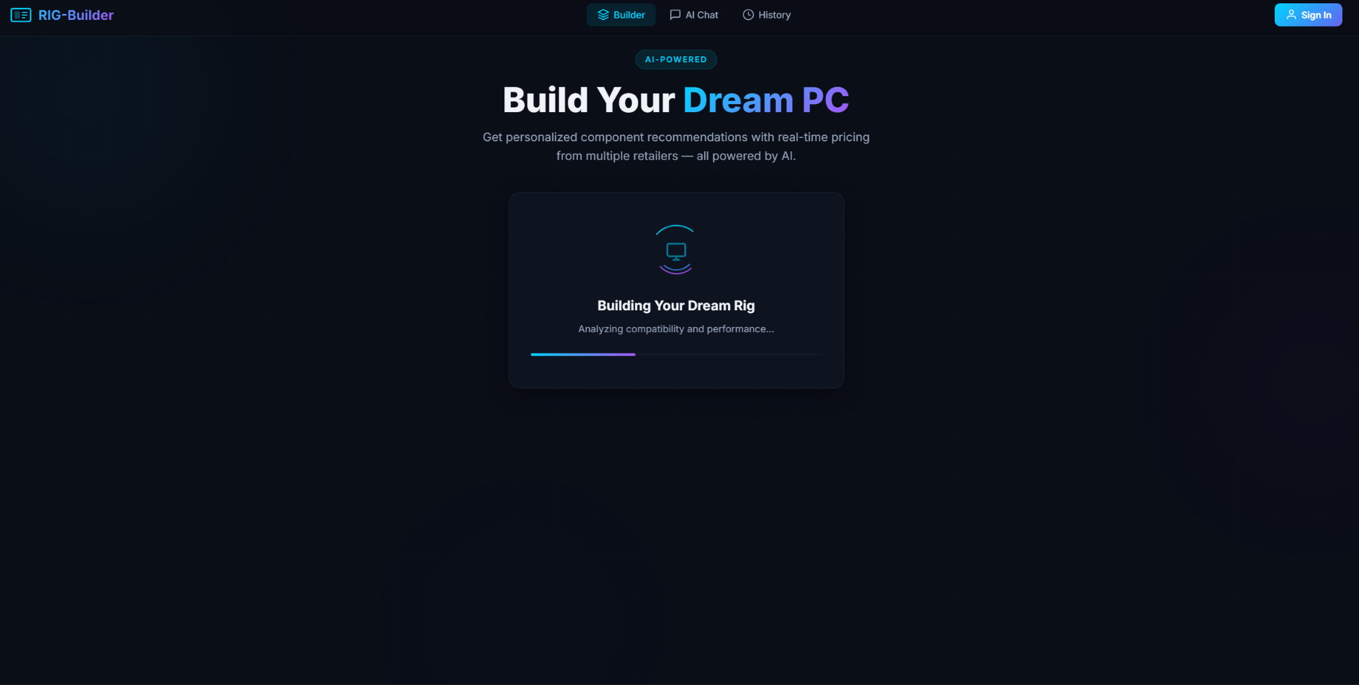

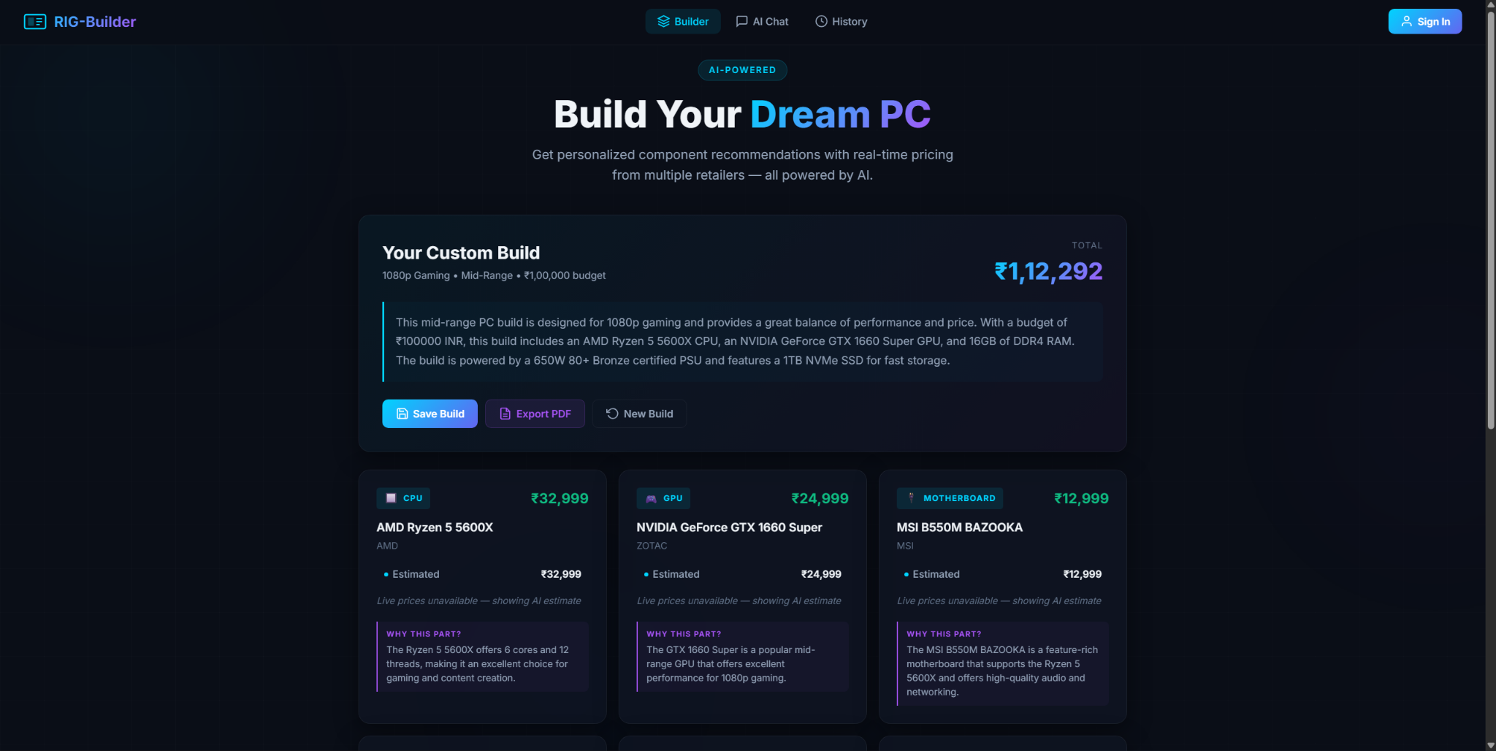

Test 3: Ai chat-bot
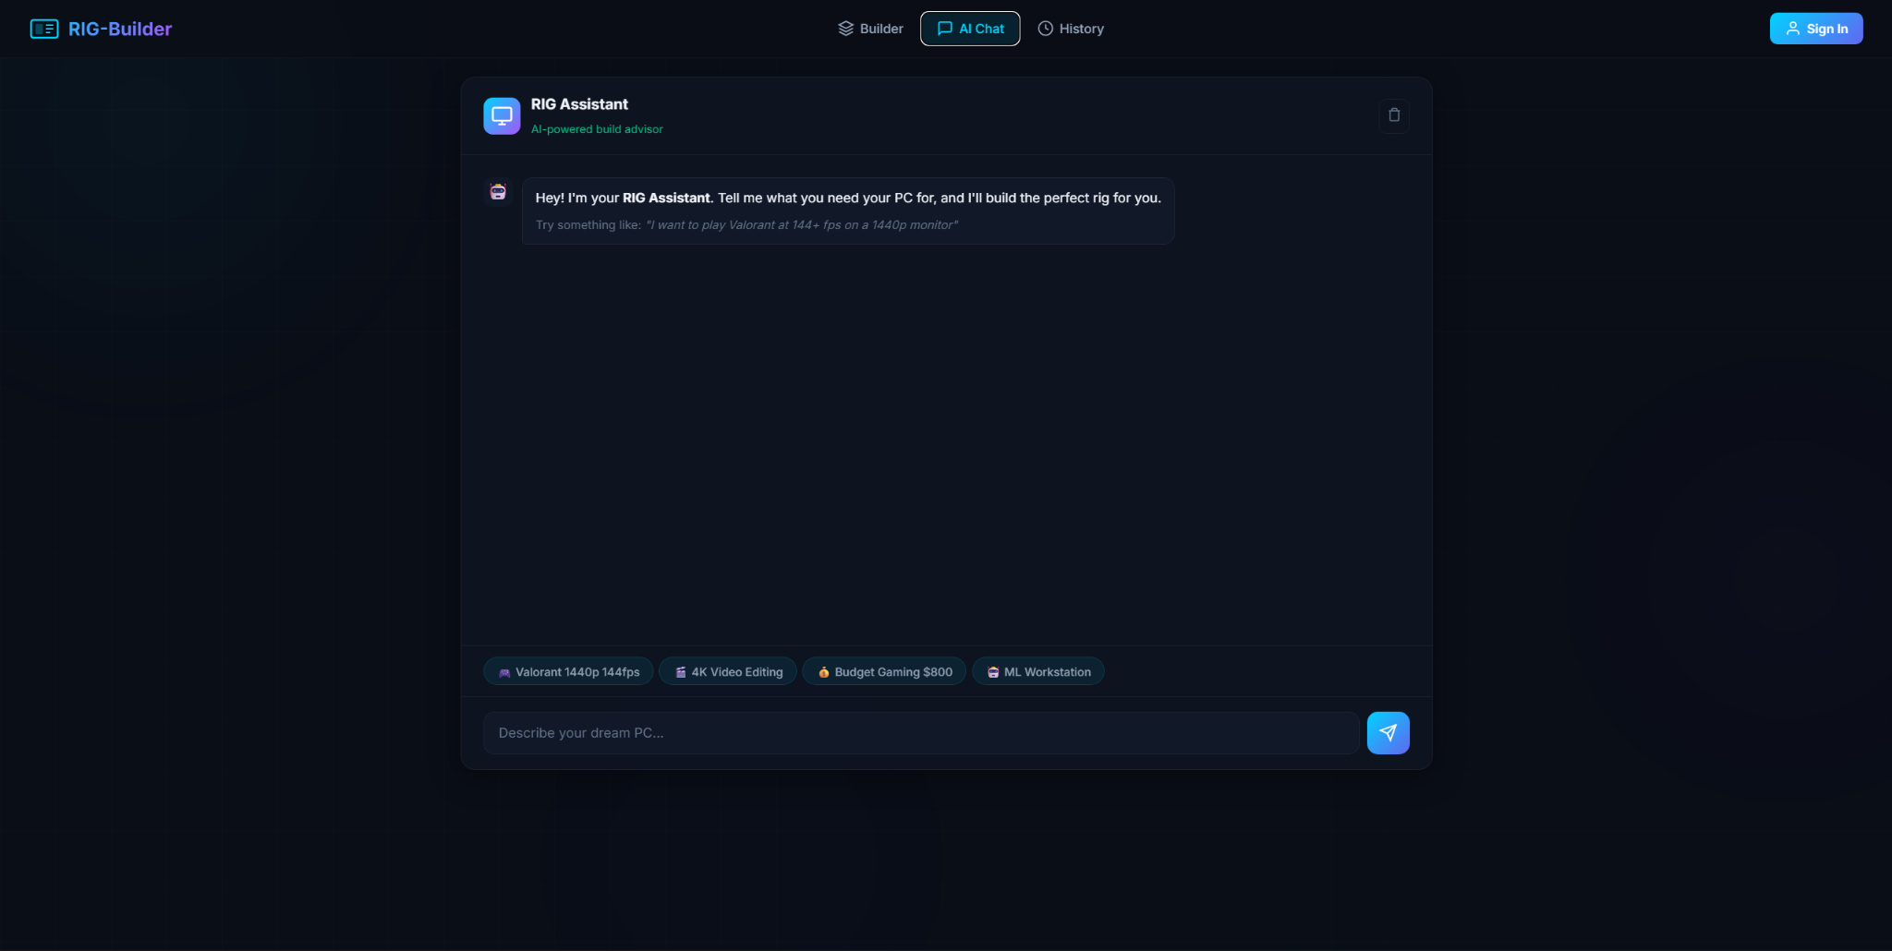

Test 4: history
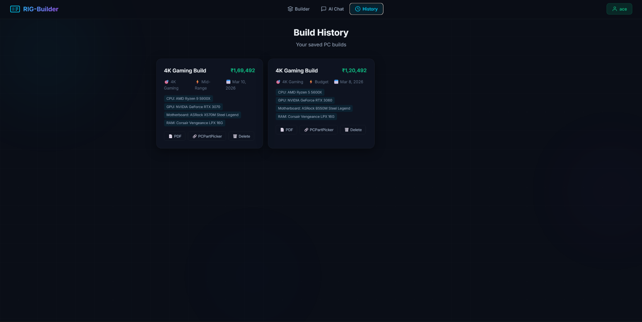

Conclusion:
RIG-Builder demonstrates how Generative AI can automate the complex and time-consuming process of PC hardware selection and budgeting. By integrating Google Gemini and Groq LLaMA models alongside a custom asynchronous web scraping engine within a Flask backend architecture, the system enables users to instantly generate highly-compatible, tailored PC builds with accurate, localized pricing.The project highlights the effectiveness of combining large language models with modern web frameworks and live data scraping to build scalable, practical applications. RIG-Builder has the potential to evolve into a full-scale hardware enthusiast platform with additional features such as automated bottleneck analysis, hardware benchmark comparisons, integration directly with retailer checkouts, and real-time inventory tracking.RIG-Builder is a project that showcases the power of Generative AI in automating the intricate and time-consuming task of selecting PC hardware and managing budgets.

Key Features and Technology:
- Instant, Tailored PC Builds: The system generates highly-compatible, customized PC configurations instantly.
- Accurate, Localized Pricing: It provides up-to-date, location-specific pricing for all components.
- Integrated LLMs and Web Scraping: This functionality is achieved through the integration of Google Gemini and Groq LLaMA models, complemented by a custom asynchronous web scraping engine.
- Robust Architecture: The system is built on a Flask backend architecture.
Significance:
RIG-Builder demonstrates the efficacy of blending large language models with modern web frameworks and live data scraping to create practical, scalable applications.

Future Potential:
The platform is poised for evolution into a comprehensive hardware enthusiast resource, with potential enhancements including:
- Automated bottleneck analysis
- Hardware benchmark comparisons
- Direct integration with retailer checkouts
- Real-time inventory tracking

