Relational to NoSQL Database Migration Project Report

Team members: Diana Iljazi, Sara Sinani.

# 1. Introduction

This project demonstrates the migration of an e-commerce relational database (MySQL) to a document-oriented NoSQL database (MongoDB). The relational database consists of normalized tables including users, addresses, products, categories, orders, and order_items. Data was migrated using a Python script, with embedded documents to represent user addresses and product categories. The goal was to understand the difference in data modeling approaches and to evaluate MongoDB's suitability for document-based storage.

# 2. Relational Database Design

The relational model follows a normalized structure with six tables. The diagram below shows the relationships between the tables. Foreign key constraints enforce referential integrity.

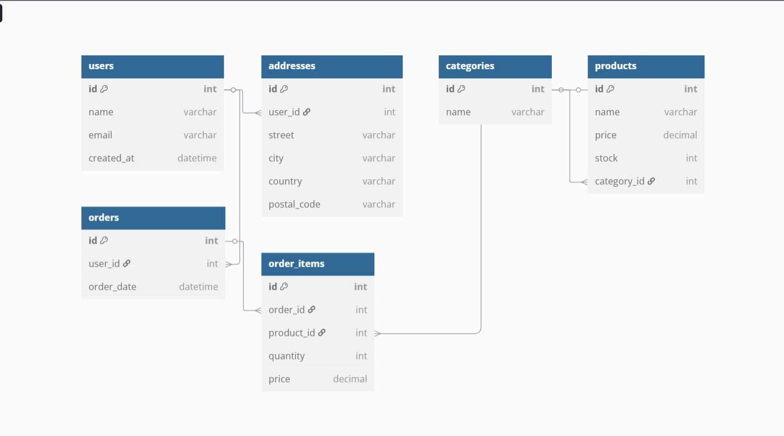

# 3. Data Population

Sample data was inserted into each table using phpMyAdmin. Screenshots below show the populated records:

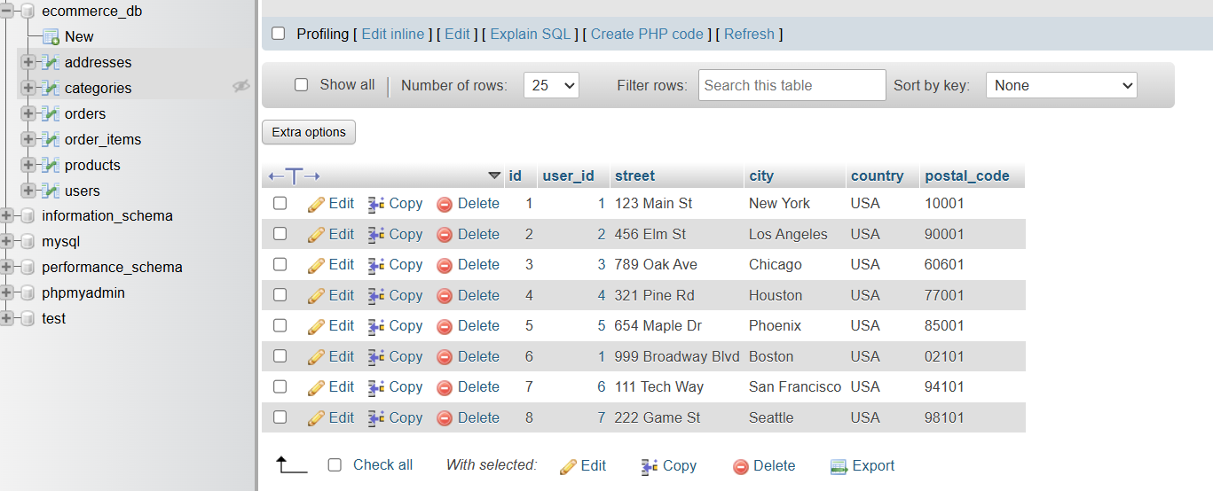

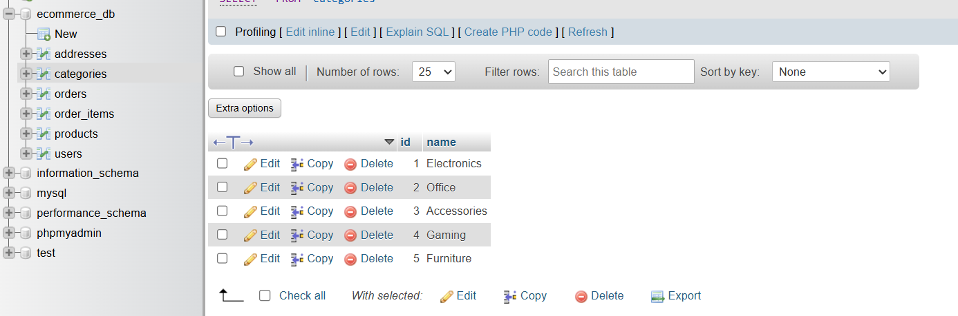

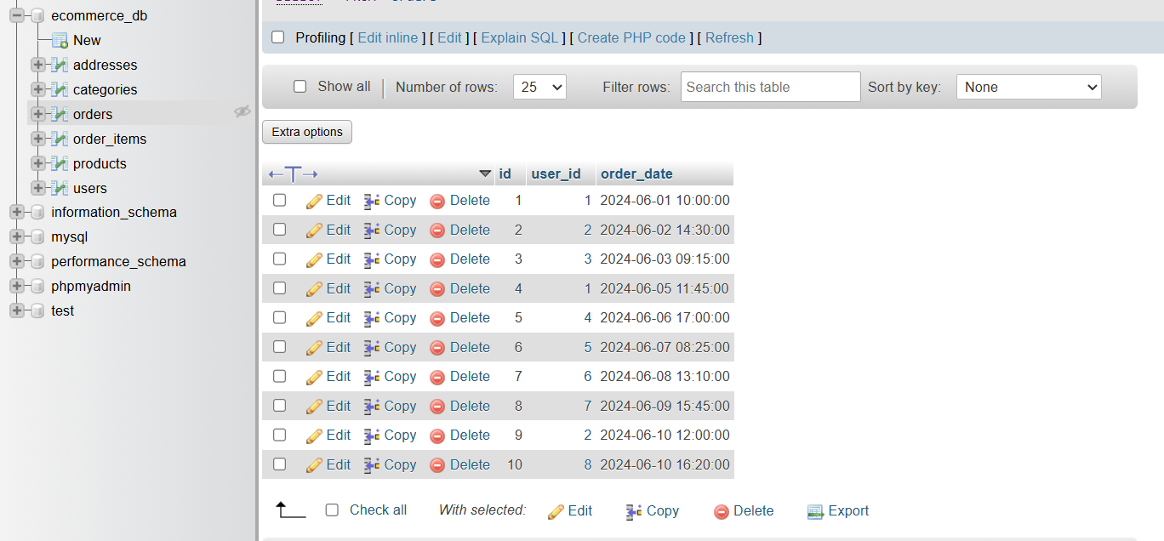

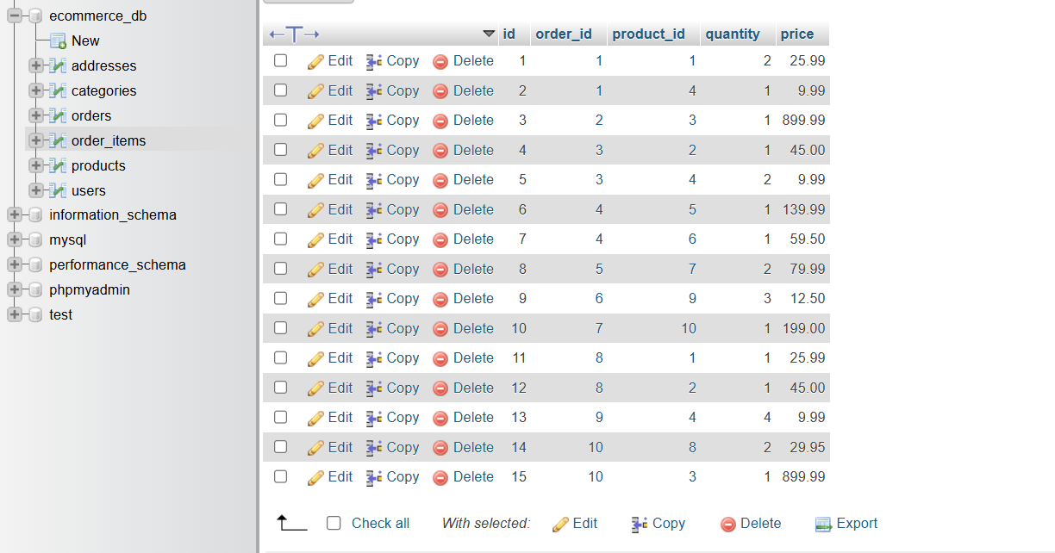

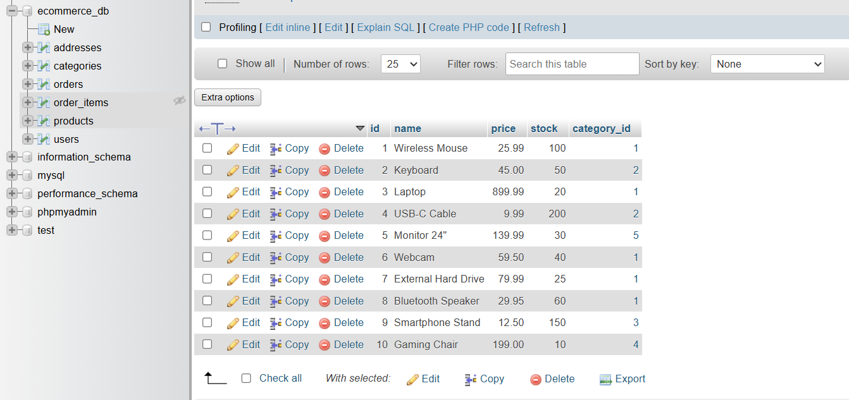

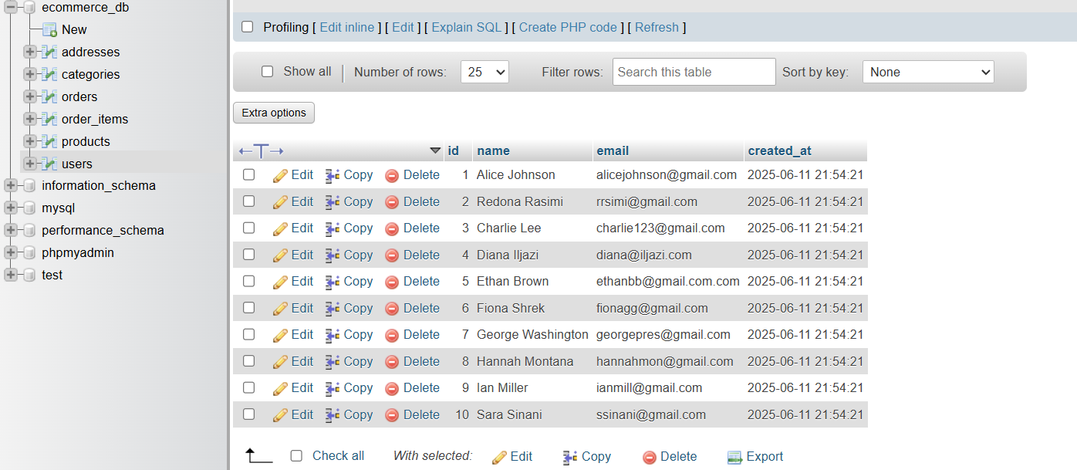

# 4. Choice of NoSQL Database

MongoDB was selected due to its flexibility with unstructured data, support for embedded documents, and ease of scaling. Compared to Redis (key-value, lacks document structure) and Neo4j (graph model), MongoDB's document model was the best fit for representing orders with nested user and product data. We connected MongoDB via Docker, as seen below.

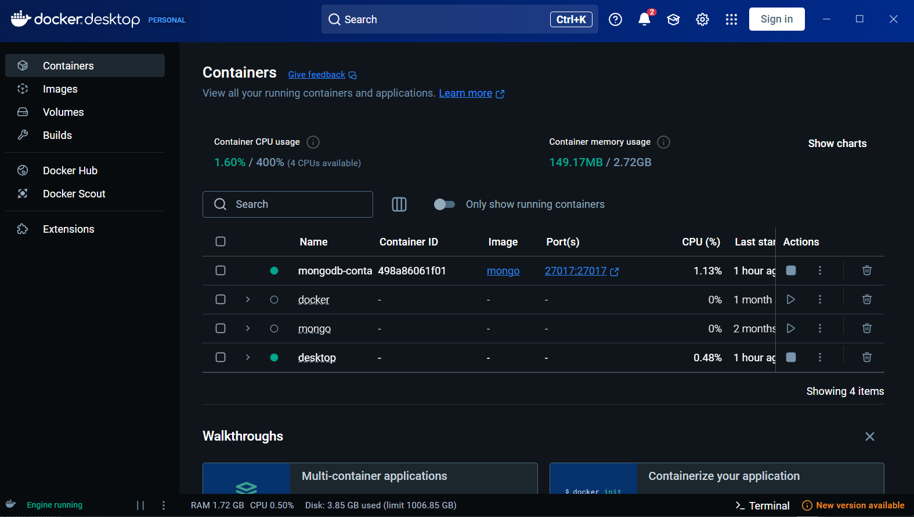

# 5. NoSQL Database Modeling

In MongoDB, data was structured using embedded documents. Each order contains a nested user object, including a list of addresses, and an array of items containing product info and category name.

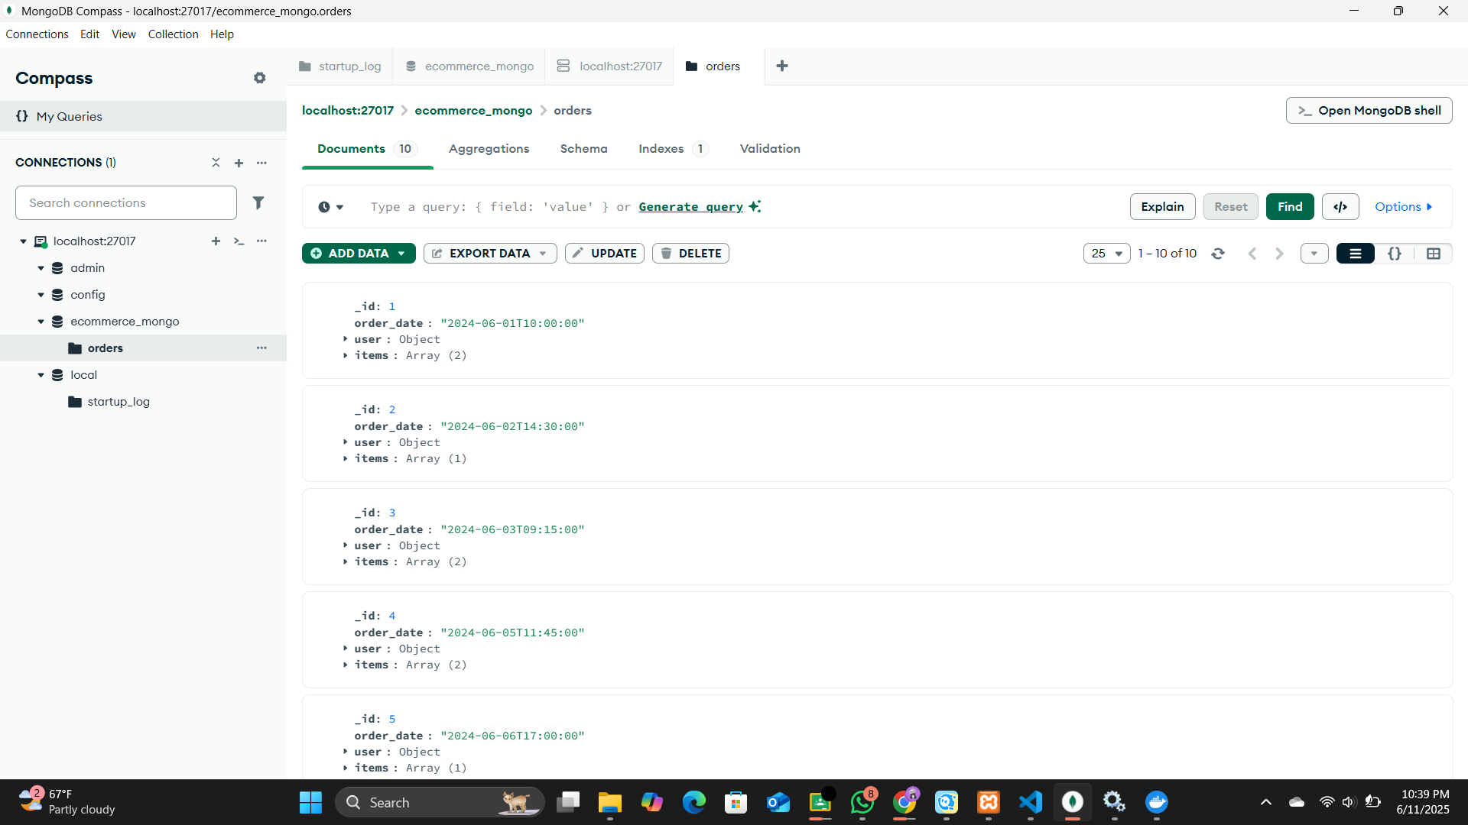

# 6. Data Migration Process

Python was used to extract data from MySQL, transform it into MongoDB-friendly documents, and insert it. The script uses `mysql-connector-python` to query relational tables and `pymongo` to insert into MongoDB. It includes logic to embed user addresses and product categories into the `orders` collection.

# 7. Challenges

One challenge was converting relational data into a nested NoSQL structure. Mapping tables like users, addresses, and order items into embedded documents in MongoDB required careful restructuring. We also faced issues with data type consistency, especially dates, during the transformation. Setting up MongoDB with Docker took some trial and error, particularly around connection settings. Lastly, we had to verify that all data was correctly migrated, which involved writing test queries and checking for completeness.

# 7. Conclusion

This project provided hands-on experience in modeling relational and NoSQL data. The migration highlighted the strengths of embedded documents for hierarchical data and reduced the need for joins. MongoDB proved effective for representing e-commerce transactions with nested order and user details.