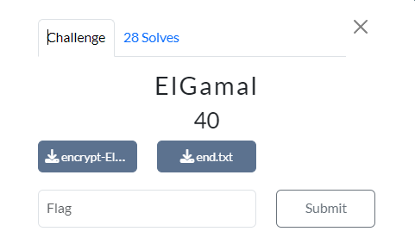

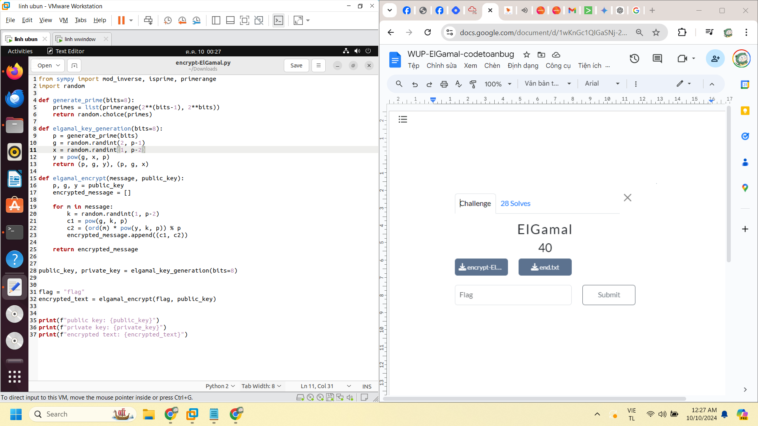

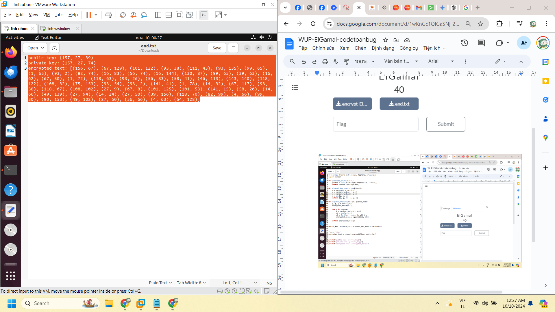

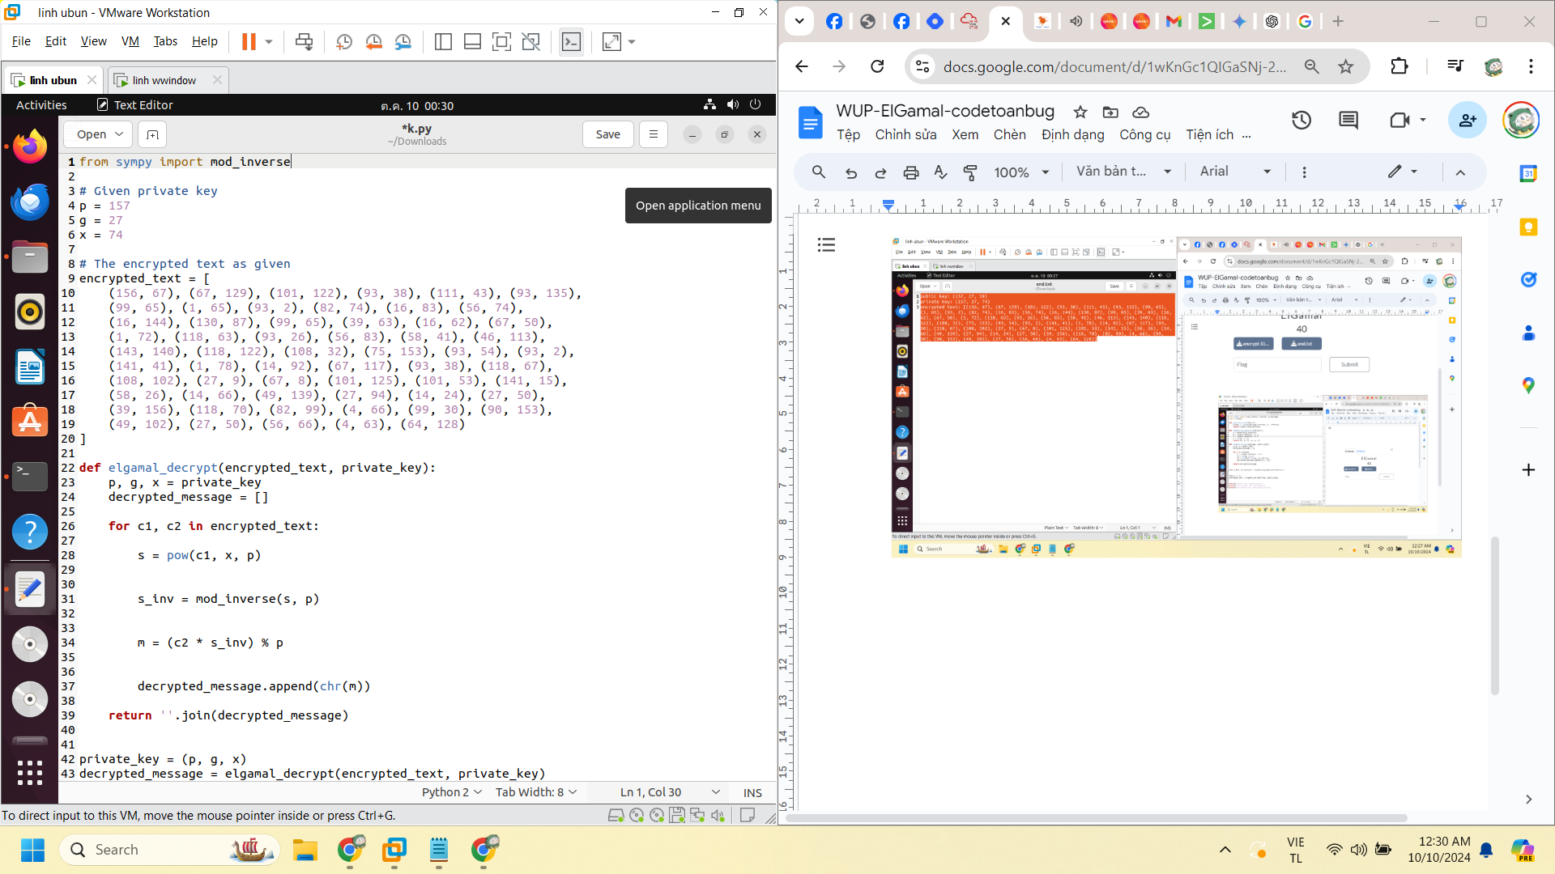

from sympy import mod_inverse

# Given private key

p = 157

g = 27

x = 74

# The encrypted text as given

encrypted_text = [

(156, 67), (67, 129), (101, 122), (93, 38), (111, 43), (93, 135),

(99, 65), (1, 65), (93, 2), (82, 74), (16, 83), (56, 74),

(16, 144), (130, 87), (99, 65), (39, 63), (16, 62), (67, 50),

(1, 72), (118, 63), (93, 26), (56, 83), (58, 41), (46, 113),

(143, 140), (118, 122), (108, 32), (75, 153), (93, 54), (93, 2),

(141, 41), (1, 78), (14, 92), (67, 117), (93, 38), (118, 67),

(108, 102), (27, 9), (67, 8), (101, 125), (101, 53), (141, 15),

(58, 26), (14, 66), (49, 139), (27, 94), (14, 24), (27, 50),

(39, 156), (118, 70), (82, 99), (4, 66), (99, 30), (90, 153),

(49, 102), (27, 50), (56, 66), (4, 63), (64, 128)

]

def elgamal_decrypt(encrypted_text, private_key):

p, g, x = private_key

decrypted_message = []

for c1, c2 in encrypted_text:

s = pow(c1, x, p)

s_inv = mod_inverse(s, p)

m = (c2 * s_inv) % p

decrypted_message.append(chr(m))

return ''.join(decrypted_message)

private_key = (p, g, x)

decrypted_message = elgamal_decrypt(encrypted_text, private_key)

print("Decrypted Message:", decrypted_message)

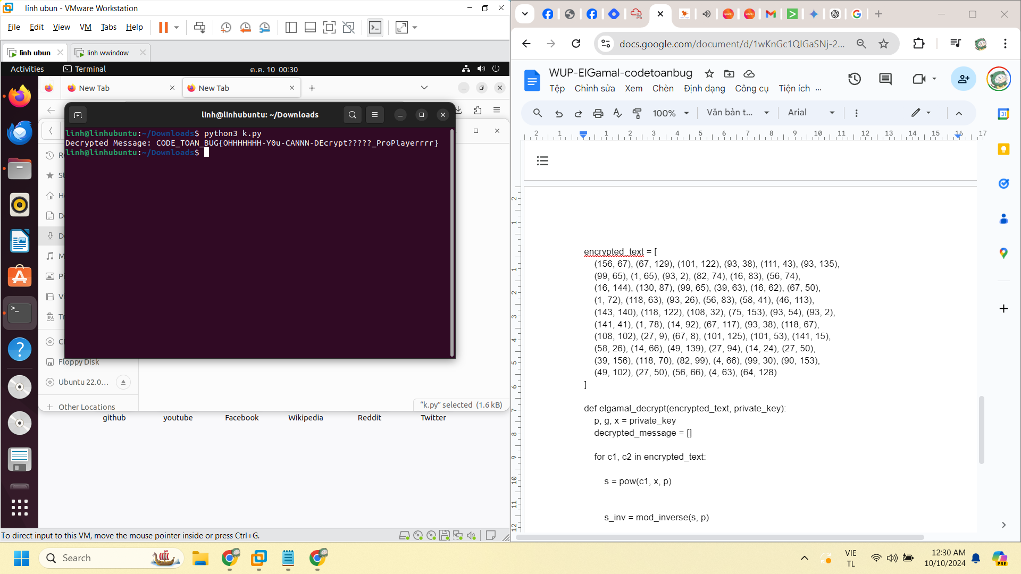

CODE_TOAN_BUG{OHHHHHHH-Y0u-CANNN-DEcrypt?????_ProPlayerrrr}