Lumi and Ludi's Review Story
Name: __________________________ Page 1 of 4
Follow the whole story. Answer every question, then read the passage aloud.
Hi, I'm Lumi.
Today is the final review challenge.
Look at the pictures and answer the questions.
Is there a table? | 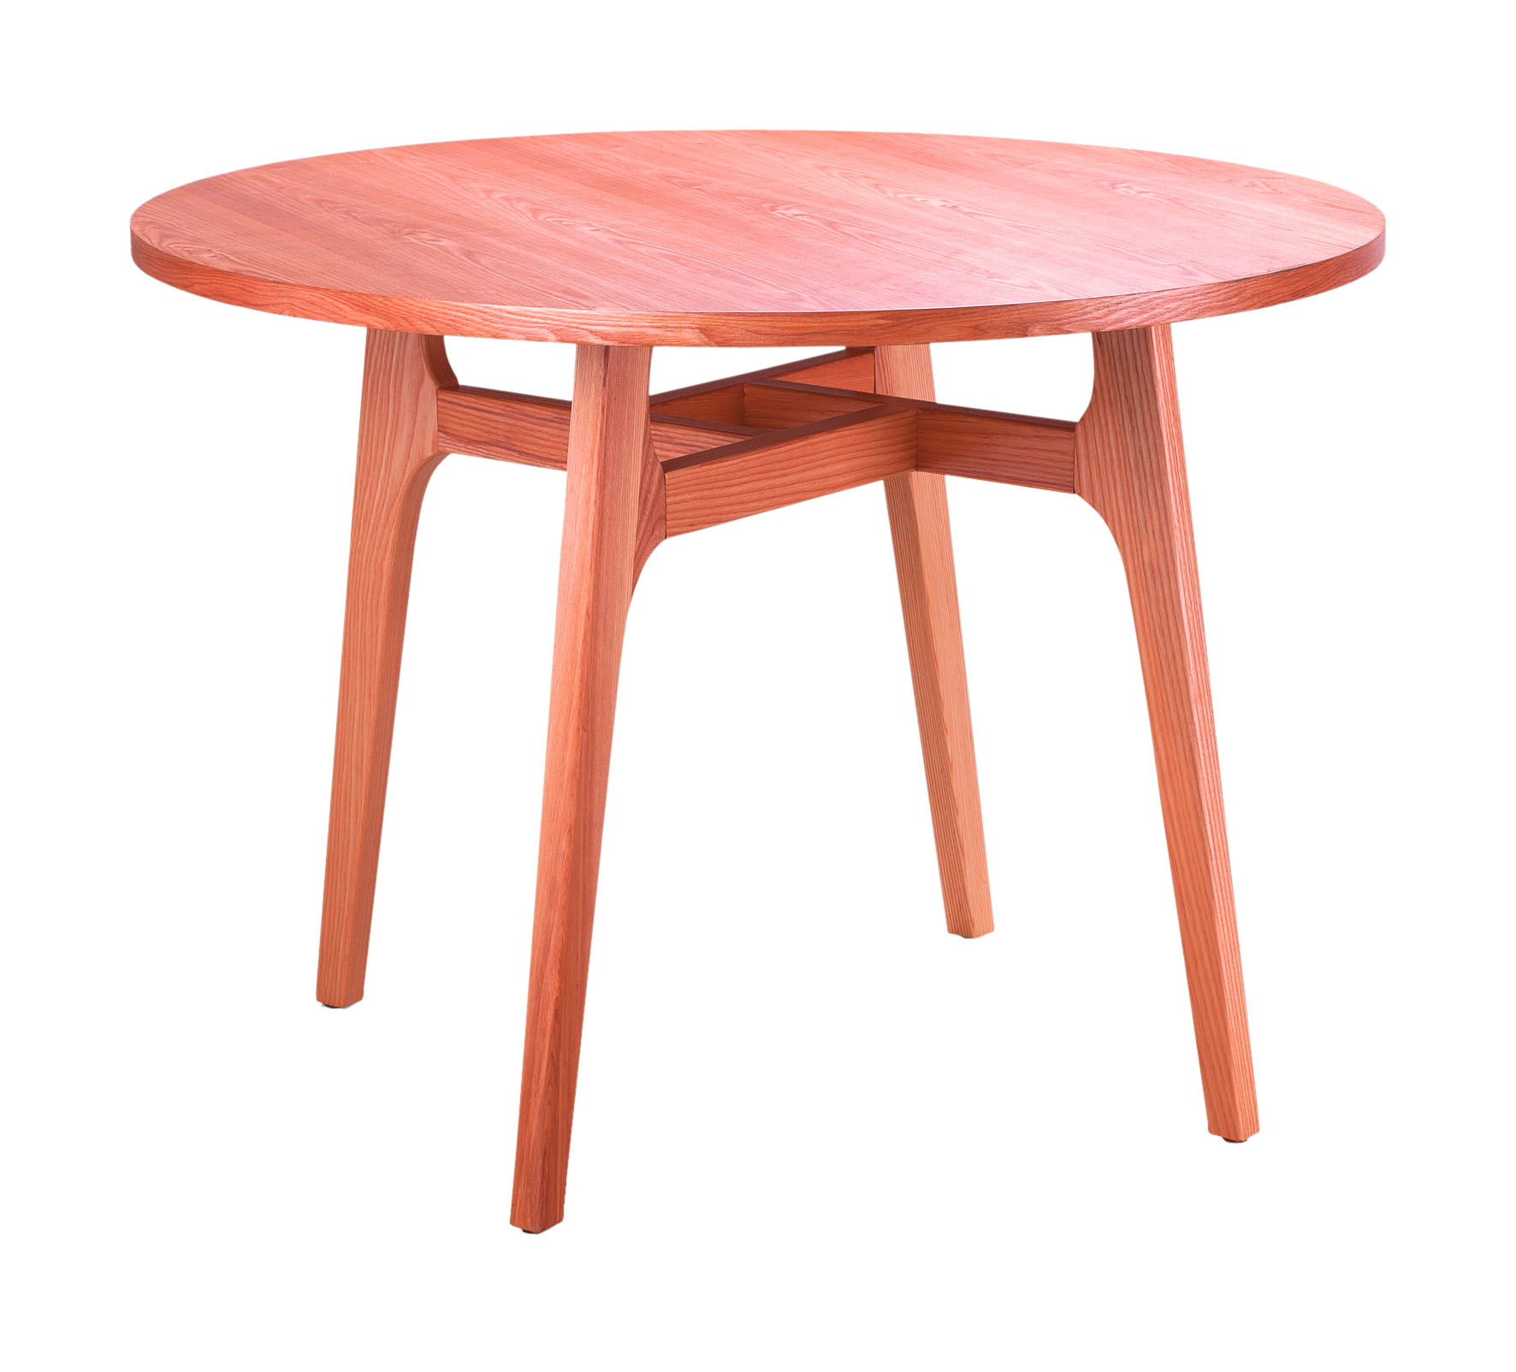
Are there eleven windows? | 11 
How many yo-yos are there? | 8 
Check every complete sentence. Great job today!

Cumulative Dialogue
Name: __________________________ Page 2 of 4
Match each question to the best complete answer.
1. Is there a door? | 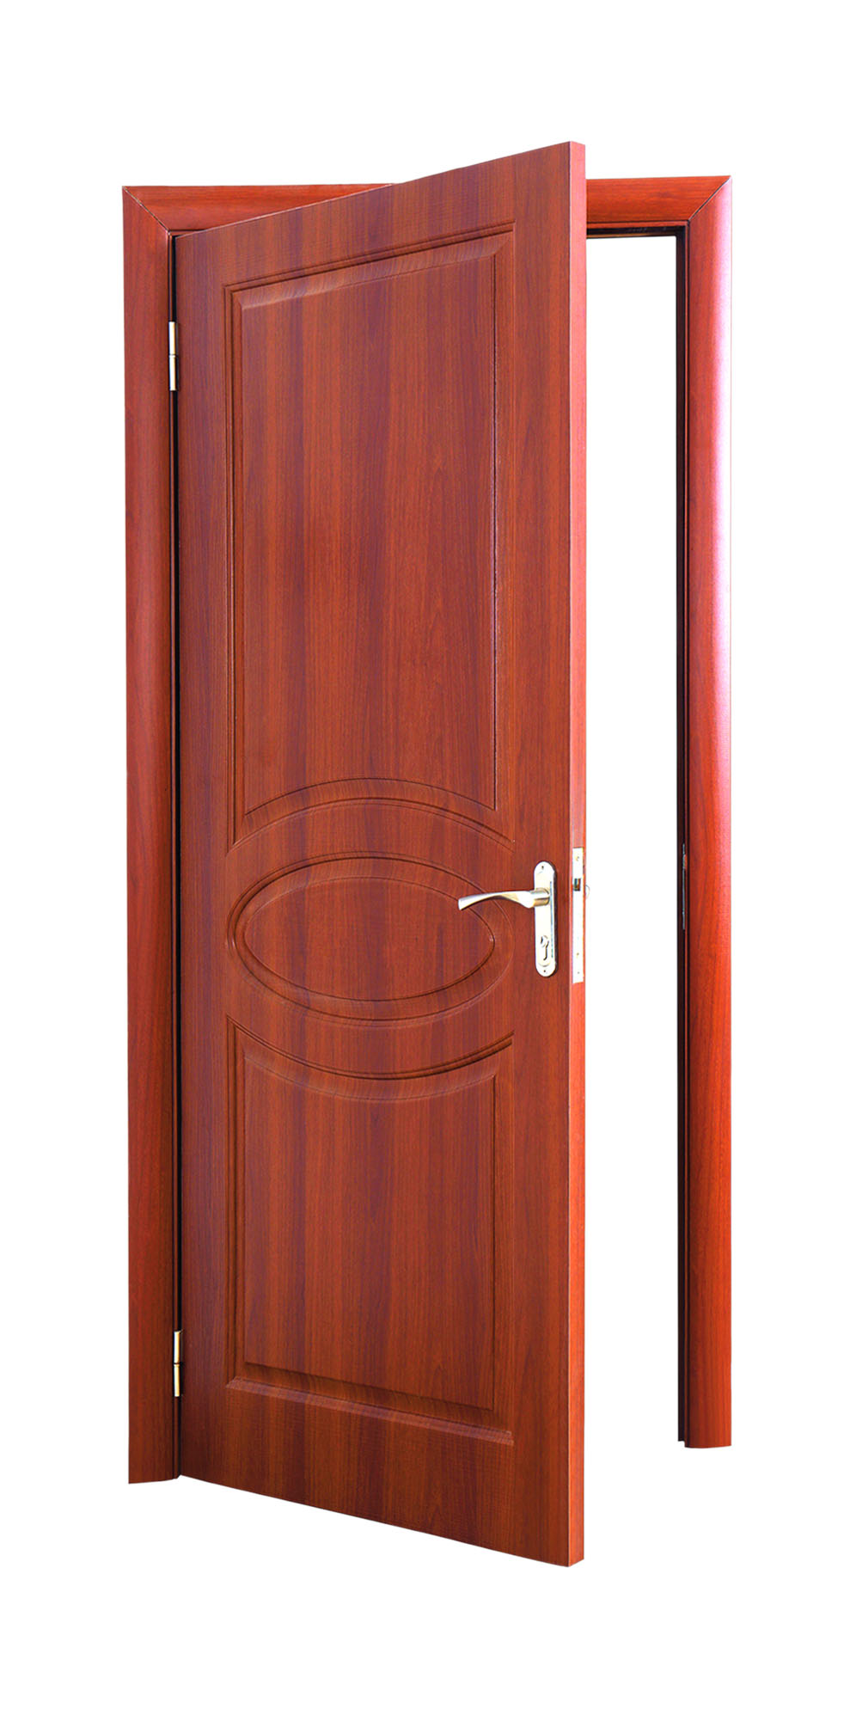 | A. Yes, there are.
2. Are there twelve books? | 12  | B. Yes, there is. There is a fan!
3. Is there a fan? |  | C. Yes, there are.
4. Are there twenty books? | 20 | D. Yes, there is.
Choose one pair. Write the complete answer.

Final Cumulative Check
Name: __________________________ Page 3 of 4
Circle the only correct question.
1. Answer: No, there is not.  A Is there a blackboard? B Is there a blackboard C Is there blackboard? | NO 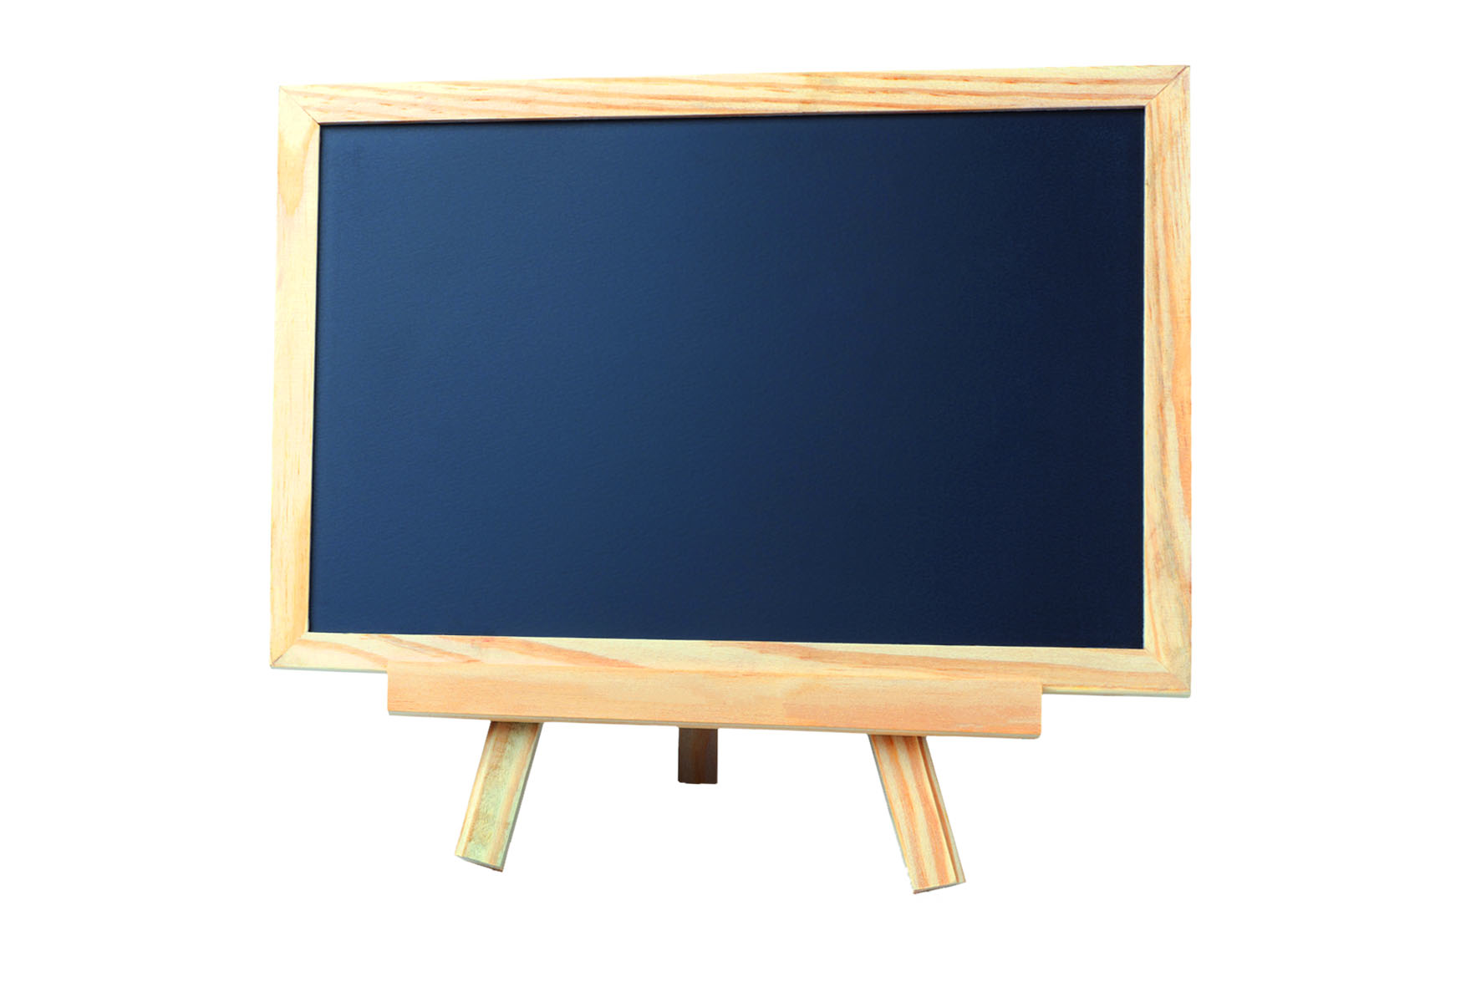
2. Answer: Yes, there are.  A Are there seventeen books? B Is there seventeen books? C There are seventeen books? | 17
3. Answer: There are ten board games.  A How many board games are there? B How much board games? C What board games there are? | 10 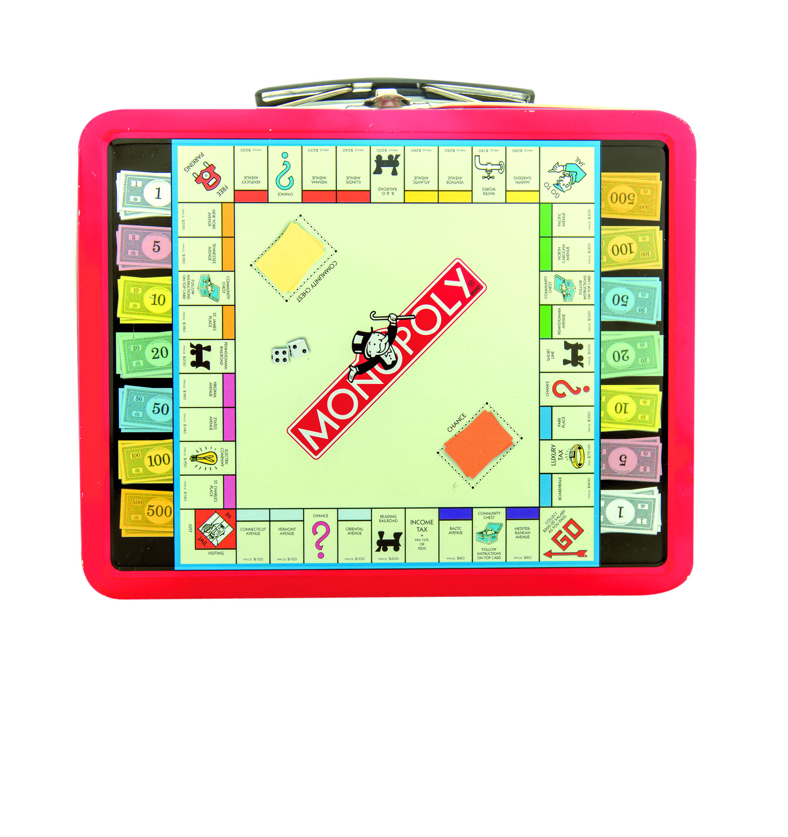
4. Answer: No, there is not.  A Is there a television? B Are there a television? C There is a television? | NO 
Choose one answer. Write the complete sentence.

Independent Chain Challenge
Name: __________________________ Page 4 of 4
Answer in complete sentences. Then write one new question that keeps the conversation going.
1. Is there a whiteboard? | 
2. Are there fourteen books? | 14
3. How many video games are there? | 9 
4. Is there a telephone? | 
5. Are there nineteen windows? | 19
6. How many blocks are there? | 16 
My next question:

