Distributed Job Scheduler — Final Submission
Candidate: ssrsh

1. Overview
This project implements a multi-tenant, distributed job scheduler capable of orchestrating reliable background tasks across independent, horizontally scalable workers.
- Database: PostgreSQL 16 (via Prisma ORM)
- Backend: Express.js, TypeScript, Zod
- Frontend: React, Vite, TailwindCSS, Zustand, Recharts
- Real-time: Socket.io for live metric streaming

2. Core Architecture
- API Server: Handles REST endpoints, authentication (JWT), RBAC, and enqueues jobs.
- Worker Nodes: Independent processes that aggressively poll the queue, claim jobs atomically, and execute them.
- Dashboard: A real-time monitoring interface connected via Socket.io.

3. Database Schema (Entity-Relationship Diagram)
The full PostgreSQL schema consists of 14 tables handling Users, Orgs, Projects, Queues, Jobs, Logs, and Workers.
View full ER Diagram on GitHub: Prisma Schema Graph

4. Proof of Functionality (Screenshots)

4.1 Dashboard Overview
Shows top-level metrics: Total Jobs, Completed, Failed, and Active Workers.
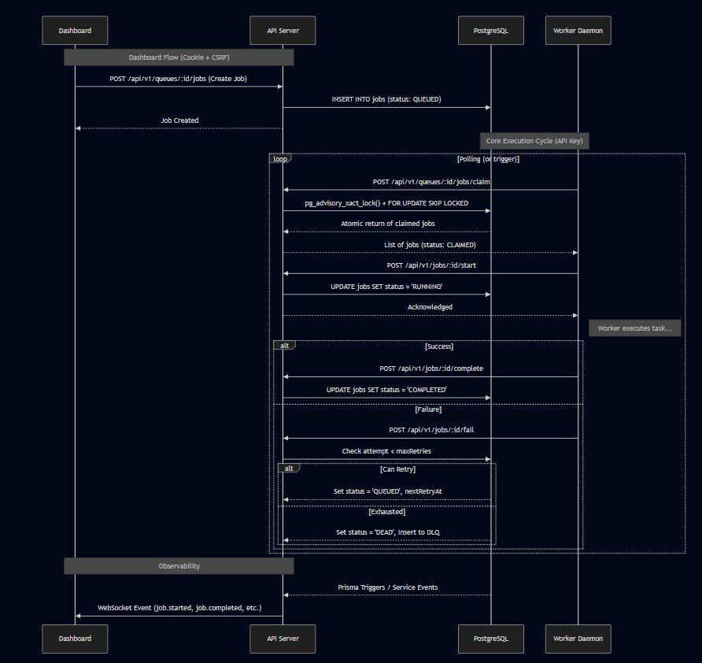

4.2 Job Explorer & Logs
Displays the comprehensive job list with search, filtering, and the job log modal open.
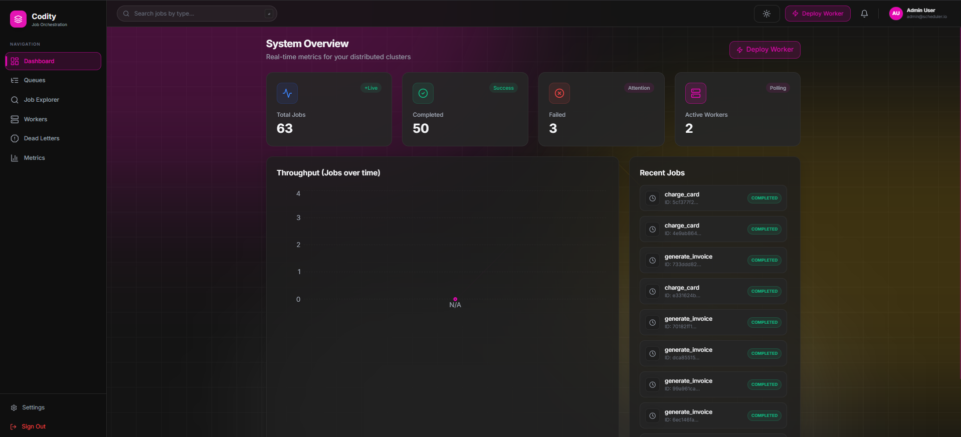

4.3 Queue Configuration
Shows a specific queue's configuration, pause/resume capability, and latency/status metrics.
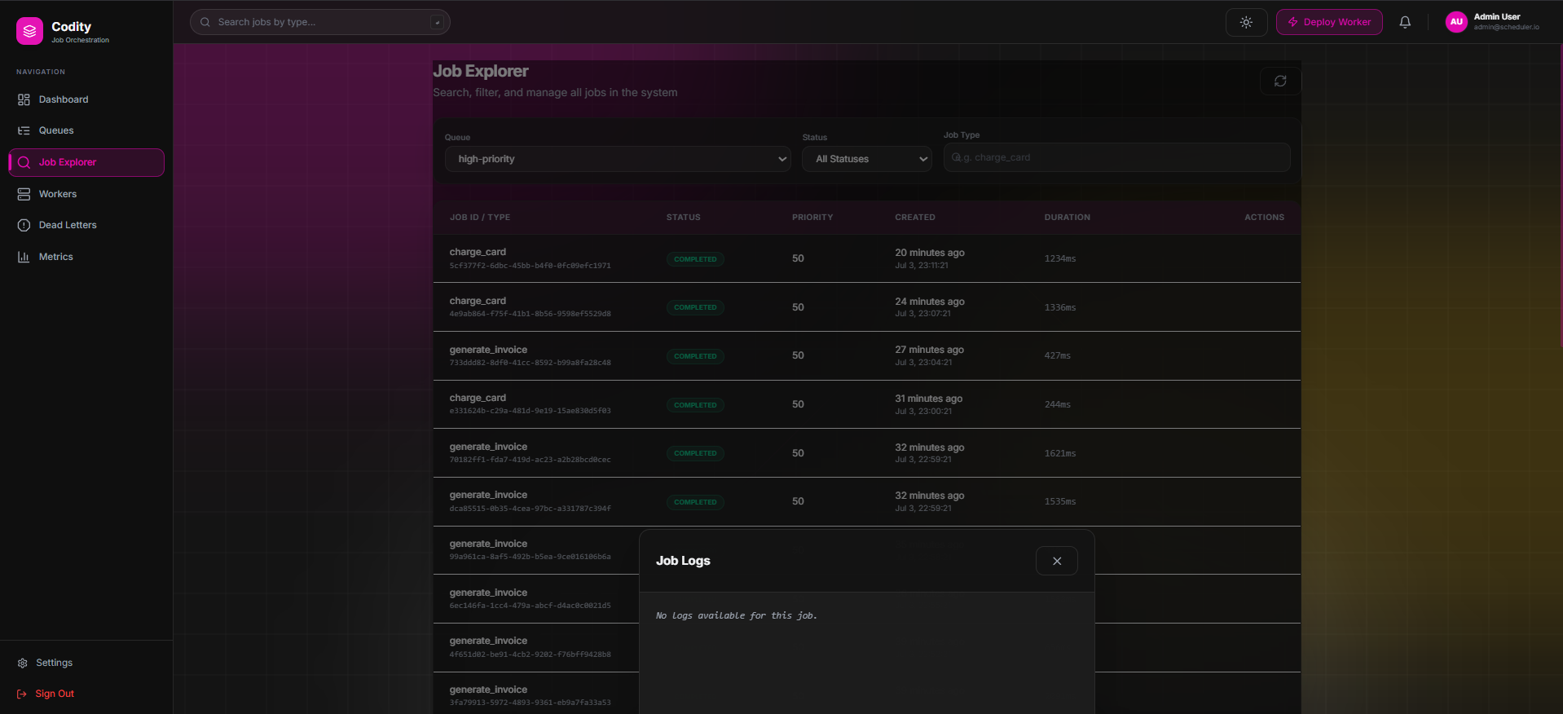

4.4 Dead Letter Queue
Shows failed jobs that exceeded max retries, complete with AI-generated failure summaries and the Requeue action.
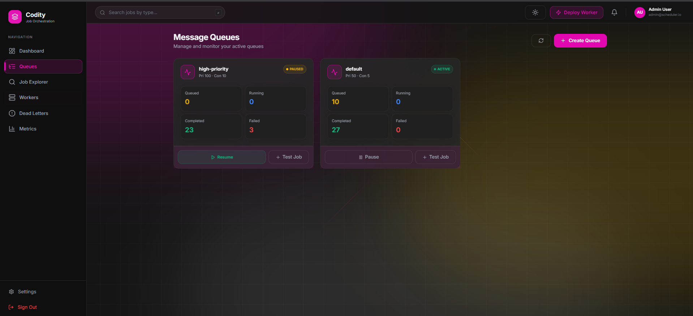

4.5 Active Worker Heartbeat
Shows the active workers currently polling the queues and executing tasks, with heartbeat timestamps.
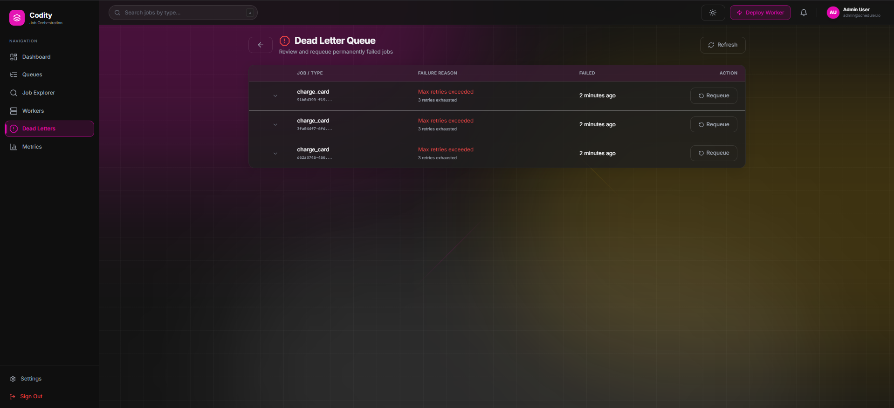

4.6 Metrics Chart
Visualizes the system throughput (jobs completed over time) and resource usage stats.
