Public health awearness

campaing analysis

INNOVATION

INTRODUCTION

In the dynamic landscape of public health, data-driven decision-making has become an indispensable tool for designing, executing, and evaluating effective awareness campaigns. The power of data analytics, harnessed through platforms like IBM Cognos, can play a pivotal role in transforming how we address public health challenges. This introduction serves as a gateway to explore the innovative applications of data analytics within the context of a public health awareness campaign.

The Evolving Landscape of Public Health Campaigns

Public health awareness campaigns are essential for disseminating critical information, promoting healthy behaviour’s, and mitigating the spread of diseases. However, the effectiveness of these campaigns has often relied on traditional methods, resulting in suboptimal outcomes and resource allocation inefficiencies. Today, the public health landscape is marked by an explosion of data sources, from social media sentiments to wearable health devices, enabling us to gain deeper insights into the communities we serve. This wealth of data, when harnessed effectively, empowers us to make data-driven decisions that can enhance the reach, impact, and efficiency of public health campaigns.

The Role of IBM Cognos in Public Health Analytics

IBM Cognos, a robust business intelligence and analytics platform, offers a comprehensive suite of tools that can be leveraged for innovative data analysis within the realm of public health awareness campaigns. It provides the means to collect, analyse, visualize, and disseminate crucial information, enabling decision-makers to make informed choices that can save lives and improve public health outcomes.

Key Innovations in Data Analytics Using IBM Cognos

This project embarks on a journey to explore ground breaking innovations in the field of public health analytics using IBM Cognos. We delve into a range of cutting-edge techniques and methodologies that promise to revolutionize the way we plan, execute, and evaluate public health awareness campaigns. In this endeavour, we will discuss predictive analytics, social media sentiment analysis, geospatial analytics, personalization and targeting, A/B testing, mobile app integration, IOT data integration, natural language processing (NLP), data visualization, machine learning for response analysis, compliance and regulatory analysis, and cost-benefit analysis. Each of these innovations brings unique strengths to the table, offering the potential to optimize resources, engage communities more effectively, and enhance the overall impact of public health campaigns.

Project Objectives

Throughout this project, we aim to:

1. Showcase how IBM Cognos can be harnessed to harness and analyse diverse data sources.

2. Highlight the potential of data-driven insights in optimizing public health campaign strategies.

3. Explore real-world examples and case studies that demonstrate the effectiveness of these innovations.

4. Provide practical guidance for public health professionals, researchers, and policymakers looking to leverage IBM Cognos and data analytics in their campaigns.

As we embark on this exploration of innovations in data analytics using IBM Cognos for public health awareness campaign analysis, we invite you to join us in uncovering new possibilities for improving public health outcomes.

Chart

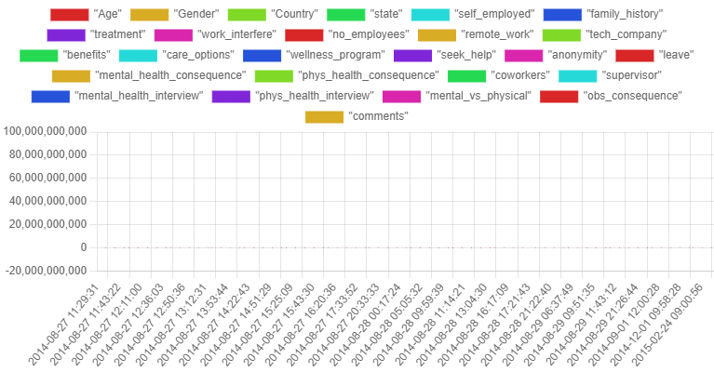

The above shown picture is the given data of the public health awareness and campaign analysis. In that picture that show’s that how much the data and what type of data are in the given data of the project of the public health awareness and campaign analysis.

Software requirements

1. Java Development Kit
2. Jupiter
3. Anaconda
4. IBM cognos
5. Python
6. And etc….

And these are the software’s that we are using throughout the entire project.

Process

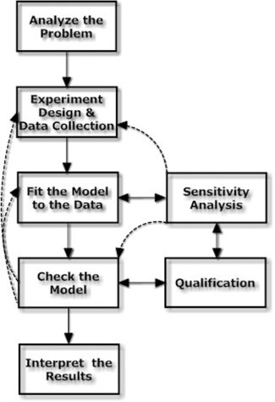

These are the processes that we are going to be using throughout the project to achieve our goal of harnessing the data’s of people’s with our knowledge of data analytics

Result

Innovative data analytics with Cognos can supercharge public health awareness campaigns. It helps predict campaign success, analyze social media sentiment, map geographic needs, and tailor messages to different groups. By using advanced techniques like machine learning and real-time data, we can respond quickly to changes and create more effective campaigns. However, it's crucial to protect people's privacy and follow regulations. In short, these innovations can make our public health campaigns smarter and more impactful.