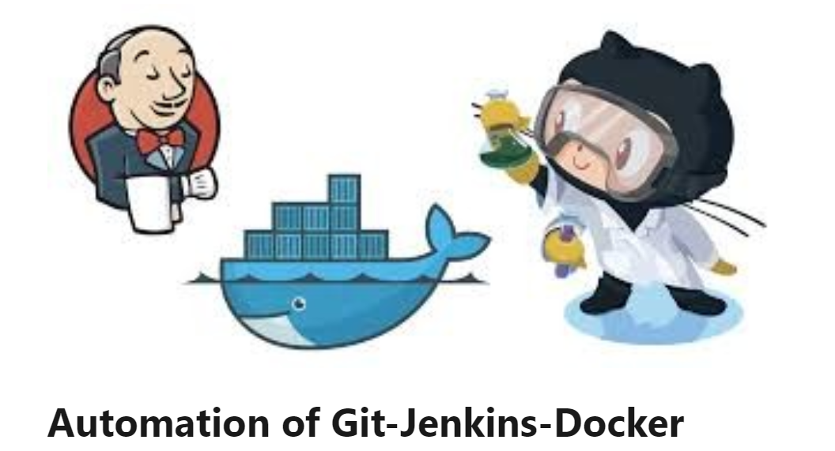

Problem Statement :
1. Create a container image that’s has Jenkins installed using Dockerfile.
2. When we launch this image, it should automatically start the Jenkins service in the container.
3. Create a job chain of job1, job2, job3, and job4 using the build pipeline plugin in Jenkins.
4. Job1: Pull the GitHub repo automatically when some developers push the repo to GitHub.
5. Job2: By looking at the code or program file, Jenkins should automatically start the respective language interpreter install image container to deploy code ( eg. If code is of PHP, then Jenkins should start the container that has PHP already installed ).
6. Job3: Test your app if it is working or not.
7. Job4: If the container where the app is running. fails due to any reason then this job should automatically start the container again.

First we can create the image as follows-:
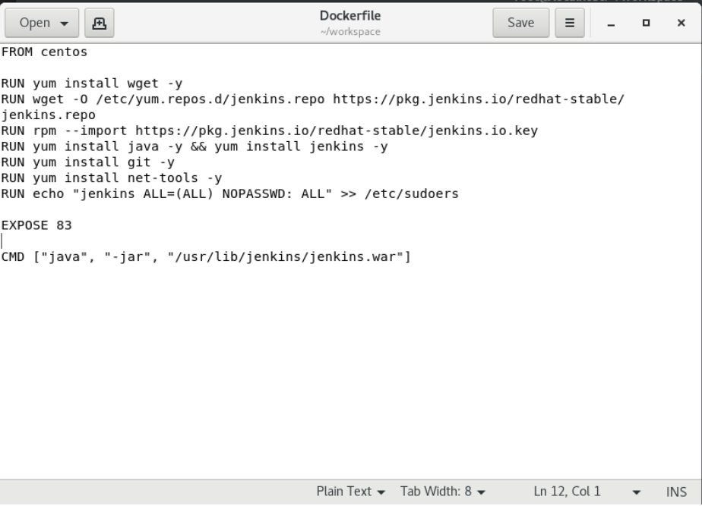

FROM: Used for the image to be used for container
RUN: Use this RUN commands to be executed while building the modified container
CMD: the CMD used here will keep the Jenkins live till the container is on and will start on container boot.
After this Build your own image:

Run the given command in the docker
docker build -t jenkin:latest
All the steps are done of building the images , after this, we have to use this image to make a container,
After is use you IP and 8765 to launch Jenkins:-
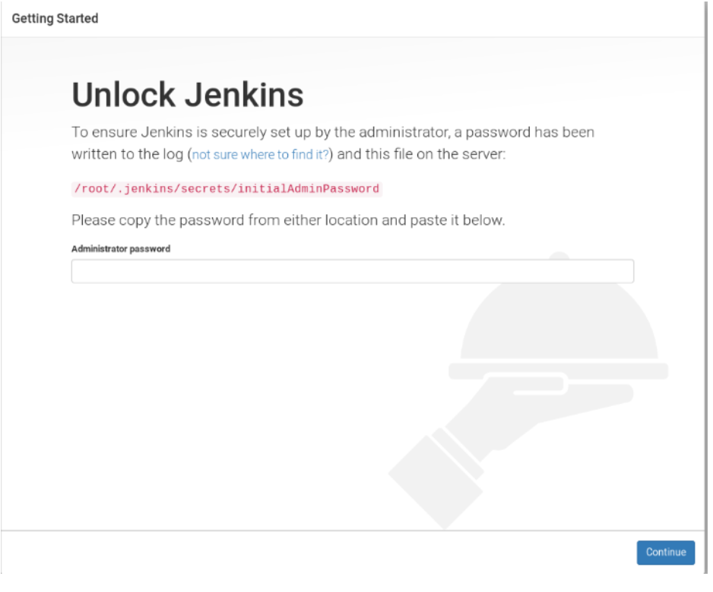
Paste the password in this and your Jenkins is ready to use:-
Now we will be moving on to our jobs.
Jobs are created in this container and the necessary plugins like Build pipeline, Git, GitHub are installed.
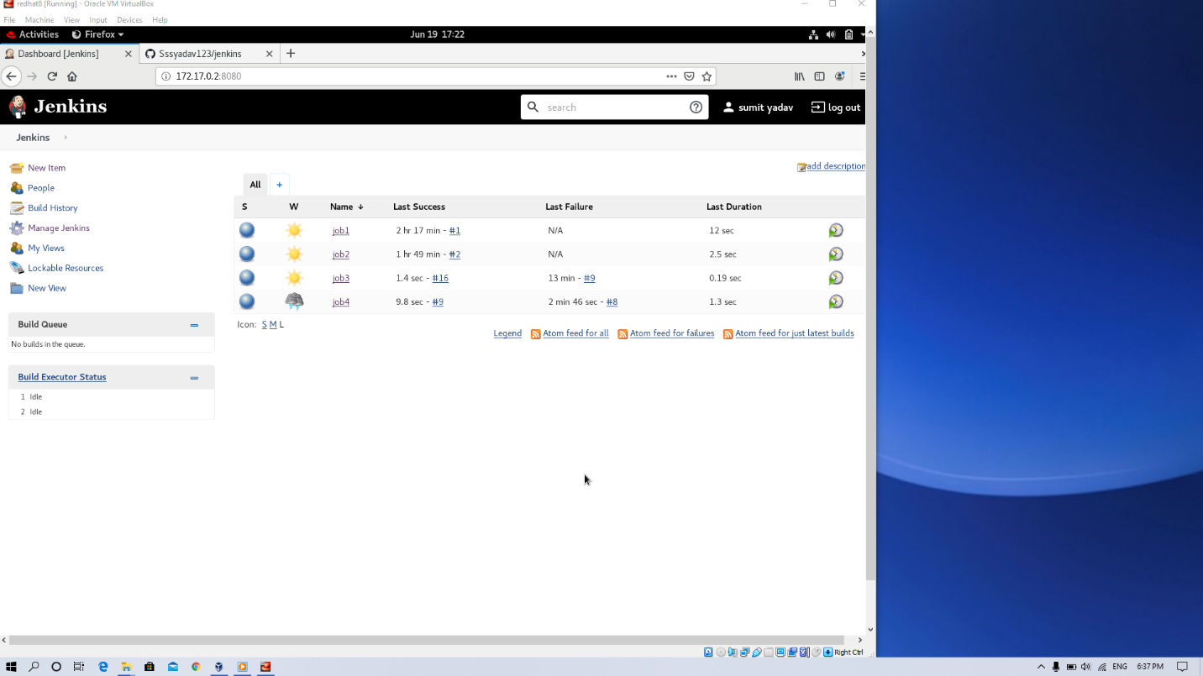

This is the dashboard of Jenkins
- JOB 1
Pull the GitHub repo automatically when some developers push the repo to GitHub.
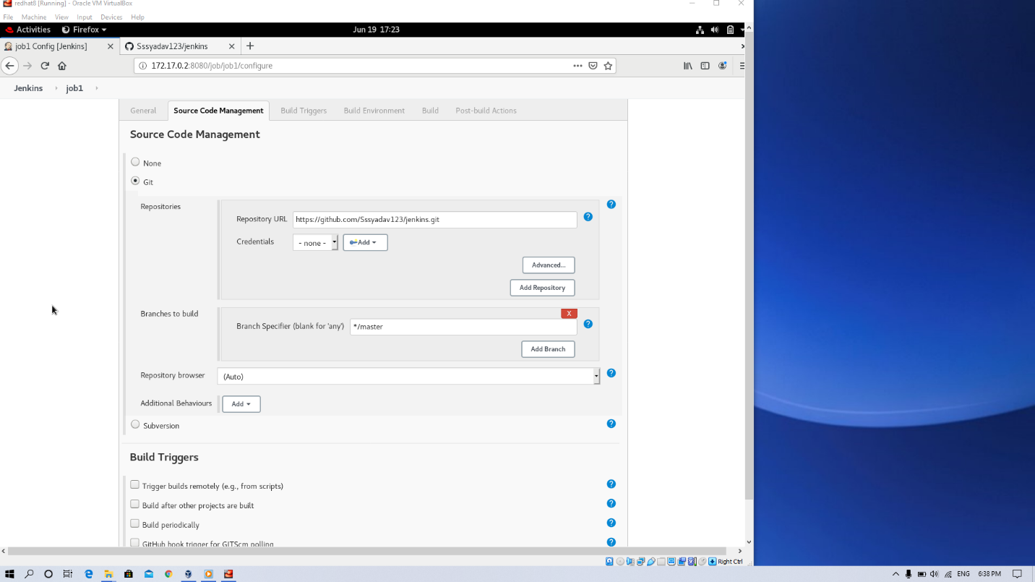
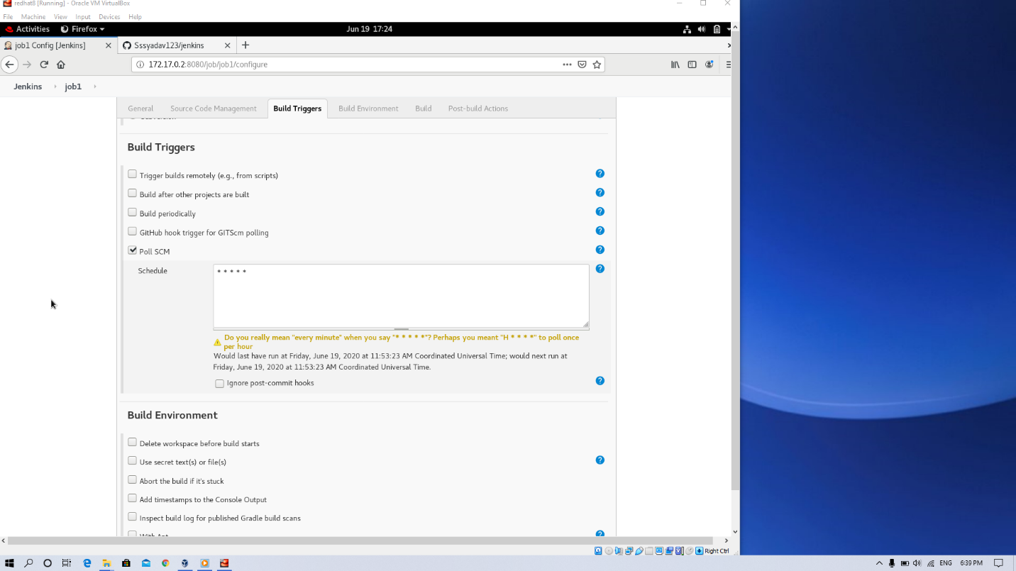
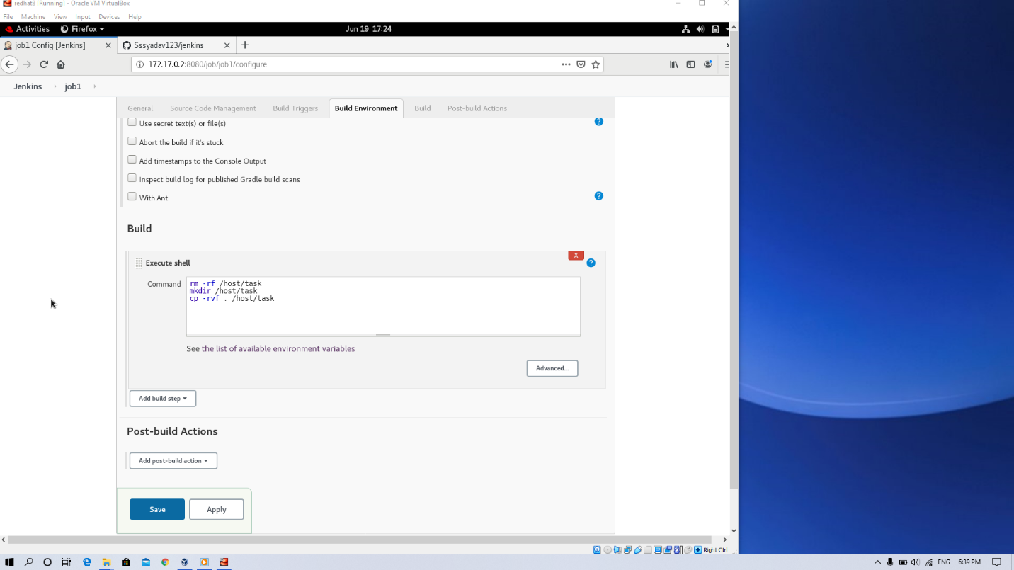

2. JOB 2:
By looking at the code or program file, Jenkins should automatically start the respective language interpreter install image container to deploy code ( eg. If code is of PHP, then Jenkins should start the container that has PHP already installed ).
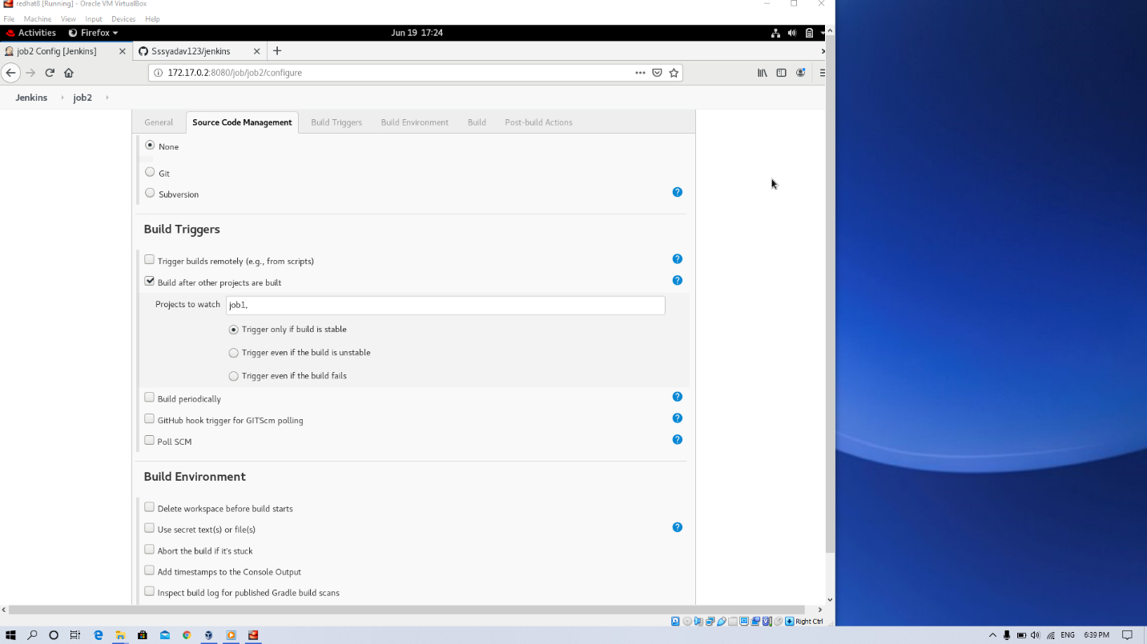
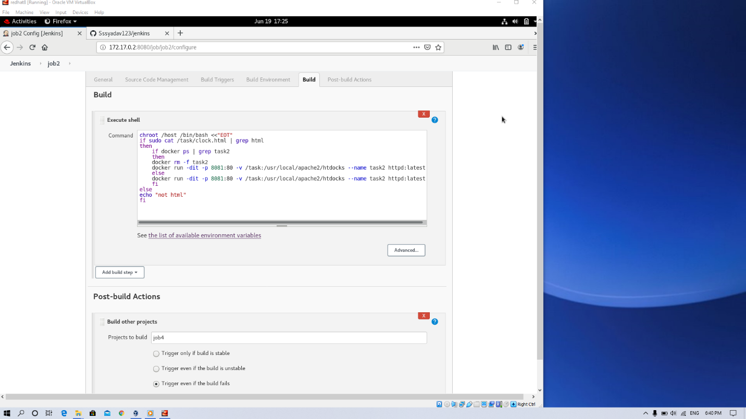

3. JOB 3
Test your app if it is working or not.
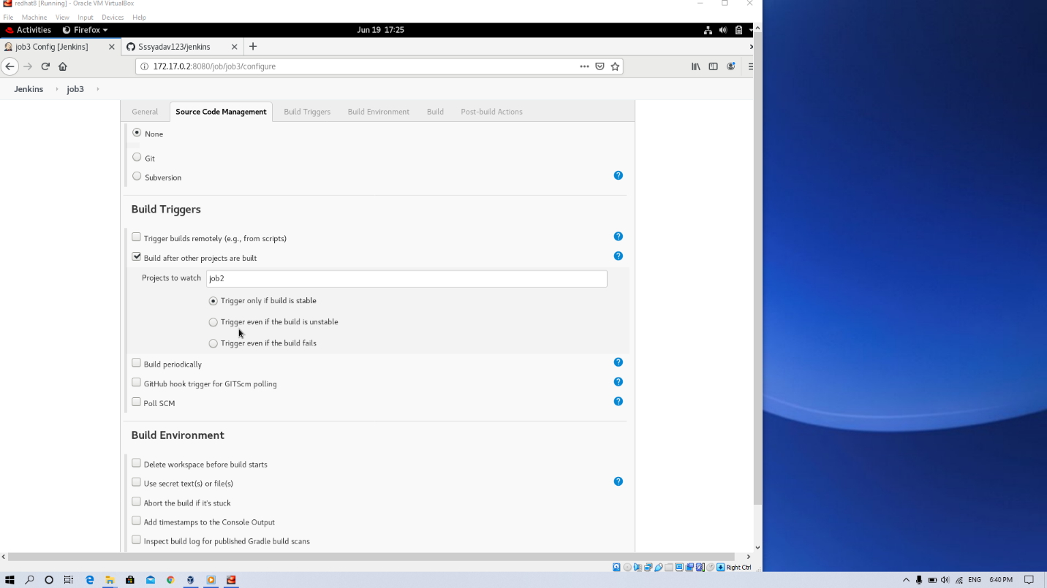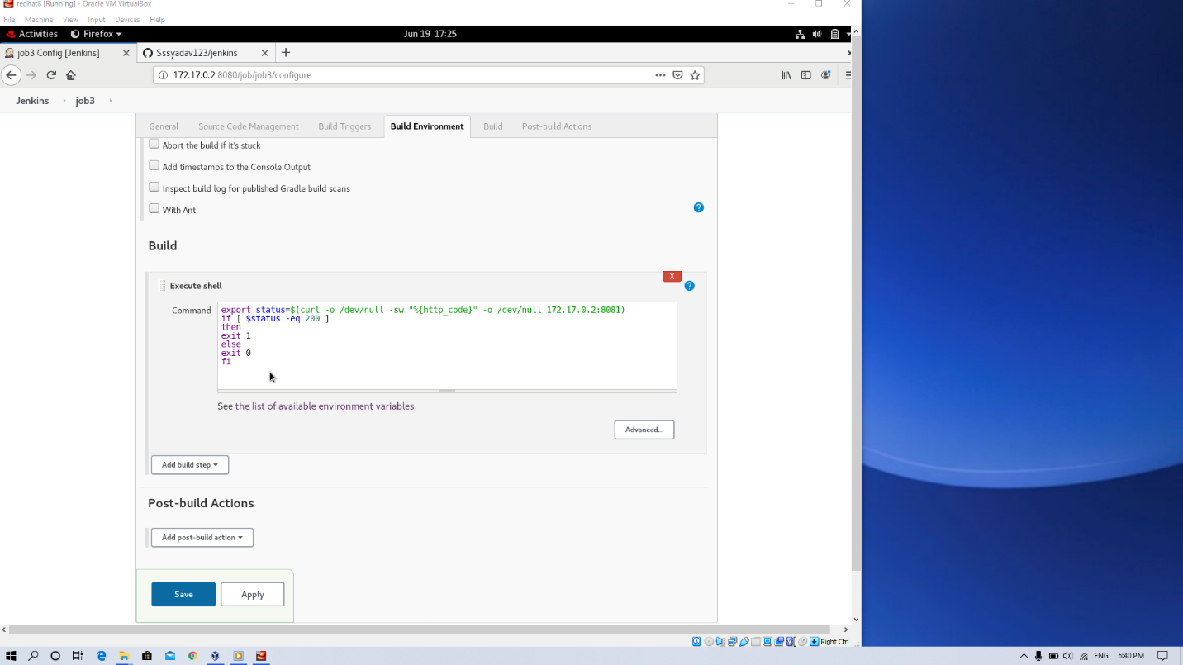

4. JOB 4:
If the container where the app is running. fails due to any reason then this job should automatically start the container again.
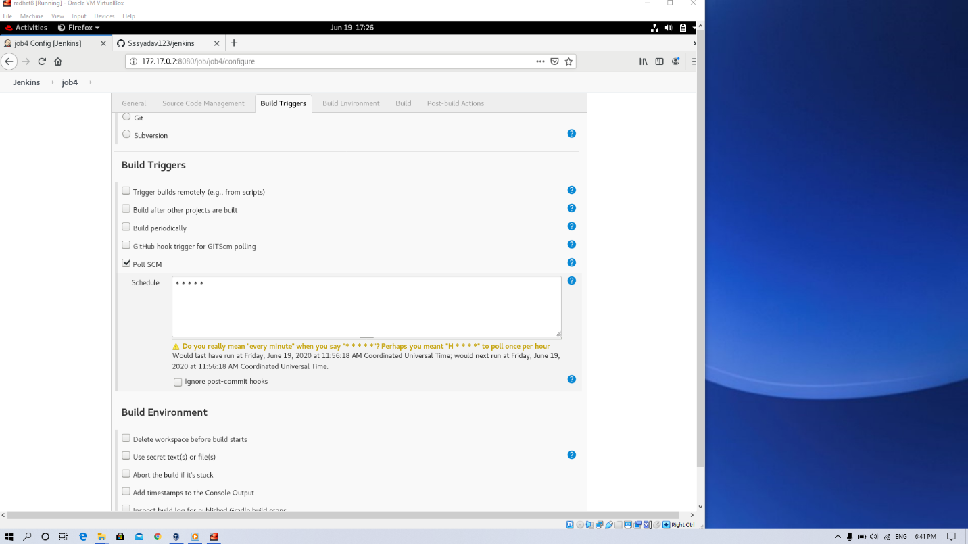
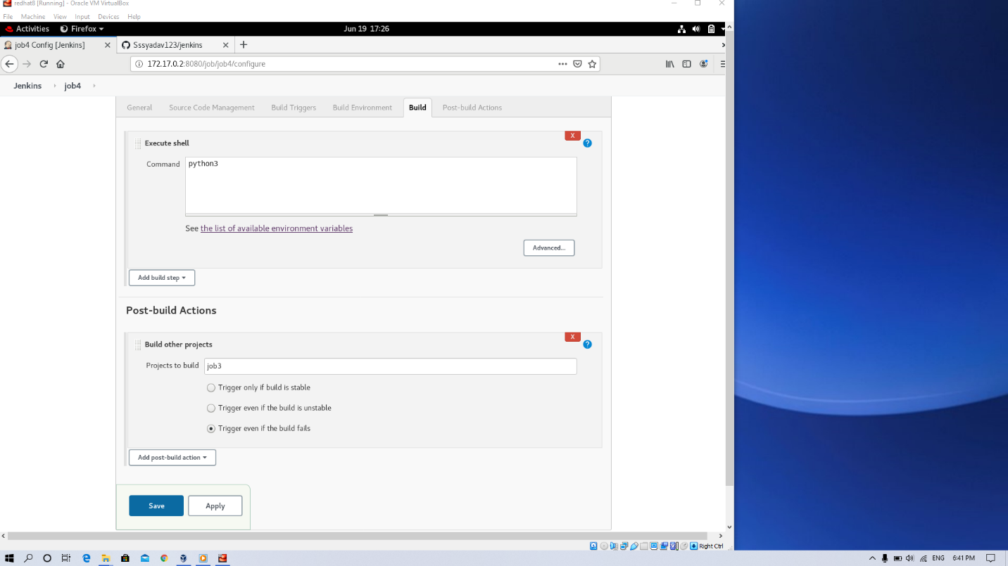
After this install BUILD PIPELINE to look your all jobs systematic
