Project Proposal on

**F*inancing* Management S*ystem***

**Suman Shahi**

*00174381*

Computing Project

Level 5 Diploma in Computing

Softwarica College of IT & E-Commerce

Kathmandu, Nepal

9th April, 2019



Table of Contents

Chapter 1: Introduction 1

Project Introduction 1

Background 1

Description 2

Features of Project 2

Overview of Project 2

Chapter 2 Scope of the project 3

2.1 Scope 3

2.2 Limitation 3

2.3 Aims 3

2.4 Objectives 3

2.5 Overview of the scope 4

Chapter 3: Development Methodology 5

3.1 Development Methods 5

Figure 1: Waterfall Model 5

3.2 Design Pattern 6

Figure 2: MVC Pattern 7

3.3 System Architecture 7

Figure 3: System Architecture 8

Chapter 4 Project Plan 9

Work Breakdown Structure 9

Figure 4: Work Breakdown Structure 9

Time Estimate 10

Milestones 11

GANT CHART 11

Figure 5: Time Estimation 12

Chapter 5 14

Risk Management 14

**Chapter 6** 16

**Configuration Management** 16

Figure 7: Project Uploaded in github 16

Figure 8: Configure Management 17

**Chapter 7** 18

Conclusion 18

Chapter 8 19

References 19

# Chapter 1: Introduction

## Project Introduction

The project Finance Management System aims to help the finance or business organizations, keeping the day by day tally record as a complete banking or financial system. Usually these finance organizations don’t have web based systems for the organization activity for customers and for own organization where the system would inspire them to try to reach their customers from a different portal. Web system would make it easier for staffs which written records won’t be needed as it makes organization to bring the help for finance management system through web organization which makes easier for users to apply for registration or checking their daily activity of their account and with plus benefit they can look at their statement, Profit and Loss, Interest information. There would be less obstacle in managing and accessing the files as it would all be available through the web.

The customers/users can do banking actions from home or anywhere and staff can verify them from wherever they are. The customers/users might even further be encouraged do banking and to have banking services.

## Background

Well every user wants to invest their money on something where “Finance” is applied different context and on every daily life basis and used on different organization or platform. Most of the users can take finance rather than banking process which is easier for them to process. Users are able to invest their money but some of the finance organization can be fraud to users which make users future worst and consequence of that result makes other company non trustable. Investing the money can make stress for users which make impact on mental health. Users documentation and data can be stolen from insiders, which impact on the investment.

So we have decided to give access to their own profile and account where they can see at their statement to make sure the organization is corresponding in right way of their investment. It makes easy convenient which is effective in organization.

## Description

The concept of this project is provide the daily activity of their investment in finance web organization which makes easier for users to apply for registration or checking their daily activity of their account and with plus benefit they can look at their statement, Profit and Loss, Interest information.

## Features of Project

Required feature of the project are:-

* First Customers/users should be registered in the system by applying for making an account from home
* Customers/users need to login for accessing the profile and to check their bank balance from anywhere through the web service
* Customers/users can access and edit, update their profile and can change their account information through the web service
* Through their account statement profit or loss can be calculated for the organization
* Manager/admin can delete a customer or update their details themselves if needed
* Search Capability

## Overview of Project

Financing system is to prepared web application which could maintain data and provide user friendly interface for retrieving customer related details just in few seconds. It is a less time consuming process where no paper work required and can be implemented further. It contains two users: - Admin and User

# Chapter 2 Scope of the project

## 2.1 Scope

The main goal of the system is to automate the process carried out in the bank with improved performance and realize the vision of paperless financing. There are many online systems available on internet but this can compete with some advancement in its functionality and can be used by any bank organization to maintain their customers account and online transaction process.

## 2.2 Limitation

a. only account holder can login

b. identification of individual account holder

c. balance check, amount transaction and bill payment

## 2.3 Aims

The main aims of this project are:-

* To build web based application for a finance/co-operative organization
* To store customer and their financing information
* To calculate the profit or loss of the organization

## 2.4 Objectives

The objectives of this project are: -

* To design a systematic approach to the financing system
* To document profit or loss
* To gather information about the organization

## 2.5 Overview of the scope

The aim of the project is to create a web based application to allow the user to keep update about their balance enquiry and to deposit cash, withdraw, transaction and to calculate the interest and profit. There is a certain boundary of the system has limited it’s in certain way because this is only based for our country only. This web based application will be very useful to attract Account Holder’s we can offer various offer during festivals months. We can have more and more customer satisfaction we will emphasize more and more on our dealing.

# Chapter 3: Development Methodology

## 3.1 Development Methods

For the development of the project Object Oriented Methodology will be used as it is very agile because of its properties. Detail planning will be needed for this project so waterfall model will be suitable for the development of this project. Each step will be carried out very carefully and one step cannot be carried out without completing the step before it.

The waterfall model is the earliest SDLC approach that was used for software development. The waterfall model is very simple to understand and use. It is referred as a linear-sequential life cycle model. Each phase must be completed before the next phase can begin and there is no overlapping in the phases which illustrates the software development process in a linear sequential flow.

The following illustration is a representation of the different phases of the Waterfall Model.

**Requirement Analysis**

**System Design**

**Implementation**

**Testing**

**Deployment**

**Maintenance**

### Figure 1: Waterfall Model

All these phases are cascaded to each other in which progress is seen as flowing steadily downwards (like a waterfall) through the phases. The next phase is started only after the defined set of goals are achieved for previous phase.

Some advantages of waterfall model:

* Simple and easy to understand and use
* Easy to manage due to the rigidity of the model. Each phase has specific deliverables and a review process.
* Phases are processed and completed one at a time.
* Works well for smaller projects where requirements are very well understood.
* Clearly defined stages.
* Well understood milestones.
* Easy to arrange tasks.
* Process and results are well documented.

Some disadvantages of waterfall model

* No working software is produced until late during the life cycle.
* High amounts of risk and uncertainty.
* Not a good model for complex and object-oriented projects.
* Poor model for long and ongoing projects.
* risk and uncertainty is high with this process model.
* It is difficult to measure progress within stages.
* Cannot accommodate changing requirements.
* Adjusting scope during the life cycle can end a project.

## 3.2 Design Pattern

Design patterns are an important technique for handling the implementation of complex functionality. Here, I will be using MVC pattern and object oriented approach using framework for my project for faster development process also the modification does not affect the entire model.

The Model View Controller (MVC) design pattern specifies that an application consist of a data model, presentation information, and control information. The pattern requires that each of these be separated into different objects.

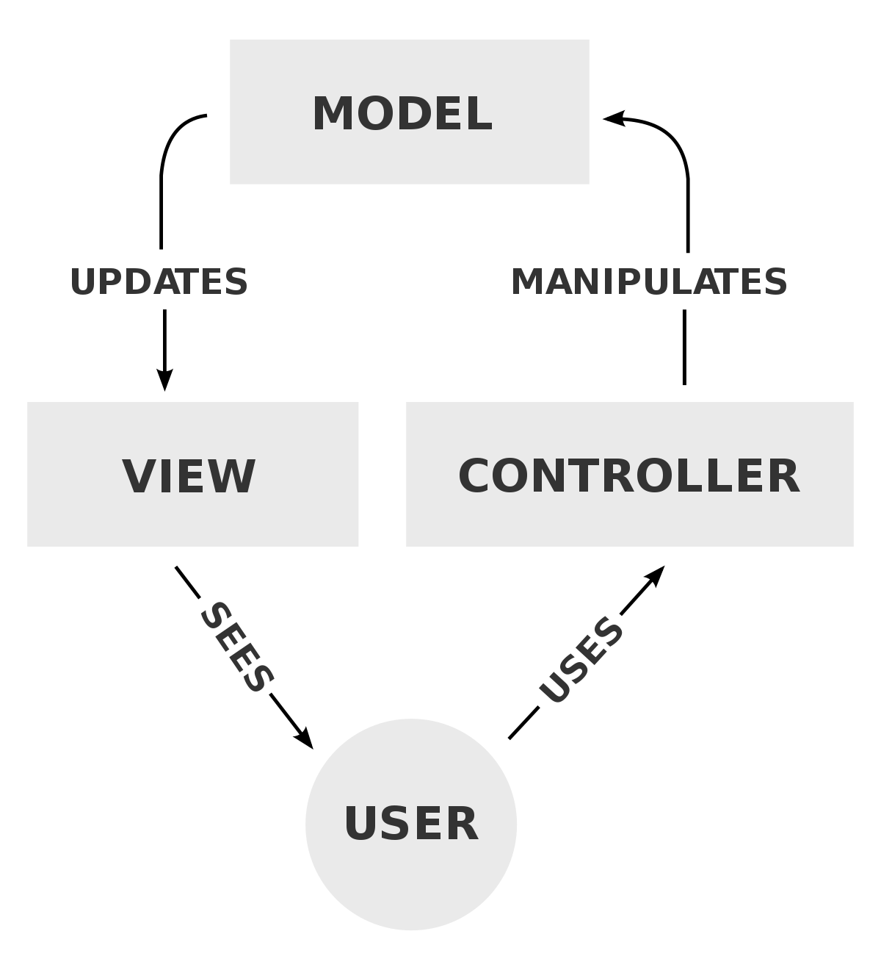

### Figure 2: MVC Pattern

## 3.3 System Architecture

Architecture serves as a blueprint for a system. It provides an abstraction to manage the system complexity and establish a communication and coordination mechanism among components.

Therefore, 3 tier architecture has been implemented to be used in the development project. A 3-tier application architecture is a modular client-server architecture that consists of a presentation tier, an application tier and a data tier.

**Presentation Tier:** Occupies the top level and displays information related to services available on a website. This tier communicates with other tiers by sending results to the browser and other tiers in the network.

**Application Tier:** Also called the middle tier, logic tier, business logic or logic tier, this tier is pulled from the presentation tier. It controls application functionality by performing detailed processing.

**Data Tier:** Houses database servers where information is stored and retrieved. Data in this tier is kept independent of application servers or business logic.

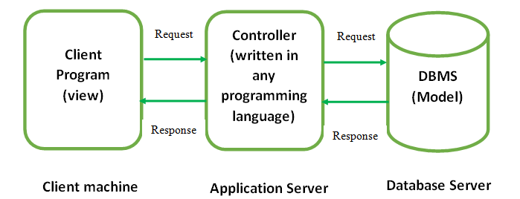

### Figure 3: System Architecture

# Chapter 4 Project Plan

## Work Breakdown Structure

Work breakdown structure helps to decompose a project into manageable sections with which we can work with. It helps in the detailed development of a project. (Workbreakdownstructure.com, 2016)

**Financing System**

**Proposal**

**Scoping**

**Planning**

**Monitoring**

**Analysis**

**Requirement Gathering**

**Requirement Analysis**

**Use Case Diagram**

**Design**

**Class Diagram**

**Sequence Diagram**

**User Interface**

**Coding**

**Testing**

**Unit Testing**

**Integration Testing**

**Documentation**

**Final Report**

**User Manual**

### Figure 4: Work Breakdown Structure

## Time Estimate

|  |  |  |
| --- | --- | --- |
| **Task Number** | **Task Name** | **Task Estimation** |
| 1 | Proposal | 17 days |
| 2 | Analysis | 23 days |
| 2.1 | Requirement Gathering | 10 days |
| 2.2 | Requirement Analysis | 8 days |
| 2.3 | Use Case Diagram | 4 days |
| 2.4 | Analysis Specification | 1 day |
| 3 | Design | 25 days |
| 3.1 | Class Diagram | 9 days |
| 3.2 | Sequence Diagram | 9 days |
| 3.3 | User Interface Design | 6 days |
| 3.4 | Design Specification | 1 day |
| 4 | Implementation | 20 days |
| 4.1 | Coding | 20 days |
| 5 | Testing | 7 days |
| 5.1 | Unit Testing | 4 days |
| 5.2 | Integration Testing | 3 days |
| 6 | Documentation | 10 days |
| 6.1 | User Manual | 5 days |
| 6.2 | Final Report | 4 days |
| 6.3 | Report Submission | 1 day |
|  | Total Days | 108 days |

## 

## Milestones

|  |  |  |  |
| --- | --- | --- | --- |
| **Milestones** | **Start Date** | **End Date** | **No. of Days** |
| Project proposal submission | 4/1/19 | 4/17/19 | 17 days |
| Planning |  |  |  |
| Scoping |  |  |  |
| Monitoring |  |  |  |
| Submission |  |  |  |
| Analysis specification | 4/19/19 | 5/11/19 | 23 days |
| Requirement Gathering |  |  |  |
| Requirement Analysis |  |  |  |
| Use Case Diagram |  |  |  |
| Analysis Specification |  |  |  |
| Design | 5/13/19 | 6/6/19 | 25 days |
| Class Diagram |  |  |  |
| Sequence Diagram |  |  |  |
| User Interface |  |  |  |
| Design Specification |  |  |  |
| Implementation | 6/10/19 | 6/29/19 | 20 days |
| Coding |  |  |  |
| Testing | 7/1/19 | 7/7/19 | 7 days |
| Unit Testing |  |  |  |
| Integration Testing |  |  |  |
| Documentation | 7/8/19 | 7/17/19 | 6 days |
| User Manual |  |  |  |
| Final Report |  |  |  |
| Report Submission |  |  |  |
| Final Deadline 7/15/2019 | | | |

## GANT CHART

Gantt chart provides a graphical illustration of a schedule that helps to plan, coordinate, and track specific tasks in a project. Gantt charts give a clear illustration of project status, but one problem with them is that they don't indicate task dependencies - you cannot tell how one task falling behind schedule affects other tasks.

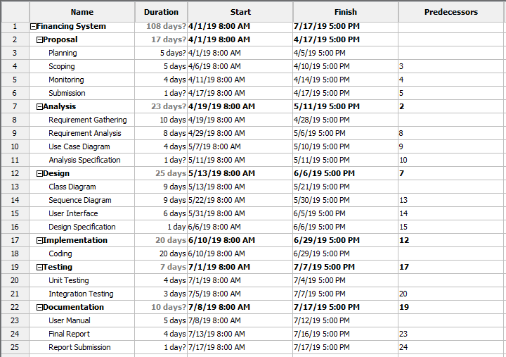

### Figure 5: Time Estimation

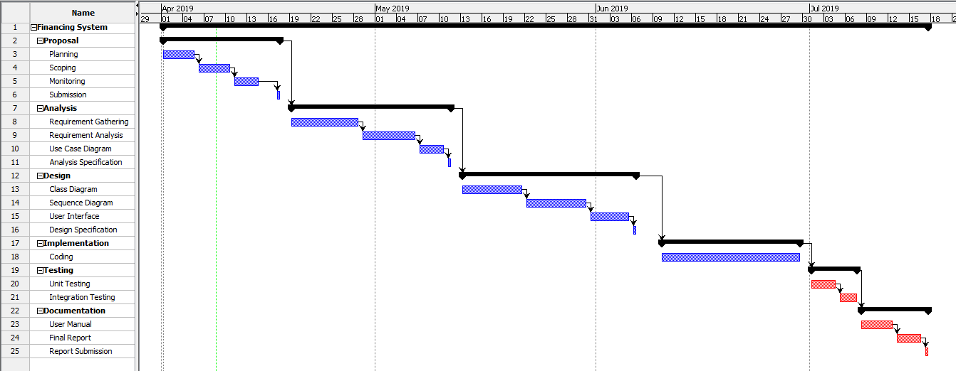

Figure 6: Gant Chart

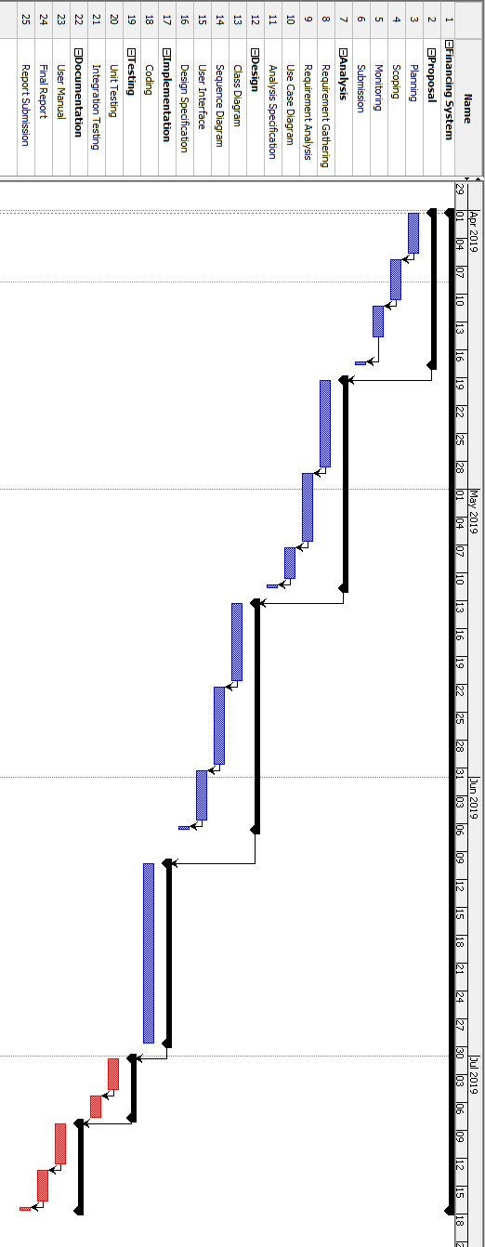

# Chapter 5

## Risk Management

Risk management is the process of identifying, assessing and controlling threats to an organization's capital and earnings. These threats, or risks, could stem from a wide variety of sources, including financial uncertainty, legal liabilities, strategic management errors, accidents and natural disasters. Managing the risk should be the part of planning process to figure out the risk that might happen in the project and also how to control the risk if in fact it occurs. So in order to manage the risk firstly all the risk must be identified with its impact of risk and then proper solution to those problem can be figure out. There are some steps for risk management they are

**Risk identification**

In this phase we try to uncover, recognize and describe risks that might affect the project outcome. There are number of technique that we can use to identify the risk.

**Risk analysis**

Once the risk is identified in this phase we determine the likelihood and consequences of each risk. We develop an understanding of the nature of the risk and its potential to affect the project goal and objectives.

[**Risk assessment**](https://searchcompliance.techtarget.com/definition/risk-assessment)**and evaluation**

In this phase or stage we evaluate or rank the risk by determining the risk magnitude, which is the combination of likelihood and consequences. We make decision about whether the risk is acceptable or whether it is serious enough to warrant the treatment.

**Risk mitigation**

In this stage we assess our highest ranked risks and set out a plan to treat or modify these risk to achieve acceptable risk level.

**Risk monitoring**

In this stage we monitor, track and review the risk that occurs during the time of project.

Risks should be managed in time before they become a problem. So here we are trying to identify and plan countermeasures to the risks.

**Likelihood table:**

|  |  |
| --- | --- |
| **Likelihood** | **Value** |
| Low | 1 |
| Medium | 2 |
| High | 3 |

**Table 1: Risk likelihood values**

**Risk consequences table:**

|  |  |
| --- | --- |
| **Consequence** | **Value** |
| Very low | 1 |
| Low | 2 |
| Medium | 3 |
| High | 4 |
| Very high | 5 |

**Table 2: Risk consequence values**

**Risk management table:**

|  |  |  |  |  |
| --- | --- | --- | --- | --- |
| **Risk** | **Likelihood** | **Consequence** | **Impact** | **Action** |
| Server failure | 2 | 5 | 10 | Backup data |
| Theft of data | 3 | 4 | 12 | Install defensive mechanisms such as verification system |
| Distributed Denial of Service (DDoS) | 2 | 3 | 6 | Install anti-virus, anti-malware systems |

# **Chapter 6**

## **Configuration Management**

Configuration management refers to the process of handling the changes to a system in a way that it maintains integrity over time. Files and the folder related to the project will be arranged in systematic way so that it will be easier to access the file whenever necessary. The phases like analysis, design, coding, testing, documentation, and proposal will have different folders. A separate folder called backup will be created to store copy of all files. I will also be using **GitHub** to store the data and for regular backup so that it will be easier for data recovery in case of failure. Here is the screenshot of configuration management on my hard drive.

The folder of Financing System contains 5 subfolders. All the required materials are managed and stored in those directories.

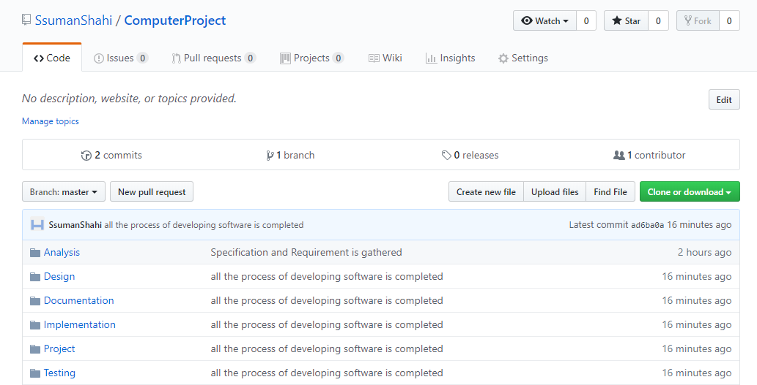

### Figure 7: Project Uploaded in GitHub

The steps for uploading project on GitHub are as follows:

Git init

Git add .

Git commit –m “first commit”

Git remote add origin <https://github.com/SsumanShahi/ComputerProject>

Git push –u <https://github.com/SsumanShahi/ComputerProject> master

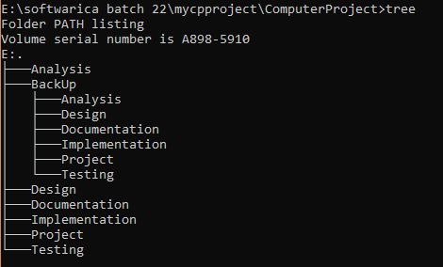

### Figure 8: Configure Management

# **Chapter 7**

## Conclusion

In this way, the software is built for the management of the customer data and financing in an organization. This software helps to manage all the customer registries and their financing data effectively and efficiently. It also helps to store the records of changes made as well as helps to find out profit and loss. It will be built with help of PHP programming language as a web based system.

# Chapter 8

## References

<http://www.assignmentpoint.com/business/banking/scope-limitation-e-banking-bangladesh.html>

<https://www.classle.net/projects/project-ideas/banking-system>

<https://searchsoftwarequality.techtarget.com/definition/3-tier-application>

<https://www.tutorialspoint.com/design_pattern/mvc_pattern.htm>

<https://www.workbreakdownstructure.com/>

<https://searchsoftwarequality.techtarget.com/definition/Gantt-chart>