# Testing

It is an activity to check whether the actual results matches with the expected results to ensure that system is running perfectly without defect. It includes system component to evaluate one or more properties of interest. Testing helps us to find any errors and bug in the system. Reason for arising bugs are code mishandling, time limit, poor coding and change in requirements. Individual functions can be tested for better functionality.

There are different tools for testing the system like non-functional testing, security testing, stress testing, smoke testing, vulnerability testing, sanity testing, soak testing, risk based testing, integration testing, regression testing, grey box testing, scalability testing, static testing, acceptance testing, localization testing, load testing, interface testing, agile testing, unit testing, happy path testing, backward compatibility testing, performance testing, GUI testing.

As for the program I have tested through Unit testing and Black Box Testing.

## **Unit Testing**

Unit Testing is a level of software testing individual components of a software are tested. The purpose is to validate that each unit of the software performs as designed.

|  |  |  |  |  |  |
| --- | --- | --- | --- | --- | --- |
| Test -1: Login | | | | | |
| Test Case | Description | Test Input Data | Expected Result | Actual Result | Remarks |
| 1 | Login customer | Email and password required | Customer should provide correct Email and Password to login | Correct email and password is accepted | Pass |

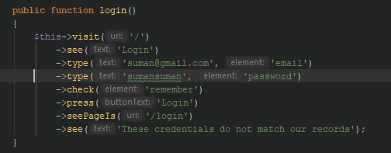

Fig: Login Unit Test

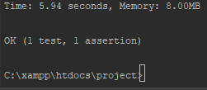

|  |  |  |  |  |  |
| --- | --- | --- | --- | --- | --- |
| Test -2: Customer Signup | | | | | |
| Test Case | Description | Test Input Data | Expected Result | Actual Result | Remarks |
| 2 | Signup  Customer  New registration | All required data is inserted | New customer should be registered | Customer is registered | Pass |

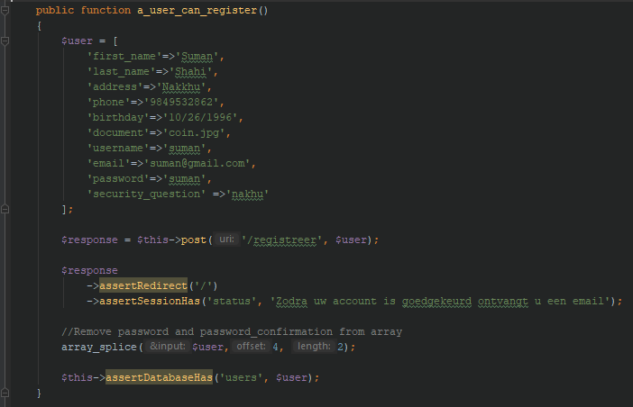

Fig: Customer Registeration Test



|  |  |  |  |  |  |
| --- | --- | --- | --- | --- | --- |
| Test -3: Customer Update | | | | | |
| Test Case | Description | Test Input Data | Expected Result | Actual Result | Remarks |
| 2 | Customer Profile updating | All required data is inserted and updated | Data are edited and need to be updated | Customer profile is updated | Pass |

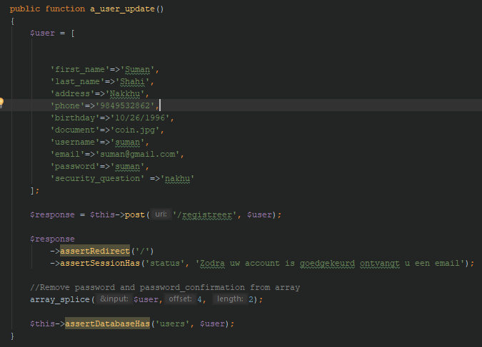

Fig: Customer Profile Update Test



|  |  |  |  |  |  |
| --- | --- | --- | --- | --- | --- |
| Test -4: Password Update | | | | | |
| Test Case | Description | Test Input Data | Expected Result | Actual Result | Remarks |
| 4 | Customer password changing and updating | New password is inserted | New password should be updated | New password is updated by customer | Pass |

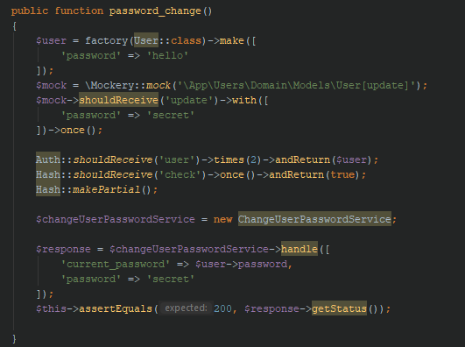

Fig: Customer Password Change test



|  |  |  |  |  |  |
| --- | --- | --- | --- | --- | --- |
| Test -5: Delete Customer | | | | | |
| Test Case | Description | Test Input Data | Expected Result | Actual Result | Remarks |
| 5 | Delete Customer account | Delete function is used | Customer should be deleted from the system | Customer Account is deleted from the system | Pass |

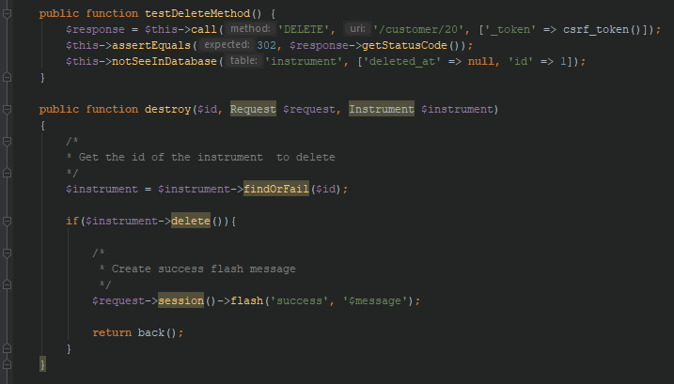

Fig: Customer delete test



## **Black Box Testing**

Black Box testing is also known as Behavioral Testing. It is a software testing method in which the internal structure, design and implementation of the item being tested is not known to the tester.

|  |  |  |  |  |
| --- | --- | --- | --- | --- |
| Test -1: Sign up Validation | | | | |
| Pre-Condition: Error validation cannot sign up account | | | | |
| Test Case | Description | Expected Result | Actual Result | Remarks |
| 1 | Signup for new customers | Customers details should be added in the database when signing-up, if the parameters in signup doesn’t match display error message | User cannot sign up for account because of error validation. | Pass |

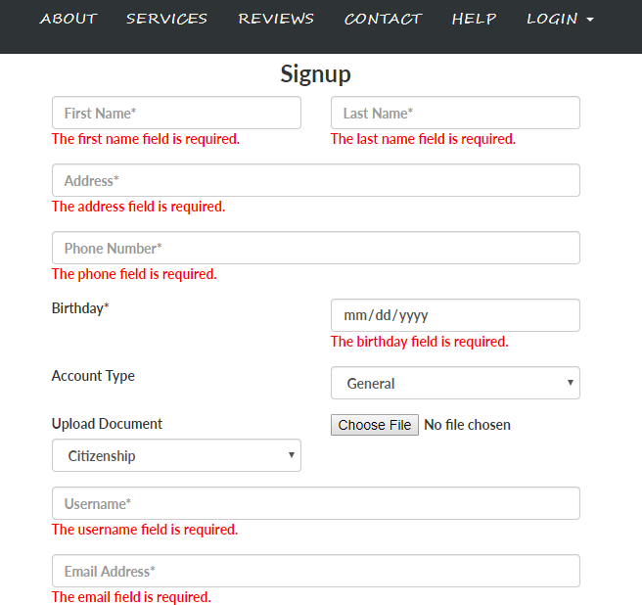

Fig: Sign Up Validation

|  |  |  |  |  |
| --- | --- | --- | --- | --- |
| Test -2: Sign up Successful | | | | |
| Pre-Condition: Customer are registered in the system | | | | |
| Test Case | Description | Expected Result | Actual Result | Remarks |
| 2 | Signup for new customers | Customers details should be added in the database when signing-up, if the parameters in signup match display success msg | Accepted data are stored in database, and user are successful for registering account. | Pass |

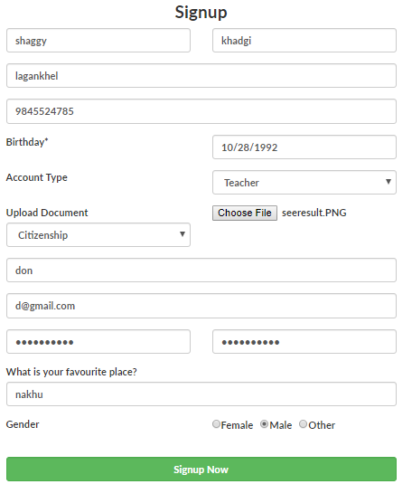

Fig: Sign up Successful

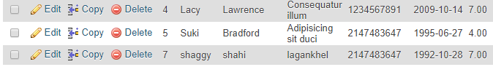

New Customer Added

|  |  |  |  |  |
| --- | --- | --- | --- | --- |
| Test -3: Username Validation | | | | |
| Pre-Condition: only unique username can be used | | | | |
| Test Case | Description | Expected Result | Actual Result | Remarks |
| 3 | Customer Username provide | If username has already been registered display error message | If other customer has same username, then username cannot be accepted | Pass |



Fig: Username Validation

|  |  |  |  |  |
| --- | --- | --- | --- | --- |
| Test -4: Login failed | | | | |
| Pre-Condition: Customer to access into the system | | | | |
| Test Case | Description | Expected Result | Actual Result | Remarks |
| 4 | Login | Customers who haven’t made an account or are not in the database are not given login privileges (error message should be shown) | Customer need to input their password with 8 characters, if not customer Cannot login, returns to login page | Pass |

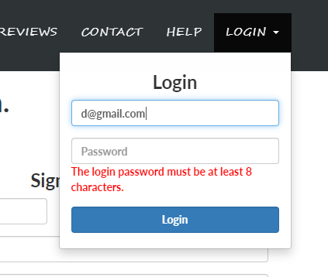

Fig: Login failed

|  |  |  |  |  |
| --- | --- | --- | --- | --- |
| Test -5: Login Successful | | | | |
| Pre-Condition: Customer to access into the system | | | | |
| Test Case | Description | Expected Result | Actual Result | Remarks |
| 5 | Login | Customers who haven’t made an account and are in the database are given login (transfer to user dashboard page) | Customer are able to get access after successful input data for login, after successful login dashboard page is opened | Pass |

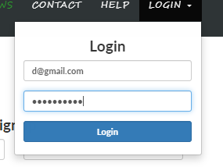

Fig: Login Successful

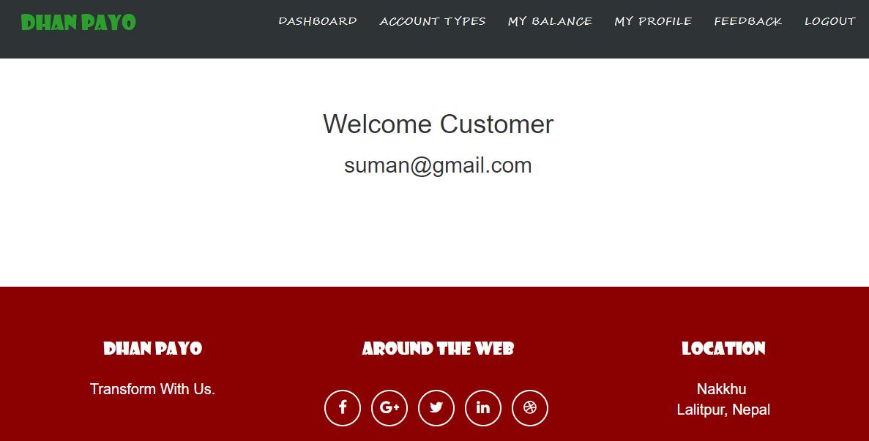

Fig: After Successful login Customer Dashboard Opens

|  |  |  |  |  |
| --- | --- | --- | --- | --- |
| Test -6: Edit Profile | | | | |
| Pre-Condition: Customer to access to edit and update own profile | | | | |
| Test Case | Description | Expected Result | Actual Result | Remarks |
| 6 | Editing and Updating own profile | Customer can change their username and name and some information in their system and their profile is updated. | Customer need to update their information with actual validation. | Pass |

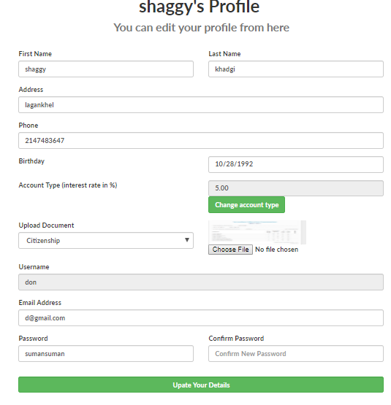

Fig: Customer Edit Profile

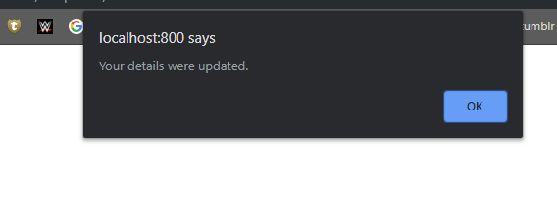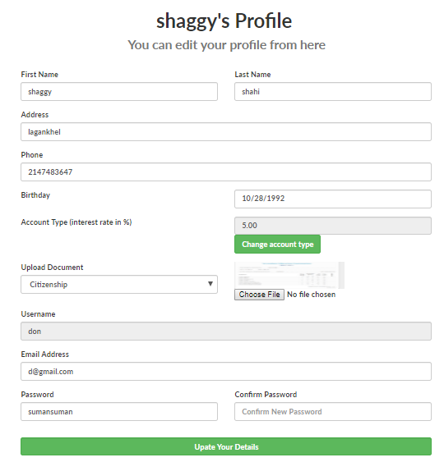

Fig: Profile Updated

|  |  |  |  |  |
| --- | --- | --- | --- | --- |
| Test -7: Customer Feedback Validation | | | | |
| Pre-Condition: Customer request to provide feedback | | | | |
| Test Case | Description | Expected Result | Actual Result | Remarks |
| 7 | Customer Feedback | After login into the system customer are able to provide the feedback to the admin of the system. | Customer cannot send blank feedback without their name and information otherwise feedback cannot be posted | Pass |

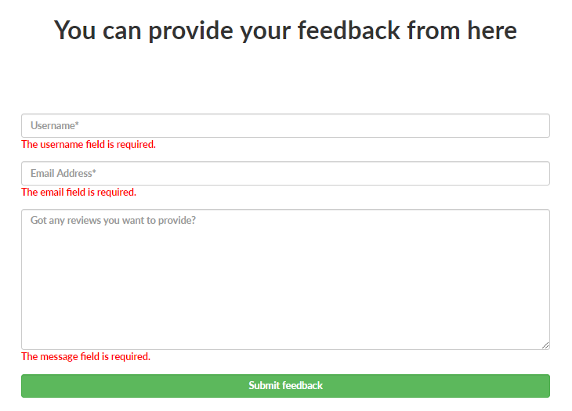

Fig: Customer Feedback Validation

|  |  |  |  |  |
| --- | --- | --- | --- | --- |
| Test -8: Customer Feedback Successful | | | | |
| Pre-Condition: Customer request to provide feedback | | | | |
| Test Case | Description | Expected Result | Actual Result | Remarks |
| 8 | Customer Feedback | After login into the system customer are able to provide the feedback to the admin of the system. | Customer send blank feedback with their name and information so feedback can be posted | Pass |

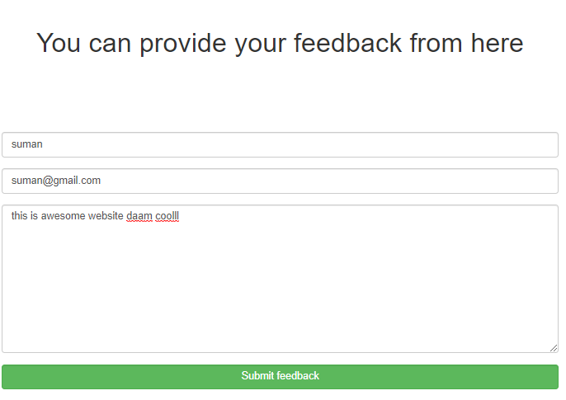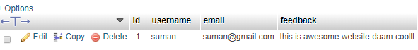

Fig: Customer Feedback Successful

|  |  |  |  |  |
| --- | --- | --- | --- | --- |
| Test -9: Admin to view customer feedback | | | | |
| Pre-Condition: Admin can view customer provided feedback about the system | | | | |
| Test Case | Description | Expected Result | Actual Result | Remarks |
| 9 | Customer Feedback  View | Admin can view the customer feedback in admin panel through view message button | Successful feedback can be preview by the admin | Pass |

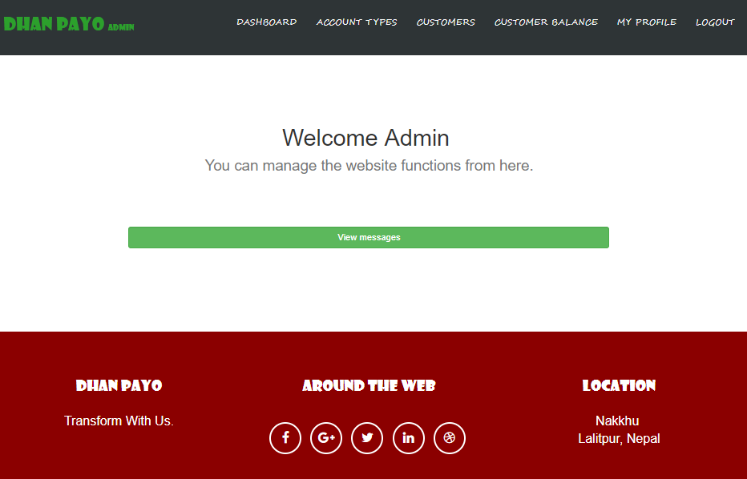

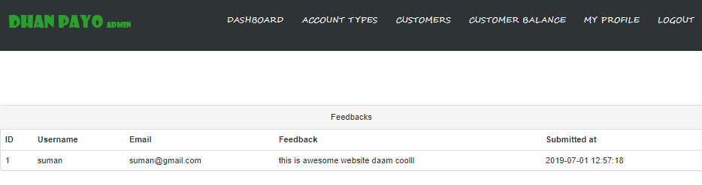

Fig: Admin to view customer feedback

|  |  |  |  |  |
| --- | --- | --- | --- | --- |
| Test -10: Admin to Add Account Types with validation | | | | |
| Pre-Condition: Admin adding the new account | | | | |
| Test Case | Description | Expected Result | Actual Result | Remarks |
| 10 | Adding new Account Types | Admin can add new account types with interest rate | New Account types is added by admin with interest need to included | Pass |

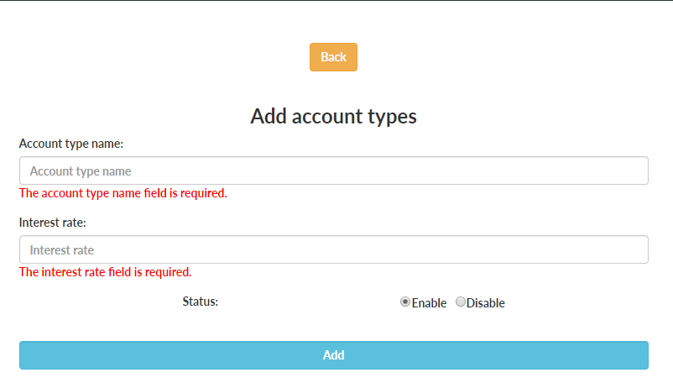

Fig: Admin to Add Account Types with validation

|  |  |  |  |  |
| --- | --- | --- | --- | --- |
| Test -11: Admin to Add Account Types | | | | |
| Pre-Condition: Admin adding the new account types for customer | | | | |
| Test Case | Description | Expected Result | Actual Result | Remarks |
| 11 | Adding new Account Types | Admin can add new account types with interest rate | New Account types is added by admin with interest | Pass |

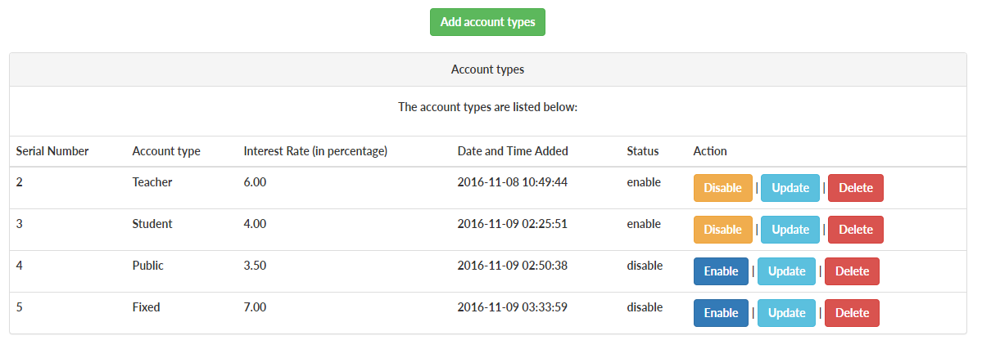

Fig: Before add account list of account types

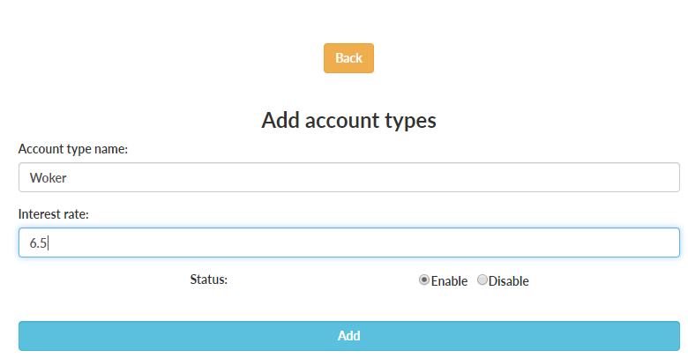

Fig: Admin to Add Account Types

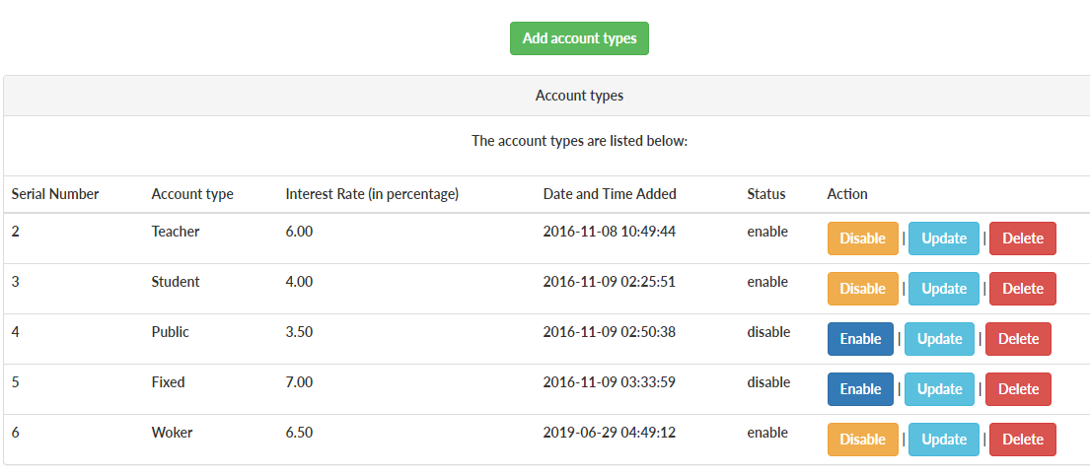

Fig: After add account list of account types

|  |  |  |  |  |
| --- | --- | --- | --- | --- |
| Test -12: Admin to Update Account Types | | | | |
| Pre-Condition: Admin updating the new account types for customer | | | | |
| Test Case | Description | Expected Result | Actual Result | Remarks |
| 12 | Updating Account Types | Admin can update account types and interest rate | Account types is updated by admin with interest | Pass |

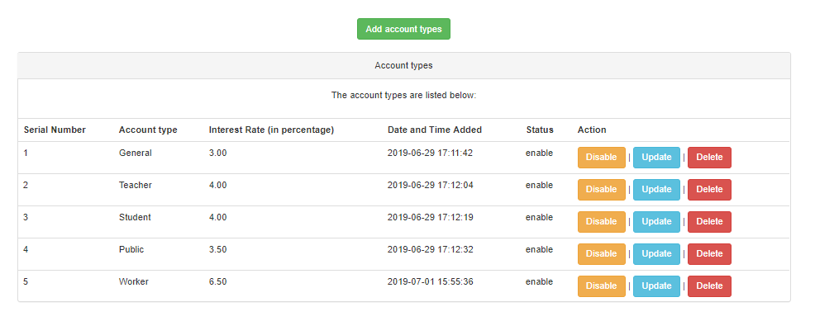

Fig: before updating account types

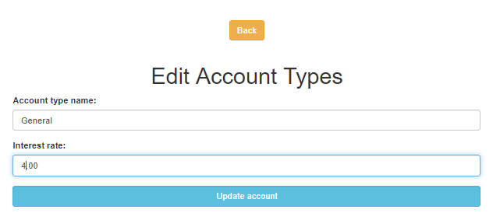

Fig: Admin to Update Account Types

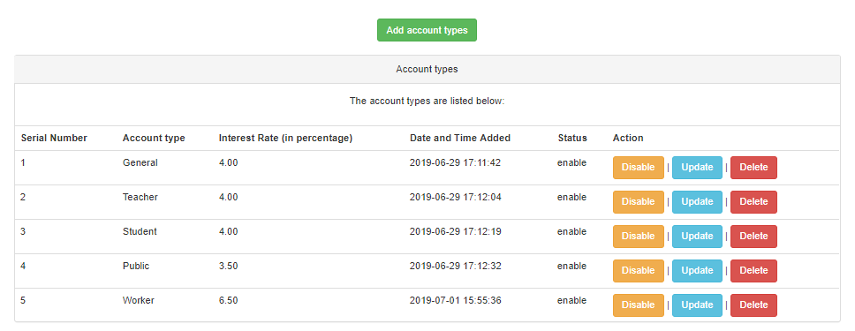

Fig: After updating account types

|  |  |  |  |  |
| --- | --- | --- | --- | --- |
| Test -13: Admin to Delete Account Types | | | | |
| Pre-Condition: Admin Deleting the new account types for customer | | | | |
| Test Case | Description | Expected Result | Actual Result | Remarks |
| 13 | Deleting Account Types | Admin can delete account types and interest rate | Account types is deleted by admin with interest | Pass |



Fig: List of account type is before deleted

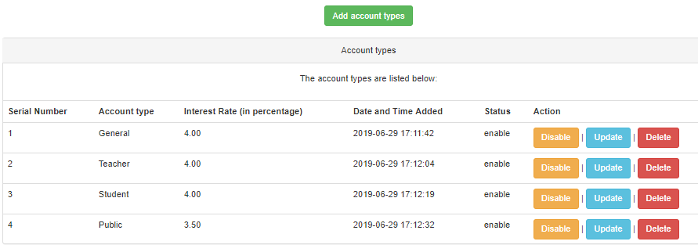

Fig: List of account type is after deleted

|  |  |  |  |  |
| --- | --- | --- | --- | --- |
| Test -14: Admin to Add Customers | | | | |
| Pre-Condition: Admin Adding the new customer | | | | |
| Test Case | Description | Expected Result | Actual Result | Remarks |
| 14 | Adding Customer Account | Admin adding new customers account with all details | Customer Account is stored in the system | Pass |

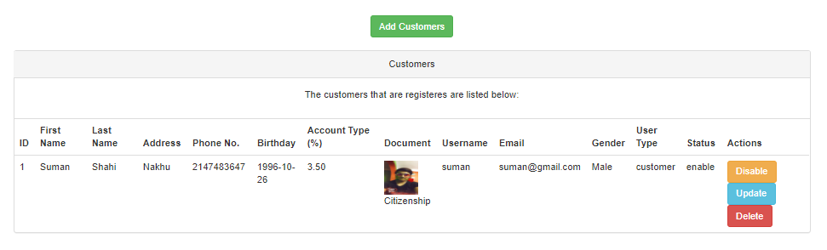

Fig: Before the customer is added

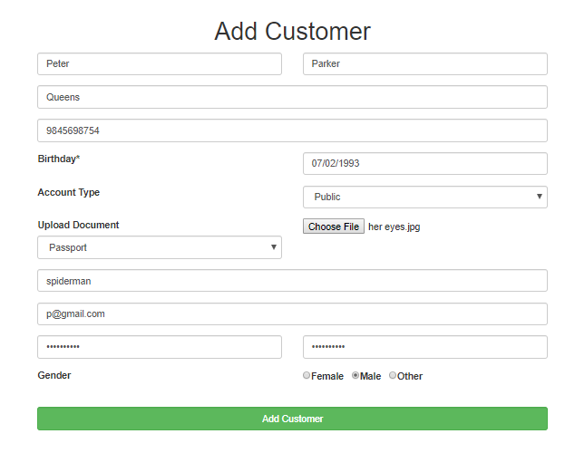

Fig: Admin to Add Customers

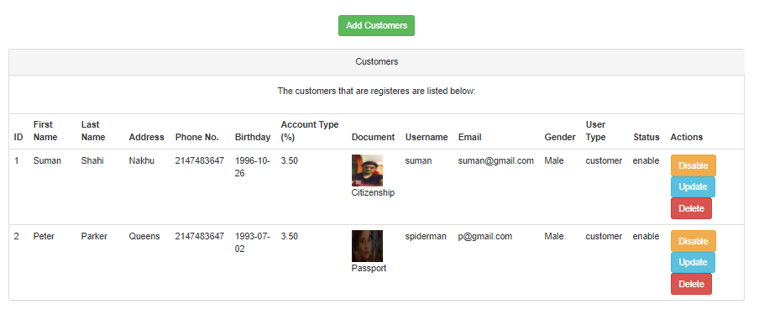

Fig: After the customer is added

|  |  |  |  |  |
| --- | --- | --- | --- | --- |
| Test -15: Admin to Disable Customers Account | | | | |
| Pre-Condition: Admin Disables the customer Account | | | | |
| Test Case | Description | Expected Result | Actual Result | Remarks |
| 15 | Disabling Customer Account | Customer account is disabled by admin | Customer Account is disabled and cannot be access by customer | Pass |



Fig: Admin to Disable Customers Account

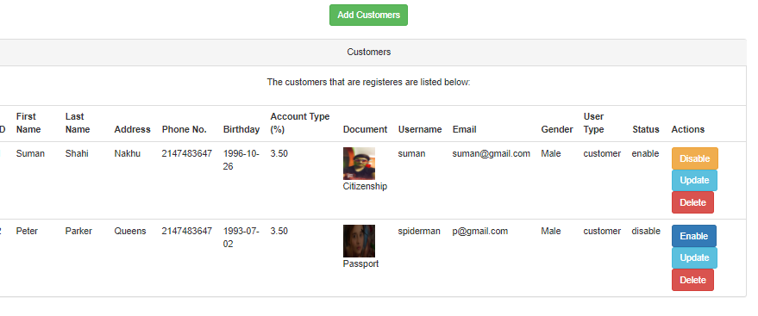

|  |  |  |  |  |
| --- | --- | --- | --- | --- |
| Test -16: Admin to Delete Customers Account | | | | |
| Pre-Condition: Admin Delete the customer Account | | | | |
| Test Case | Description | Expected Result | Actual Result | Remarks |
| 16 | Deleting Customer Account | Customer account is deleted by admin | Customer Account is delete and cannot be access by customer | Pass |



Fig: Admin to Delete Customers Account



Fig: After the deleting customer

|  |  |  |  |  |
| --- | --- | --- | --- | --- |
| Test -17: Admin to Update Customers Account and details | | | | |
| Pre-Condition: Admin to Update Customers Account and details | | | | |
| Test Case | Description | Expected Result | Actual Result | Remarks |
| 17 | Updating Customer Account | Customer account is updated by admin | Customer Account is updated with new information | Pass |



Fig: button to update

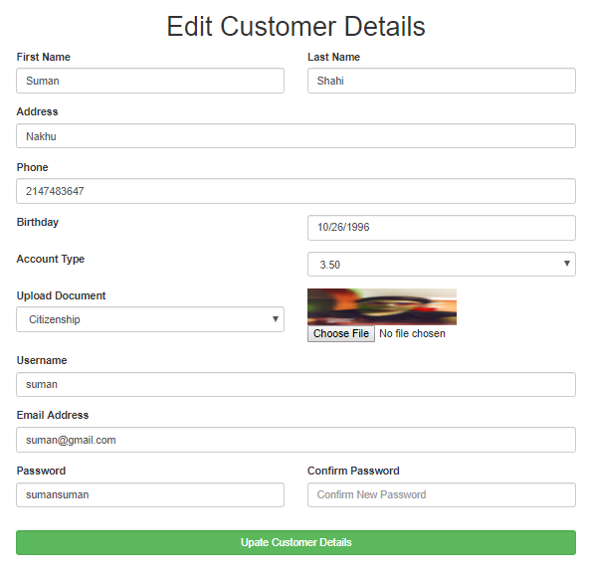

Fig: Admin to Update Customers Account and details

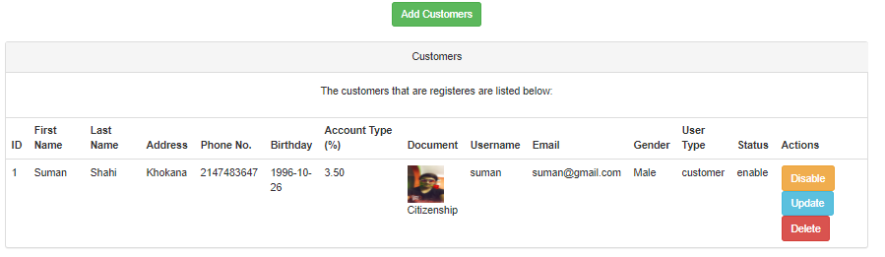

Fig: After updating the customer profile

|  |  |  |  |  |
| --- | --- | --- | --- | --- |
| Test -18: Account type change and setting | | | | |
| Pre-Condition: Account type change and setting | | | | |
| Test Case | Description | Expected Result | Actual Result | Remarks |
| 18 | Account type Changing | List of account types should be automatically displayed in the signup form and Customers can change their account type | Account type can be change whenever customer wants | Pass |

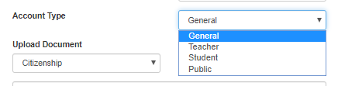

Fig: Account type change and setting

|  |  |  |  |  |
| --- | --- | --- | --- | --- |
| Test -19: Admin to perform Balance addition | | | | |
| Pre-Condition: Admin to perform Balance addition | | | | |
| Test Case | Description | Expected Result | Actual Result | Remarks |
| 19 | Adding Balance to Customer Account | Balance should be added to the customer account | Balance is added successfully to customer account | Pass |

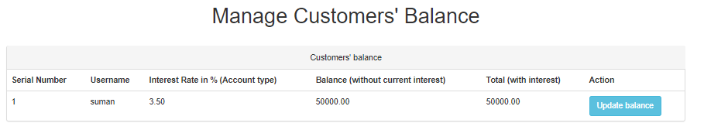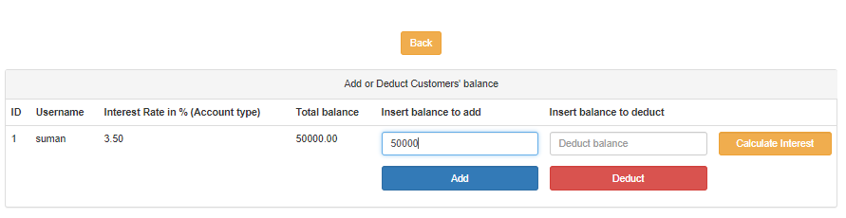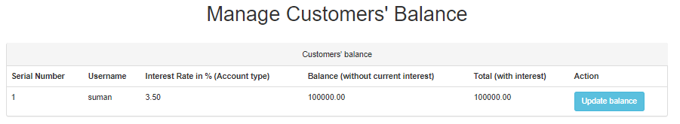

Fig: Admin to perform Balance addition

|  |  |  |  |  |
| --- | --- | --- | --- | --- |
| Test -20: Admin to perform Balance deduction | | | | |
| Pre-Condition: Admin to perform Balance deduction | | | | |
| Test Case | Description | Expected Result | Actual Result | Remarks |
| 20 | Deducting Balance to Customer Account | Balance should be subtracted from the balance that was stored last time | Balance is deducted successfully to customer account | Pass |



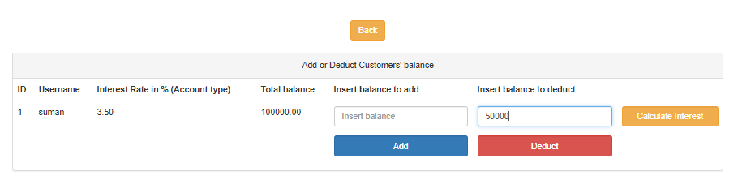



Fig: Admin to perform Balance deduction

|  |  |  |  |  |
| --- | --- | --- | --- | --- |
| Test -21: Admin to perform Interest calculation | | | | |
| Pre-Condition: Admin to perform Interest calculation | | | | |
| Test Case | Description | Expected Result | Actual Result | Remarks |
| 21 | Calculating Interest to Customer Account | Interest should be calculated of the balance that was stored last time and shown in a separate column | Interest calculated and displayed in a separate column | Pass |



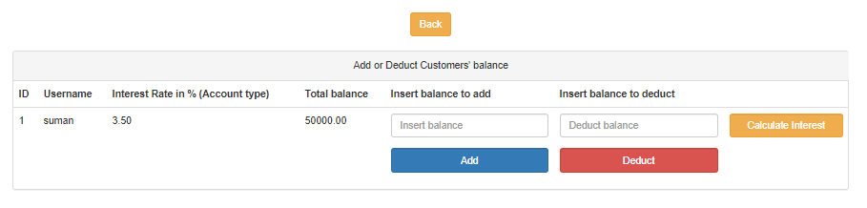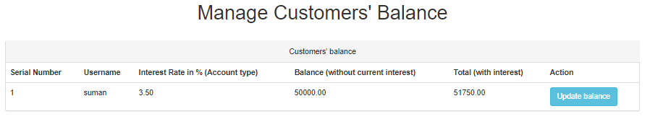

Fig: Admin to perform Interest calculation