NepAirWatch
A Real-time Big Data Platform for Air-Quality Monitoring and Early Warning in Nepal
using Apache Kafka and Apache Spark

Big Data — Implementation Task (Project Report)

Submitted by:
[Student Name 1] — Roll No. [____]
[Student Name 2] — Roll No. [____]

Submitted to: [Instructor Name], [Department / Institute]
October 2026

Abstract
Air pollution is one of Nepal's most serious public-health problems. The Kathmandu Valley and the Terai cities regularly record fine-particulate (PM2.5) levels several times higher than the World Health Organization guideline, yet citizens get little timely, localised or actionable information. This project designs and implements NepAirWatch, an end-to-end big-data platform that continuously collects hourly air-quality and meteorological data for 15 cities across all seven provinces of Nepal. Apache Kafka is the distributed ingestion backbone. Apache Spark (Structured Streaming, Spark SQL and MLlib) does the real-time and batch processing. The data is stored in a partitioned Parquet data lake and a MongoDB serving layer. The system computes the Air Quality Index (AQI) in real time, raises health alerts with advice in English and Nepali, measures exceedance of the Nepal National Ambient Air Quality Standard and the WHO guideline, explains pollution episodes through weather drivers, and forecasts PM2.5 six hours ahead with a Gradient-Boosted Trees model. Over one year of data (131,775 city-hour records), the platform found that Biratnagar breached the national 24-hour standard on 270 days and Kathmandu on 174 days. The forecaster reduced error against a persistence baseline from 16.82 to 10.31 µg/m³ RMSE (R² 0.67).
Keywords: big data, Apache Kafka, Apache Spark, structured streaming, air quality, PM2.5, Nepal, early warning, MLlib, data lake

Table of Contents
1. Introduction
2. Problem Definition (Part a)
3. Data Sources (Part a)
4. Important Features Considered in the Design (Part a)
5. Data Storage Design (Part b)
6. Choice of Big Data Ecosystem Components (Part b)
7. System Architecture and Block Diagram (Part b)
8. Implementation
9. Results and Analysis
10. Demonstration
11. Implementation Guidelines
12. Limitations and Future Work
13. Conclusion
References
Appendix A — Message Schema
Appendix B — Work Division

1. Introduction
Nepal's urban air quality gets markedly worse during the dry season (November–April). The Kathmandu Valley is a bowl-shaped basin. On winter nights a temperature inversion forms and the atmospheric boundary layer collapses to a few tens of metres, trapping emissions from vehicles, brick kilns, refuse burning and construction close to the ground. The southern Terai plains are part of the Indo-Gangetic Plain, one of the most polluted airsheds in the world, and also suffer from crop-residue burning and spring forest fires. Long-term exposure to PM2.5 causes respiratory and cardiovascular disease, and air pollution is consistently ranked among the leading risk factors for premature death in Nepal.
Air-quality data is a natural big-data problem. It arrives continuously (velocity), comes from many locations and many pollutant and weather variables (variety), and accumulates without limit (volume). Its usefulness depends on being processed and acted upon quickly (value). This project shows how a modern open-source big-data stack built from Apache Kafka and Apache Spark can turn raw environmental measurements into timely, location-specific public-health information for Nepal.

1.1 Objectives
- Continuously ingest hourly air-quality and weather data for major cities in all 7 provinces of Nepal.
- Process the stream in real time to compute AQI, classify health risk and raise alerts.
- Store the full history in a scalable, query-efficient data lake and serve results with low latency.
- Analyse the history at scale: exceedance of standards, seasonal and daily patterns, weather drivers.
- Train a machine-learning model that forecasts PM2.5 hours ahead to enable early warning.
- Present everything on an interactive dashboard with advisories in Nepali.

2. Problem Definition (Part a)
Problem statement.
Nepal has no unified, real-time and nationwide system that (i) monitors air quality continuously across both hill and Terai cities, (ii) translates measurements into understandable health advice in the local language, (iii) warns people before pollution episodes happen, and (iv) gives authorities historical evidence of where and when air-quality standards are breached.

2.1 Why this is a real problem in Nepal
- Severity: In our year of data, every one of the 15 cities exceeded the WHO 24-h PM2.5 guideline on most days. Even comparatively clean Pokhara exceeded it on 204 days. Biratnagar averaged 64.0 µg/m³ over the year, more than four times the WHO annual guideline of 5 µg/m³ (WHO, 2021).
- Sparse monitoring: Government reference stations are concentrated in the Kathmandu Valley, and many Terai and far-western cities have little or no reliable public monitoring.
- No early warning: Schools, hospitals and outdoor workers learn about bad air after exposure has already happened. Episodes are predictable from weather (inversions, low wind) but no forecast is published at city level.
- Information gap: Raw µg/m³ numbers mean little to most citizens. Advice must be categorical (Good … Hazardous) and in Nepali.
- Policy evidence: Measures such as brick-kiln regulation, vehicle emission testing and odd-even schemes need quantitative, long-term, multi-city evidence.

2.2 Stakeholders
Stakeholder | Need served by NepAirWatch
Citizens / vulnerable groups | Current AQI, Nepali health advice, 6-hour outlook
Schools & hospitals | Alerts to reschedule outdoor activity, prepare for respiratory cases
Department of Environment (DoEnv), MoFE | Nationwide view, exceedance statistics, policy evidence
Ministry of Health & Population | Episode detection for public-health advisories
Municipalities (e.g. KMC) | City-level hotspots and seasonal timing for interventions
Researchers & media | Clean historical dataset in open formats (Parquet)

3. Data Sources (Part a)
The platform collects data from public, free web APIs, so it can be reproduced without licences. Every source is ingested through the same Kafka topic with a common JSON schema, so new sources (ground stations, IoT sensors) can be added without changing the downstream processing.
Source | Variables | Granularity | Use
Open-Meteo Air-Quality API (Copernicus Atmosphere Monitoring Service, CAMS global model) | PM2.5, PM10, CO, NO₂, SO₂, O₃, dust | Hourly, ~40 km grid, 15 locations | Primary pollution signal, AQI
Open-Meteo Historical-Forecast & Forecast Weather API | Temperature, relative humidity, wind speed, precipitation, boundary-layer height | Hourly, same locations | Explanatory features, ML inputs
(Extension) DoEnv Nepal — pollution.gov.np reference stations | PM2.5, PM10 (measured) | Hourly, ~25 stations | Ground truth / model calibration
(Extension) Low-cost IoT sensors (e.g. PurpleAir-type) | PM2.5 | Minute-level | Dense urban coverage
(Extension) NASA FIRMS active-fire data | Fire hotspots | Daily | Forest-fire episodes (spring)

Monitored locations (15 cities, all 7 provinces):
Province | Cities
Koshi | Biratnagar, Dharan
Madhesh | Janakpur, Birgunj
Bagmati | Kathmandu, Lalitpur, Bhaktapur, Hetauda, Bharatpur
Gandaki | Pokhara
Lumbini | Butwal, Nepalgunj
Karnali | Surkhet
Sudurpashchim | Dhangadhi, Mahendranagar

Dataset collected for this project: one year (October 2025 – October 2026) × 15 cities × 24 hours = 131,775 hourly records with 17 attributes each, plus a live feed polled every 15 minutes. The Parquet lake holds 5,707 files (47.2 MB compressed). The design is horizontally scalable to thousands of sensors at minute resolution (tens of millions of records per year) by adding Kafka partitions and Spark executors.

4. Important Features Considered in the Design (Part a)

4.1 Data features (attributes)
Feature | Why it matters
PM2.5 (µg/m³) | Main health-relevant pollutant; basis of AQI and Nepal NAAQS (40 µg/m³, 24 h)
PM10, CO, NO₂, SO₂, O₃, dust | Source fingerprinting: traffic (NO₂, CO), kilns/industry (SO₂), dust storms
Boundary-layer (mixing) height | Captures temperature inversions that trap smoke in the Kathmandu Valley
Wind speed | Ventilation and dispersion of pollutants
Precipitation, humidity | Wet deposition (rain cleans the air); hygroscopic growth of particles
Temperature | Season and inversion strength
City, province, lat/lon | Spatial analysis and partitioning key
Event time (Nepal time, UTC+5:45) | Event-time windows, seasonality, diurnal cycle
Derived: AQI, category, lags, 24-h rolling mean | Alerts and ML forecasting features

4.2 System design features (non-functional requirements)
- Scalability: Kafka topics are partitioned (key = city) and Spark parallelises across partitions. Both scale horizontally by adding brokers or executors.
- Low latency / real-time: Spark Structured Streaming micro-batches (5–10 s triggers) make new readings visible on the dashboard within seconds.
- Fault tolerance & durability: Kafka keeps messages for 7 days (replayable). Spark checkpoints its offsets and state, so a crashed job resumes where it stopped.
- Exactly-once results / idempotency: MongoDB writes are upserts on the natural key (city, event_ts) and the batch job de-duplicates the lake, so replays never double-count.
- Event-time correctness: Daily windows use observation time aligned to Nepal midnight, with a 3-hour watermark to accept late data.
- Data quality: Schema enforcement on JSON parsing, null and range checks (0–1000 µg/m³), and unparseable records are dropped.
- Storage efficiency: Columnar, compressed Parquet partitioned by city/date allows partition pruning for city-level queries.
- Extensibility: New data sources just publish to the same topic. New consumers (SMS gateway, mobile app) subscribe to the alerts topic.
- Usability & localisation: Colour-coded AQI categories and health advice in English and Nepali.
- Reproducibility: Infrastructure as code (Docker Compose), pinned versions, one-command pipeline.

5. Data Storage Design (Part b)
NepAirWatch uses polyglot persistence. Each storage tier is chosen for its access pattern, following the data-lake + serving-layer pattern used in production big-data systems.
Tier | Technology | Content | Access pattern
1. Message log (hot buffer) | Apache Kafka topics | nepal.air.raw (all readings), nepal.air.alerts | Append-only, sequential, replayable, 7-day retention
2. Landing zone (raw) | JSON-Lines files | Exact copy of source responses per city | Write-once, audit/re-processing
3. Data lake — refined zone | Apache Parquet (HDFS/S3-compatible) | air_quality/ partitioned by city=…/date=… | Large scans by Spark; partition pruning
4. Data lake — curated zone | Apache Parquet | monthly_city, daily_city, exceedance | Analytics-ready aggregates
5. Serving layer | MongoDB 7 (document NoSQL) | readings, latest, alerts, daily_stats, forecasts, model_metrics … | Indexed point & range queries (ms)
6. Model store | Spark ML pipeline directory | data/models/pm25_gbt | Load for scoring

5.1 Why Parquet for the lake
- Columnar layout: analytical queries read only the needed columns (e.g. pm2_5, event_ts).
- Compression (Snappy) and encoding shrink storage several-fold compared to JSON.
- Schema stored with the data. It is the native format for Spark and is readable by Hive, Presto/Trino, pandas and DuckDB.
- Partitioning by city and date lets Spark skip irrelevant files (partition pruning).
- The path is configurable: on a cluster, LAKE_PATH=hdfs://namenode:9000/nepairwatch stores the same lake on HDFS with 3× replication, with no code changes.

5.2 Why MongoDB for serving
- Flexible document schema fits sensor readings whose attributes differ by source.
- Unique compound indexes on (city, event_ts) support idempotent upserts and fast time-range queries.
- Millisecond reads for the dashboard. The dashboard never scans the lake.
- Scales horizontally through sharding (shard key: city) and offers replica sets for high availability.

5.3 MongoDB collections
Collection | Written by | Key / index | Purpose
readings | Streaming (Q2) | (city, event_ts) unique | Hourly history for charts
latest | Streaming (Q2) | _id = city | Current state per city
alerts | Streaming (Q2) | (city, event_ts) unique | Unhealthy-air alerts with message & severity
daily_stats | Streaming window (Q3) | (city, day) unique | Daily mean/max PM2.5
stream_batches | Streaming (Q2) | batch_id | Throughput monitoring
exceedance, monthly_city, hourly_profile, province_summary, weather_corr | Batch job | — | Historical analytics
model_metrics, forecasts, test_predictions | Batch MLlib | — | Early-warning model outputs

6. Choice of Big Data Ecosystem Components (Part b)
The assignment requires at least two big-data tools. NepAirWatch is built on two core tools, Apache Kafka and Apache Spark, supported by Parquet (data-lake format, HDFS-compatible) and MongoDB (NoSQL serving store). The table compares each choice with the alternatives in the Hadoop ecosystem.
Requirement | Chosen | Alternatives considered | Reason for choice
Ingestion / messaging | Apache Kafka | Apache Flume, RabbitMQ, Sqoop | Partitioned, durable, replayable log; high throughput; decouples producers from many consumers; native Spark connector. Flume is file/HDFS-oriented, RabbitMQ deletes messages after delivery, Sqoop is for RDBMS bulk transfer.
Stream processing | Spark Structured Streaming | Apache Flink, Storm, Kafka Streams | Same engine and API for streaming and batch; event-time windows and watermarks; checkpointing; large community. Flink has lower latency, but hourly data does not need sub-second processing.
Batch analytics / ML | Spark SQL + MLlib | Hadoop MapReduce, Hive, Mahout | In-memory processing is far faster than disk-based MapReduce. SQL + DataFrames + distributed ML in one framework.
Long-term storage | Parquet data lake (HDFS/S3) | HBase, Hive tables on ORC | Cheap, columnar, compressed, engine-neutral; ideal for large scans.
Serving database | MongoDB | HBase, Cassandra, PostgreSQL | Flexible documents, secondary indexes, simple operations; Cassandra/HBase are better at much larger write volumes but need more operational work.

6.1 Apache Kafka in NepAirWatch
- Runs in KRaft mode (no ZooKeeper) and exposes two topics, each with 3 partitions.
- Producer key = city, which guarantees per-city ordering and spreads load across partitions.
- Producer settings: acks=all, idempotence enabled, lz4 compression, 50 ms linger for batching.
- Topic nepal.air.alerts is written by Spark so that downstream alert services (SMS, push, sirens) can subscribe independently. This is the publish/subscribe benefit of Kafka.

6.2 Apache Spark in NepAirWatch
- Streaming job: three concurrent queries on one Kafka source. Q1 writes the Parquet lake, Q2 runs a foreachBatch sink to MongoDB with alert detection, and Q3 computes an event-time 1-day tumbling window with a watermark.
- AQI is a native Spark column expression (no Python UDF), so the work stays in the JVM and is optimised by Catalyst.
- Batch job: de-duplication, Spark SQL aggregations, percentile_approx, Pearson correlations, and an MLlib Pipeline (StringIndexer → OneHotEncoder → VectorAssembler → GBTRegressor) trained with a time-based split.

7. System Architecture and Block Diagram (Part b)
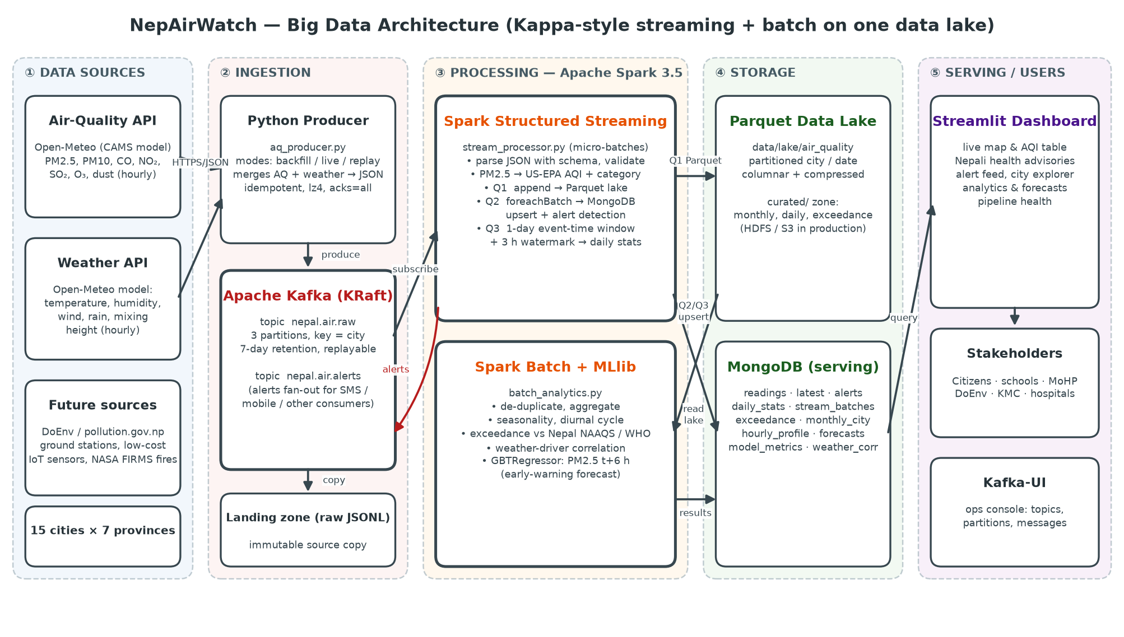
Figure 1: NepAirWatch block diagram — sources, ingestion, processing, storage, serving

7.1 Data flow
Step 1. Collection: the Python producer calls the Open-Meteo air-quality and weather APIs for each of the 15 cities, merges the two responses by timestamp and builds one JSON message per city-hour.
Step 2. Ingestion: messages are published to Kafka topic nepal.air.raw (key = city), and a raw copy is written to the landing zone.
Step 3. Stream processing: Spark Structured Streaming subscribes to the topic, parses and validates each message, computes AQI and category, and in every micro-batch (a) appends to the Parquet lake, (b) upserts readings and the latest state into MongoDB, raises alerts and publishes them to nepal.air.alerts, and (c) updates event-time daily windows.
Step 4. Batch processing: Spark reads the whole lake, de-duplicates it, computes historical analytics, trains and evaluates the GBT forecasting model, scores the newest observations, and writes the results to MongoDB and the curated zone.
Step 5. Serving: the Streamlit dashboard reads only from MongoDB and refreshes the live view every 5 seconds. Kafka-UI gives operators visibility into topics and messages.

7.2 Architecture style
The design is Kappa-style. Kafka is the single source of truth, and both the real-time view and the historical lake come from the same stream, so there is one processing code path. The batch layer re-reads the lake for heavy analytics and model training, which is the useful part of the Lambda architecture, without maintaining two separate ingestion pipelines. Because Kafka retains data, the streaming job can be reset and reprocessed from the beginning at any time (--reset).

8. Implementation

8.1 Technology stack
Layer | Technology / version
Containers | Docker Compose: apache/kafka 3.8.0 (KRaft), kafka-ui, mongo 7.0, and the NepAirWatch app image (Python 3.11 + Java 17 + Spark) running 5 services
Processing | Apache Spark 3.5.3 (PySpark), spark-sql-kafka-0-10 connector, Java 17
Language & libraries | Python 3.11, confluent-kafka, pymongo, pandas, pyarrow, requests
Visualisation | Streamlit, Plotly, Matplotlib

8.2 Source code modules
File | Responsibility
docker-compose.yml | Kafka broker (KRaft), Kafka-UI and MongoDB with health checks
common/config.py | Cities, thresholds, connection settings (environment-overridable)
common/aqi.py | US-EPA AQI breakpoints, categories, English/Nepali health advice
producer/aq_producer.py | Kafka producer with backfill, live and replay modes
spark_jobs/stream_processor.py | Structured Streaming: validation, AQI, lake, MongoDB, alerts, windows
spark_jobs/batch_analytics.py | Spark SQL analytics and MLlib GBT forecasting
dashboard/app.py | 5-tab Streamlit dashboard
Dockerfile, docker/*.sh | App image and container entry scripts — one-command deployment

8.3 AQI computation
The AQI follows the US EPA (2024) PM2.5 breakpoints, the scale used by most public AQI displays in Nepal. For concentration C in the breakpoint interval [C_lo, C_hi] with index range [I_lo, I_hi]:
AQI = (I_hi − I_lo) / (C_hi − C_lo) × (C − C_lo) + I_lo
PM2.5 (µg/m³) | AQI | Category | Advice (Nepali)
0 – 9.0 | 0 – 50 | Good | हावा स्वच्छ छ।
9.1 – 35.4 | 51 – 100 | Moderate | संवेदनशील व्यक्तिले लामो समय बाहिर कडा परिश्रम नगर्नुहोस्।
35.5 – 55.4 | 101 – 150 | Unhealthy for Sensitive Groups | बालबालिका, वृद्ध र दम/मुटुरोगीले बाहिरी गतिविधि घटाउनुहोस्।
55.5 – 125.4 | 151 – 200 | Unhealthy → ALERT (WARNING) | सबैले बाहिरी गतिविधि घटाउनुहोस्; N95 मास्क लगाउनुहोस्।
125.5 – 225.4 | 201 – 300 | Very Unhealthy → ALERT (CRITICAL) | बाहिर ननिस्कनुहोस्।
> 225.5 | 301 – 500 | Hazardous → ALERT (CRITICAL) | स्वास्थ्य आपतकाल: घरभित्रै बस्नुहोस्।

8.4 Streaming job (key logic)
parsed = (spark.readStream.format('kafka').option('subscribe', 'nepal.air.raw').load()
.select(from_json(col('value').cast('string'), RAW_SCHEMA).alias('m')).select('m.*')
.withColumn('event_ts', to_timestamp('event_time'))
.filter(col('pm2_5').between(0, 1000))
.withColumn('aqi', aqi_expr(col('pm2_5')))
.withColumn('category', category_expr(col('aqi'))))
parsed.writeStream.format('parquet').partitionBy('city', 'date')... # Q1 lake
parsed.writeStream.foreachBatch(write_serving)... # Q2 MongoDB + alerts
(parsed.withWatermark('event_ts', '3 hours')
.groupBy(window('event_ts', '1 day', '1 day', '18 hours 15 minutes'), 'city')
.agg(avg('pm2_5'), max('pm2_5'), max('aqi'), count('*'))
.writeStream.outputMode('update').foreachBatch(write_daily)) # Q3 windows
The window offset of 18 h 15 min aligns the 1-day UTC windows to midnight in Nepal (UTC+5:45).

8.5 Forecasting model (Spark MLlib)
Target: PM2.5 6 hours ahead in the same city. Features: current pollutants and weather, hour of day, month, PM2.5 lags of 1, 3, 6 and 24 hours, 24-hour rolling mean, and one-hot city. Lag and lead features are built with Spark window functions partitioned by city. The model is a Gradient-Boosted Trees regressor (40 trees, depth 6). The first 80% of the timeline is used for training and the last 20% for testing. A chronological split avoids the information leakage that a random split would cause. The baseline is persistence ("PM2.5 in 6 hours = PM2.5 now").

9. Results and Analysis

9.1 Exceedance of air-quality standards
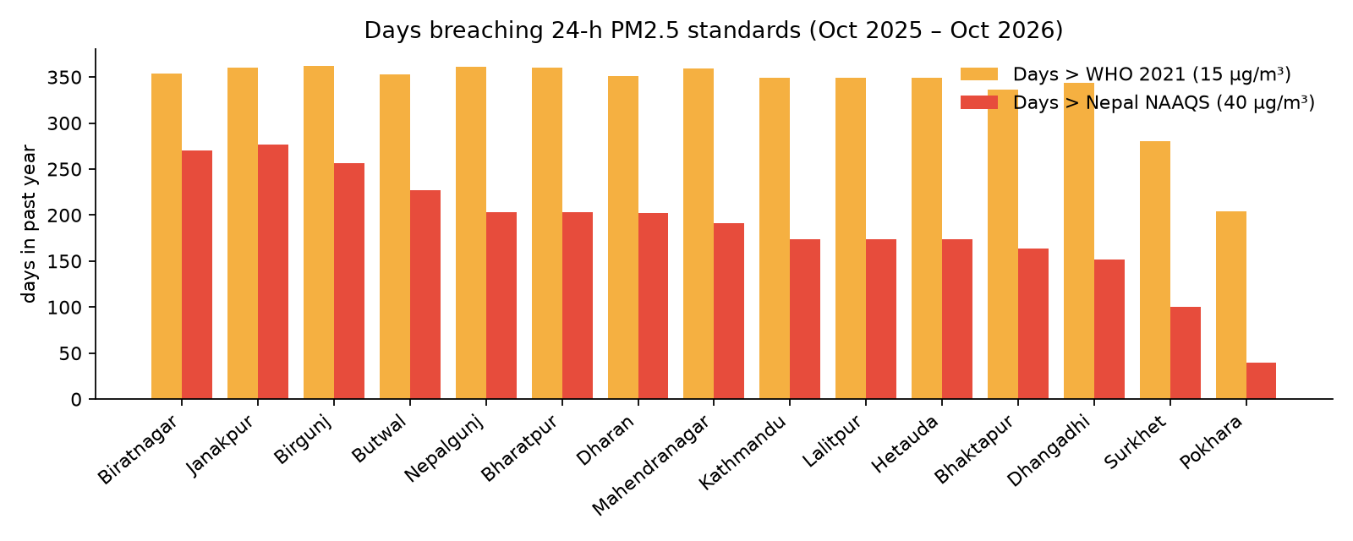
Figure 2: Days in the past year on which the 24-h mean PM2.5 exceeded each standard
City | Province | Annual mean PM2.5 | Days > Nepal (40) | Days > WHO (15) | Worst day
Biratnagar | Koshi | 64.0 | 270 (73.8%) | 354 | 140.6
Janakpur | Madhesh | 63.2 | 277 (75.7%) | 360 | 180.1
Birgunj | Madhesh | 54.5 | 256 (69.9%) | 362 | 184.3
Butwal | Lumbini | 52.9 | 227 (62.0%) | 353 | 157.5
Nepalgunj | Lumbini | 50.1 | 203 (55.5%) | 361 | 166.9
Bharatpur | Bagmati | 47.3 | 203 (55.5%) | 360 | 132.3
Dharan | Koshi | 47.1 | 202 (55.2%) | 351 | 111.9
Mahendranagar | Sudurpashchim | 46.8 | 191 (52.2%) | 359 | 134.3
Kathmandu | Bagmati | 43.1 | 174 (47.5%) | 349 | 136.6
Lalitpur | Bagmati | 43.1 | 174 (47.5%) | 349 | 136.6
Hetauda | Bagmati | 43.1 | 174 (47.5%) | 349 | 136.6
Bhaktapur | Bagmati | 41.8 | 164 (44.8%) | 336 | 112.5
Dhangadhi | Sudurpashchim | 41.2 | 152 (41.5%) | 344 | 138.4
Surkhet | Karnali | 30.2 | 100 (27.3%) | 280 | 105.6
Pokhara | Gandaki | 20.2 | 40 (10.9%) | 204 | 60.2

Findings: the Terai cities of Koshi and Madhesh provinces (Biratnagar, Janakpur, Birgunj) are the most polluted, with annual means of 54–64 µg/m³. That is above the national 24-hour standard on average, and they breach it on 70–76% of days. This matches the role of the Indo-Gangetic Plain airshed. Kathmandu breached the national standard on 174 days. Pokhara is the cleanest city (20.2 µg/m³), yet it still exceeded the WHO guideline on 204 days.

9.2 Seasonal and diurnal patterns
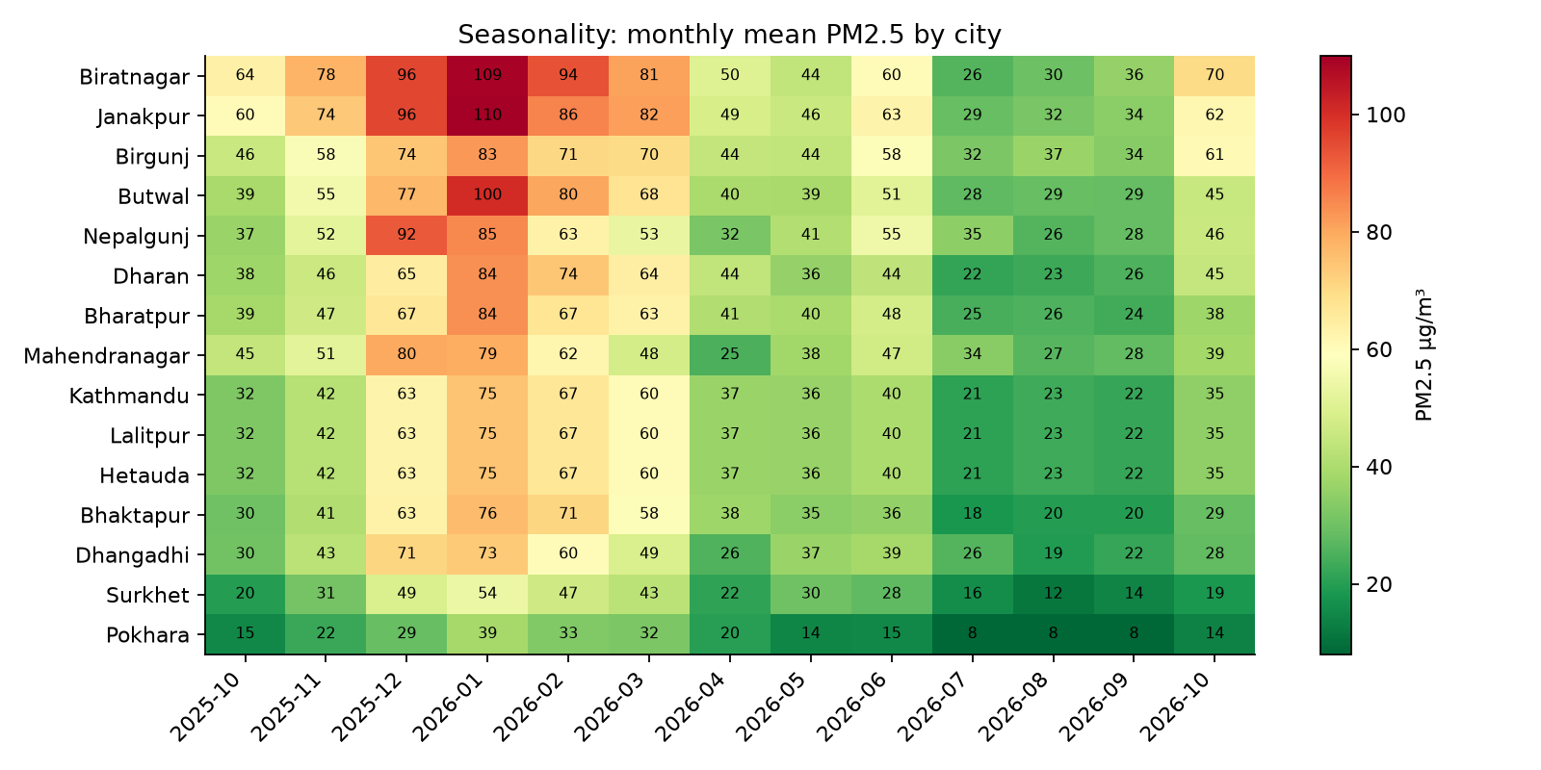
Figure 3: Monthly mean PM2.5 per city (Spark batch aggregation)
PM2.5 peaks sharply in the dry season (December to April). The monsoon (June to September) brings the cleanest air through wet deposition and stronger mixing. Air-quality interventions such as kiln operating restrictions and school schedule changes should therefore target the winter and spring months.
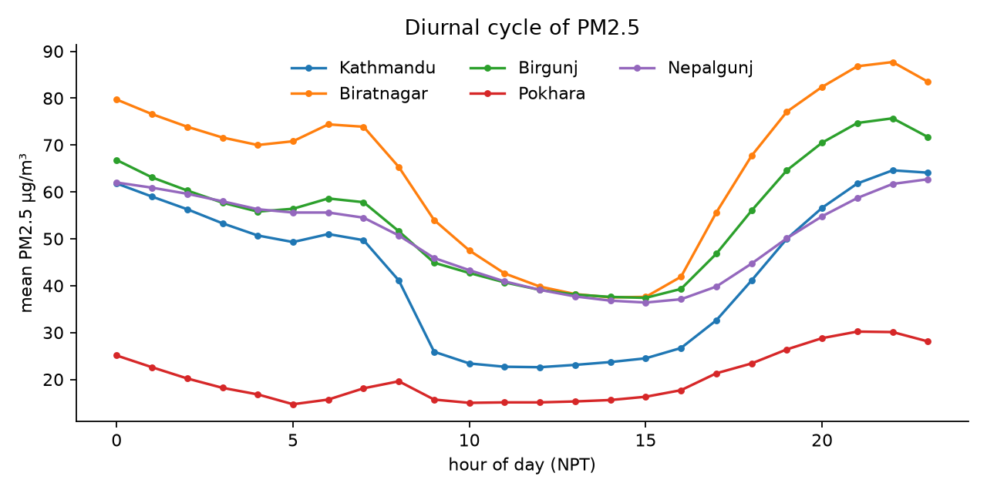
Figure 4: Average PM2.5 by hour of the day
A clear diurnal cycle is visible: concentrations rise in the evening and stay high through the night and early morning, when the boundary layer is shallow. They drop around midday, when solar heating deepens the mixing layer.

9.3 Weather drivers
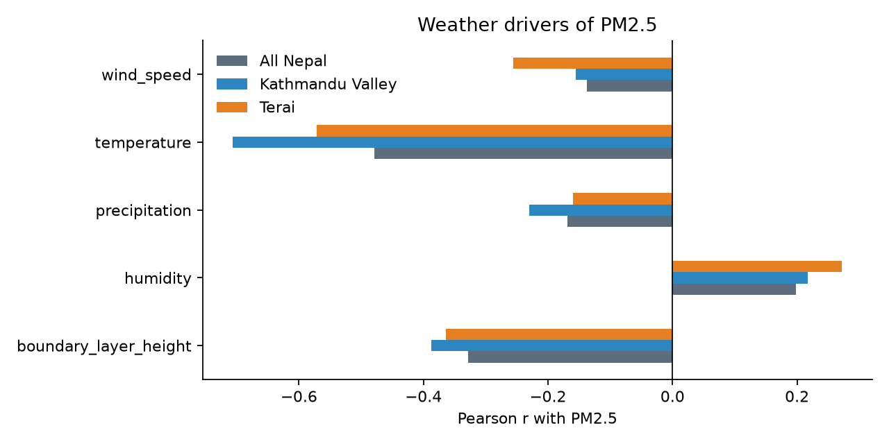
Figure 5: Pearson correlation of PM2.5 with weather variables
PM2.5 is negatively correlated with boundary-layer height (r = -0.387 in the Kathmandu Valley): a shallow mixing layer traps pollution, which confirms the inversion mechanism. Precipitation is also negatively associated (r = -0.169 nationally) through wet scavenging. These relationships justify using weather forecasts as inputs for early warning.
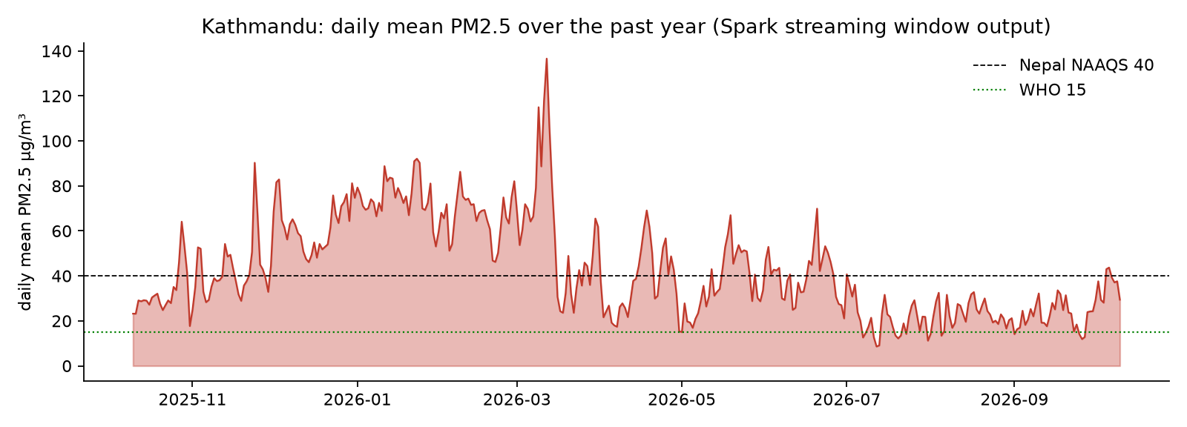
Figure 6: Kathmandu daily mean PM2.5 produced by the streaming event-time window (Q3)

9.4 Forecasting performance
Model | RMSE (µg/m³) | MAE (µg/m³) | R²
Persistence baseline | 16.82 | 11.72 | 0.124
Spark MLlib GBT (t+6 h) | 10.31 | 7.22 | 0.67

The GBT model reduces the forecast error by 38.7% compared with persistence. It was trained on 105,060 rows and evaluated on 26,265 unseen later rows. The most important features are pm25_roll24, hour, pm2_5, pm25_lag24. A 6-hour lead time gives schools and hospitals time to act before an episode peaks.
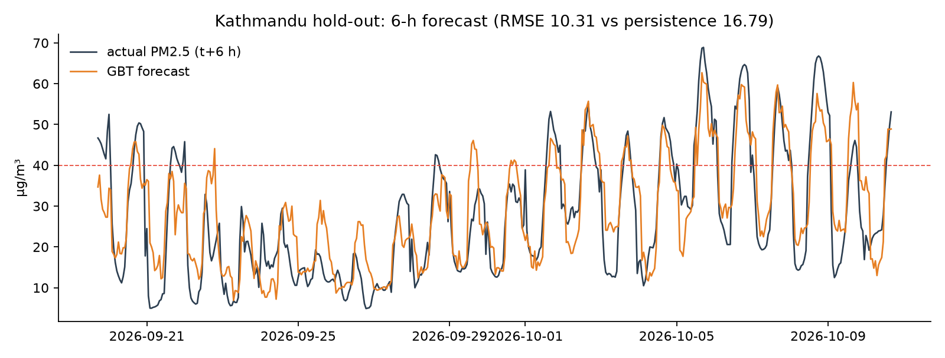
Figure 7: Actual vs forecast PM2.5 for Kathmandu during the hold-out period
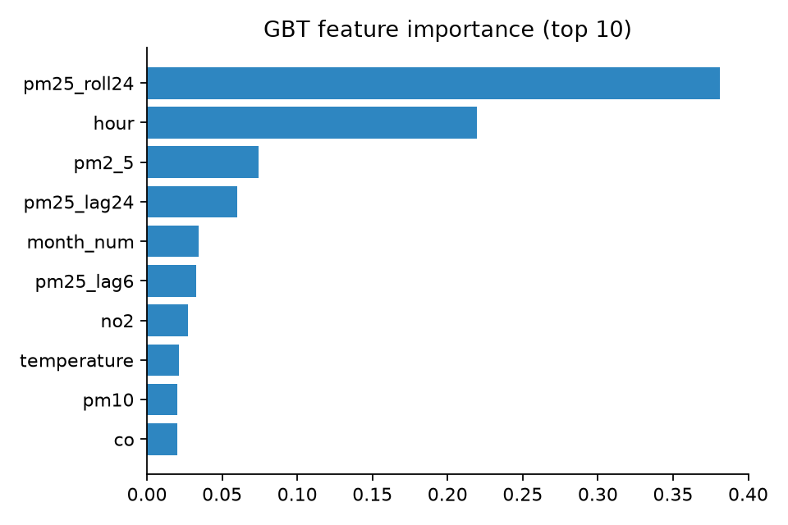
Figure 8: Top-10 feature importances of the GBT model

9.5 Pipeline performance
- 131,775 records ingested through Kafka and processed by Spark Structured Streaming. The largest micro-batch was 24,999 records (bounded by maxOffsetsPerTrigger = 25,000).
- 40,320 alert events generated and published to the nepal.air.alerts topic.
- Parquet lake: 5,707 files, 47.2 MB, partitioned by city and date.
- Full batch analytics + model training run: 182.3 s on a single 4-core laptop (Spark local mode).
- In live mode new readings reach the dashboard within one trigger interval (≈5–10 s).

10. Demonstration
The dashboard has five tabs. Screenshots from the running system:
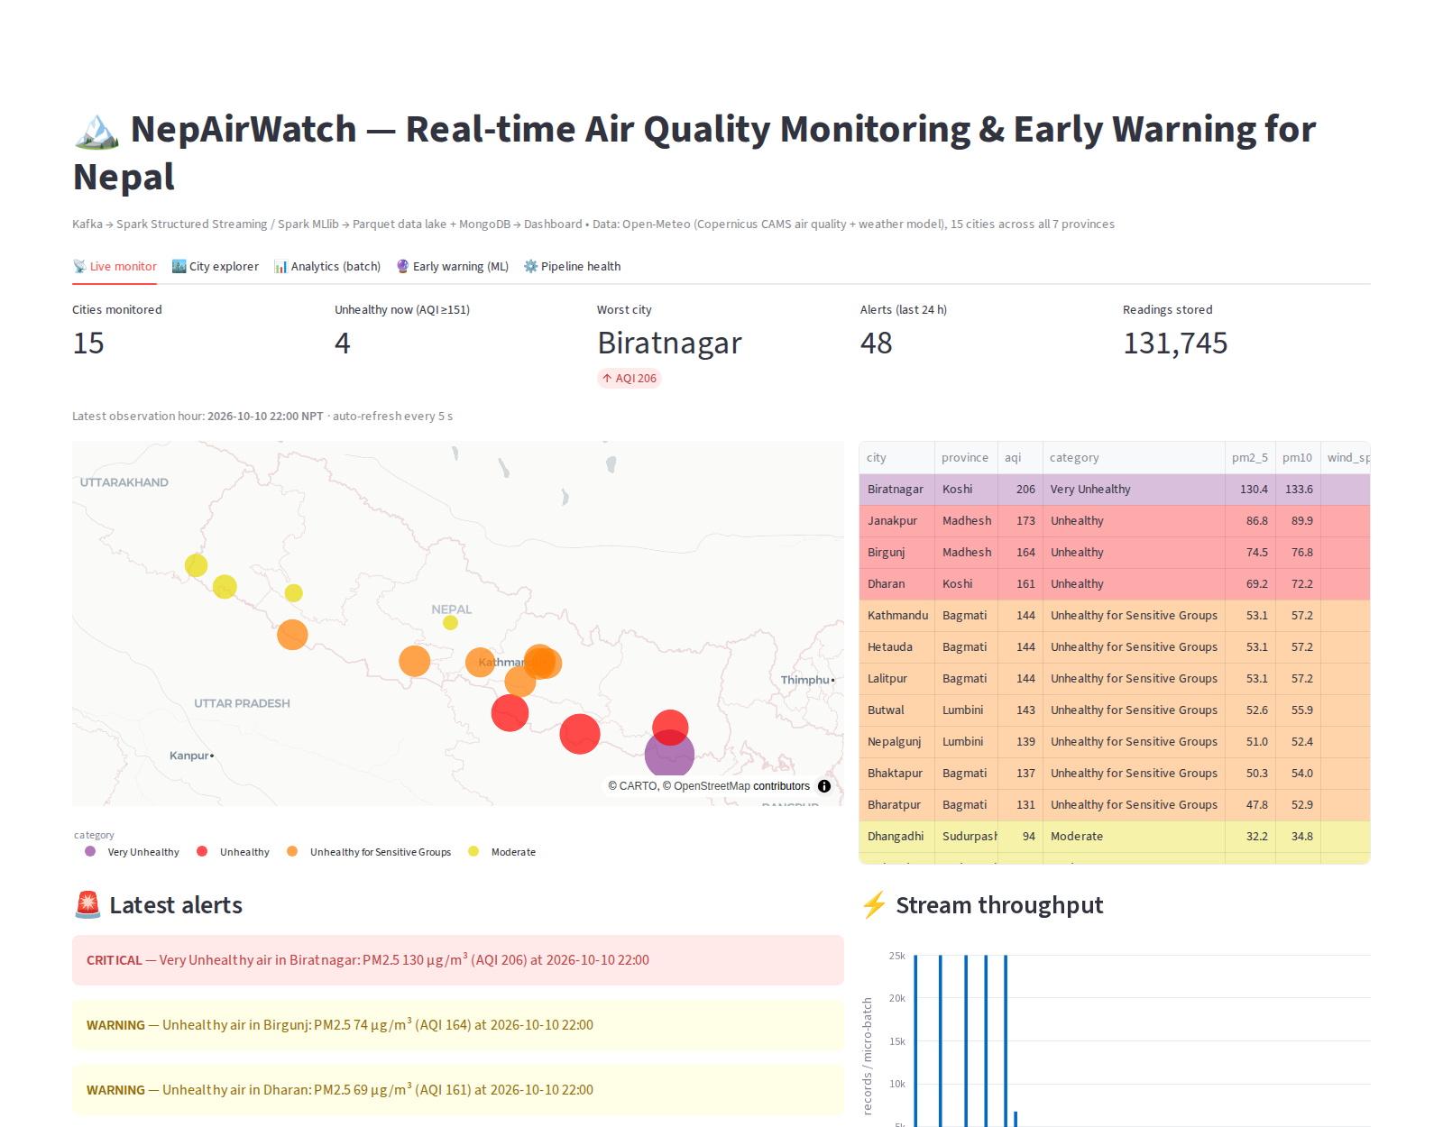
Figure 9: Live monitor — map, current AQI per city with Nepali advice, alert feed, stream throughput
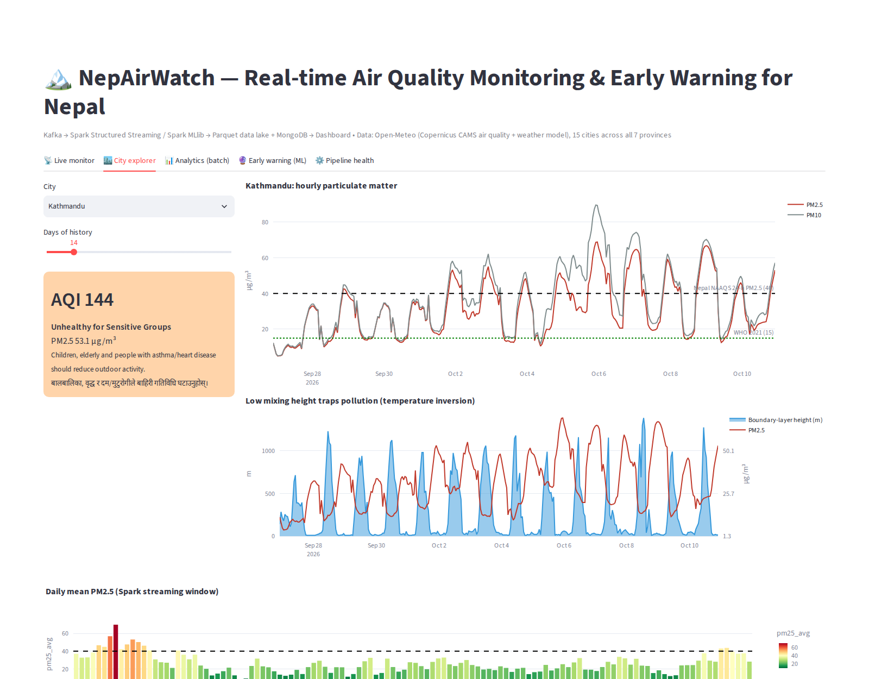
Figure 10: City explorer — PM2.5/PM10 vs standards and boundary-layer height
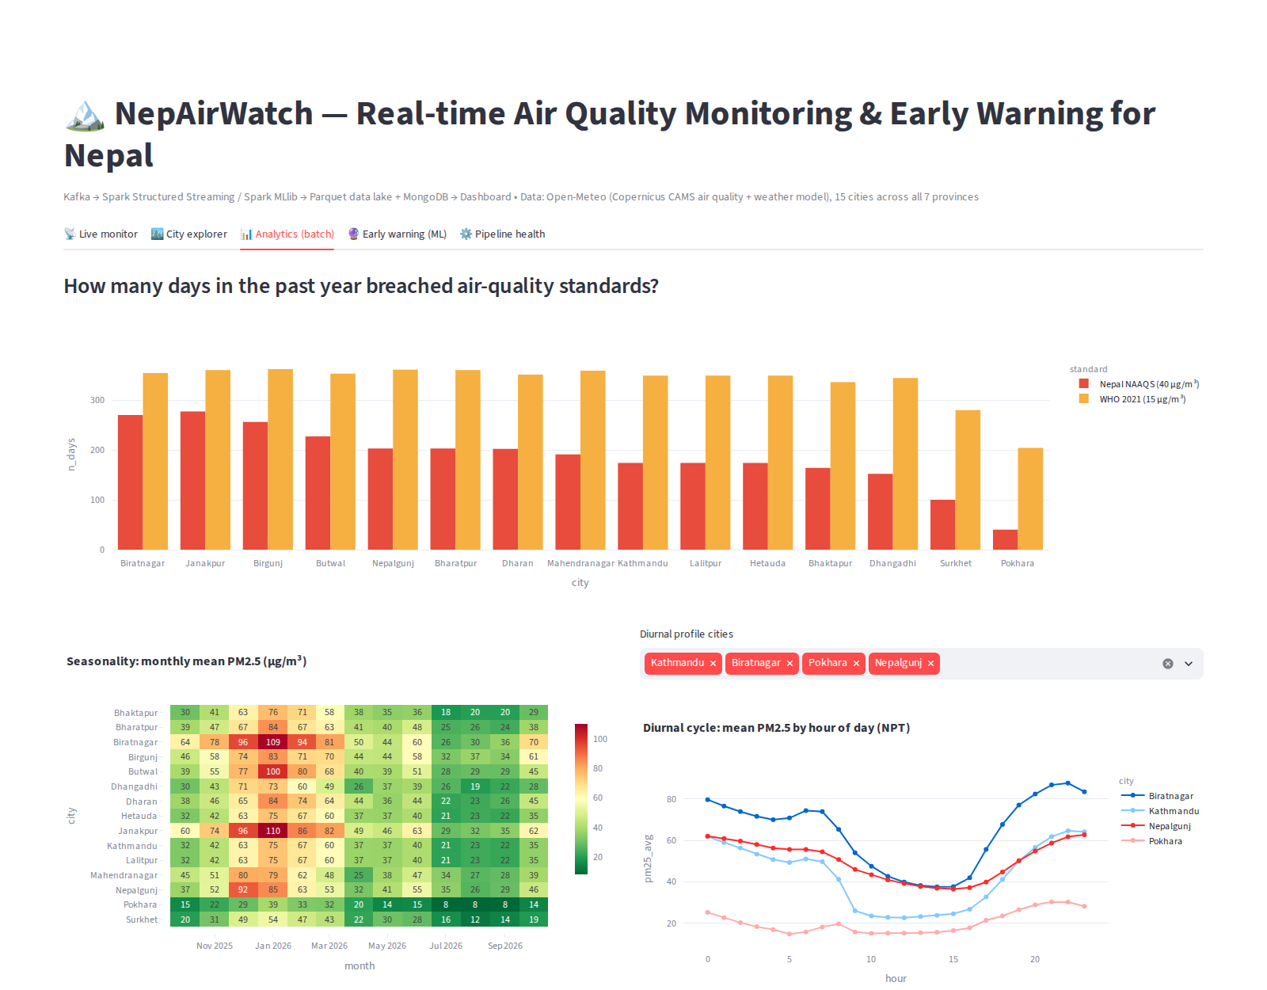
Figure 11: Analytics — exceedance days, seasonality heat-map, diurnal profile
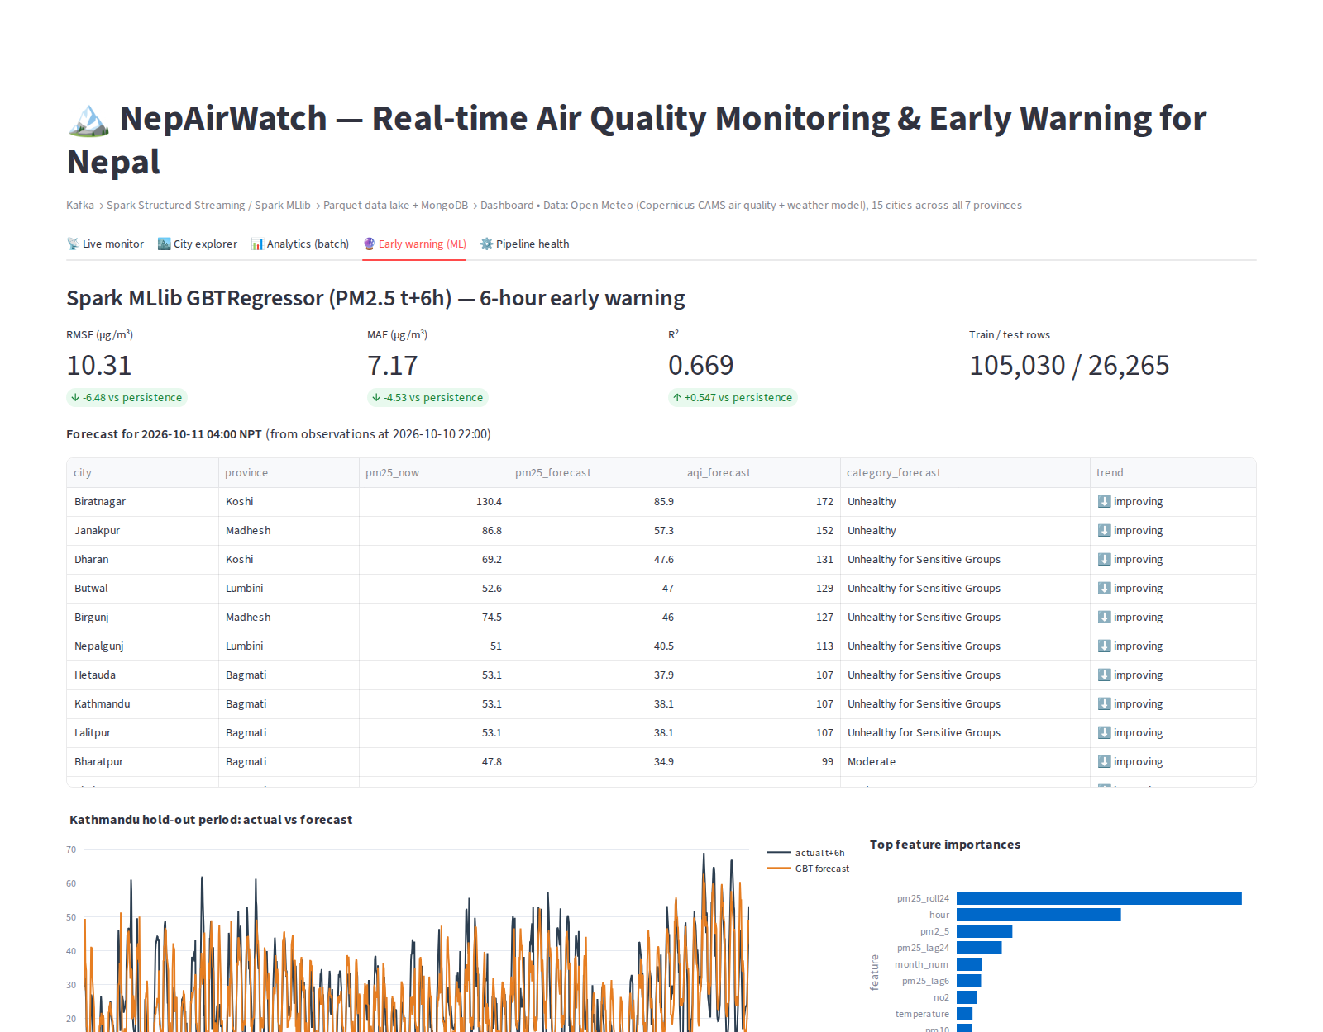
Figure 12: Early warning — model metrics vs baseline and 6-hour forecast per city
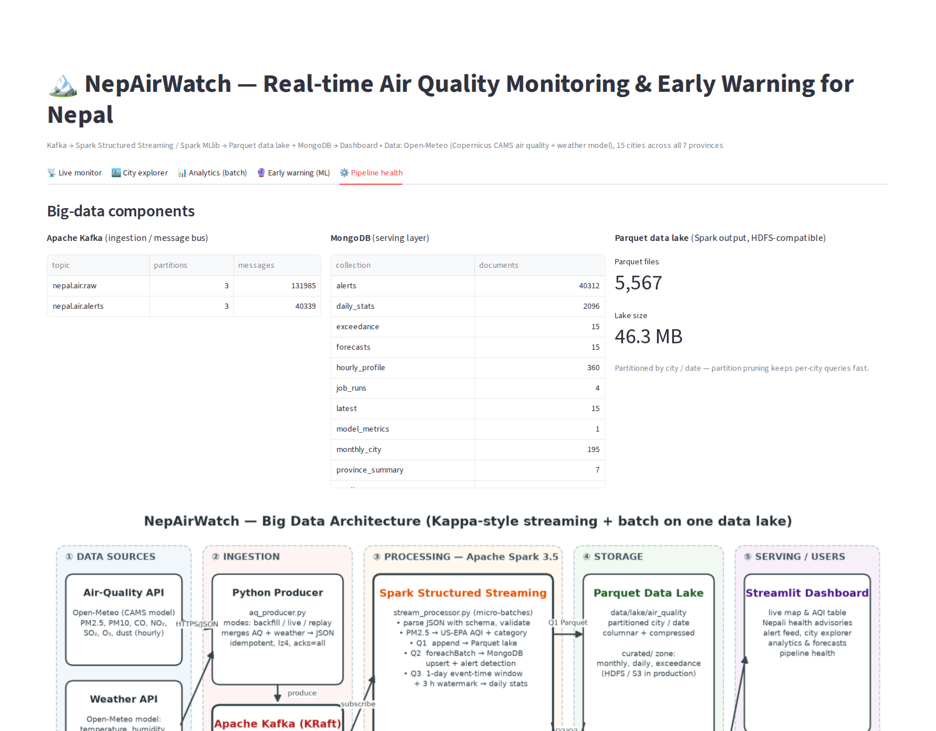
Figure 13: Pipeline health — Kafka topic offsets, MongoDB collections, data-lake size

10.1 Demo plan
1. Introduce the problem using the Analytics tab (exceedance days and seasonality).
2. Explain the architecture with the block diagram.
3. Open Kafka-UI (localhost:8080) and show the nepal.air.raw topic: partitions, keys, a sample message.
4. Start the replay producer (docker compose run --rm replay) and watch the Spark micro-batch log and the dashboard throughput chart update every few seconds.
5. Show alerts appearing in the dashboard and in the nepal.air.alerts Kafka topic.
6. Explore Kathmandu in the City tab and explain the inversion effect.
7. Show the 6-hour forecast and model accuracy in the Early-warning tab.
8. Show the Pipeline-health tab and the Parquet partitions on disk (data/lake/air_quality/city=…/date=…).

11. Implementation Guidelines
Prerequisites: Docker with Compose v2, internet access, ~6 GB free RAM. Every component, including Python, Java 17 and Spark, runs in containers, so nothing else needs to be installed on the host.
Step | Command | What it does
Start everything | docker compose up -d --build | Builds the app image, then starts Kafka, Kafka-UI, MongoDB, topic creation, the one-time 1-year back-fill, Spark streaming, Spark batch + MLlib (repeats every 6 h), the live producer (every 15 min) and the dashboard.
Dashboard | http://localhost:8501 | Streamlit dashboard. Kafka-UI: http://localhost:8080, Spark UI: :4040.
Status / logs | docker compose ps  docker compose logs -f spark-streaming | Service health and Spark micro-batches.
Demo replay | docker compose run --rm replay | Re-streams the last 2 days, 1 hour every 2 s.
Stop | docker compose stop | Stops all services and keeps the data.
Reset | docker compose down -v | Deletes all data. The next start back-fills again.

Configuration is through environment variables (BACKFILL_DAYS, LIVE_INTERVAL, BATCH_INTERVAL, KAFKA_BOOTSTRAP, MONGO_URI, LAKE_PATH, SPARK_MASTER). To run on a cluster, point SPARK_MASTER to YARN, Kubernetes or a standalone master, and LAKE_PATH to an hdfs:// or s3a:// location. The full source code and README accompany this report.

12. Limitations and Future Work
- Model resolution: CAMS is a ~40 km global model. Kathmandu, Lalitpur and Hetauda fall in the same grid cell and report identical values, and local hotspots are smoothed out. Fusing DoEnv reference stations and low-cost sensors through the same Kafka topic, with bias correction, is the next step.
- Single-node deployment: The demo runs on one machine. Production would use a 3-broker Kafka cluster (replication factor 3), Spark on YARN/Kubernetes and HDFS/S3 storage.
- Alert delivery: Alerts are published to Kafka and shown on the dashboard. An SMS/Viber/push consumer (for example via Sparrow SMS) is planned.
- Small files: Frequent micro-batches create many small Parquet files. A periodic compaction job, or Delta Lake/Iceberg tables, would fix this.
- Richer features: NASA FIRMS fire counts, traffic and brick-kiln operating calendars could improve forecasts, as could deep-learning sequence models (LSTM).

13. Conclusion
NepAirWatch shows that an open-source big-data stack can address a pressing real-world problem in Nepal. Apache Kafka provides a scalable, fault-tolerant and replayable ingestion backbone. Apache Spark provides real-time AQI computation and alerting, event-time windowed aggregation, large-scale historical analytics and distributed machine learning in one engine. The Parquet data lake and the MongoDB serving layer separate cheap long-term storage from low-latency access. The analysis shows that PM2.5 standards are breached on most days of the year in the Terai and on almost half the days in Kathmandu, and that episodes can be forecast six hours ahead with good accuracy. With ground-sensor integration and an SMS alert service, the platform could serve as a national early-warning system protecting millions of people.

References
- World Health Organization (2021). WHO Global Air Quality Guidelines: PM2.5, PM10, ozone, nitrogen dioxide, sulfur dioxide and carbon monoxide. Geneva: WHO.
- Government of Nepal (2012). National Ambient Air Quality Standards for Nepal, Nepal Gazette.
- Department of Environment, Nepal. Air Quality Monitoring — https://pollution.gov.np
- U.S. EPA (2024). Technical Assistance Document for the Reporting of Daily Air Quality — the Air Quality Index (AQI).
- Copernicus Atmosphere Monitoring Service (CAMS). Global atmospheric composition forecasts.
- Open-Meteo. Air Quality API and Weather Forecast API documentation — https://open-meteo.com
- Apache Software Foundation. Apache Kafka 3.8 Documentation — https://kafka.apache.org
- Apache Software Foundation. Structured Streaming Programming Guide, Spark 3.5 — https://spark.apache.org
- Kleppmann, M. (2017). Designing Data-Intensive Applications. O'Reilly Media.
- Kreps, J. (2014). Questioning the Lambda Architecture. O'Reilly Radar.
- Health Effects Institute (2024). State of Global Air 2024.

Appendix A — Kafka Message Schema (nepal.air.raw)
{ "city": "Kathmandu", "province": "Bagmati", "lat": 27.7172, "lon": 85.324,
"event_time": "2026-01-12T08:00:00+05:45",
"pm2_5": 112.4, "pm10": 140.2, "co": 1450.0, "no2": 38.1, "so2": 12.0, "o3": 20.3, "dust": 3.0,
"temperature": 6.2, "humidity": 81.0, "wind_speed": 2.1, "precipitation": 0.0,
"boundary_layer_height": 35.0,
"source": "open-meteo/live", "ingest_time": "2026-01-12T02:20:11+00:00" }

Appendix B — Work Division
Member | Responsibilities
[Student Name 1] | Problem study, data-source analysis, Kafka producer & ingestion, MongoDB design, dashboard
[Student Name 2] | Spark Structured Streaming job, batch analytics & MLlib model, data lake, evaluation
Both | Architecture design, testing, report and presentation

