

Procedure for Staff
CONSENT2GO – To Make a Student Group -by selecting individual students:

To make a student group Select ‘Student Groups’ & ‘Add New Student Group’
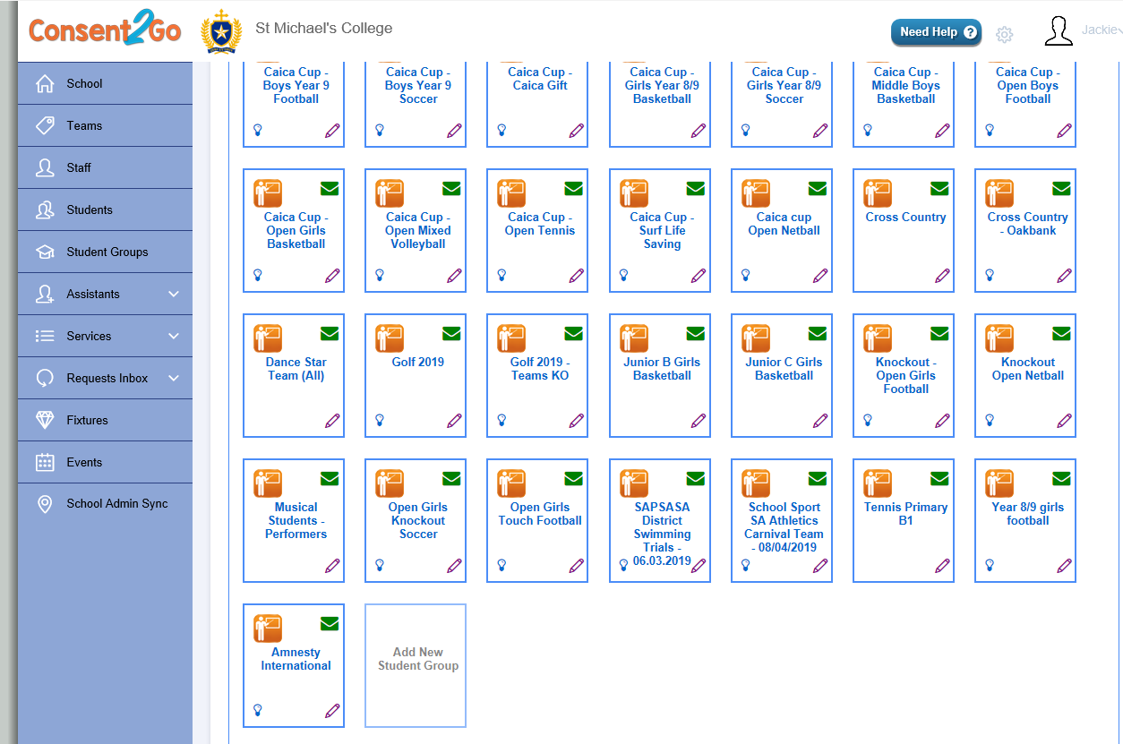
- Group Name: Enter identifiable Name for Group Eg : Chess Club 2019
- Group Description: Brief description of Group
- Students: Select Male, Female or Mixed
- Group Campus - Henley
- Group Category: Select appropriate category from drop down list
- Max Students: N/A
- Year Groups: Do not tick any
- Active: Tick
- Available for Selection: Do not tick
- Click Save
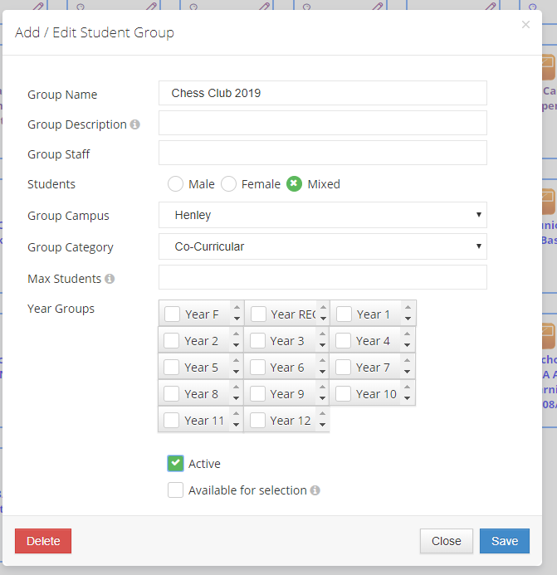
- Click on ‘Student Groups’. Locate and click on the name of the Group you just created.
- Click on the green Students icon
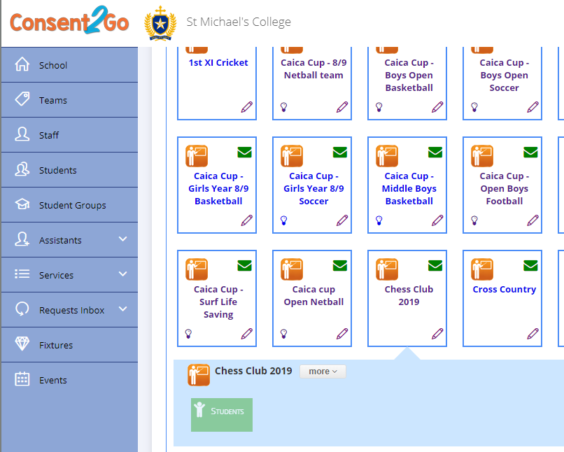

- To filter students, select or unselect the appropriate year level/s.
- To select a student, type the student’s name in the top left corner, or click directly on the student’s name in the ‘School Student List’. When all students have been selected, click ‘Save’
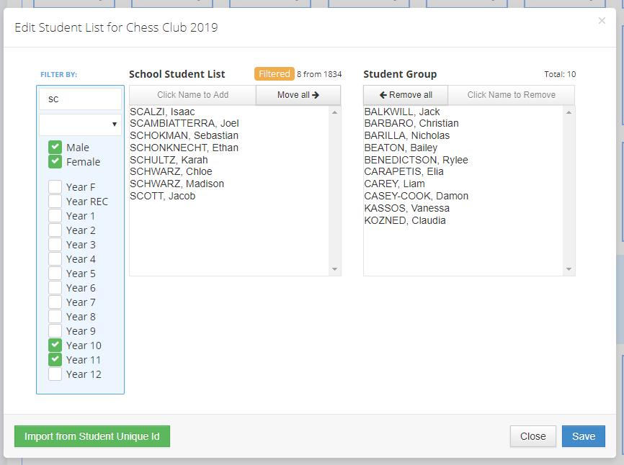
- To check your group has saved, click on Students Groups, click on your Group and the student names will appear.
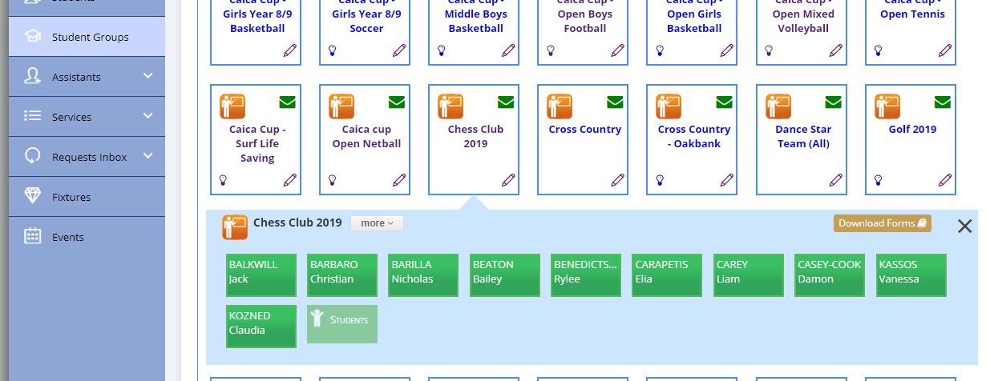
Procedure for Staff
CONSENT2GO – To Make a Student Group -by selecting a class group
- OPEN SEQTA
- Blackboard
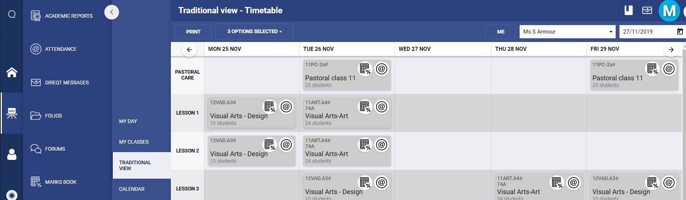
- Select teacher’s name
- Traditional View
- Find the class and select % icon
NB : If % icon (Marks Book) is not available to select, follow these instructions before proceeding to Step 5:
- Click anywhere on the class
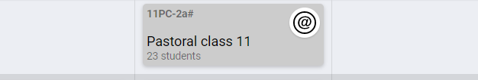
- Click New Program
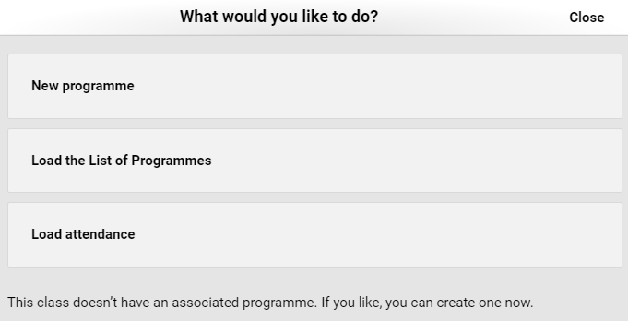

- A new window will appear. Click on the blackboard icon and the classes will reappear
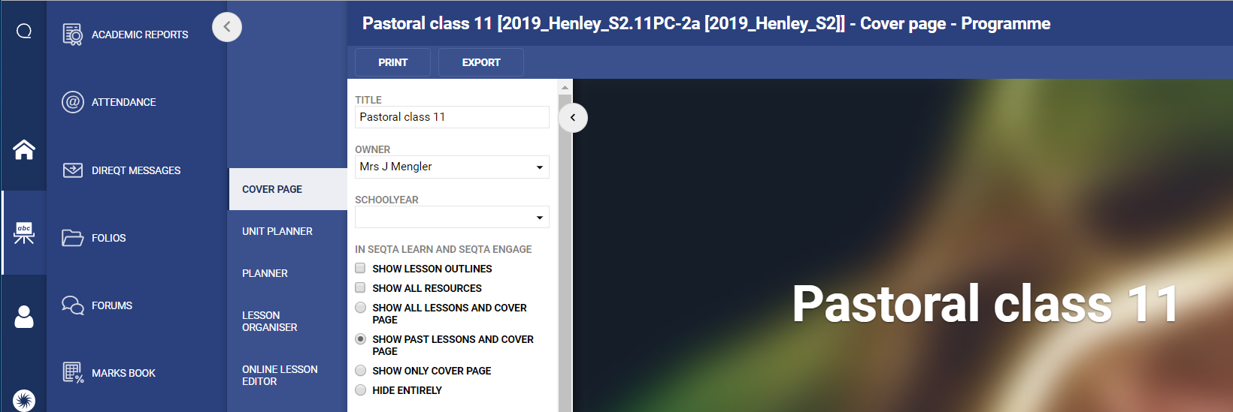
- Click on the % (Marks Book) icon of the class you wish to export
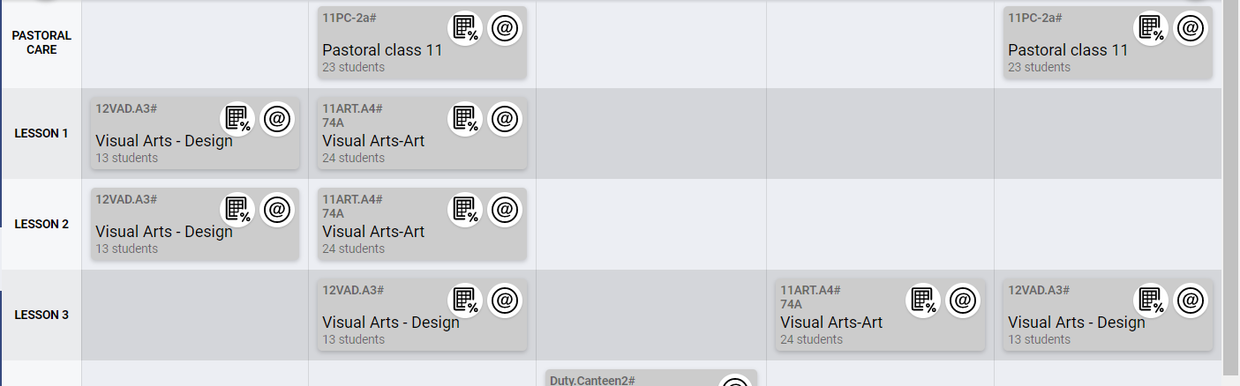

- Click TO EXCEL
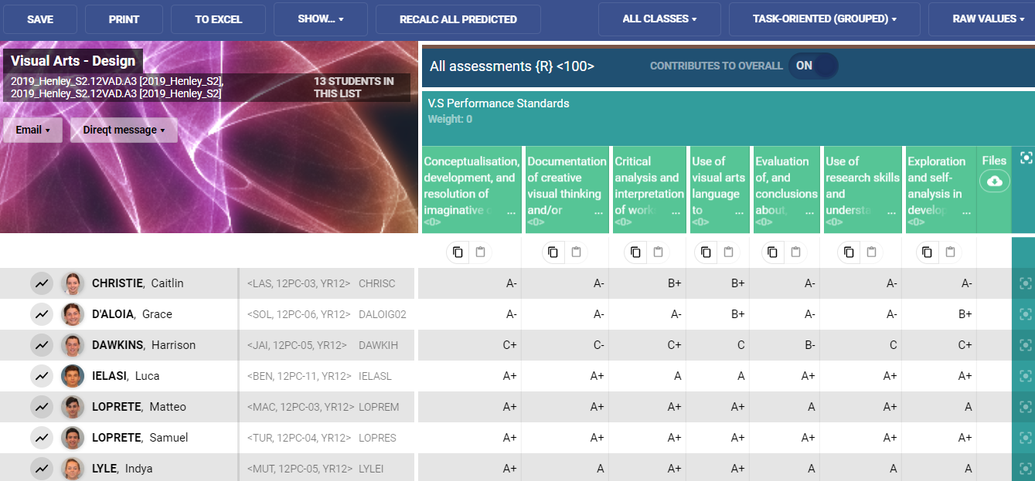
- Click Student Details
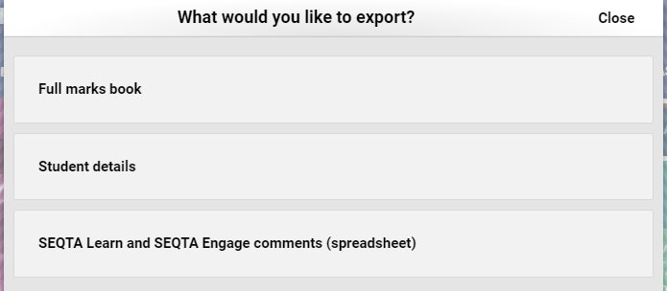
- ‘Click here to access your document’
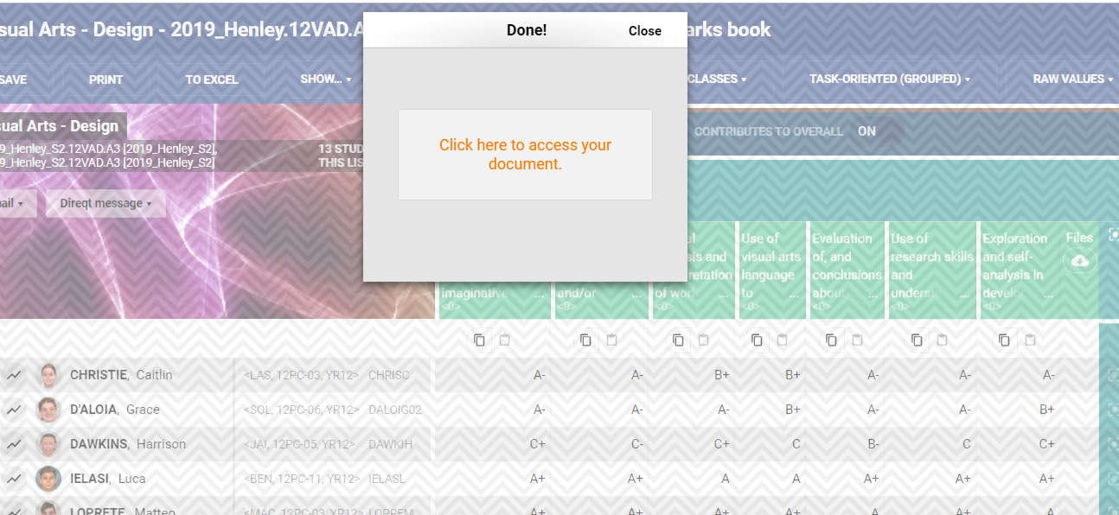

- Highlight names under code
- Copy
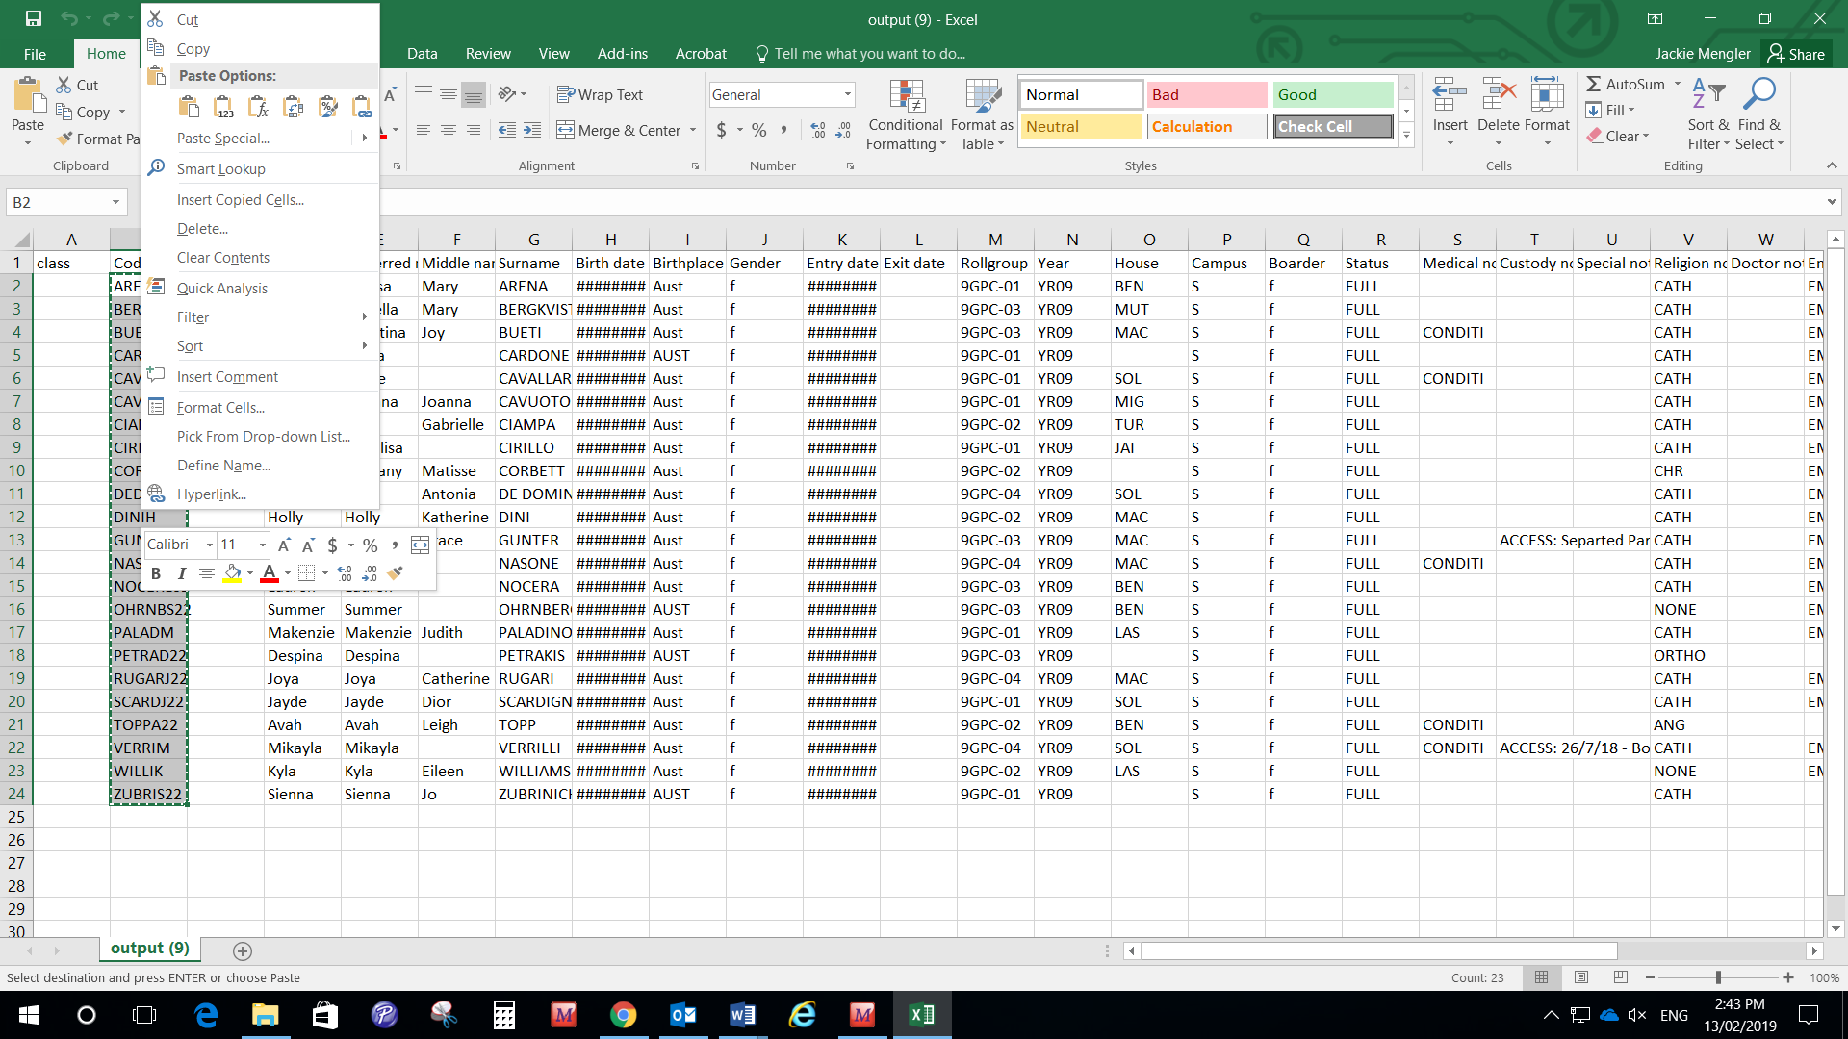
- Open Consent2Go
- Student Groups
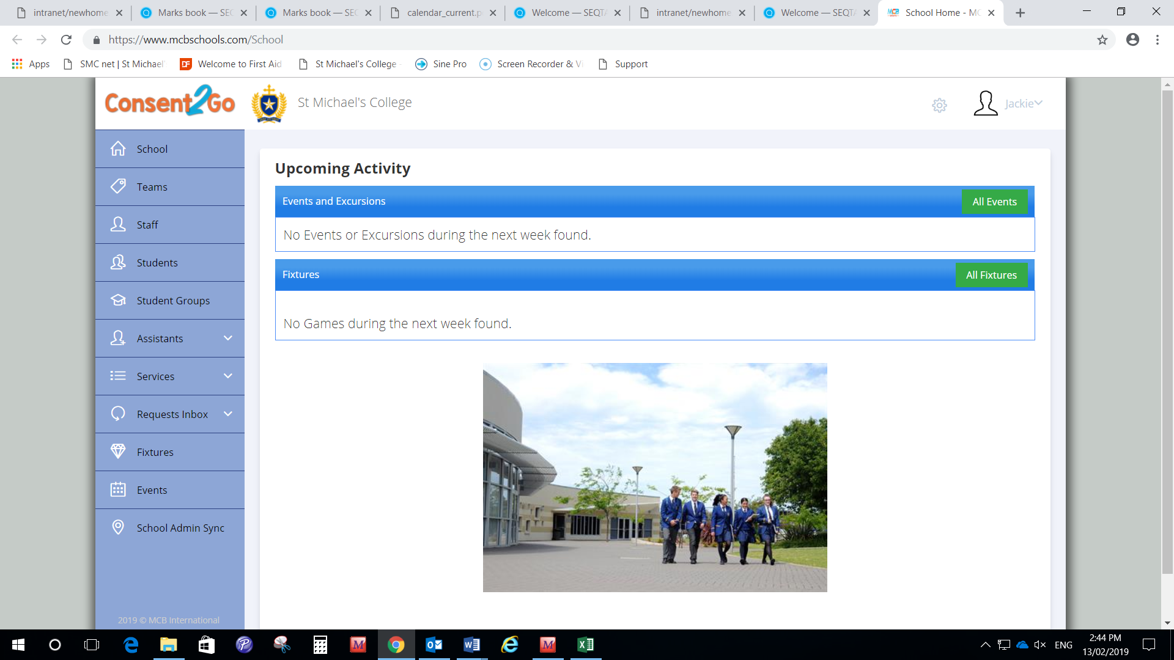

- Add New Student Group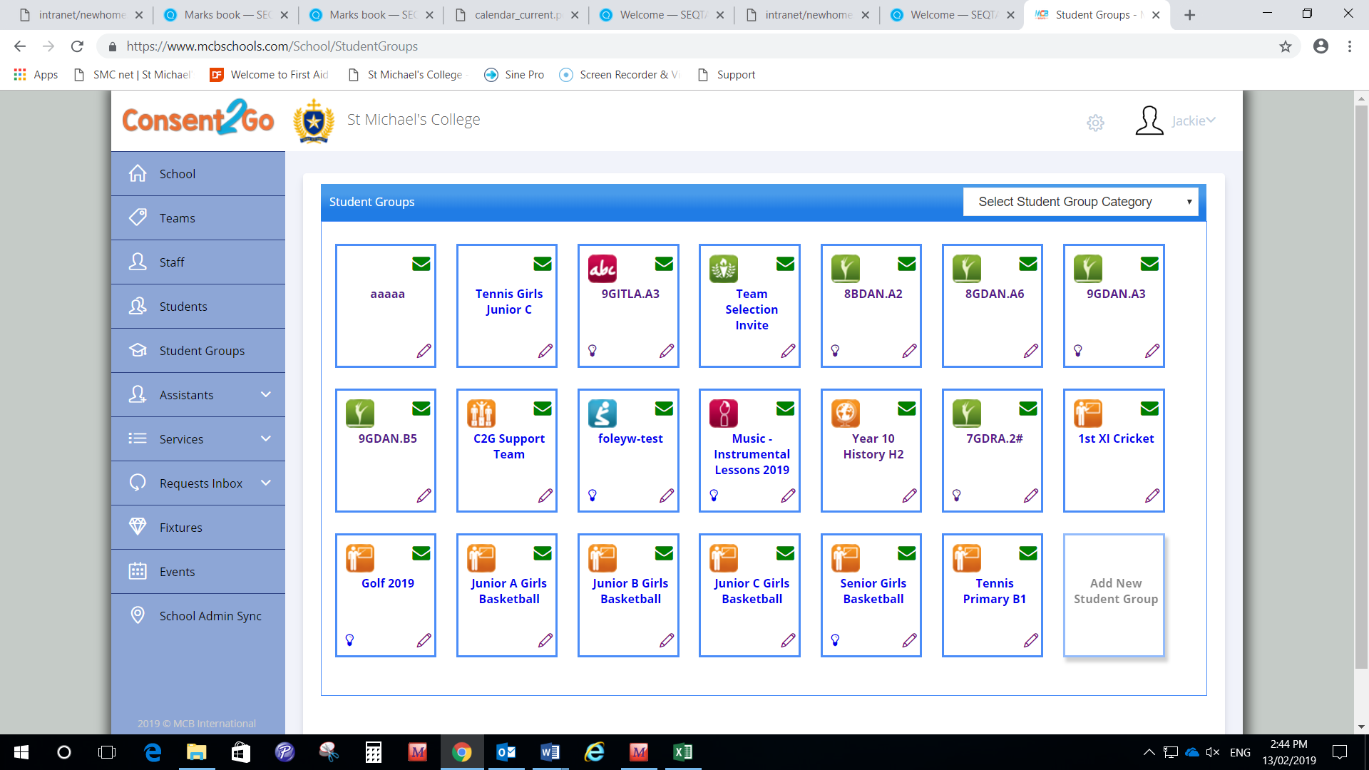

- A pop up will appear for you to enter details (Don’t tick Available for selection)
- ‘Group Name’ where possible, use the Class Code from SEQTA to name the Group. ie 9GITAL.A3 2019
- ‘Save’
- Your Student Group is now saved and can be located from the Student Group section.
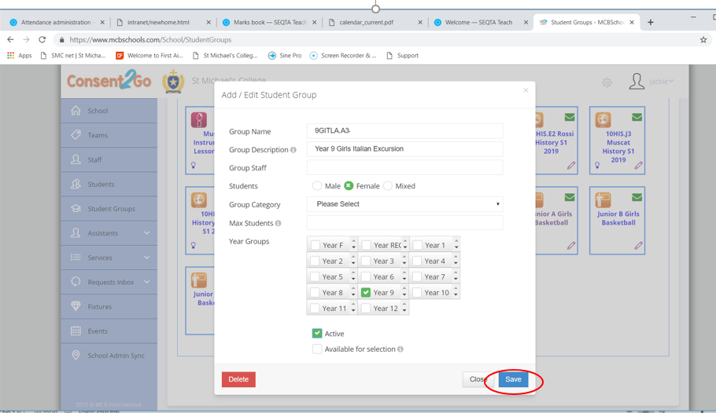

- Locate and click on the Student Group you created.
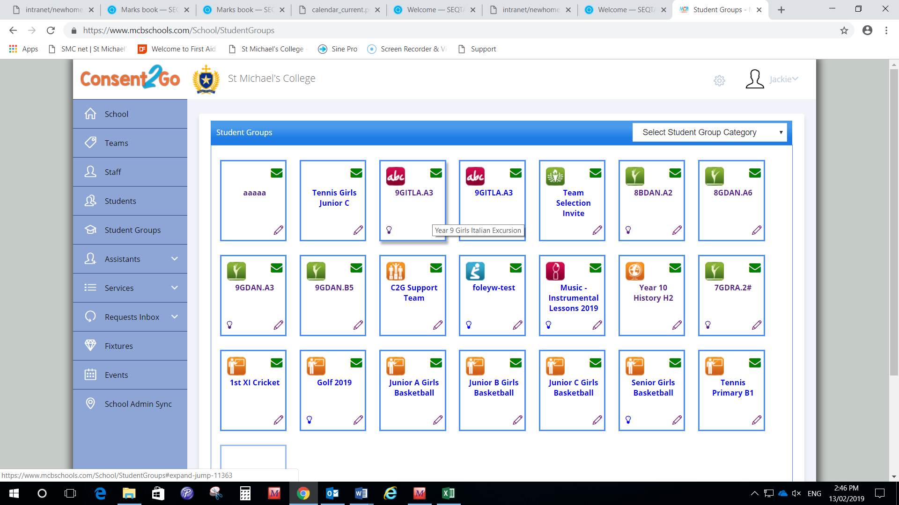

- Click students (green box)
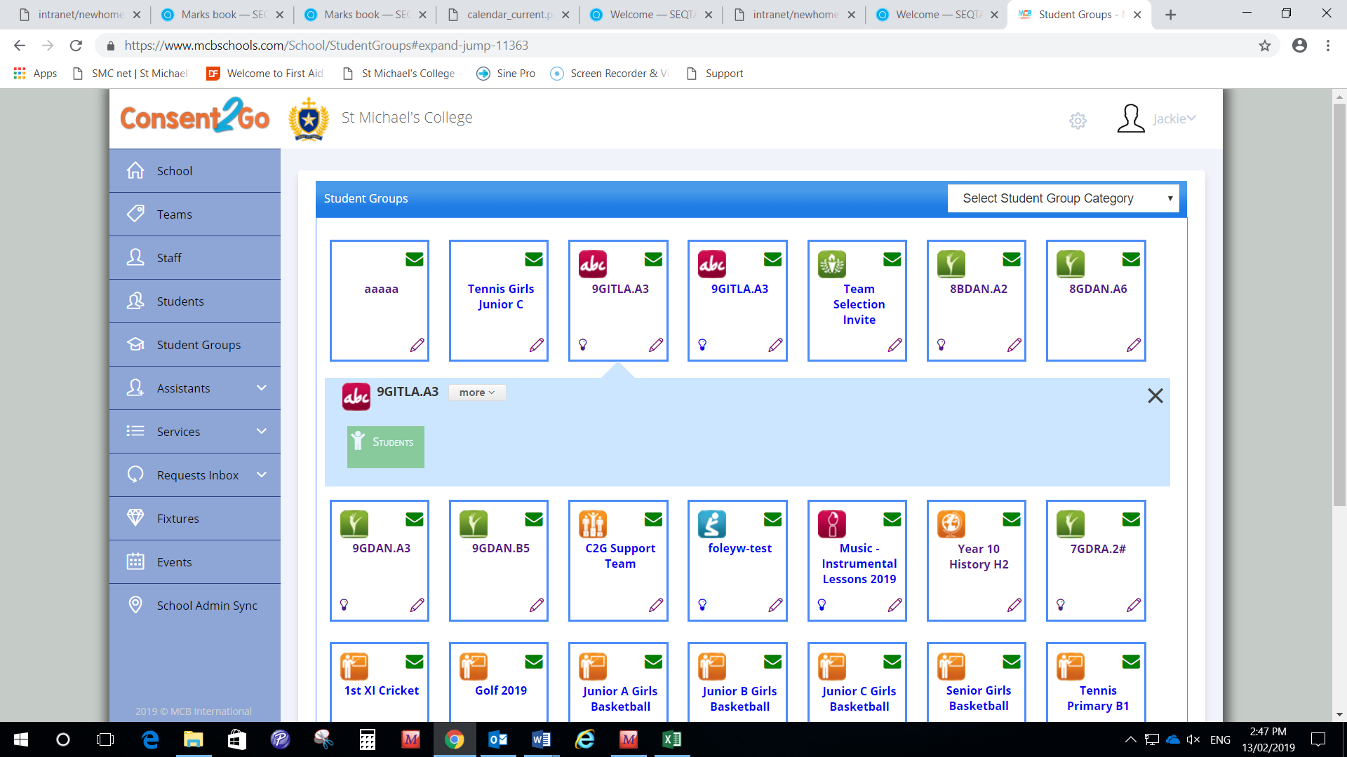
- Import from Student Unique ID
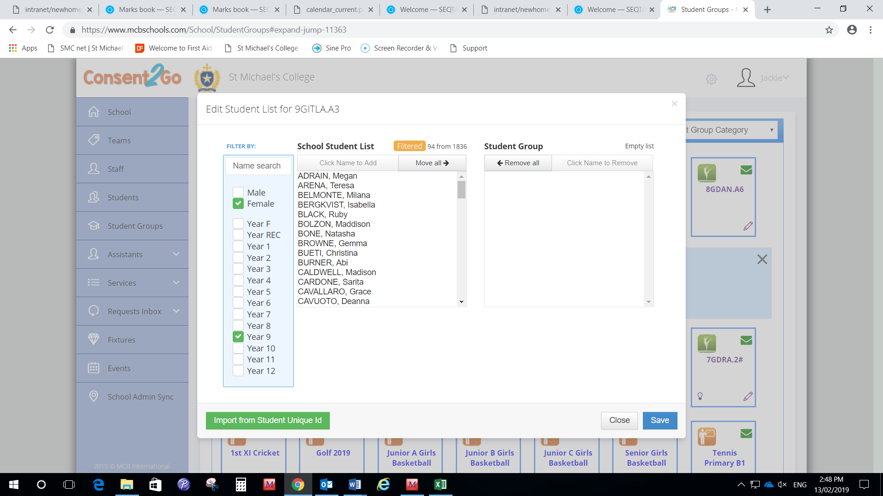
- Paste

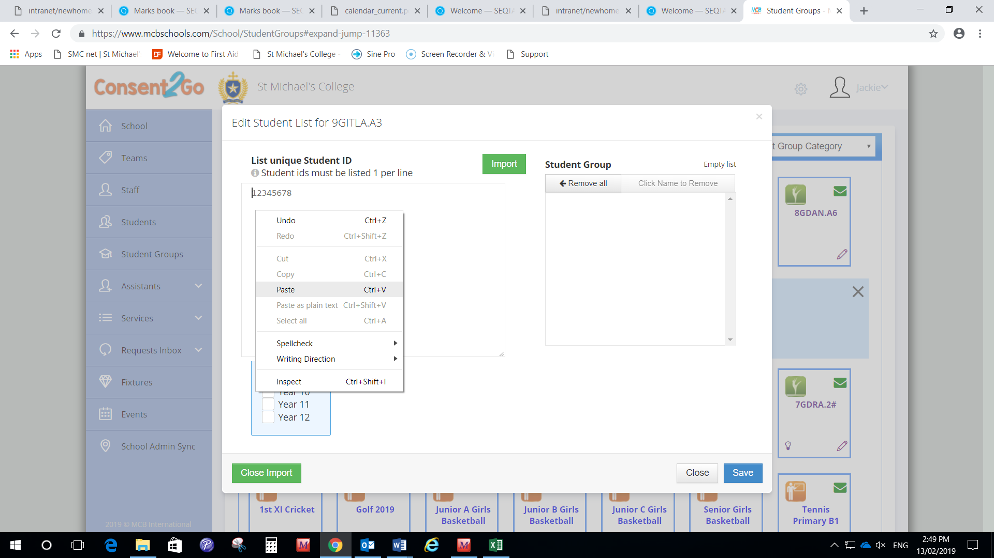

- Import
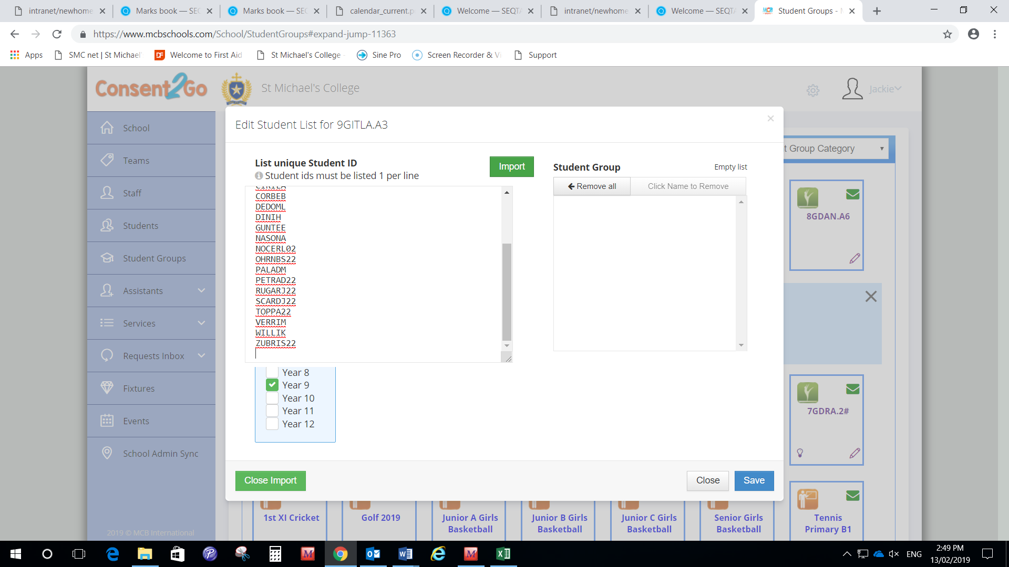

- Save
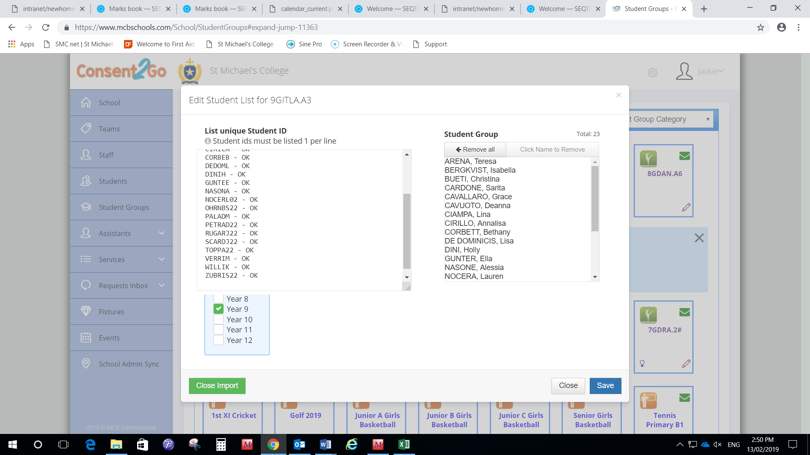

- IMPORTANT: DO NOT TICK ON THE FOLLOWING (Exception: unless a whole year level is required).
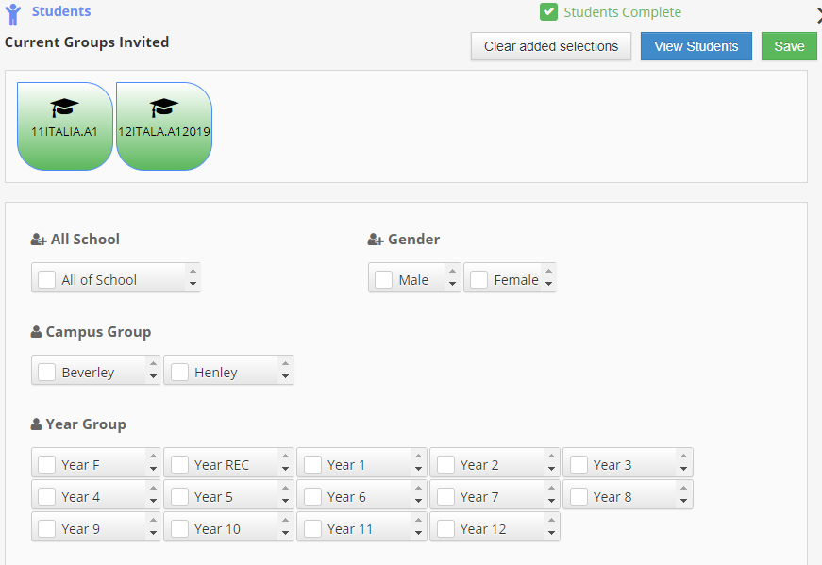
- PLEASE CHECK THE NAMES OF STUDENTS IN THE GROUP ARE CORRECT

