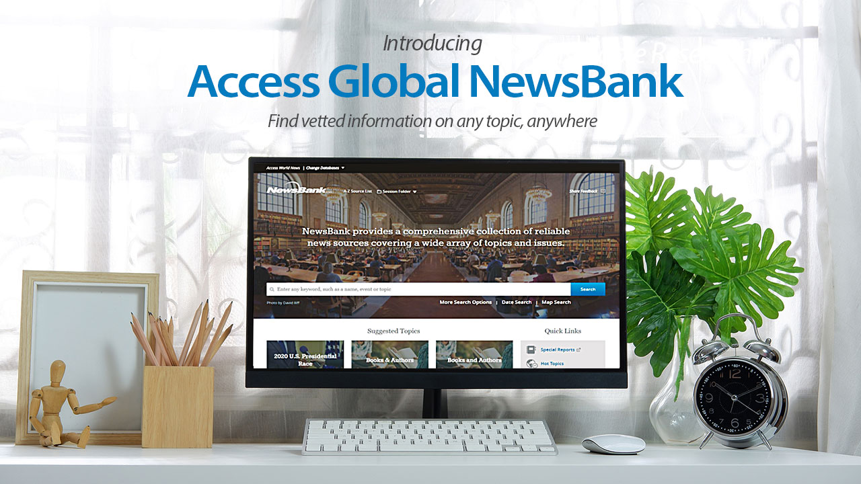

Introducing Access Global NewsBank – This resource features a wide variety of credible, vetted news sources from more than 200 countries, which allows exploration of diverse perspectives and useful information on virtually any topic, such as health, education, environment, political and social issues and more.
(Feel free to edit this to include any school access information.)

