## Task 1

**Discuss the questions with your partner(s). What answers would you give if someone asked you a such questions at a job interview?**

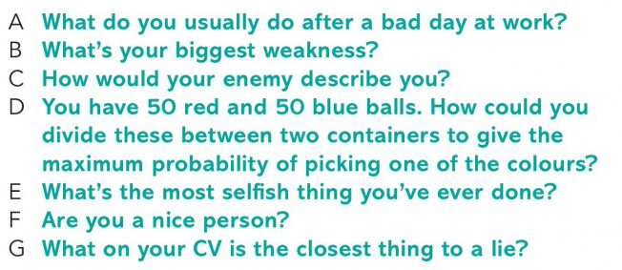

## Task 2

**Read the text. Discuss which question (A-G) is each paragraph about with your partner(s).**

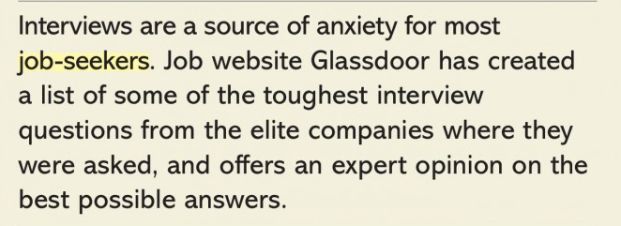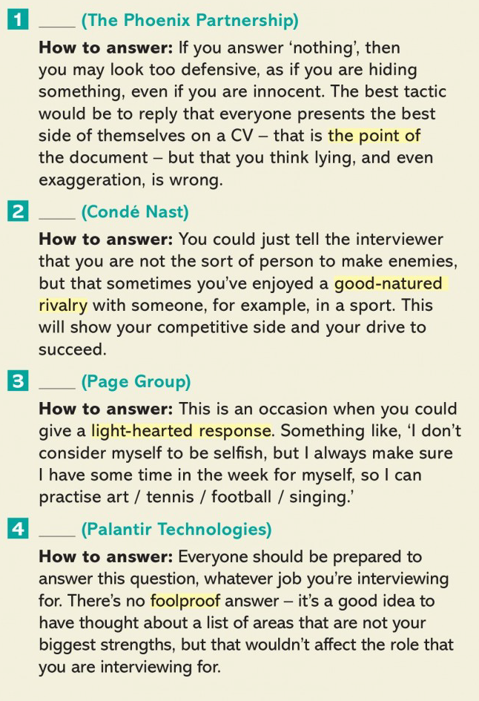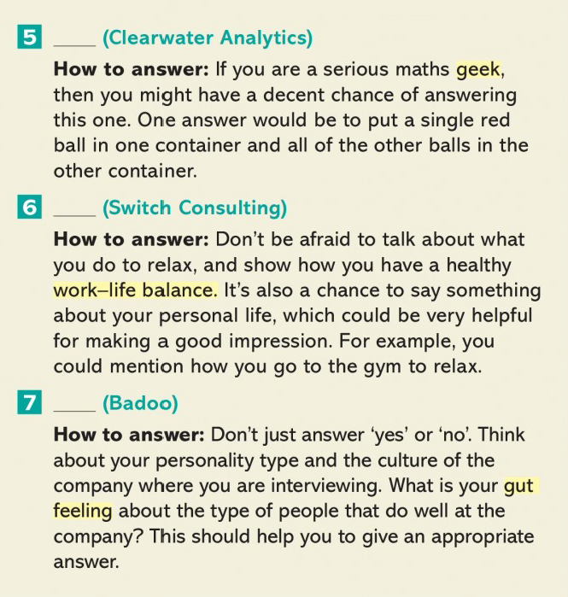

**What do you think of the advice in the article?**

## **Task 3**

**Look at the questions that many famous companies use at their interviews. Discuss the questions. Why do you think they ask such questions? What can each question tell them about the candidate?**

**You don’t need to answer the questions, but you can discuss possible answers if you want :)**

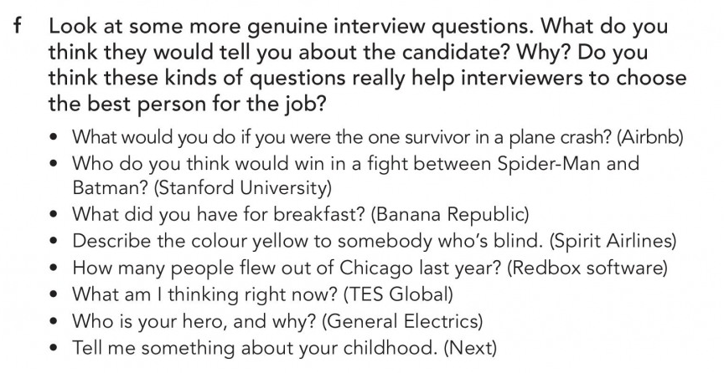

## Task 4. Student A.

**1. Decide who is student A and who is student B (C) between yourselves.**

**2. Ask student B a question from your list. Listen to their answer. You can share your feedback if you want.**

**3. Listen to student B’s question. Answer it the best you can. Use filler phrases to give yourself some time to organize your thoughts.**

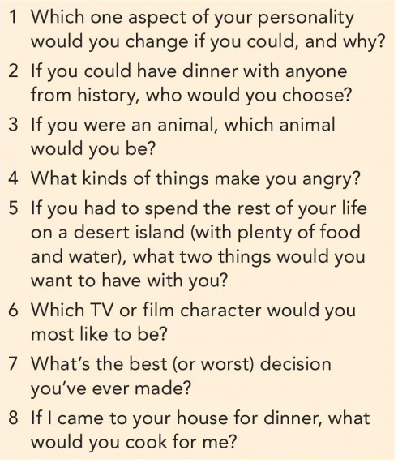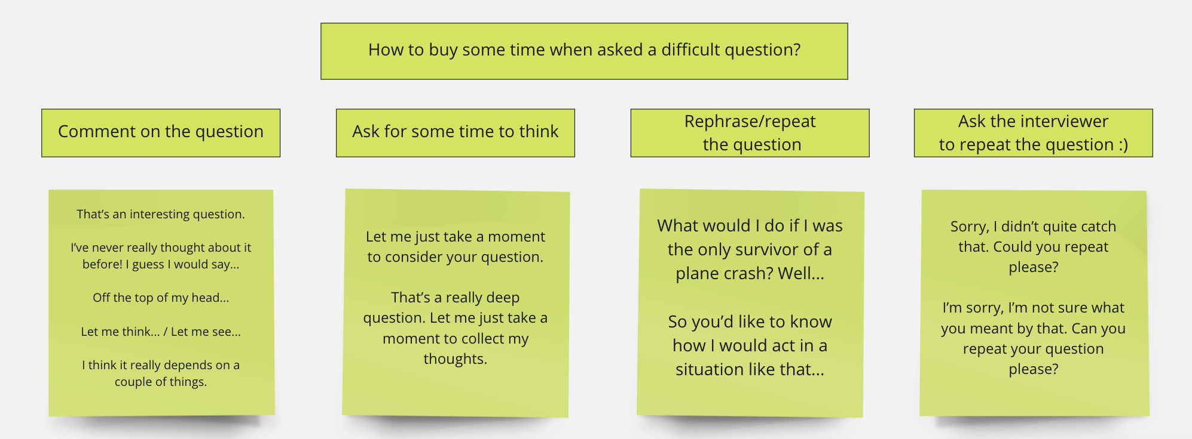

## **Task 4. Student B.**

**1. Decide who is student A and who is student B (C) between yourselves.**

**2. Listen to student A’s question. Answer it the best you can. Use filler phrases to give yourself some time to organize your thoughts.**

**3. Ask student A (C) a question from your list. Listen to their answer. You can share your feedback if you want.**

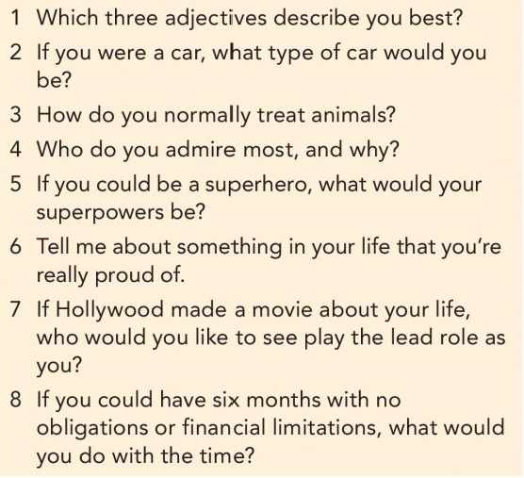

## **Task 4. Student C.**

**1. Decide who is student A and who is student B (C) between yourselves.**

**2. Listen to student A’s question. Listen to student B’s answer. Share your ideas if you have something to add.**

**3. Listen to student B’s question. Answer it the best you can. Use filler phrases to give yourself some time to organize your thoughts.**

**3. Ask student A a question from your list. Listen to their answer. You can share your feedback if you want.**

* What would you do if you won the lottery?
* If you could rob a bank without anyone knowing, would you do it?
* Where do you want to go for your next vacation?
* What was the last gift you gave someone?
* Do you prefer cats or dogs? Why?
* What would I find in your fridge right now?
* What has been your strangest life experience?
* Why do you think only a small percentage of population make more than $100,000 USD a year?

