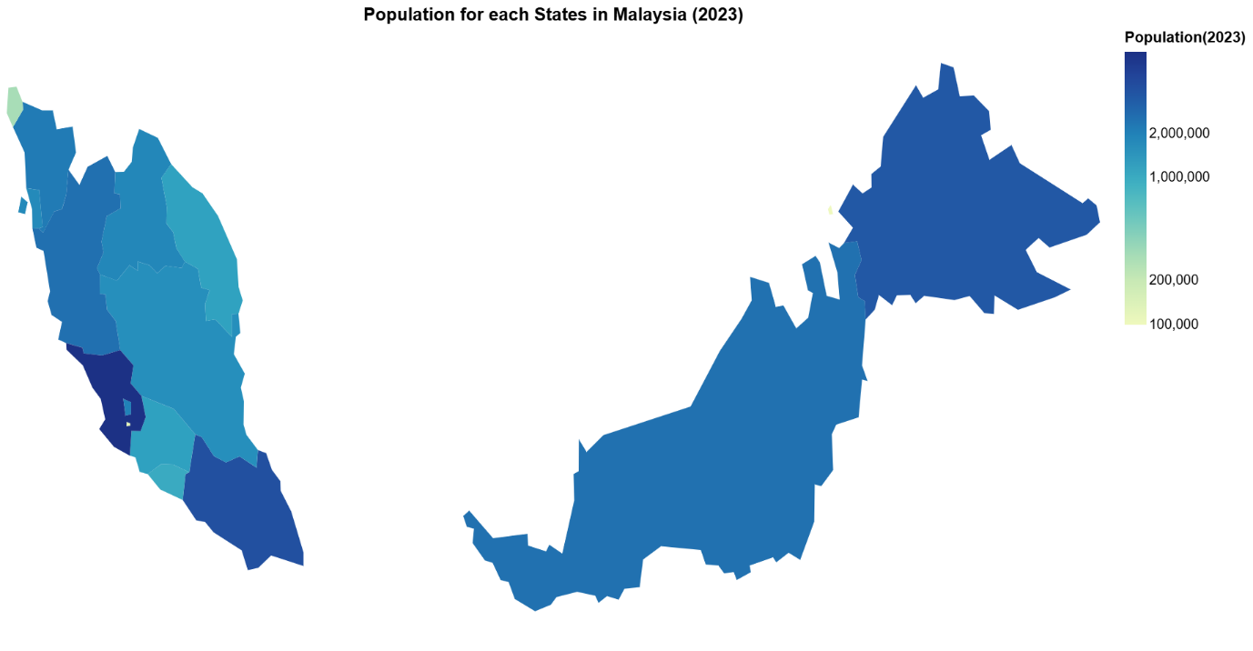

**Domain:** Population and housing transaction for each state in Malaysia for year 2023

**Dataset:**

* Population : Quantitative data
* Housing Transactions : Quantitative data
* States : Categorical data

**Idiom used:** Choropleth map was chosen because it represents state-level quantitative differences for population density and housing transactions for each state using colour intensity, which is more intuitive.