Grant’s gazelle project overview

**Data description**

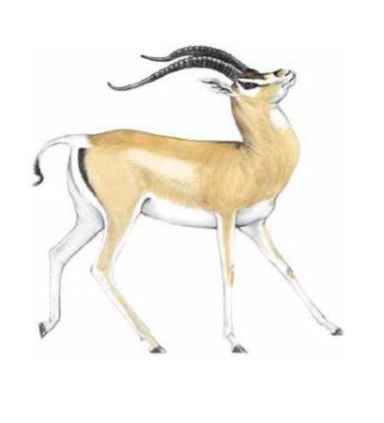The data set you will be given comes from 91 individuals of Grant’s gazelle (Nanger granti) and 4 individuals of Thomson’s gazelle (Eudorcas thomsonii). Grant’s gazelle is interesting because it was recently discovered by genetic methods that it probably consists of three species (N. granti, N. notate and N. petersii) rather than one. Some morphological evidence suggests that N . granti may be further subdivided into N. g. granti and N. g. robertsii. The puzzling thing is how strong genetic barriers have evolved without any obvious isolating mechanism, i.e. no landscape barriers to gene flow and no obvious ecological differentiation between the three species.

The data was generated by a technique called RAD sequencing (Restriction site Associated DNA sequencing, or RADseq. RADseq subsamples the genome with a restriction enzyme so that you end up with about 10 megabases of the genome sequenced in each individual. The data set you will be getting consists of PLINK files with SNP genotypes from the variable positions in these 10 megabases. PLINK is a standard SNP format that can be used in many other programs and can be easily converted to other file formats. Remember that the PLINK files represent the full data set, meaning all individuals from both species. For some analyses it will be obvious to subset the PLINK files by species or populations. It could be a good idea to filter the data when you do various analyses, particularly for missing data. The full data set has been pre-filtered removing sites with more than 20% missing data across individuals.

**Problems to address**

Although you are free to explore any aspect of the data you may like, some of the obvious questions to

address are:

1) Can you confirm the strong genetic differentiation within the Grant’s gazelles, and what are the

most prominent groupings (or genetic clusters) within the species complex?

2) Is there any indication of admixed populations, i.e. populations that could be hybrids between two of the Grant’s species?

3) What is the level of genetic diversity in different populations, and does it differ between

populations?

4) Other possible directions: demographic history and technical/methodological issues.

**Suggested software**

This is a non-exhaustive list of computer programs that could be relevant. Use this as a guideline; if you

want to do something else or use other programs to do similar analyses, feel free to do so. You are also

encouraged to use R to manually (or by using other popgen packages) to explore the data as you see fit.

Please also refer to the exercises you have been doing during the course, as there will be methods, R code

etc. that you can use in the analysis. Software manuals, examples etc. should be readily available by

googling the software names.

* adegenet: an R package that can do basic calculations like heterozygosity, HWE, Fst etc. It can also

do more fancy “spatial genetics”.

* snpmatrix: an R package that can perform PCA. It is pre-installed in the popgen server.
* admixture: a program to infer the admixture proportions under different values of k, the number of

assumed clusters. Can be used to find genetic structure. It is pre-installed in the popgen server.

* treemix: a program to infer the drift tree between different pre-determined genetic groups (or

populations). It is pre-installed in the popgen server.

**Suggested literature**

* Siegismund, H.R., E.D. Lorenzen & P. Arctander 2013. Nanger (granti) Grant’s gazelle species group;pp. 373–379 in Kingdon, J. & Hoffmann, M. (eds). 2013 Mammals of Africa: Volume VI. Pigs, Hippopotamuses, Chevrotain, Giraffes, Deer and Bovids. Bloomsbury Publishing, London.
* Lorenzen, E.D., P. Arctander & H.R. Siegismund 2008a. Three reciprocally monophyletic mtDNA lineages elucidate the taxonomic status of Grant’s gazelles. Conservation Genetics 9: 593–601.
* Arctander, P., P. W. Kat, R. A. Aman & H.R. Siegismund 1996. Extreme genetic differences between populations of Gazella granti, Grant's gazelle, in Kenya. Heredity 76: 465–475.