Biology and structure

1STE is the PDB database ID of the SEC2 protein, it is an enterotoxin type C-2 protein produced by Staphylococcus Aureus. It is a superantigen that activates the host immune system by binding to major histocompatibility (MHC) complex class II and T-Cell receptors. It is one of the causes of food poisoning.
SEC2 is composed by a single polypeptide chain (type A) and its crystal structure reveal a zync-binding site (1.00 occupancy). The experimental method used is the X-ray diffraction.

Structure quality

- The resolution is 2Å (acceptable)
- R-factor is 25 (acceptable)
- B-factor: there are no electron density maps for this structure, so the information about the B-factor is not available
- Ramachandran plot: 1.7% outliers (bad)
- Side chains: 3,9% outliers (bad)

The resolution and R-factor of the 1STE file are acceptable but there are several outliers and the information about the B-factor is not available. So even if it has a decent resolution, since there may be several errors in the model I think that the overall quality is not so good.

Biological and asymmetric unit

The biological and asymmetric unit are the same.

Two pictures of the PDB file with captions

- Picture 1
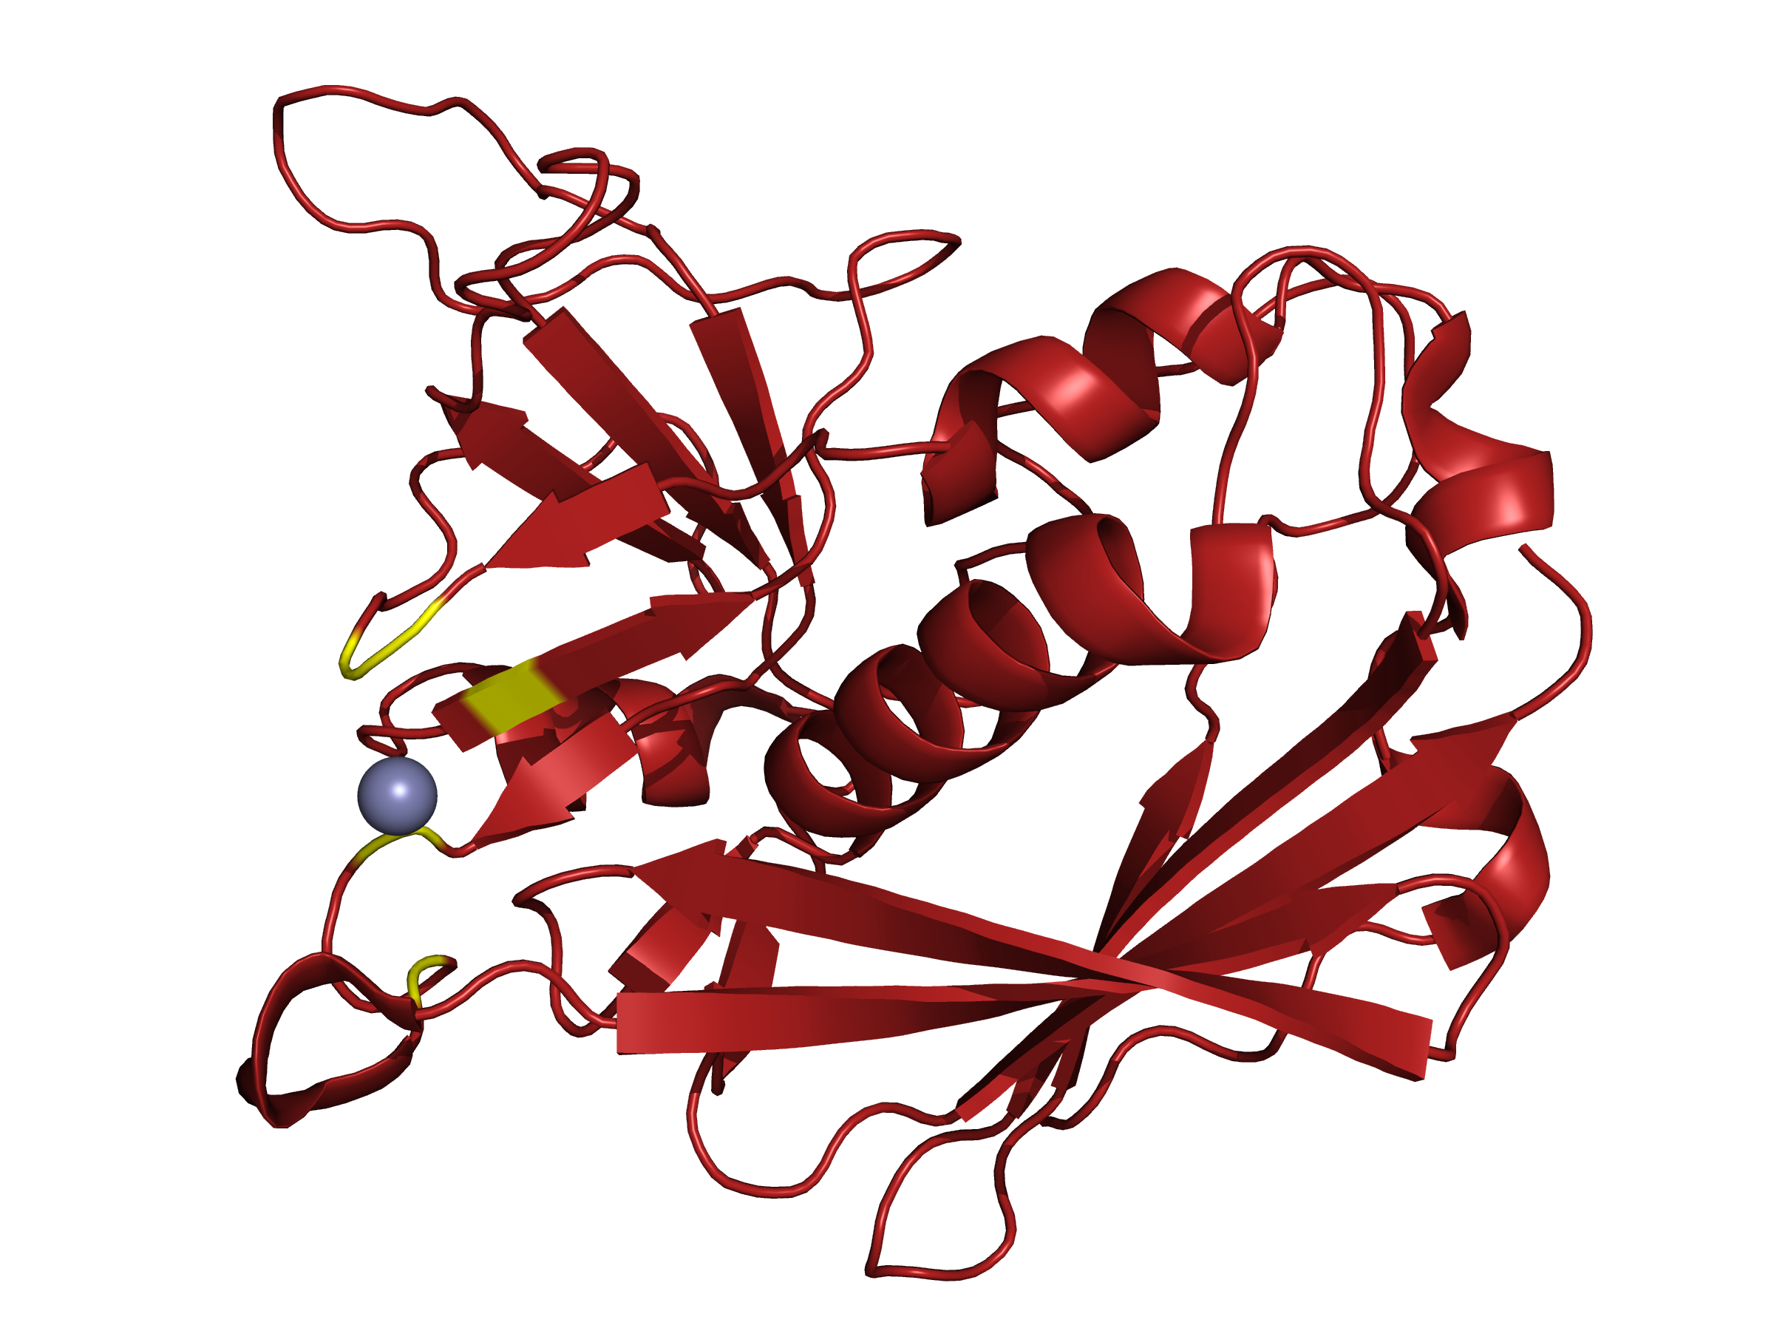
The picture represent the overall structure of the SEC2 protein. Its type A chain is composed of alpha helix, beta sheets and other secondary structures. The grey sphere represent the zinc ion which has interactions with the yellow portion of the protein.
- Picture 2

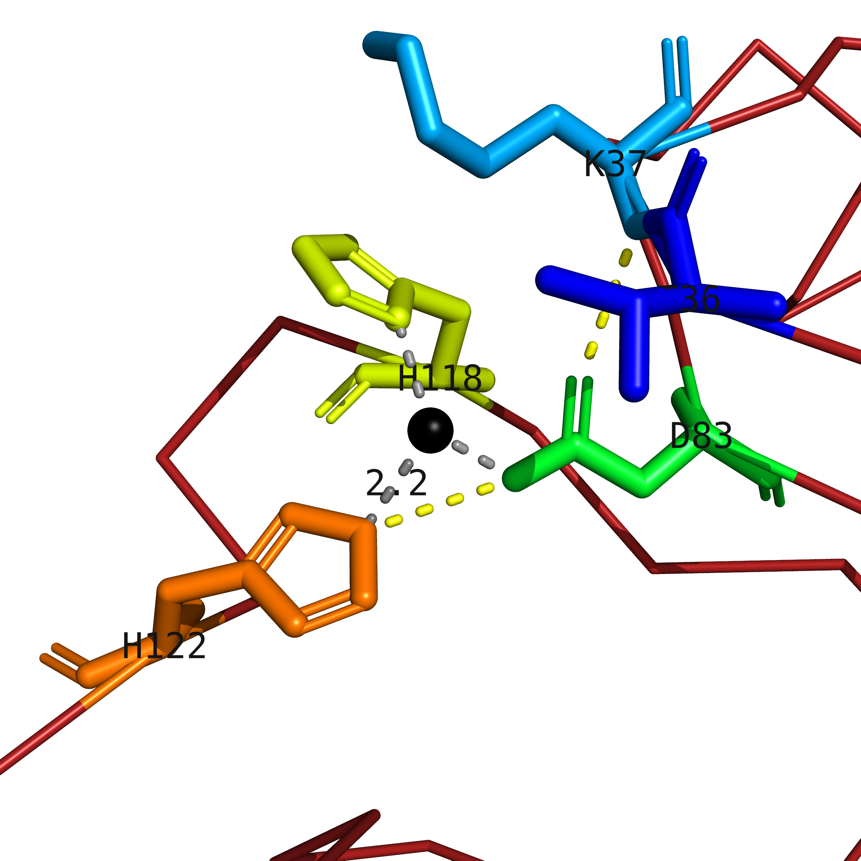

This picture illustrate the five amino acids that interact with the zinc ion (black sphere). Hiss-122 (orange), Hiss-118 (yellow) and Asp-83 (green) bind to the ligand and the bonds are represented by grey dashed lines, while Lys-37 (light blue) and Thr-36 (dark blue) have an indirect interaction. The yellow dashed lines represent the hydrogen bonds between the amino acids that interact with the metal.

