# Session 1

## 1.1

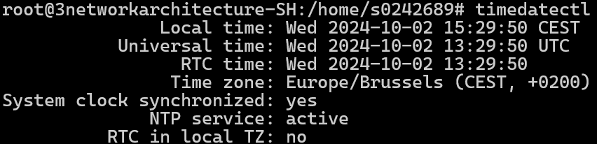First, I wanted to change the time zone, but as a normal user it was not possible. In response to that I used *“sudo su”* to get in the root and change the time zone with *“timedatectl set-timezone 'Europe/Brussels'”*, the results are in the image below. After that I went back to normal user with *“exit”*

Knowing that the time zone is correct I could continue with *“date +’Today is %A, %B %d, %Y’”*, which gave the result shown below. (I know time zone was not needed to get to this result, but it felt better to do it anyway.)

## 1.2

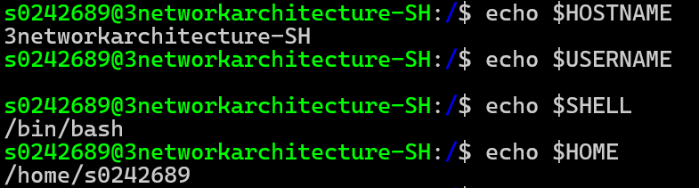Printing variables is done with *“echo”* and the outcome is as follows:

## 1.3

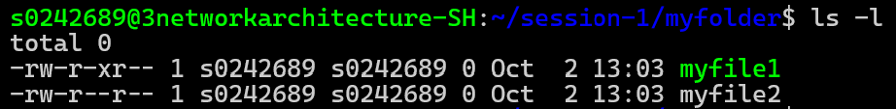First, creating the folder **myfolder** using *“mkdir myfolder”* followed by *“cd myfolder”* to move into the newly created folder. After that create both **myfile1** and **myfile2** using *“touch myfile1; touch myfile2”* and lastly change permissions of **myfile1** so the user can read and write, groups can read and execute, and others can read. Since the default is *“rw-r--r--"*, the only setting to change is to allow group to execute. This is done by using *“chmod g+x myfile1”*, *“g+x”* means add **g**roup can e**x**ecute permissions, the results are shown below.

## 1.4

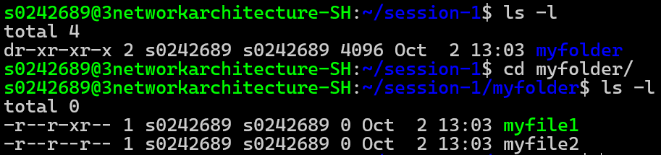Recursively changing permissions of **myfolder** is done using *“-R”* in *“chmod -R a-w myfolder”*, *“a-w”* means remove **w**rite permissions for **a**ll, the results are shown below.