# Session 2

## 2.1

To find the tty-files use the following command: ‘find /usr/bin -name tty 2>/dev/null’, this will find all the files in “/usr/bin” that are named (-name) tty and redirect (2>) the error messages to “/dev/null”.

## 2.2

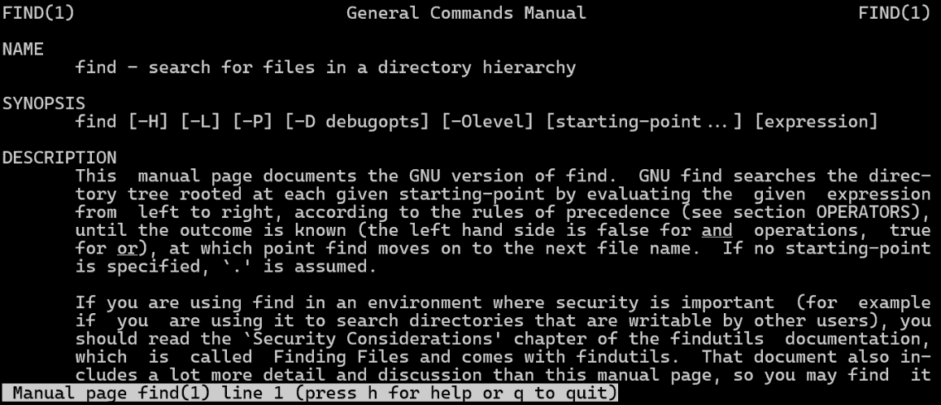By using “man find” it is possible to see a ‘manual’ of the command that you want to use. The command that is used looks as follows: ‘‘find ~ -type f -exec cp {} {}.bak \;” where ‘~’ means the home of the user, ‘-type f’ means it is searching for files and ‘-exec cp {} {}.bak \;’ means to copy each file that is found to a .bak-file.

With the changes made to myfile1 and myfile2 in session 1, there will be an error like shown below.

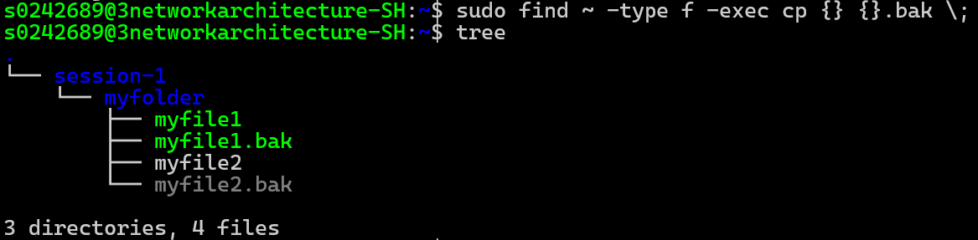Running the command as super-user will work, this command is as follows: ‘sudo find ~ -type f -exec cp {} {}.bak \;’, like said before means, find every file in home and copy to (file).bak. After installing tree with ‘sudo apt install tree’ and using ‘tree’ in the home, shows all the files (except hidden files) in all the folders.

## 2.3

To find files in ‘/usr/bin’ that have not been modified in a certain timerange, use this command: ‘find /usr/bin -mtime +3652 -ls’ where ‘-mtime’ is for “File's data was last modified less than, more than or exactly n*24 hours ago” with n=3652(days), which means total time is 3652*24 = 10 years, and ‘-ls’ is to give a list of the files that meet this criteria.

## 2.4

To run the task in the background it is mandatory to know to place ‘&’ after the command like the following: ‘yes > /dev/null **&**’. This will return an ID linked to the background job like shown in the image bellow.

By using the command ‘jobs -l’ a list of active processes is shown to verify that the process is running, ‘-l’ is used to see the process ID as additional information.

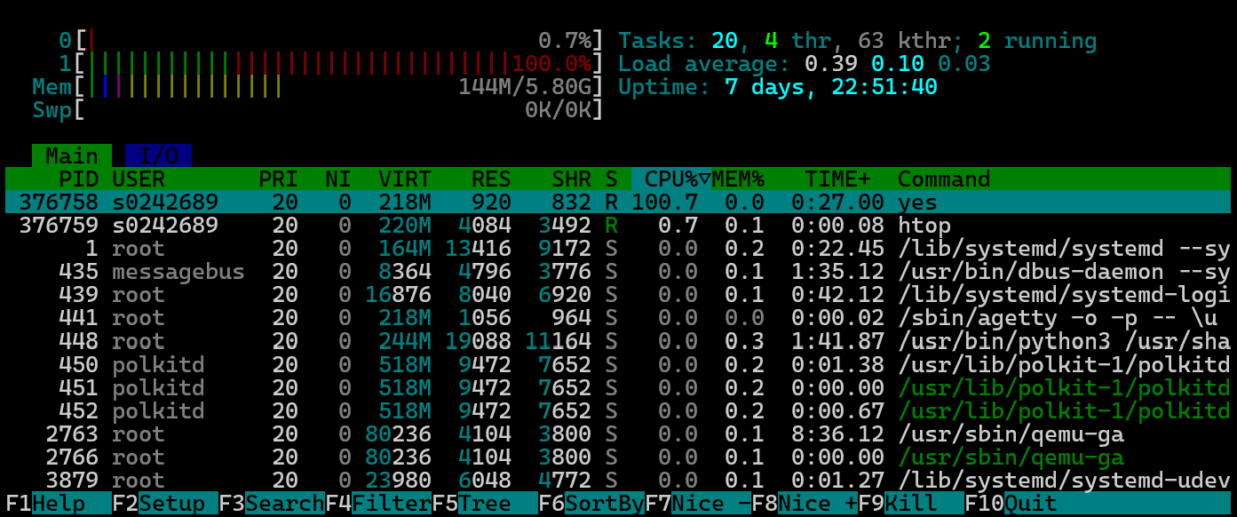After installing htop with ‘sudo apt install htop’ and then using ‘htop’ it is noticeable that core 1 is used 100% by this task.

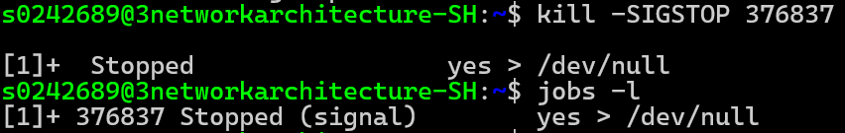After using ‘kill -SIGSTOP 376837(=process ID)’ to pause the process and verifying with ‘jobs -l’, it says “Stopped (signal)” like shown in the image bellow.

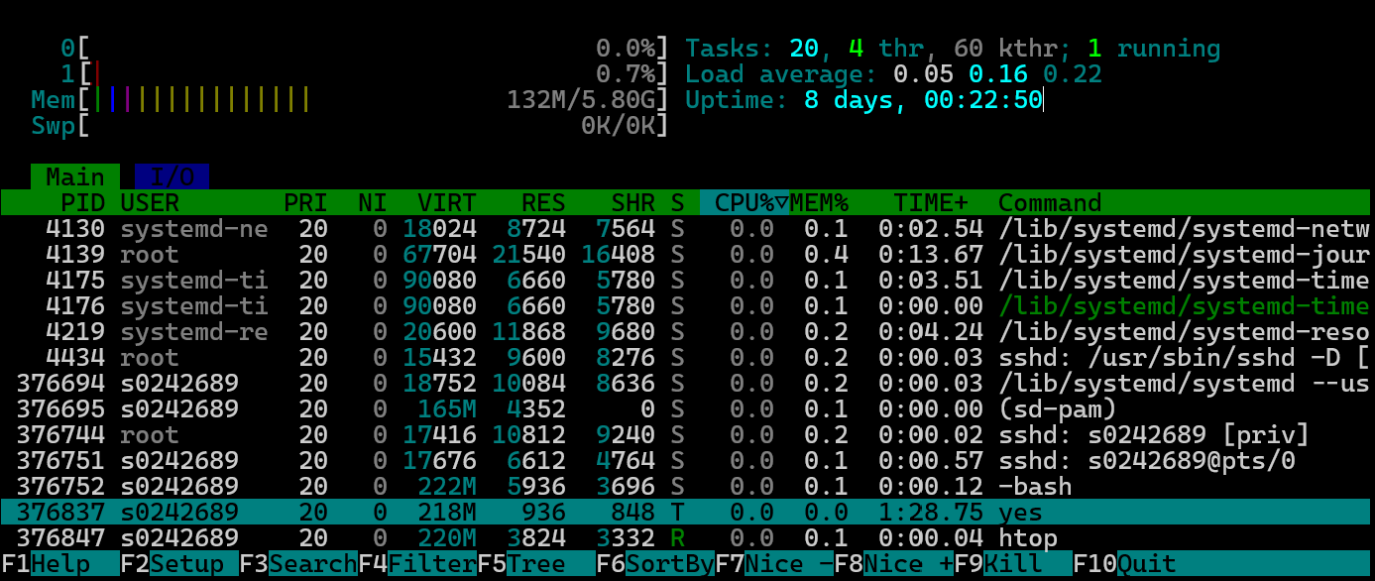When looking at ‘htop’, it is clear the process has been paused and the CPU usage is back to idle. The process is still in the memory like highlighted bellow.

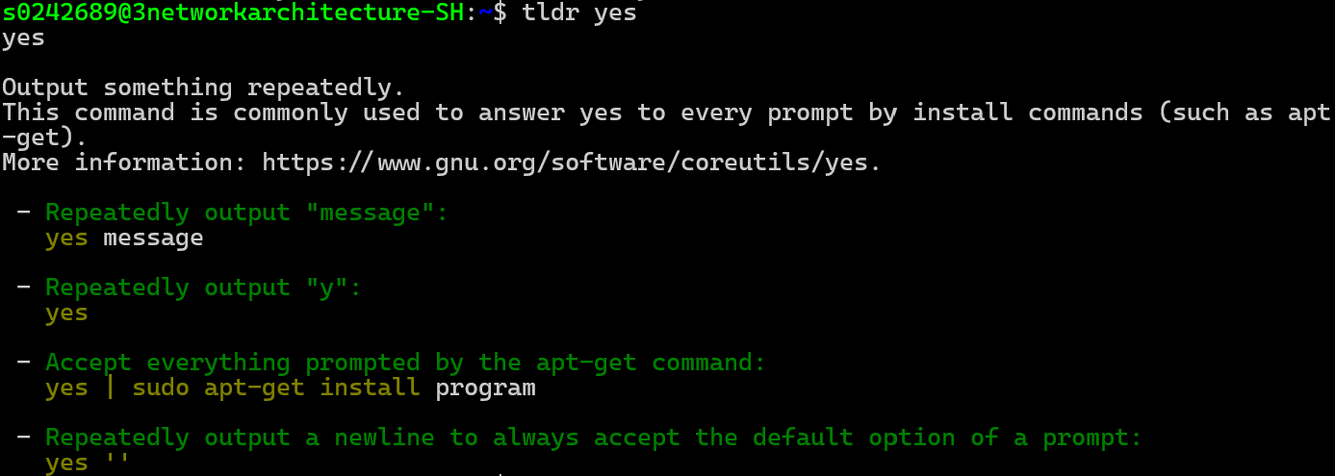To get a quick understanding what the command ‘yes’ does, install tldr with ‘sudo apt install tldr’ followed by ‘tldr yes’ to get a quick overview of what the command does, as shown in the image bellow.

With this information it is clear what ‘yes > /dev/null’ does. This command appears to output “y” repeatedly in the “/dev/null” without any delay so the process will take a lot of resources to run.

## 2.5

After using ‘kill -SIGCONT 376837(=process ID)’ to let the process continue and verifying with ‘jobs -l’, it says “running” like shown in the image bellow.

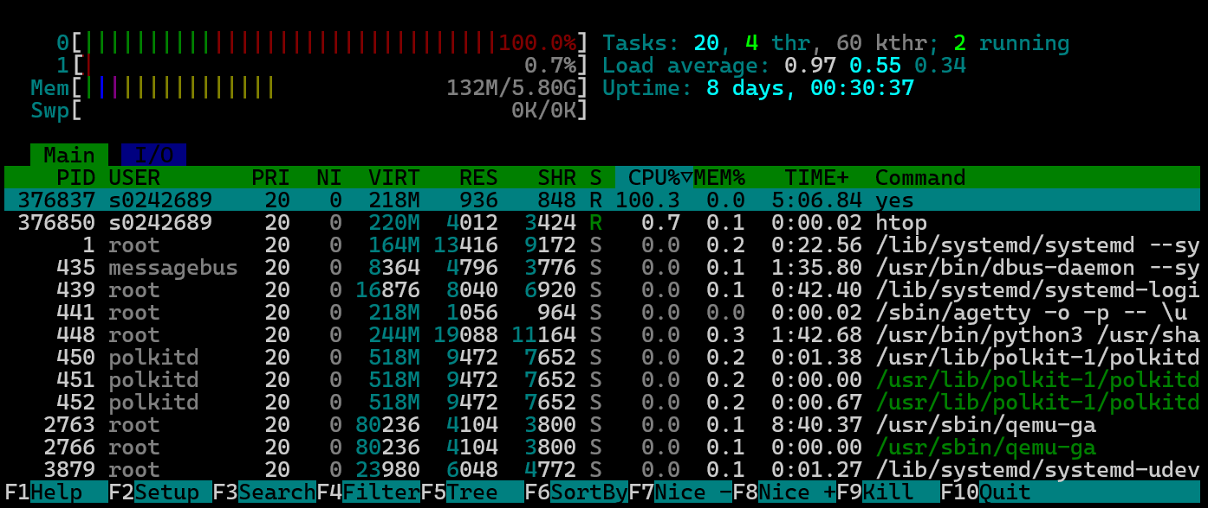Continuing this process is also noticeable in ‘htop’, this time core 0 is used for 100%.

After using ‘kill -SIGKILL 376837(=process ID)’ to kill the process and verifying with ‘jobs -l’, it says “killed” like shown in the image bellow.

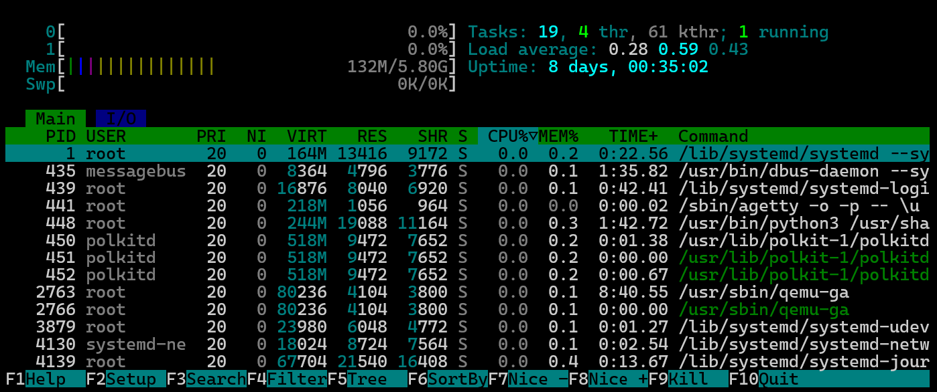When opening ‘htop’ it is also clear that the process has been killed since both core 0 and core 1 are not used by any heavy processes, and the process is also nowhere to be found in the list.