**Task 1: Entity relationship diagrams**

# 1. What is an **entity** in the context of databases?

Answer

In DBMS, an entity set is a collection of entities that are all of the same kind. An entity collection of vehicles, bank accounts, etc. are a few examples. Each row in a tabular representation of data is an entity in a database management system (DBMS), while the entire table is an entity set.

# 2. The relationship between two entities may be one of three types, or degrees.

# What are the three degrees of relationship between entities?

**Answer**

**One-to-One Connection.**

**Relationships that are one-to-many or many-to-one**

**Multiple Relationships.**

# 3. Draw entity relationship diagrams for each of the following pairs of related entities:

(a) Dentist and patients

Answer

PATIENTS

DENTIST

(b) Students and teachers

Answer

STUDENT

TEACHERS

(c) UK citizen and UK Passport

Answer

UK PASSPORT

UK CITIZEN

(d) Products and components

Answer

COMPONENT

CPRODUCT

4. A company makes a range of kitchen utensils which they sell online. They record details of their customers, products and orders received in a database. An order may be for several products.

Complete the E-R diagram to show all the relationships between all the entities.

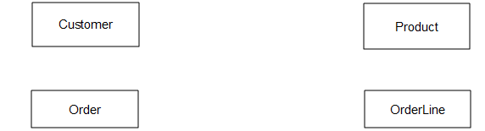

5. Complete the design of the order form shown below. Enter some data for a sample order for **three** different products.

|  |  |  |  |
| --- | --- | --- | --- |
| |  |  |  | | --- | --- | --- | | (Customer details) |  | KitchenTools Ltd  (address)  Order number:  Date: | |
|  |
| |  |  |  |  |  |  | | --- | --- | --- | --- | --- | --- | | Line | Qty | Product code | Description | Unit price  Total: | Total price | |

On your order form, what are the primary key fields of the entities Customer, Product, Order, OrderLine?

I PRODUCT CODE

II ORDEE NUMBER

**Task 2**

This is a practical exercise using MS Access. You are going to be working with the database **RevisionSubs_stage1.accdb**. This consists of three tables called **bblCustomer, tblProduct, tblSubscription.**

Step 1: Add some records to the database

1. Load Access and find the database called **RevisionSubs_stage1.accdb**.
2. Open the database. Double-click the table **tblCustomer** and it will appear in **Datasheet View**. In this view, you can enter, delete or amend data.
3. Add the following record to the table **tblCustomer**

C444 Mr Basil Brown [basil@brown.com](mailto:basil@brown.com)

4. Add the following two records to **tblSubscription**

S1400 21/03/2016 20/06/2017 C444 P47

S1401 21/03/2016 20/06/2017 C444 P36

**Step 2: Designate primary key attribute in each table**

C:\Users\Pat\AppData\Roaming\PixelMetrics\CaptureWiz\Temp\9.jpgThe **structure** of a table is defined when it is first created. These tables have been defined without primary keys, so the structure needs to be amended to define one or more fields in each table as a primary key.

C:\Users\Pat\AppData\Roaming\PixelMetrics\CaptureWiz\Temp\1.jpg5. Click **tblCustomer**. Click **View** at the left-hand end of the toolbar underneath the main menu, and select **Design View**.

6. Click the **custID** field name. Now click the **Primary key** icon in the toolbar.   
A key symbol appears next to the field name.

7. In **tblProduct**, make **productID** a key field.

8. In **tblSubscription**, make **subID** a key field.

9. Right-click the tabs for each table in turn, and choose **Close** each time. Answer **Yes** when asked if you wish to save the table.

**Step 3: Creating relationships between the tables**

C:\Users\Pat\AppData\Roaming\PixelMetrics\CaptureWiz\Temp\2.jpg We now need to create the one-to-many relationship between **tblCustomer** and **tblSubscription**, and the one-tp-many relationships between **tblSubscription** and **tblProduct**.

9. Click **Database Tools** in the main menu. Then double-click the **Relationships** icon in the toolbar.

10. A “Show table” window opens. Click each table in turn and click **Add**. Close the window and you will see the three tables displayed. Click and drag to put tblSubscription in the middle.

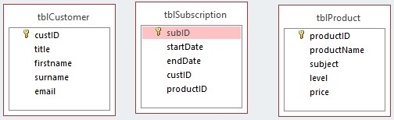

11. To create a relationship, you drag the primary key field from the “one” side to the corresponding field in the “many side of the related table. Drag **CustID** from **tblCustomer** table to **custID** in **tblSubscription**.

12 A window appears. Click the box next to **Enforce referential integrity**. This will ensure that you cannot create a record in **tblSubscription** for a customer who does not exist in **tblCustomer**. Now click **Create**.

If there is already data in tblSubscription which refers to a non-existent customer, you will see this message:

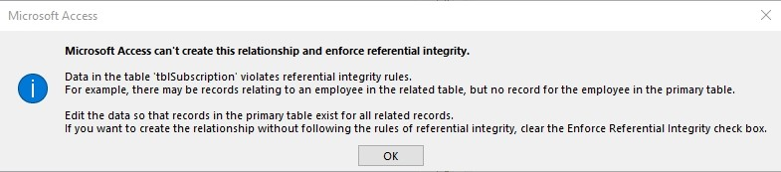

If you get this message, you need to take another look at the records in **tblCustomer** and **tblSubscription** and make sure you have all the necessary records on **tblCustomer**.

13. Create the relationship between **tblProduct** and **tblSubscription**. Remember to enforce referential integrity.

Now the relationships will be shown:

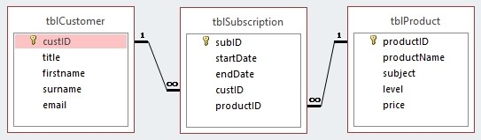

14. Save and close the database.