AI Personal Fitness Recommendation Platform
Pre-defense 1 report: analysis, design and planning
Arman Amankeldi · Abzal Bakhtiyarov · Bakhytzhan Abdilmazhit
Scientific supervisor: Dana Altynbek
Astana IT University
24 October 2026
Repository: https://github.com/St3rben11/prob-period-1 (tag pre-defense-1)
YouTrack: https://aipersonalfitness.youtrack.cloud (project APF)

Contents
- Project Proposal
- Confirmation of Relevance
- Literature Review
- Comparison of Existing Systems
- Technology Comparison
- Requirements Specification
- Architecture and Diagrams
- UX and Prototype
- Verification and Evaluation Plan
- Project Management and Risks
- Scientific Supervisor Feedback

1. Project Proposal
Item | Value
Project title | AI Personal Fitness Recommendation Platform
Project type | Diploma project, web application
Field | Artificial intelligence, recommender systems, personalised health and fitness
University | Astana IT University
Scientific supervisor | Dana Altynbek
Repository | https://github.com/St3rben11/prob-period-1
Task tracker | YouTrack project APF, https://aipersonalfitness.youtrack.cloud

1.1 Team
Member | Role | Area of responsibility
Arman Amankeldi | Frontend lead, project coordinator | User interface, user dashboard, deployment and system integration, requirements (APF-1, APF-11, APF-12, APF-16)
Abzal Bakhtiyarov | AI & evaluation lead | Calorie and macronutrient calculation, AI recommendation model, testing and evaluation (APF-6, APF-13, APF-14, APF-15)
Bakhytzhan Abdilmazhit | Backend lead | System architecture, database, backend REST API, authentication and authorization (APF-2, APF-3, APF-4, APF-8, APF-9, APF-10)

1.2 Problem statement
Physical inactivity is one of the leading risk factors for early death. WHO data cited by Chen & Wang [2] show that more than 25% of adults worldwide do not meet the minimum physical activity guidelines. Public health programmes and most consumer fitness apps give generic advice. They do not take into account a person’s age, sex, body size, activity level and goal [2, 3]. People who are just starting out run into two problems:
- They don’t know their numbers. Daily energy needs and macronutrient targets depend on several parameters, such as basal metabolic rate (BMR), activity multipliers and the goal-dependent energy deficit or surplus. Most beginners cannot calculate these correctly themselves.
- Personalisation is locked or fragmented. Popular apps either focus on food logging only, or on workouts only, or they put the personalised features behind a subscription (see 04-system-comparison.md).
Research prototypes show that machine-learning recommenders can personalise physical-activity advice [2, 4, 6, 7]. However, the reviews in [1, 3] report that most such systems are evaluated only in the laboratory, are not transparent, and rarely reach end users. There is a gap between accurate but opaque research models and simple but generic consumer tools.

1.3 Goal
To design and develop a web platform that turns a user’s personal and physical data into transparent, personalised recommendations for daily calories, macronutrients and workouts. The platform must have an architecture in which the current rule-based recommendation engine can later be replaced by a machine-learning model without changing the API.
Core pipeline:
User data → Validation → Data processing → Recommendation logic → Personalised recommendations

1.4 Objectives (tasks)
# | Objective | YouTrack
O1 | Review existing research on AI/ML-based fitness and health recommenders (≥ 12 sources) | —
O2 | Compare existing fitness applications on a common set of criteria | —
O3 | Confirm the problem with potential users (3–5 interviews) and derive requirements | APF-1
O4 | Design the system architecture and diagrams (context, use case, component, ER) | APF-2
O5 | Design and implement the database | APF-3
O6 | Implement the backend REST API with validation and error handling | APF-8
O7 | Implement authentication and authorization | APF-10
O8 | Implement the user profile module | APF-4
O9 | Implement calorie and macronutrient calculation | APF-6
O10 | Implement rule-based fitness and workout recommendation logic | APF-5, APF-7
O11 | Design and integrate an ML recommendation model (content-based / KNN) | APF-9, APF-13
O12 | Develop the frontend and user dashboard | APF-11, APF-12
O13 | Test the system (unit, integration, functional) | APF-14
O14 | Evaluate results against the baseline and acceptance criteria | APF-15
O15 | Deploy and integrate the final version | APF-16

1.5 Target users
- Primary: beginners in fitness, especially university students aged 18–30, who train on their own (home or gym) and want simple guidance without a personal trainer.
- Secondary: people with a specific body-composition goal (weight loss, muscle gain, maintenance) who want to know their calorie and macronutrient targets.
- Not targeted: people with medical conditions that need clinical supervision, professional athletes, and children under 14.

1.6 Expected results
- A working web application, available in a browser on desktop and mobile, in which a user can:
  - register and log in;
  - enter and update a fitness profile (age, sex, height, weight, activity level, goal, workout preference);
  - receive a daily calorie target, a macronutrient split and a structured workout plan;
  - view a history of previous recommendations on a dashboard.
- A documented REST API and database schema.
- An ML-based recommendation component compared against the rule-based baseline (see 09-verification-plan.md).
- Project documentation: literature review, comparisons, requirements, architecture, test report and evaluation.

1.7 Project scope
In scope (MVP + final version) | Out of scope
Three goals: weight loss, muscle gain, maintenance | Medical diagnosis or clinical nutrition therapy
Profile-based calorie calculation (Mifflin-St Jeor + activity multiplier) | Meal plans, recipes and food logging
Macronutrient split (protein / fat / carbohydrates) | Integration with wearables (Google Fit, Apple Health); planned as future work
Rule-based workout plans with sets/reps by goal and level | Video exercise instructions, computer-vision form checking
Registration, login (JWT), profile, history | Native mobile apps (the web UI is responsive instead)
ML recommendation component trained on a public dataset | Payment or subscription features
English-language web interface | LLM chatbot coach; discussed in the literature review as future work
Disclaimer. All recommendations are approximate and educational. They do not replace advice from a doctor, dietitian or certified trainer. The UI shows this disclaimer.

1.8 Engineering complexity
The project is more than a simple calculator for the following reasons:
- Multi-tier architecture: a browser client, a stateless REST API, an authentication layer and a relational database, with clear interfaces between them.
- Security: password hashing (scrypt), token-based sessions (JWT), input validation, and protection of personal health-related data.
- Recommendation engine designed for replacement: the rule-based engine and the planned ML model share one interface (generateRecommendation(profile)). This allows A/B comparison with the baseline.
- Evaluation: the work is checked against measurable criteria, including calculation accuracy against reference formulas, ML metrics (precision@k, accuracy), API performance and a usability score (SUS).
- Process: Git branching with YouTrack-linked commits and pull requests, automated tests, and tagged pre-defense versions.

1.9 Current status (pre-defense 1, 24 October 2026)
Component | Status
Analysis documents (this folder) | Done (v1)
Frontend MVP form + results | Done
Backend API: guest recommendation, register/login, profile, history | Done, 16 automated tests passing
Database schema (SQLite) | Done
Rule-based recommendation engine | Done (baseline)
User dashboard, login UI | Planned
ML recommendation model | Planned (design in 07-architecture.md)
Deployment | Planned

2. Confirmation of Relevance
This section records the evidence that the problem is real and that our requirements come from facts rather than from guesses. Confirmed findings (backed by data or sources) are kept separate from assumptions (still to be confirmed).

2.1 Evidence sources
# | Source of evidence | Type | Status
E1 | Interviews with 3–5 potential users (students who train on their own) | Primary | ⚠️ To be completed by the team, see 2.3 and 2.4
E2 | Published data on physical inactivity and on limitations of fitness recommenders | Secondary (literature) | ✅ Done, see 2.2
E3 | Hands-on analysis of 4 existing apps (MyFitnessPal, Fitbod, Freeletics, Nike Training Club) | Secondary (product analysis) | ✅ Done, see 04-system-comparison.md
E4 | Discussion of scope with the scientific supervisor (Dana Altynbek) | Expert | ⚠️ To be recorded in 11-supervisor-feedback.md

2.2 Evidence from data and literature
Finding | Evidence | Implication for the project
Physical inactivity is widespread | WHO data cited in [2]: more than 25% of adults do not meet minimum activity guidelines | There is a large potential user base that needs guidance
Generic programmes ignore individual differences | [2] reports that national programmes “lack the granularity required to address individual variability” | Recommendations must depend on the profile (age, sex, height, weight, activity, goal)
Personalised AI recommenders work in studies but are rarely transparent or deployed | [1] (34 studies) and [3] (24 studies): lab evaluation, no standard protocols, short-term only | Keep the logic explainable; show BMR/TDEE behind each number; evaluate against a clear baseline
New users have no history, which is the cold-start problem | [1, 6, 7, 8] all name cold start as a key difficulty | The MVP must work from the profile alone (rule-based / content-based), not from interaction history
Unsafe advice is a real risk | [12] shows large variability in the safety awareness of LLM coaches; [11] discusses hallucination | Add safety rules (calorie floor, protein limits, input ranges) and a disclaimer
Existing apps split features across apps or behind paywalls | Product analysis in doc 04 (e.g. gram-level macro goals are Premium in MyFitnessPal; Freeletics sells nutrition separately) | Combine calories, macros and workouts free of charge in one flow

2.3 Interview protocol (for E1)
Who: 3–5 people from the target group (age 18–30, train at least occasionally or want to start). Each team member interviews 1–2 people. Format: 10–15 minutes, in person or by call, in any language, with notes taken. Consent: explain the purpose, record no names (use R1, R2…), and collect no health data beyond what the respondent chooses to share.
Questions:
- How often do you exercise now? At home or in a gym?
- What is your main goal (lose weight, gain muscle, maintain, other)?
- How do you currently decide what to train and how much to eat? (apps, YouTube, friends, trainer, nothing)
- Which fitness or nutrition apps have you tried? What did you like or dislike? Did you pay?
- Do you know your daily calorie needs? How did you find out?
- Would you trust a recommendation more if the app showed how it was calculated?
- Which data would you be comfortable entering (age, weight, height, sex, activity level, health conditions)?
- Would you create an account to keep a history, or would you prefer to use it without registration?
- What would make you stop using such an app?
- On a scale of 1–5, how useful would a free tool that gives calories, macros and a workout plan in one place be for you?

2.4 Interview results (to be filled in)
⚠️ Fill this table with the real answers before submission. Do not invent responses. The committee checks whether requirements are based on actual data.
ID | Profile (age, activity, goal) | Current approach | Main pain points | Apps tried / paid? | Wants transparency? (Q6) | Account vs guest (Q8) | Usefulness 1–5 (Q10) | Interviewer, date
R1
R2
R3
R4
R5
Summary of interviews (write 3–5 bullet points after filling the table):
- …

2.5 Confirmed findings vs assumptions
ID | Statement | Status | Based on | Requirements affected
F1 | Many adults are insufficiently active and need guidance | Confirmed | E2 [2] | Overall goal
F2 | Recommendations must depend on individual characteristics | Confirmed | E2 [2, 3], E3 | FR-03, FR-06 to FR-09
F3 | Users have no activity history at first (cold start) | Confirmed | E2 [1, 6, 7] | FR-06, FR-09 (profile-only logic)
F4 | Existing apps split nutrition and workout features, or put them behind a paywall | Confirmed | E3 | FR-06 to FR-09 in one free flow
F5 | Safety constraints are necessary | Confirmed | E2 [11, 12] | FR-05, NFR-08
A1 | Beginners do not know their calorie needs | Assumption, check with Q5 | E1 | FR-06
A2 | Users trust recommendations more when the calculation is shown | Assumption, check with Q6 | E1 | FR-07, UI
A3 | Users are willing to register to keep a history | Assumption, check with Q8 | E1 | FR-01, FR-02, FR-10
A4 | A free combined tool would be rated ≥ 4/5 by the target group | Assumption, check with Q10 | E1 | Overall value
A5 | Users are comfortable sharing age, sex, height and weight | Assumption, check with Q7 | E1 | FR-03, NFR-05
After the interviews, move each assumption to Confirmed or Rejected and update 06-requirements.md where needed.

3. Literature Review

3.1 Method
Research questions
- RQ1. Which AI/ML approaches are used to personalise physical-activity, exercise and nutrition recommendations?
- RQ2. What data do they need, and how are they evaluated?
- RQ3. What limitations are reported, and which of them must our platform take into account?
Search. We searched Google Scholar, ScienceDirect, PubMed, IEEE Xplore, MDPI and arXiv with combinations of “fitness recommendation”, “exercise recommender system”, “physical activity” AND “machine learning”, “personalized nutrition” AND “artificial intelligence”, “collaborative filtering” AND diet, “health chatbot” and “LLM” AND “fitness coaching”.
Inclusion criteria: peer-reviewed articles or preprints from 2021–2026 that propose or review a personalised recommendation method for physical activity, exercise, nutrition or health behaviour. Exclusion criteria: papers about clinical treatment only, papers without a described method, and non-English papers without an English abstract.
Result: 12 scientific publications were selected and analysed in depth: 5 reviews/surveys, 6 original method papers and 1 benchmark. All 12 were published in the last five years (2021–2026). Three foundational, older sources [13–15] were added because the calculation logic of the platform directly depends on them. In total, 15 sources are used, of which 15 are scientific.

3.2 Thematic review

A. Overviews: AI for physical activity and healthy habits
Lopez-Barreiro et al. (2024) [1] conducted a PRISMA systematic review of 34 studies on AI-powered recommender systems for healthy habits and active ageing. Collaborative filtering (CF), content-based and hybrid recommenders are the main families. CF captures preferences well, but it suffers from data sparsity and the cold-start problem. Hybrid methods, user profiling and data imputation are the usual remedies. The authors’ key critical finding is that, “although there are many proposals, they often lack a systematic process and mechanisms to encourage adherence”. Systems also tend to perform well in closed environments but fail to engage users in real life. They call for traceable, verifiable recommendation systems.
An et al. (2024) [3] reviewed 24 studies that apply ML, deep learning (DL) and reinforcement learning (RL) to physical-activity interventions. In most studies AI models predicted better than traditional statistics. However, comparisons between AI models gave mixed results, because performance depends strongly on the dataset and the task. The authors note a shift from classic ML towards DL and RL. They list six future directions: personalised interventions, real-time adaptation, multimodal data, evaluation of effectiveness, wider access, and injury prevention. Limitations they report include short-term effects only, no standardised protocols and unreliable cross-study comparisons.
Critical note. Both reviews agree that personalisation is promising. They also agree that the evidence is weak because it comes from laboratory settings and non-standard evaluation. For our project this means two things. First, a clear, reproducible evaluation protocol with a baseline matters more than choosing the “most advanced” model. Second, a simple, transparent model is a defensible starting point.

B. ML on profile data for personalised fitness prescription
Chen & Wang (2025) [2] built a framework on the US NHANES survey, enriched with behavioural variables from BRFSS. They used XGBoost, Decision Trees and an ANN both to estimate weekly activity minutes (regression) and to assign risk groups (classification). XGBoost performed best (MeanIoU 0.789, F1 > 0.79 for every risk class), with fairness gaps below 0.05 across age, gender and ethnicity. The paper is close to our use case because it starts from demographic and biometric profile data, as our platform does. Its limitations are a cross-sectional dataset (no change over time), self-reported activity (recall bias) and under-represented minorities.
Lee & Jeong (2021) [6] propose a home-training exercise recommender. First, a k-nearest-neighbour classifier groups users by obesity level from eating habits and physical condition (Kaggle obesity dataset, 2,111 records, 17 attributes; ≈ 84% accuracy with k = 3). Then SVD, a model-based collaborative-filtering method, recommends exercises within each group, using a calories-burned-per-activity dataset. Dimensionality reduction addresses the sparsity and scalability problems of memory-based CF. The work is small-scale and uses public, non-local datasets. Even so, its two-step design (classify the user profile → recommend within the segment) can be reproduced with student-level resources. We adopt it as the reference design for our ML component (APF-13).

C. Deep and sequential recommenders for exercise
Chatterjee et al. (2023) [4] combine deep learning with a semantic ontology (OntoeCoach) for activity eCoaching. Time-series forecasting (CNN1D, LSTM, GRU, autoregression) predicts activity; classifiers (MLP, Rocket/MiniRocket) assign activity levels; and SPARQL queries over the ontology turn the results into readable recommendations. CNN1D reached 97% forecasting accuracy and MLP 74% classification accuracy on PMData and a private dataset. The strength of this work is its interpretability: rules in the ontology explain why something is recommended. The weaknesses are that it needs continuous wearable data and has high system complexity.
Mahyari, Pirolli & LeBlanc (2022) [7] develop a deep recurrent neural network with user-profile and temporal attention to recommend daily exercises (mHealth study with 72 adults and 44 exercises; also tested on MovieLens). They point out a key difference from movie or music recommenders: exercise apps do not get click feedback. They therefore propose a real-time expert-in-the-loop active learner, which asks a human expert when the model’s certainty is low. Accuracy improved after the expert feedback was added. This supports our decision to keep a rule-based, expert-defined baseline and to treat ML as an add-on.
Zhen & Wang (2024) [8] recommend physical-education courses from IoT data (smart bracelets, environment sensors, social interaction) and academic data. They use an improved conditional GAN (RP-CFGAN) to fight sparsity and cold start. Top-N metrics (P@N, R@N, NDCG@N) beat classic models on a MOOCCube-based dataset. The approach is powerful, but it depends on IoT infrastructure and large interaction logs that our MVP does not have. Its open issues include privacy, regularisation and cross-platform use.

D. Nutrition personalisation
Silva et al. (2022) [5] compared user-based (UBCF) and item-based (IBCF) collaborative filtering for dietary advice using food-frequency questionnaires from 12,667 participants of the ELSA-Brasil cohort. Precision was similar (88–91%), and UBCF had lower error (RMSE 1.49 vs 1.67). This shows that simple CF can give useful diet suggestions. However, the questionnaire does not capture preferences, allergies or restrictions, and the data date from 2008–2010.
Agrawal et al. (2025) [10] review AI in personalised nutrition and food manufacturing: real-time dietary recommendations, meal planning from biomarkers, deep learning, federated learning and computer vision for food recognition. They stress open challenges in algorithmic transparency, data privacy and equitable access. For our project, the review confirms that our scope (calorie and macro targets) is the foundation that richer nutrition AI builds on. It also confirms that privacy must be designed in from the start.

E. Conversational AI, LLMs and safety
Aggarwal et al. (2023) [9] systematically reviewed 15 studies of AI chatbots for health behaviour change. Chatbots were effective for healthy lifestyle (40% of studies), smoking cessation and adherence. The most effective strategies were goal setting, monitoring, real-time feedback and on-demand support. The evidence quality was moderate to low, with a high risk of bias and poor descriptions of the AI techniques.
Abo El-Enen, Saad & Nazmy (2025) [11] survey retrieval-augmented generation (RAG) for healthcare (Naive, Advanced and Modular RAG). RAG reduces two problems of large language models (LLMs), hallucination and static knowledge, by grounding answers in trusted sources. It still depends on retrieval quality and needs transparency about its sources.
Li et al. (2026) [12] (MoveBench) evaluated 15 LLMs on 809 sports-and-health coaching questions with 5,012 rubric criteria, including a safety redline mechanism. Overall scores ranged from 0.875 to 0.943. Open-ended coaching scores varied more widely (0.812–0.917), especially in safety awareness, structured programme design and personalisation. The authors call this a gap “between knowing and doing”. They explicitly state that the benchmark is not a certification of safe coaching.
Critical note. LLM coaches are the most visible trend. However, [11] and [12] show that they still need grounding and safety checks, and [9] shows that the evidence for chatbots is weak. We therefore do not use an LLM to generate the numbers. Calories, macros and workout structure come from deterministic, testable logic. An LLM explanation layer grounded with RAG over our own rules is listed as future work.

F. Foundational sources used directly in the calculation logic
- Mifflin et al. (1990) [13]: the Mifflin-St Jeor equation for resting energy expenditure, 10·kg + 6.25·cm − 5·age + 5 (men) / −161 (women). This is the equation implemented in backend/src/calculations.js.
- Bull et al. (2020) [14]: WHO 2020 guidelines (150–300 min of moderate or 75–150 min of vigorous activity per week, plus muscle-strengthening activity on 2 or more days). These justify the session counts in the workout plans.
- Jäger et al. (2017) [15]: ISSN position stand, protein intake of 1.4–2.0 g/kg/day for exercising individuals. All our protein targets stay within this range.

3.3 Analytical table of publications
# | Reference | Type | Data | Method / model | Key result | Reported limitations | Use in our project
1 | Lopez-Barreiro et al., 2024, Appl. Sci. | Systematic review (PRISMA) | 34 studies | CF, content-based, hybrid, ML/DL recommenders | AI recommenders promising; cold start and sparsity are common | Lab-only evaluation; no adherence mechanisms; no comparable tests | Motivates a transparent, verifiable baseline and adherence features (history, dashboard)
2 | Chen & Wang, 2025, Sci. Rep. | Original | NHANES + BRFSS | XGBoost, DT, ANN | XGBoost MeanIoU 0.789, F1 > 0.79, fairness gap < 0.05 | Cross-sectional; self-reported activity; minorities under-represented | Profile features (age, sex, BMI, activity) as model inputs; fairness check by sex/age in evaluation
3 | An et al., 2024, J. Sport Health Sci. | Scoping review | 24 studies | ML, DL, RL in PA interventions | AI beats statistics; model ranking depends on data | Short-term; no standard protocols; unreliable comparisons | Need for a fixed evaluation protocol and baseline (doc 09)
4 | Chatterjee et al., 2023, Sci. Rep. | Original | PMData, MOX2-5 | CNN1D/LSTM/GRU forecasting + MLP + OWL ontology + SPARQL | CNN1D 97% forecast acc.; MLP 74% classification | Needs wearable time series; complex | Explainable, rule-based layer; show reasoning (BMR/TDEE) to the user
5 | Silva et al., 2022, IJERPH | Original (cross-sectional) | ELSA-Brasil, n = 12,667 | User-based vs item-based CF | Precision 88–91%; UBCF RMSE 1.49 | FFQ ignores preferences and allergies; old data | CF needs many users, so not suitable for the MVP; possible later for nutrition
6 | Lee & Jeong, 2021, J. Korea Soc. Comput. Inf. | Original | Kaggle obesity (2,111 records) + calories-burned dataset | KNN classification + SVD (model-based CF) | KNN ≈ 84% accuracy; SVD reduces sparsity | Small public datasets; no user study | Reference design for the ML component: KNN profile segmentation, then recommendation
7 | Mahyari et al., 2022, IEEE J. Biomed. Health Inform. | Original | mHealth study (72 adults, 44 exercises), MovieLens | Attention RNN + expert-in-the-loop active learning | Accuracy improved with expert feedback | No implicit feedback in exercise apps; needs an expert | Keep an expert-defined rule baseline; collect explicit feedback later
8 | Zhen & Wang, 2024, Heliyon | Original | MOOCCube-based, IoT data | RP-CFGAN (conditional GAN) | Better P@N, R@N, NDCG@N than baselines | Privacy; needs IoT; regularisation | Use top-N metrics (precision@k) in evaluation; wearables out of scope
9 | Aggarwal et al., 2023, J. Med. Internet Res. | Systematic review | 15 studies | AI chatbots for behaviour change | Effective for healthy lifestyle in 40% of studies | Low evidence quality; AI techniques poorly described | Goal setting and feedback as UX principles; chatbot only as future work
10 | Agrawal et al., 2025, Front. Nutr. | Review | — | DL, federated learning, CV for nutrition | AI moves nutrition from population-level to individual | Transparency, privacy, equity challenges | Privacy-by-design (NFR-05); nutrition limited to calorie and macro targets
11 | Abo El-Enen et al., 2025, Neural Comput. Appl. | Survey | — | Naive / Advanced / Modular RAG with LLMs | RAG reduces hallucination by grounding answers | Retrieval errors; interpretability of sources | Future LLM explanation layer must be grounded (RAG) over our rules
12 | Li et al., 2026, arXiv (MoveBench) | Benchmark | 809 questions, 5,012 rubric criteria | Rubric-based multi-judge LLM evaluation with a safety redline | 15 LLMs score 0.875–0.943; weak on safety and personalisation | Judge disagreement; not a safety certification | Numbers not produced by an LLM; safety rules (NFR-08)
13 | Mifflin et al., 1990, Am. J. Clin. Nutr. | Foundational | Healthy adults | Regression equation for REE | Mifflin-St Jeor equation | Population-level estimate | Implemented BMR formula
14 | Bull et al., 2020, Br. J. Sports Med. | Guideline | WHO evidence review | — | 150–300 min moderate activity per week + strength on 2+ days | General population guidance | Session frequency in workout plans
15 | Jäger et al., 2017, J. Int. Soc. Sports Nutr. | Position stand | Evidence review | — | Protein 1.4–2.0 g/kg/day for exercising people | General recommendation | Protein targets and test TC-U07

3.4 Synthesis: what is known and what gaps remain
- Approaches (RQ1). There are three families: (a) collaborative filtering (user/item CF [5], SVD [6]), which needs interaction data from many users; (b) profile- or content-based ML (KNN [6], XGBoost [2]), which works from the user’s own attributes; and (c) deep sequential models (RNN/attention [7], CNN/LSTM [4], GAN [8]), which need time-series or IoT data. LLM-based coaching [9, 11, 12] is emerging but is not yet safe enough to produce numbers unsupervised.
- Data and evaluation (RQ2). Studies use very different data (surveys, wearables, course logs) and metrics (accuracy, RMSE, MeanIoU, P@N, NDCG, rubric scores). This makes cross-study comparison unreliable [3].
- Limitations (RQ3) and how we account for them:
Limitation found in the literature | How our project takes it into account
Cold start: new users have no history [1, 6, 7, 8] | Recommendations are computed from the profile alone; ML component is profile-based (KNN), not CF
Opaque models, low trust [1, 4, 10] | Deterministic rules with shown intermediate values (BMR, TDEE); rules referenced to [13–15]
Laboratory-only, non-standard evaluation [1, 3] | Fixed evaluation plan with a rule-based baseline, defined metrics and test data (doc 09)
Safety of automated advice [11, 12] | Calorie floor, protein range, input-range validation, medical disclaimer
Privacy of health data [8, 10] | Hashed passwords, JWT, minimal data collection, no secrets in the repository
Fairness across demographic groups [2] | Evaluation reports results separately by sex and age group
Lack of adherence support [1, 9] | Goal setting, recommendation history and dashboard (feedback loop)
Gap addressed by this project. Research systems are accurate but heavy (they need wearables, large logs or IoT) and opaque. Consumer apps are easy to use but generic or behind paywalls. Our contribution is a transparent, profile-based recommender that works from the first use (no cold start), in which an ML component can be measured against an explicit rule-based baseline.

3.5 References
[1] J. Lopez-Barreiro, J. L. Garcia-Soidan, L. Alvarez-Sabucedo, J. M. Santos-Gago, “Artificial Intelligence-Powered Recommender Systems for Promoting Healthy Habits and Active Aging: A Systematic Review,” Applied Sciences, vol. 14, 10220, 2024. doi:10.3390/app142210220
[2] J. Chen, Y. Wang, “Personalized fitness recommendations using machine learning for optimized national health strategy,” Scientific Reports, vol. 15, 41652, 2025. doi:10.1038/s41598-025-25566-4
[3] R. An, J. Shen, J. Wang, Y. Yang, “A scoping review of methodologies for applying artificial intelligence to physical activity interventions,” Journal of Sport and Health Science, vol. 13, pp. 428–441, 2024.
[4] A. Chatterjee, A. Prinz, M. A. Riegler, Y. K. Meena, “An automatic and personalized recommendation modelling in activity eCoaching with deep learning and ontology,” Scientific Reports, vol. 13, 10182, 2023. doi:10.1038/s41598-023-37233-7
[5] V. C. Silva, B. Gorgulho, D. M. Marchioni, et al., “Recommender System Based on Collaborative Filtering for Personalized Dietary Advice: A Cross-Sectional Analysis of the ELSA-Brasil Study,” Int. J. Environ. Res. Public Health, vol. 19, 14934, 2022. doi:10.3390/ijerph192214934
[6] H.-Y. Lee, O.-R. Jeong, “A personalized exercise recommendation system using dimension reduction algorithms,” Journal of The Korea Society of Computer and Information, vol. 26, no. 6, pp. 19–28, 2021. doi:10.9708/jksci.2021.26.06.019
[7] A. Mahyari, P. Pirolli, J. A. LeBlanc, “Real-Time Learning from an Expert in Deep Recommendation Systems with Application to mHealth for Physical Exercises,” IEEE Journal of Biomedical and Health Informatics, 2022.
[8] A. Zhen, X. Wang, “The deep learning-based physical education course recommendation system under the internet of things,” Heliyon, vol. 10, e38907, 2024.
[9] A. Aggarwal, C. C. Tam, D. Wu, X. Li, S. Qiao, “Artificial Intelligence–Based Chatbots for Promoting Health Behavioral Changes: Systematic Review,” J. Med. Internet Res., vol. 25, e40789, 2023. doi:10.2196/40789
[10] K. Agrawal, P. Goktas, N. Kumar, M.-F. Leung, “Artificial intelligence in personalized nutrition and food manufacturing: a comprehensive review of methods, applications, and future directions,” Frontiers in Nutrition, vol. 12, 1636980, 2025. doi:10.3389/fnut.2025.1636980
[11] M. Abo El-Enen, S. Saad, T. Nazmy, “A survey on retrieval-augmentation generation (RAG) models for healthcare applications,” Neural Computing and Applications, vol. 37, pp. 28191–28267, 2025. doi:10.1007/s00521-025-11666-9
[12] Y. Li, J. Bian, J. Wang, P. Ding, C. Gu, “MoveBench: A Rubric-Based Benchmark for Evaluating Large Language Models in Sports and Health Coaching,” arXiv:2610.26185, 2026.
[13] M. D. Mifflin, S. T. St Jeor, L. A. Hill, B. J. Scott, S. A. Daugherty, Y. O. Koh, “A new predictive equation for resting energy expenditure in healthy individuals,” American Journal of Clinical Nutrition, vol. 51, no. 2, pp. 241–247, 1990.
[14] F. C. Bull, S. S. Al-Ansari, S. Biddle, et al., “World Health Organization 2020 guidelines on physical activity and sedentary behaviour,” British Journal of Sports Medicine, vol. 54, pp. 1451–1462, 2020.
[15] R. Jäger, C. M. Kerksick, B. I. Campbell, et al., “International Society of Sports Nutrition Position Stand: protein and exercise,” Journal of the International Society of Sports Nutrition, vol. 14, 20, 2017.

4. Comparison of Existing Systems

4.1 Selection of systems
We selected four widely used consumer applications. Together they cover the two halves of our problem, nutrition targets and workout recommendations:
System | Why it was selected
MyFitnessPal (MFP) | The best-known calorie and macronutrient tracker; computes a calorie goal from the profile
Fitbod | Algorithmic strength-workout generator; publicly documents its personalisation logic
Freeletics | “AI Coach” that builds bodyweight and gym training plans; sells nutrition coaching separately
Nike Training Club (NTC) | Large free workout library with programmes; a free benchmark without a paywall
Research prototypes from the literature review ([4], [6], [7]) are not included in this table, because they are not available to end users. They are compared at the method level in 03-literature-review.md.
Method. The information comes from official app-store listings, the vendors’ own help and blog pages, and one independent review, all accessed on 24 October 2026 (sources S1–S5 below). “Not stated” means that no public source confirmed the feature. Hands-on verification of each app by the team is planned before pre-defense 2.

4.2 Comparison criteria
ID | Criterion | Why it matters for our users
C1 | Calorie target from personal profile | Beginners don’t know their energy needs (A1)
C2 | Gram-level macronutrient targets | Needed to act on the goal (weight loss / muscle gain)
C3 | Personalised workout recommendations | The second half of the problem
C4 | Nutrition and training in one product | Fragmentation is a pain point (F4)
C5 | Works for a new user without history (cold start) | Literature [1, 6, 7]; first-use experience
C6 | Transparency of how recommendations are produced | Trust (A2); opaque models are a known limitation [1, 4]
C7 | Cost of the personalised features | Students’ budget
C8 | Platform / access | Our target group uses laptops and phones

4.3 Comparison table
Criterion | MyFitnessPal | Fitbod | Freeletics | Nike Training Club | Our platform (target)
C1 Calorie target from profile | ✅ From weight, goal weight, activity level and weekly goal [S1] | ❌ Not stated (training-focused) [S2] | ⚠️ Only in separate Nutrition app / bundle [S3] | ❌ Not stated [S4] | ✅ Mifflin-St Jeor × activity, adjusted to goal
C2 Gram-level macro targets | ⚠️ Premium only; free plan has total calories [S1] | ❌ | ⚠️ Paid bundle [S3] | ❌ | ✅ Protein / fat / carbs in grams, free
C3 Personalised workouts | ❌ Exercise logging only [S1] | ✅ Scores 800+ exercises by muscle recovery, goal, experience, equipment, history [S2] | ✅ AI Coach from goal, level, preferences, equipment, time, feedback [S3] | ⚠️ Programmes chosen by level; no adaptive personalisation described [S4] | ✅ Rule-based by goal + activity level (ML planned)
C4 Nutrition + training in one product | ❌ | ❌ | ❌ Two apps / bundle [S3] | ❌ | ✅
C5 Works without history | ✅ | ✅ Onboarding questions; new exercises seeded from similar users [S2] | ✅ Onboarding questions [S3] | ✅ (static content) | ✅ Profile-only
C6 Transparency | ⚠️ Goal shown, formula not explained in the app | ✅ Algorithm described publicly (recovery %, estimated 1RM) [S2] | ❌ “AI Coach” not explained | n/a (no algorithm) | ✅ BMR, TDEE and rules shown and documented
C7 Cost | Free basic; Premium $19.99/mo or $79.99/yr [S1] | Subscription, e.g. $12.99–15.99/mo or $79.99–95.99/yr; free trial [S5] | Limited free tier (34 HIIT workouts); paid plans $34.99–89.99 per 3–12 months [S3] | Free [S4] | Free (academic project)
C8 Platform | Mobile + web | Mobile (iOS/Android) | Mobile (iOS/Android) | Mobile (iOS/Android) | Responsive web (desktop and mobile browser)
✅ supported ⚠️ partly / paid ❌ not supported or not stated

4.4 Analysis
- No single free product covers C1 to C4 together. MFP is strong for calories but gives no workouts, and its gram-level macro goals are paid. Fitbod and Freeletics personalise training well, but nutrition is either absent or sold separately. NTC is free but static.
- The strongest personalisation (Fitbod, Freeletics) is behind a subscription. That is a barrier for students.
- Transparency varies. Fitbod is the positive example: it publicly explains its scoring (muscle recovery, estimated one-rep max). We follow that approach and show intermediate values such as BMR and TDEE.
- Lessons we adopt: onboarding questions solve cold start (all four apps do this); recovery and history-aware adaptation (Fitbod) is a good future extension once our users have logged history.

4.5 Why the proposed solution is needed
The comparison supports confirmed finding F4 in 02-relevance.md. Our target users need a single, free, transparent tool that turns a basic profile into calorie, macronutrient and workout guidance from the first use. Our platform does not try to beat Fitbod’s workout engine or MFP’s food database. Its value is the combination and the explainability, together with an architecture prepared for an ML model that can be measured against the rule-based baseline.
Limitations of this comparison. It is based on public descriptions, and features and prices change often. Features hidden inside the apps may be missing. The team will verify the table hands-on (task added to YouTrack) and update it for pre-defense 2.

4.6 Sources
- [S1] RepReturn, “MyFitnessPal Review: Free vs. Premium — Is It Worth It?”, https://repreturn.com/myfitnesspal-review/ (accessed 24.10.2026)
- [S2] Fitbod, “How the Fitbod algorithm works”, https://fitbod.me/blog/fitbod-algorithm (accessed 24.10.2026)
- [S3] Freeletics: Workouts & Fitness, Apple App Store listing, https://apps.apple.com/app/id654810212 (accessed 24.10.2026)
- [S4] Nike Training Club, Apple App Store listing, https://apps.apple.com/us/app/-/id301521403 (accessed 24.10.2026)
- [S5] Fitbod: Gym & Fitness Planner, Apple App Store listing, https://apps.apple.com/app/id1041517543 (accessed 24.10.2026)

5. Technology Comparison
Each key technical decision is compared with 2–3 alternatives. Every choice is justified by the requirements (IDs from 06-requirements.md) and by the team’s constraints: 3 students, about 7 months, no budget, and existing skills in JavaScript.
Scores range from 1 (poor) to 5 (excellent). Weights reflect the importance of each criterion for this project.

D1. Backend platform
Criterion (weight) | Node.js + Express | Python + FastAPI | Java + Spring Boot
Team experience (0.30) | 5: whole team knows JS; the MVP was already started in Express | 3: known by one member | 2: little experience
Same language as frontend (0.15) | 5: shared JS, shared validation ideas | 2 | 2
ML ecosystem (0.20) | 2: limited (TF.js, ml.js) | 5: scikit-learn, pandas | 3
Speed of development for a small REST API (0.20) | 5 | 5 | 3: more boilerplate
Performance for our load, NFR-01 (0.15) | 4: non-blocking I/O, more than enough for <100 concurrent users | 4 | 5
Weighted score | 4.25 | 3.80 | 2.85
Decision: Node.js 22 + Express 4. It best fits the team and the already-written code (FR-01 to FR-12, NFR-09). The weak ML ecosystem is mitigated by D6: the ML model is trained in Python offline, and only the trained model or rules are served.

D2. Data storage
Criterion (weight) | SQLite (via built-in node:sqlite) | PostgreSQL | MongoDB
Fit to data model (0.30): users → recommendations → workout items, fixed fields | 5: relational, foreign keys, CHECK constraints | 5: relational | 3: documents fit, but referential integrity is manual
Setup and deployment effort (0.25) | 5: single file, no server, nothing to install | 3: separate server or managed service | 3: separate server or Atlas
Data integrity / validation in the DB, NFR-06 and NFR-08 (0.20) | 4: CHECK, FK, transactions | 5 | 2
Scalability (0.10) | 2: single writer | 5 | 5
Testability, NFR-07 (0.15) | 5: in-memory DB per test | 3: needs a test container | 3
Weighted score | 4.50 | 4.20 | 3.00
Decision: SQLite for the MVP and diploma demo, with SQL kept portable to PostgreSQL. Our data is small, strongly structured and relational. The built-in node:sqlite module needs no native compilation. Tests run against an in-memory database (16 automated tests). If the platform is deployed for many users, migration to PostgreSQL only means changing db.js, because the schema uses standard SQL types. MongoDB was rejected because the data has fixed relations and we want constraints (age 14–100, enumerated goals) enforced by the database.

D3. Interaction between components
Criterion (weight) | REST + JSON over HTTP | GraphQL | gRPC
Simplicity for browser client (0.35) | 5: native fetch | 3: needs a client library and a schema | 1: browser needs gRPC-Web proxy
Fit to our resources (0.25): few, simple resources | 5 | 3: flexible querying is not needed | 3
Tooling and testability (0.20) | 5: curl, Postman, supertest | 4 | 3
Performance (0.10) | 4 | 4 | 5
Team experience (0.10) | 5 | 2 | 1
Weighted score | 4.90 | 3.20 | 2.30
Decision: REST + JSON. The API has a small number of resources (auth, profile, recommendations), and a browser is the only client. REST is the simplest option to implement, test and document (see API examples in 08-ux-prototype.md).

D4. Authentication
Criterion (weight) | JWT access token (stateless) | Server-side session + cookie | External provider (Firebase Auth / OAuth)
Security when implemented correctly, NFR-04 (0.30) | 4: signed, short expiry (2 h) | 5: easy revocation | 5
Fit with stateless REST API (0.25) | 5 | 3: needs a session store | 4
Independence from third parties / data privacy, NFR-05 (0.20) | 5 | 5 | 2: user data held by a third party
Implementation effort (0.15) | 4 | 4 | 3: SDK setup, accounts
Learning value for the diploma (0.10) | 5 | 4 | 2
Weighted score | 4.55 | 4.25 | 3.55
Decision: JWT (HS256, 2-hour expiry) + scrypt password hashing with Node’s built-in crypto. The main drawback of JWT is that a token cannot be revoked before it expires. This is mitigated by the short expiry; refresh tokens or a deny-list will be considered for the final version.

D5. Frontend
Criterion (weight) | Vanilla HTML/CSS/JS | React | Vue
Complexity of our UI (0.30): form, results, dashboard | 4: enough for 3–4 views | 5 | 5
Setup and build tooling (0.20) | 5: no build step; served by Express | 3: bundler | 3
Team experience (0.25) | 5 | 3 | 2
Maintainability as UI grows (0.25) | 2 | 5 | 4
Weighted score | 3.95 | 4.10 | 3.60
Decision: keep vanilla HTML/CSS/JS for pre-defense 1 and re-evaluate before building the dashboard (APF-12). The scores are close. React wins only on maintainability, which becomes important when the dashboard and the login pages are added. The decision will be reviewed with the supervisor (logged in doc 11).

D6. Recommendation / AI component
Criterion (weight) | Rule-based engine in Node + offline-trained KNN (Python, scikit-learn) exported to the backend | TensorFlow.js model trained and served in Node | External LLM API generating recommendations
Works without user history, cold start (0.25) | 5 | 3: needs training data | 5
Transparency and testability (0.25) | 5: deterministic, unit-tested | 3 | 1: non-deterministic, hard to test
Safety, NFR-08 (0.20) | 5: hard rules | 4 | 2: hallucination risk [11, 12]
Cost and privacy (0.15) | 5: free, local | 5 | 2: paid per call; user data sent to a third party
ML quality potential (0.15) | 3 | 4 | 4
Weighted score | 4.70 | 3.65 | 2.80
Decision: keep the rule-based engine as the baseline (implemented in calculations.js). For APF-13, train a KNN profile classifier in Python (following the design of Lee & Jeong [6]) on a public dataset and serve it behind the same generateRecommendation(profile) interface. An LLM is only considered as a future explanation layer, grounded with RAG [11].

5.7 Summary of the selected stack
Layer | Technology | Version
Frontend | HTML5, CSS3, vanilla JavaScript (fetch API) | —
Backend | Node.js, Express | Node ≥ 22.13, Express 4.21
Auth | jsonwebtoken (JWT), Node crypto.scrypt | jsonwebtoken 9
Database | SQLite via node:sqlite | SQLite 3.50
Testing | node:test, supertest | supertest 7
ML (planned) | Python 3, scikit-learn, pandas (offline training) | —
Diagrams | Mermaid (sources in docs/architecture/source) | —
Process | Git + GitHub (branches, PRs, tags), YouTrack | —

6. Requirements Specification
Priorities (MoSCoW): M = Must (needed for the diploma result), S = Should, C = Could, W = Won’t (in this release). Source refers to the evidence in 02-relevance.md (F = confirmed finding, A = assumption) and in the literature review [n]. Status as of pre-defense 1: ✅ implemented and tested, 🟡 partly implemented, ⬜ not started.
Each requirement has an acceptance criterion that can be checked. The related test cases are listed in 09-verification-plan.md.

6.1 Functional requirements
ID | Requirement | Priority | Source | Acceptance criterion | UC | Status
FR-01 | The user can register with email, password and name | M | A3 | POST /api/auth/register with a valid email and a password of ≥ 8 characters returns 201 and a token; a duplicate email returns 409; invalid data returns 400 | UC-01 | ✅ backend, ⬜ UI
FR-02 | The user can log in and log out | M | A3 | Correct credentials return 200 + JWT; a wrong password returns 401; after logout the token is removed from the client and protected pages are not shown | UC-02 | ✅ backend, ⬜ UI
FR-03 | The user can enter and update a fitness profile: name, age, sex, height, weight, activity level, goal, workout preference (home/gym) | M | F2, A5 | PUT /api/profile stores all fields; GET /api/profile returns the same values | UC-03 | ✅ backend, 🟡 UI (guest form)
FR-04 | The user selects one of 3 goals (weight loss, muscle gain, maintenance) and one of 3 activity levels (low, moderate, high) | M | F2 | Only these values are accepted; any other value returns 400 with a message naming the field | UC-04, UC-05 | ✅
FR-05 | The system validates all input before processing | M | F5 | Age 14–100, height 100–250 cm, weight 30–300 kg, required fields present; invalid input returns 400 with a list of errors and the UI shows the message; no calculation is done | UC-10 | ✅
FR-06 | The system calculates BMR (Mifflin-St Jeor) and TDEE (BMR × activity multiplier 1.2 / 1.55 / 1.725) | M | F2, [13] | For the reference profile (male, 25 y, 180 cm, 80 kg) BMR = 1805 kcal; female, same data = 1639 kcal; TDEE = BMR × multiplier ± 1 kcal | UC-06 | ✅
FR-07 | The system calculates a daily calorie target adjusted to the goal: −15% (loss), 0% (maintenance), +10% (gain), never below 1500 kcal (men) / 1200 kcal (women) | M | F2, F5 | Loss < maintenance < gain for the same profile; maintenance = TDEE; the floor is applied | UC-06 | ✅
FR-08 | The system calculates protein, fat and carbohydrate targets in grams | M | [15] | Protein 1.4–2.0 g/kg depending on goal; fat = 25% of kcal; energy of the macros = calorie target ± 10 kcal | UC-06 | ✅
FR-09 | The system generates a workout plan for the goal and activity level: level, sessions per week, list of exercises with sets/reps or minutes | M | F3, [14] | Each of the 9 goal × activity combinations returns a non-empty plan; sessions per week = 3 / 4 / 5 for low / moderate / high | UC-07 | ✅
FR-10 | Each recommendation of a logged-in user is saved and shown in the history (newest first) | S | A3, [1] | After POST /api/recommendations, GET /api/recommendations returns it with its exercises; other users cannot see it | UC-08 | ✅ backend, ⬜ UI
FR-11 | Dashboard: profile summary, current targets, latest workout plan and history | S | [1, 9] | A logged-in user sees all four blocks on one page, filled from the API | UC-09 | ⬜ (APF-12)
FR-12 | Guest mode: a calculation without registration, nothing stored | S | A3 | POST /api/recommendation works without a token; no rows are written to the DB | UC-06, UC-07 | ✅
FR-13 | ML recommendation component (KNN profile classifier) available behind the same interface as the rule engine | S | [2, 6] | The model is trained on a public dataset; the backend can switch engine by configuration; evaluation report compares it with the baseline (doc 09) | UC-07 | ⬜ (APF-9, APF-13)
FR-14 | A medical disclaimer is shown together with every recommendation | M | F5 | The disclaimer text is visible on the results view and the dashboard | — | 🟡 (in docs, UI pending)
FR-15 | The administrator can maintain the exercise library and rule parameters without code changes | C | — | Exercises are loaded from a DB table or config file; a change is visible after restart | UC-11 | ⬜
FR-16 | The user can delete the account and all personal data | C | [10] | DELETE /api/profile removes the user and the history (cascade) | — | ⬜
FR-17 | Import of activity data from wearables | W | [4, 8] | — (future work) | — | —
FR-18 | LLM chat coach | W | [9, 11, 12] | — (future work, RAG-grounded) | — | —

6.2 Non-functional requirements
ID | Category | Requirement | Priority | Acceptance criterion / measurement | Status
NFR-01 | Performance | The recommendation endpoint responds quickly | S | p95 latency < 300 ms at 50 concurrent users (autocannon, local server) | ⬜ to measure
NFR-02 | Usability | The main scenario is easy for a beginner | S | System Usability Scale (SUS) ≥ 70 with ≥ 5 target users; the task “get a recommendation” is completed in < 2 min without help | ⬜
NFR-03 | Responsiveness | UI works on phones | M | No horizontal scroll and all controls usable at 360 px width (screenshot docs/prototype/04-mobile.png) | ✅
NFR-04 | Security | Credentials and sessions are protected | M | Passwords are stored only as salted scrypt hashes; the hash is never returned by the API; JWT expires after 2 h; protected endpoints return 401 without a valid token (tests TC-A06, TC-A07) | ✅
NFR-05 | Privacy | Only necessary personal data is collected and secrets are not committed | M | No secrets in Git (.env is in .gitignore, .env.example has placeholders); no data collected beyond FR-03 | ✅
NFR-06 | Reliability | Invalid requests never crash the server | M | Malformed JSON and invalid values return 4xx with JSON {error, details}; no 5xx in the test suite | ✅
NFR-07 | Maintainability | Code is modular and covered by tests | S | Calculation, validation, auth and DB are separate modules; line coverage ≥ 80% for calculations.js and validation.js | ✅
NFR-08 | Safety | Recommendations stay within safe ranges | M | Calorie floor (1500/1200 kcal), protein 1.4–2.0 g/kg, input ranges per FR-05 (tests TC-U05, TC-U07) | ✅
NFR-09 | Portability / deployment | Easy to run and deploy | M | npm install && npm start runs the full app (API + UI) on Node ≥ 22.13 with no extra services | ✅
NFR-10 | Accuracy | Calculations match reference formulas | M | BMR equals the Mifflin-St Jeor value to ± 1 kcal for all test profiles | ✅
NFR-11 | Compatibility | Works in current browsers | S | The main scenario works in the latest Chrome, Firefox and Safari | ⬜
NFR-12 | Explainability | The user can see how targets were obtained | S | BMR and TDEE are shown with the calorie target; the formulas are documented | ✅

6.3 Use cases (summary)
UC | Name | Actor | Main success scenario
UC-01 | Register account | Guest | Opens sign-up → enters name, email, password → account created, logged in
UC-02 | Log in / log out | Registered user | Enters email and password → receives a session → can open the dashboard
UC-03 | Enter / update fitness profile | Guest, registered user | Fills in the form (includes UC-04, UC-05, UC-10) → profile saved (registered) or used once (guest)
UC-04 | Select fitness goal | (included) | Chooses weight loss / muscle gain / maintenance
UC-05 | Select activity level | (included) | Chooses low / moderate / high
UC-06 | Get calorie & macronutrient targets | Guest, registered user | Submits profile → sees calories, BMR, TDEE, protein, fat, carbs
UC-07 | Get workout recommendation | Guest, registered user | Submits profile → sees plan summary, sessions per week, exercises
UC-08 | View recommendation history | Registered user | Opens history → sees past recommendations, newest first
UC-09 | View dashboard | Registered user | Opens dashboard → profile, current targets, latest plan, history
UC-10 | Validate input data | (included) | Invalid values → error message, no calculation
UC-11 | Maintain exercise library & rules | Administrator | Edits exercise list / parameters → new recommendations use them

6.4 Traceability
Requirement | Design element | YouTrack | Test
FR-01, FR-02, NFR-04 | auth.js, /api/auth/* | APF-10 | TC-A05, TC-A06, TC-A07
FR-03, FR-04, FR-05 | validation.js, /api/profile, users table | APF-4, APF-8 | TC-A03, TC-A04, TC-A05
FR-06 to FR-08, NFR-08, NFR-10 | calculations.js | APF-6 | TC-U01 to TC-U07
FR-09 | calculations.js (recommendWorkout) | APF-5, APF-7 | TC-U08, TC-U09
FR-10 | db.js, recommendations, workout_items tables | APF-3, APF-8 | TC-A05
FR-11 | Dashboard page | APF-12 | TC-F05 (planned)
FR-12 | /api/recommendation | APF-8, APF-11 | TC-A02
FR-13 | ML module | APF-9, APF-13 | EV-02

7. Architecture and Diagrams
All diagrams are kept as editable Mermaid sources in architecture/source/ and as exported PNG files in architecture/. To edit one, open the .mmd file in https://mermaid.live or any Mermaid plugin (VS Code, GitHub renders them natively), then re-export it:
npx -p @mermaid-js/mermaid-cli mmdc -i docs/architecture/source/<name>.mmd -o docs/architecture/<name>.png -b white -s 2

7.1 Architectural style
The system uses a three-tier client–server architecture with a stateless REST API:
- Presentation tier. A static HTML/CSS/JS frontend running in the browser.
- Application tier. A Node.js + Express backend made of separate modules: routing, validation, authentication, recommendation engine and data access.
- Data tier. A relational database (SQLite in the MVP, with standard SQL portable to PostgreSQL).
Key design decisions (justified in 05-technology-comparison.md):
- The recommendation engine is a pure module with one entry point, generateRecommendation(profile). The planned ML model (APF-13) implements the same interface, so it can replace or be compared with the rule-based baseline without changes to the API or the UI.
- Stateless authentication with JWT keeps the API horizontally scalable and easy to test.
- The API factory pattern (createApp({ db, jwtSecret })) allows each test to inject an in-memory database.
- The backend also serves the frontend, so a single process runs the full application and the frontend can call the API by relative URL. This removed a previously hard-coded Codespaces URL.

7.2 System context diagram
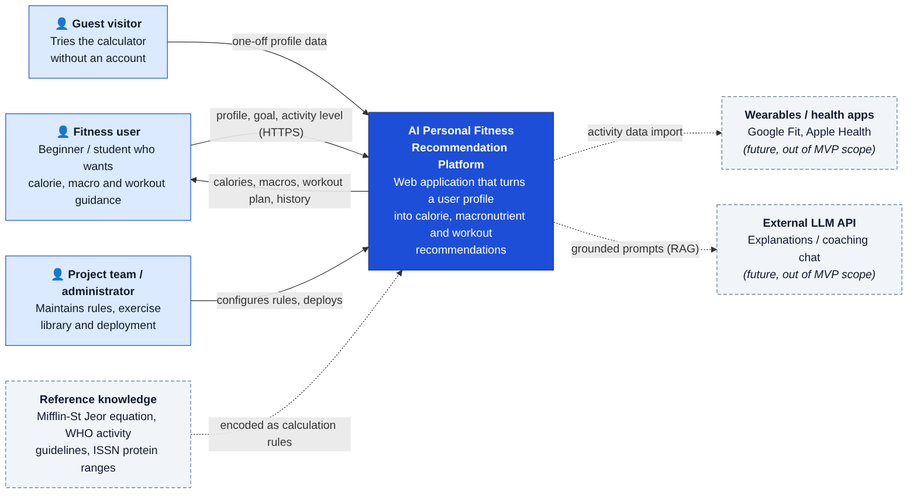
Context diagram
External entity | Interaction | In MVP?
Fitness user (registered) | Sends profile, goal and activity level; receives targets, plan and history | Yes
Guest visitor | One-off calculation, nothing stored | Yes
Project team / administrator | Maintains rules and exercise library; deploys | Yes (via code/config)
Reference knowledge (Mifflin-St Jeor, WHO, ISSN) | Encoded as calculation rules [13–15] | Yes
Wearables / health apps | Activity data import | No (future, FR-17)
External LLM API | RAG-grounded explanations | No (future, FR-18)

7.3 Use case diagram
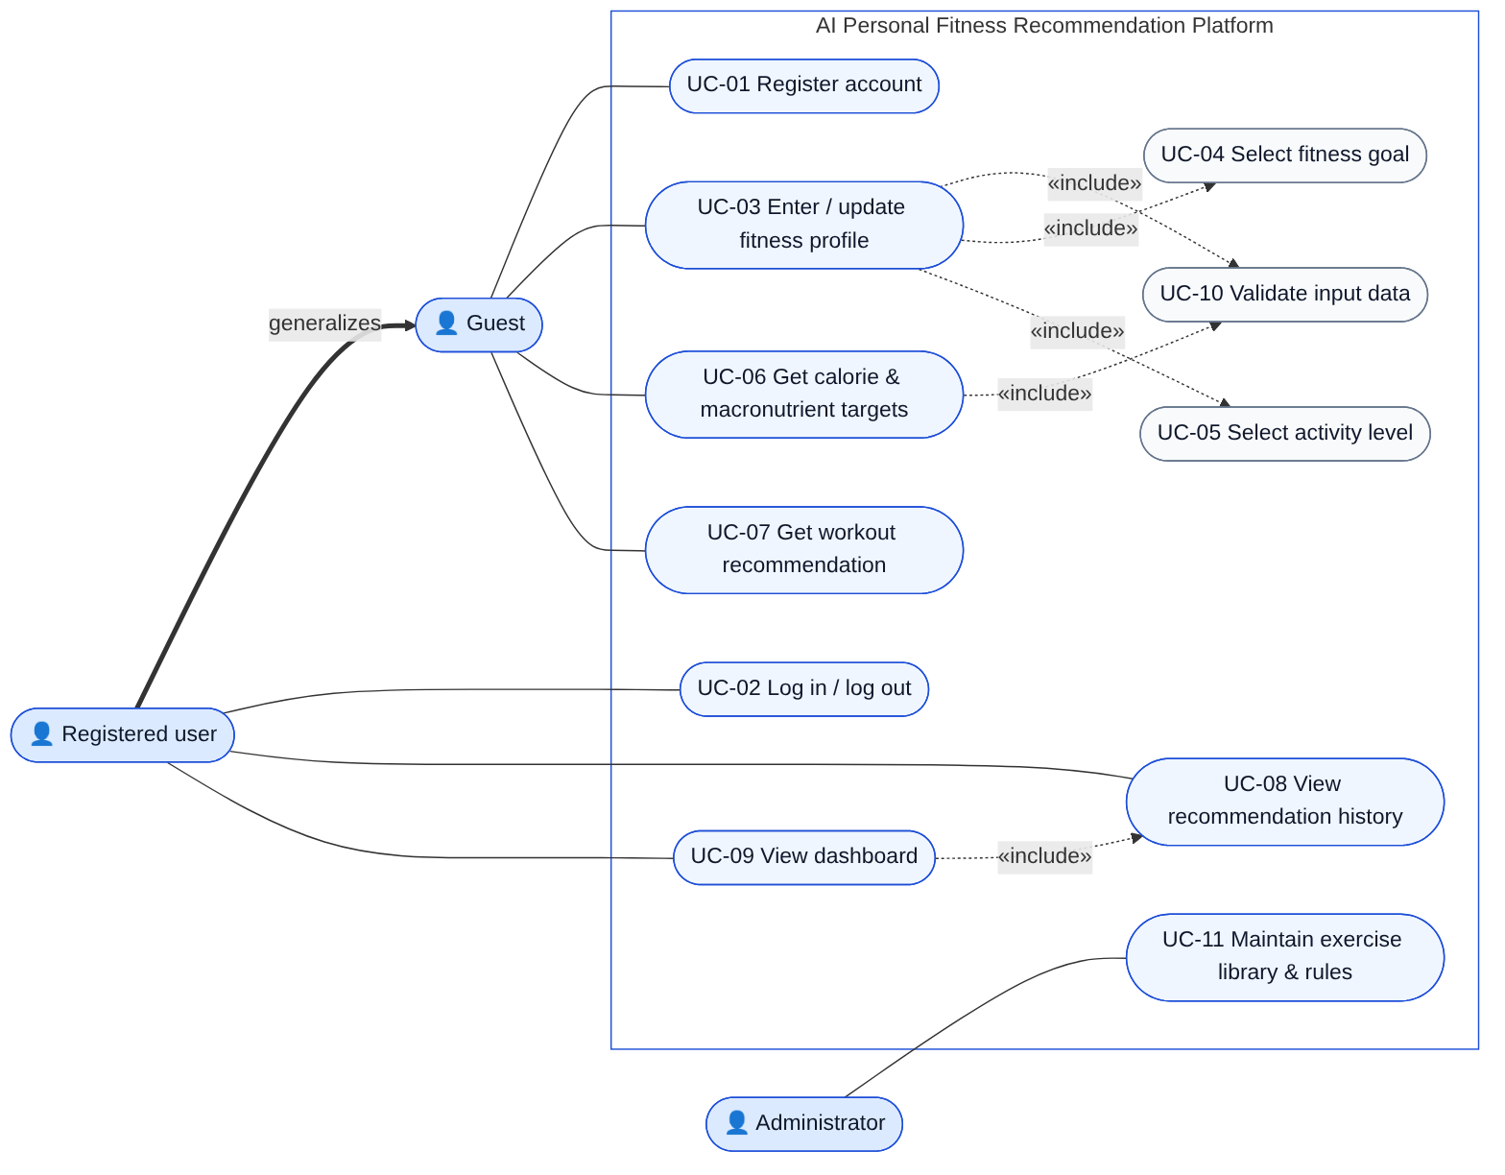
Use case diagram

7.4 Component diagram (draft)
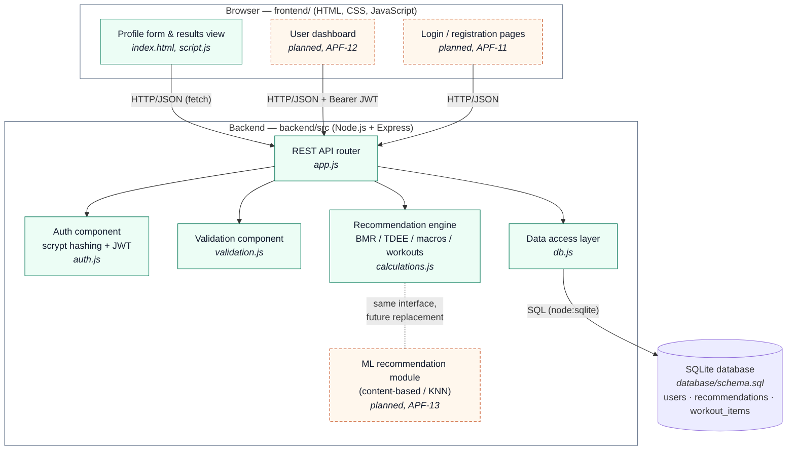
Component diagram
Component | File | Responsibility | Owner
Profile form & results view | frontend/index.html, script.js | Collect input, call API, render results and errors | Arman
User dashboard, login pages | planned | Profile summary, targets, history (FR-11) | Arman
REST API router | backend/src/app.js | Endpoints, HTTP status codes, error handling | Bakhytzhan
Auth component | backend/src/auth.js | scrypt hashing, JWT issue/verify, requireAuth middleware | Bakhytzhan
Validation component | backend/src/validation.js | Ranges, enums, error messages (FR-05) | Bakhytzhan
Recommendation engine | backend/src/calculations.js | BMR, TDEE, calorie target, macros, workout plan | Abzal
Data access layer | backend/src/db.js | Schema loading, prepared statements, transactions | Bakhytzhan
ML recommendation module | planned (ml/) | KNN profile classifier trained offline, same interface | Abzal
Database | database/schema.sql | users, recommendations, workout_items | Bakhytzhan

7.5 Data model
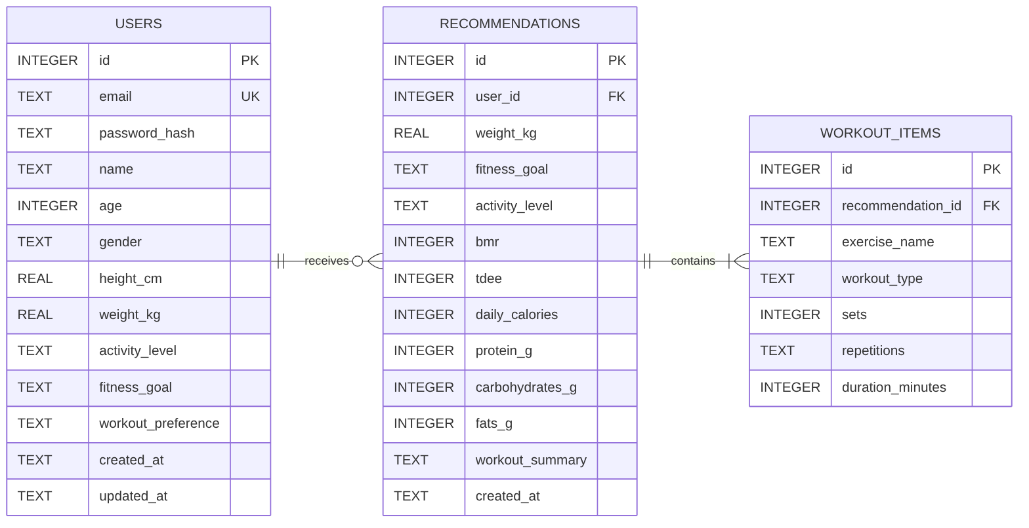
ER diagram
- users: account and profile data in one row (1:1). CHECK constraints enforce the same ranges as the API validation, so the database is a second line of defence (NFR-06, NFR-08).
- recommendations: one row per generated recommendation. It stores a snapshot of the inputs (weight, goal, activity) and of the outputs, so the history stays correct after the profile changes.
- workout_items: the exercises of a recommendation (1:N), saved in the same transaction as the recommendation.
- Deleting a user cascades to that user’s recommendations and items (prepares FR-16).

7.6 Main scenario: sequence diagram
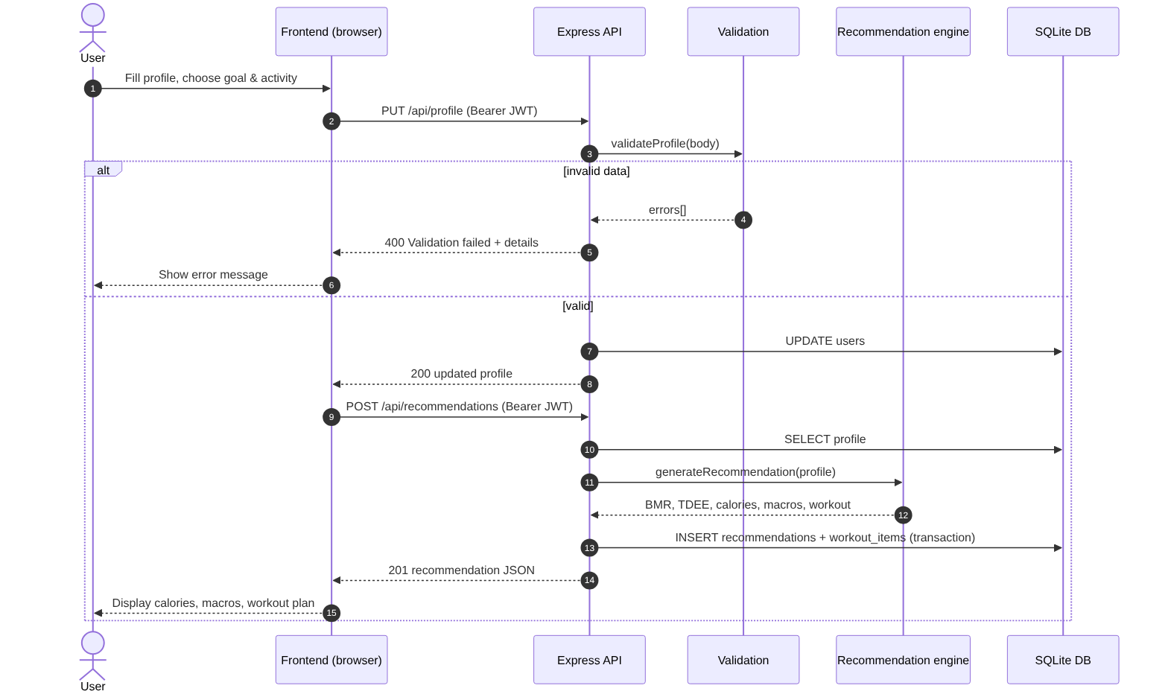
Sequence diagram

7.7 REST API
Method & path | Auth | Purpose | Success | Errors | FR
GET /api/health | — | Service status | 200 | — | NFR-09
POST /api/auth/register | — | Create account {email, password, name} | 201 {token, user} | 400, 409 | FR-01
POST /api/auth/login | — | Log in {email, password} | 200 {token, user} | 400, 401 | FR-02
GET /api/profile | Bearer | Read own profile | 200 | 401, 404 | FR-03
PUT /api/profile | Bearer | Update profile {name, age, gender, height, weight, goal, activity, workoutPreference} | 200 | 400, 401 | FR-03 to FR-05
POST /api/recommendation | — | Guest calculation from a profile in the body | 200 | 400 | FR-06 to FR-09, FR-12
POST /api/recommendations | Bearer | Generate from stored profile and save to history | 201 | 401, 422 (incomplete profile) | FR-06 to FR-10
GET /api/recommendations?limit=20 | Bearer | History, newest first, with exercises | 200 | 401 | FR-10
All errors have the same JSON shape: {"error": "<message>", "details": ["<field message>", ...]}.

7.8 Recommendation logic (baseline engine)
BMR = 10·weight + 6.25·height − 5·age + 5 (male)
− 161 (female) [Mifflin-St Jeor, 13]
TDEE = BMR × {low 1.2, moderate 1.55, high 1.725}
Calories = max(TDEE × {loss 0.85, maintenance 1.00, gain 1.10}, floor{male 1500, female 1200})
Protein = weight × {loss 1.8, maintenance 1.4, gain 1.8} g [ISSN range 1.4–2.0, 15]
Fat = 25 % of calories / 9 kcal·g⁻¹
Carbs = (calories − 4·protein − 9·fat) / 4
Workout = template[goal] with sessions/week = {low 3, moderate 4, high 5} [WHO 2020, 14]
Planned ML component (APF-13). Following Lee & Jeong [6]: (1) train a KNN classifier on a public dataset, e.g. the UCI/Kaggle “Estimation of obesity levels based on eating habits and physical condition” dataset used in [6], to place a user into a body-composition / activity segment from profile features; (2) choose the workout template and intensity for that segment; (3) compare the result with the rule-based engine using the protocol in 09-verification-plan.md.

7.9 Consistency check
Check | Result
Every Must functional requirement maps to at least one component and endpoint | ✅ see traceability table in doc 06
Every use case in the diagram exists in doc 06 and vice versa | ✅ UC-01 to UC-11
Every profile field in FR-03 exists in the users table and in the validation | ✅ (workout preference is optional)
Planned components (dashboard, ML) are marked as planned in all diagrams | ✅

8. UX and Prototype

8.1 Working prototype
The prototype is the running application in this repository. Start it with:
cd backend
cp .env.example .env # then set JWT_SECRET
npm install
npm start # opens on http://localhost:3000
The screenshots below were taken from this build on 24 October 2026.

8.2 Key user scenario: guest gets a recommendation (UC-03 → UC-06 → UC-07)
Step | User action | System response
1 | Opens the site | The profile form is shown
2 | Enters name, age, height, weight; chooses sex, goal, activity level | Form fields with units; dropdowns limit the choices to valid values
3 | Clicks Get Recommendation | The frontend sends POST /api/recommendation
4 | — | Shows daily calories, BMR and TDEE (explainability, NFR-12), macros in grams, workout summary and list of exercises
4a | (invalid input) | Shows “Unable to get recommendation” plus the exact validation message; nothing is calculated
Screen 1: profile form
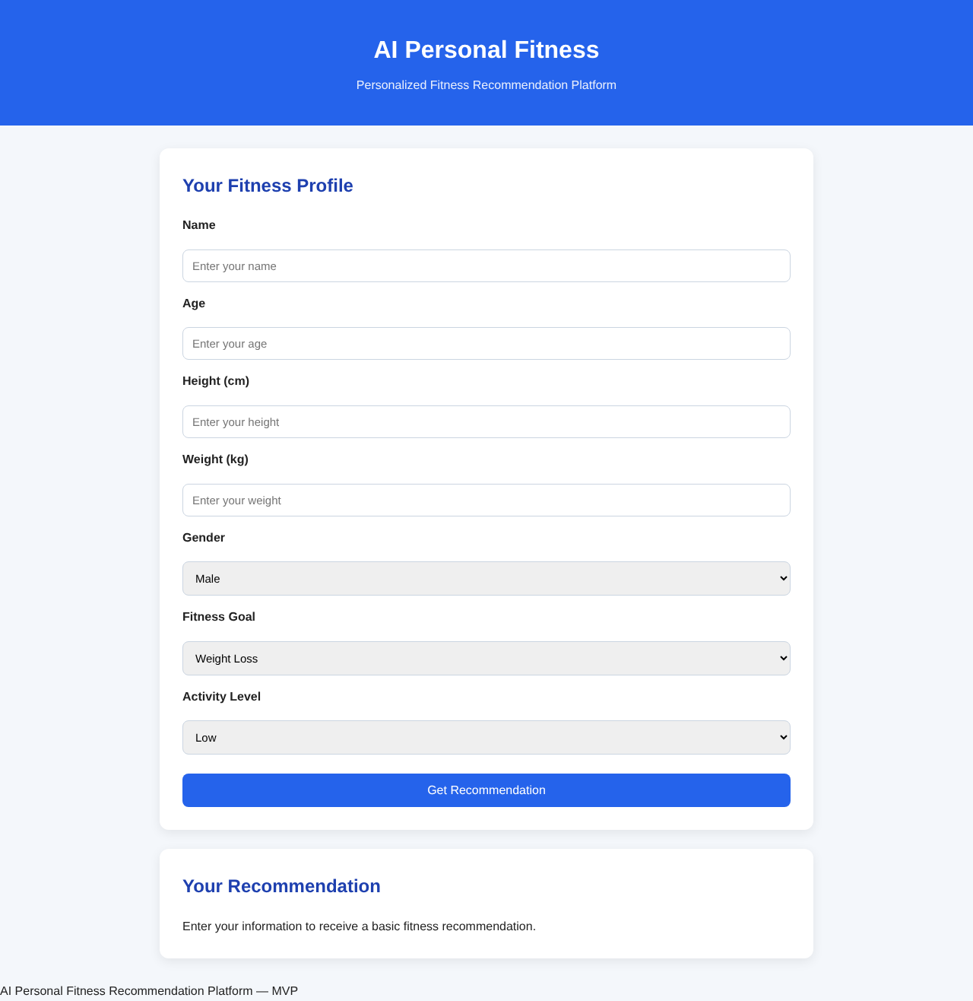
Empty form
Screen 2: recommendation result (female, 22 y, 165 cm, 58 kg, muscle gain, moderate activity)
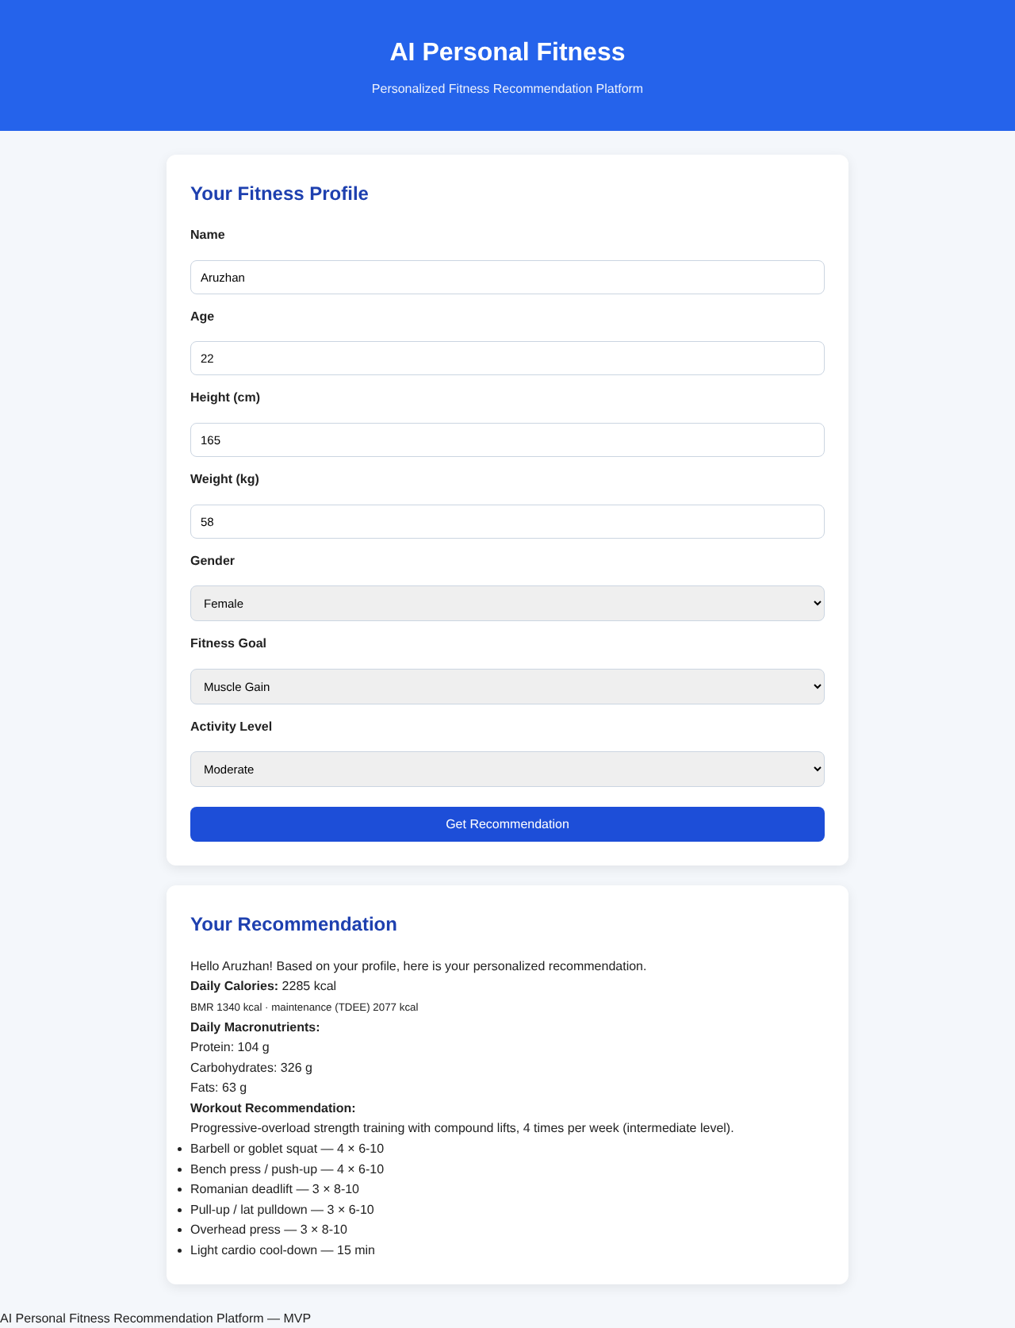
Recommendation
Screen 3: validation error (age = −3)
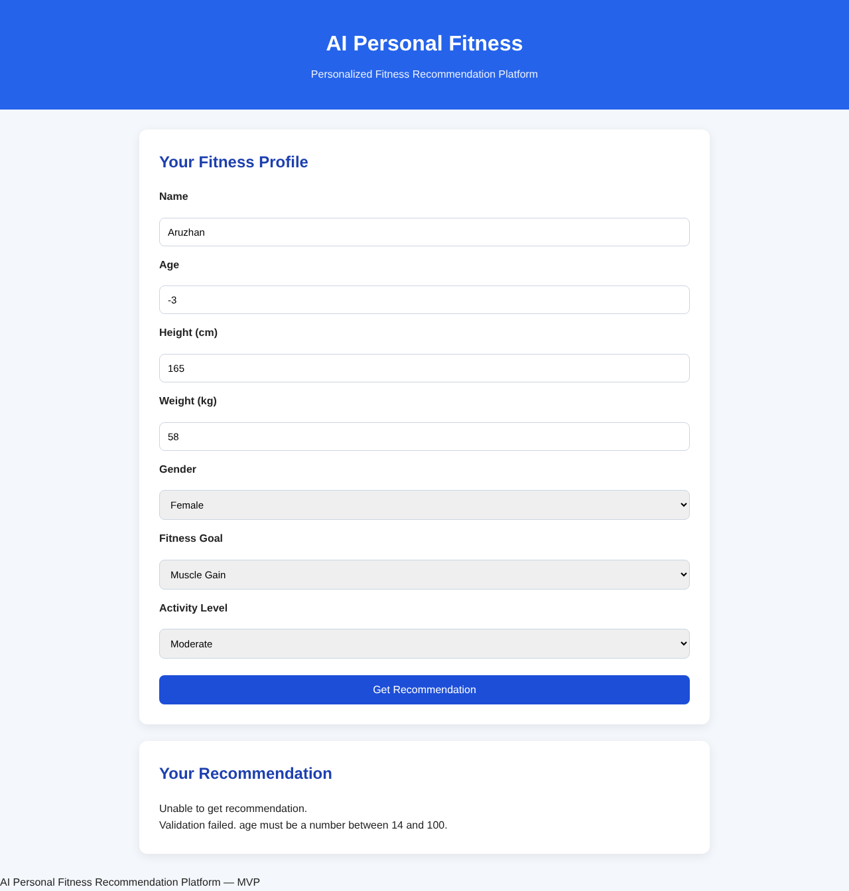
Validation error
Screen 4: mobile layout, 390 px (NFR-03)
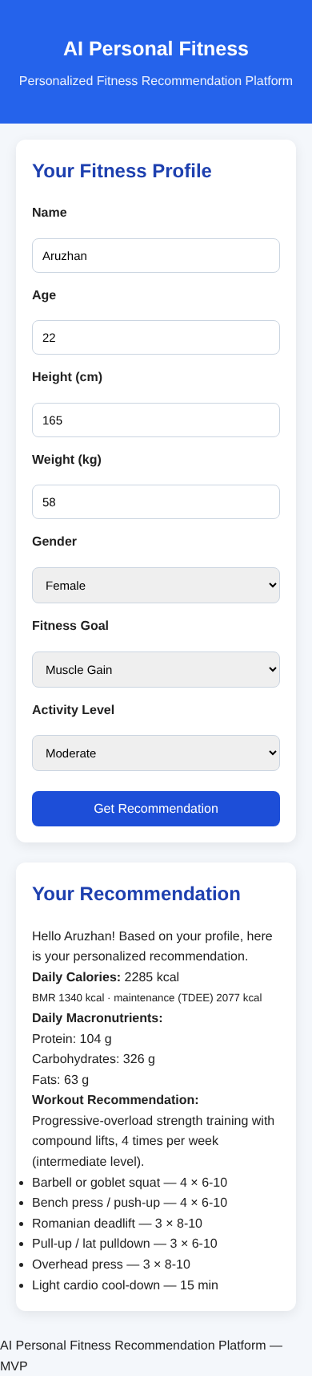

8.3 Planned screens (registered user, pre-defense 2)
Screen | Content | Requirements
Sign up / Log in | Email, password (≥ 8 chars), name; error messages; link between the two forms | FR-01, FR-02
Profile | Same fields as the guest form plus workout preference (home/gym); Save button | FR-03
Dashboard | Cards: My profile, Today’s targets (calories, BMR, TDEE, macros), My workout plan, History (date, goal, calories), and a Generate new recommendation button; disclaimer footer | FR-10, FR-11, FR-14
Wireframe of the dashboard:
┌──────────────────────────────────────────────────────────────┐
│ AI Personal Fitness Hello, Aruzhan [Log out]│
├───────────────────────┬──────────────────────────────────────┤
│ MY PROFILE │ TODAY'S TARGETS │
│ 22 y · F · 165 cm │ 2285 kcal (BMR 1340 · TDEE 2077) │
│ 58 kg · Moderate │ Protein 104 g · Fat 63 g · Carbs 326 g│
│ Goal: Muscle gain │ │
│ [Edit profile] │ [Generate new recommendation] │
├───────────────────────┴──────────────────────────────────────┤
│ MY WORKOUT PLAN · 4 sessions / week · intermediate │
│ • Goblet squat 4×6-10 • Bench press 4×6-10 • RDL 3×8-10 ... │
├──────────────────────────────────────────────────────────────┤
│ HISTORY │
│ 24.10.2026 Muscle gain 2285 kcal │
│ 10.10.2026 Maintenance 2077 kcal │
├──────────────────────────────────────────────────────────────┤
│ ⚠ Recommendations are approximate and do not replace advice │
│ from a doctor or dietitian. │
└──────────────────────────────────────────────────────────────┘

8.4 API examples (input and output)
Guest recommendation: request
curl -X POST http://localhost:3000/api/recommendation \
-H "Content-Type: application/json" \
-d '{"name":"Daniyar","age":25,"height":178,"weight":90,"gender":"male","goal":"weight-loss","activity":"low"}'
Response 200 OK (abridged; full file: prototype/api-example-response.json)
{
"name": "Daniyar",
"goal": "weight-loss",
"activity": "low",
"bmr": 1893,
"tdee": 2271,
"calories": 1930,
"macronutrients": { "protein": 162, "carbohydrates": 199, "fats": 54 },
"workout": {
"level": "beginner",
"sessions_per_week": 3,
"summary": "Full-body strength circuits combined with moderate-intensity cardio, 3 times per week (beginner level).",
"exercises": [
{ "exercise_name": "Bodyweight squat", "workout_type": "strength", "sets": 3, "repetitions": "12-15" },
{ "exercise_name": "Brisk walking / cycling", "workout_type": "cardio", "duration_minutes": 30 }
]
}
}
Invalid input: response 400 Bad Request
{
"error": "Validation failed.",
"details": [
"age must be a number between 14 and 100.",
"goal must be one of: weight-loss, muscle-gain, maintenance."
]
}
Registered flow
# 1. Register → token
curl -X POST localhost:3000/api/auth/register -H "Content-Type: application/json" \
-d '{"email":"student@example.com","password":"secret-pass-1","name":"Student"}'
# 2. Save profile
curl -X PUT localhost:3000/api/profile -H "Authorization: Bearer <token>" -H "Content-Type: application/json" \
-d '{"name":"Student","age":22,"height":165,"weight":58,"gender":"female","goal":"maintenance","activity":"moderate","workoutPreference":"home"}'
# 3. Generate and store a recommendation → 201
curl -X POST localhost:3000/api/recommendations -H "Authorization: Bearer <token>"
# 4. History
curl localhost:3000/api/recommendations -H "Authorization: Bearer <token>"

8.5 UX principles applied
- Show the reasoning: BMR and TDEE are displayed next to the target, which supports user trust (A2) and follows the transparency gap identified in [1, 4].
- Prevent errors early: dropdowns for enumerated fields and numeric inputs with units; the server re-validates (FR-05).
- Specific error messages that name the field and the allowed range.
- One screen, one task for the guest flow; the dashboard groups everything for returning users. Goal setting and feedback are among the most effective behaviour-change strategies [9].

9. Verification and Evaluation Plan
The plan answers one question: how will we prove that the project goal has been reached? The goal is personalised, correct and safe recommendations delivered through a usable web platform. We use two complementary checks:
- Verification: “did we build it right?” This means tests against the requirements in 06-requirements.md.
- Evaluation: “did we build the right thing, and is it better than the baseline?” This means metrics measured under fixed conditions.

9.1 Test levels and tools
Level | What | Tool | Who | When
Unit | calculations.js, validation.js | node:test (built in) | Abzal, Bakhytzhan | Every commit (npm test)
Integration (API + DB) | All endpoints with an in-memory SQLite DB | node:test + supertest | Bakhytzhan | Every commit
Functional / end-to-end | User scenarios in the browser | Manual checklist; Playwright planned | Arman, Abzal | Before each pre-defense
Performance | Latency under load | autocannon | Bakhytzhan | Pre-defense 2
Usability | SUS questionnaire + task completion | Google Form, observation | Whole team | Pre-defense 2 (≥ 5 users)
ML evaluation | Model vs baseline | Python, scikit-learn | Abzal | After APF-13
Rule: a pull request is merged only if npm test passes and another team member has reviewed it.

9.2 Test cases

Automated (implemented, 16/16 passing as of 24.10.2026)
ID | Requirement | Input | Expected result | Status
TC-U01 | FR-06, NFR-10 | male, 25 y, 180 cm, 80 kg | BMR = 1805 | ✅ Pass
TC-U02 | FR-06 | same, female | BMR = 1639 | ✅ Pass
TC-U03 | FR-06 | BMR 1000 × each level | 1200 / 1550 / 1725 | ✅ Pass
TC-U04 | FR-07 | same profile, 3 goals | loss < maintenance < gain; maintenance = TDEE | ✅ Pass
TC-U05 | FR-07, NFR-08 | female, 80 y, 145 cm, 38 kg, low, loss | calories = 1200 (floor) | ✅ Pass
TC-U06 | FR-08 | 3 goals | macro energy = calories ± 10 kcal | ✅ Pass
TC-U07 | FR-08, NFR-08 | 3 goals | protein 1.4–2.0 g/kg | ✅ Pass
TC-U08 | FR-09 | muscle gain, low vs high | 3 vs 5 sessions; plans differ by goal | ✅ Pass
TC-U09 | FR-09 (personalisation) | User A vs User B from the project description | different calories and plans | ✅ Pass
TC-A01 | NFR-09 | GET /api/health | 200 | ✅ Pass
TC-A02 | FR-12 | valid guest profile | 200 with calories, macros, exercises | ✅ Pass
TC-A03 | FR-05 | age −5; weight “abc”; goal “fly”; empty height; empty body | 400 with details for each | ✅ Pass
TC-A04 | NFR-06 | malformed JSON | 400 (not 500) | ✅ Pass
TC-A05 | FR-01 to FR-03, FR-10 | register → duplicate → login → recommendation before profile → profile → recommendation → history | 201 → 409 → 200 → 422 → 200 → 201 → 1 history item with exercises | ✅ Pass
TC-A06 | FR-02, NFR-04 | wrong password; no token; fake token | 401 each | ✅ Pass
TC-A07 | NFR-04 | register | password not in response or in the DB | ✅ Pass
Line coverage (npm run test:coverage): calculations.js 100%, validation.js 100%, auth.js 100%, app.js 94%, db.js 94%; 98% overall (NFR-07 ✅).

Manual functional tests (to run before each pre-defense)
ID | Scenario | Expected result
TC-F01 | Guest fills in the form with valid data for each of the 3 goals | A recommendation is shown; calories change with the goal
TC-F02 | Guest enters invalid values (negative age, empty weight) | Error message names the field; no numbers shown
TC-F03 | Open on a phone at 360–390 px width | No horizontal scroll; all controls usable
TC-F04 | Register → log in → edit profile → generate → see history | All steps succeed; data persists after a page reload
TC-F05 | Dashboard shows profile, targets, plan, history | All four blocks filled (after APF-12)
TC-F06 | Log out → open dashboard | Redirected to log in

9.3 Evaluation metrics, measurement conditions and baseline
ID | Question | Metric | Measurement conditions | Baseline / reference | Target
EV-01 | Are the calculations correct? | Absolute error of BMR and TDEE | 30 synthetic profiles (all sex × goal × activity combinations, ages 18–65, BMI 17–35) computed independently in a spreadsheet | Reference formula [13] computed by hand | 0 profiles with error > 1 kcal
EV-02 | Does the ML component improve on the rules? | Segment classification accuracy and macro-F1; precision@3 of recommended workout templates | Public obesity / eating-habits dataset as used in [6] (2,111 records); stratified 70/30 split, 5-fold CV, fixed random seed | Rule-based engine (current calculations.js) and a majority-class classifier | ML ≥ baseline accuracy and macro-F1 > 0.75; otherwise keep the rules and report why
EV-03 | Are recommendations really personalised? | Number of distinct plans and coefficient of variation of calories over the 30 test profiles | Same 30 profiles | “Generic” app = one plan for all | All 9 goal × activity combinations produce distinct outputs
EV-04 | Are recommendations safe? | Number of outputs that violate a safety rule (calories < floor, protein outside 1.4–2.0 g/kg, plan > 5 sessions for low activity) | Exhaustive grid: age 14–100 step 5, height 100–250 step 10, weight 30–300 step 10, all enums | — | 0 violations
EV-05 | Is the platform usable? | SUS score; task success rate; time on task | ≥ 5 target users (students, 18–30), task: “get your recommendation” and “find your history”; observed, no help | SUS 68 = industry average | SUS ≥ 70; success ≥ 90%; < 2 min
EV-06 | Is it fast enough? | p50/p95 latency, error rate | autocannon -c 50 -d 30 against POST /api/recommendation on a local laptop, production mode | — | p95 < 300 ms; 0 errors
EV-07 | Is it fair across groups? | Difference in EV-04 violations and EV-05 SUS between sexes and age groups | Same data split by group | Fairness analysis approach from [2] | No group with violations; SUS gap reported
Note on the ML baseline. Results in [3] show that ML models do not always beat simpler approaches, because performance depends on the data. Our success criterion is therefore an honest comparison with the rule-based engine, and keeping the rules is an acceptable result if ML does not improve on them.

9.4 Reporting
- Test results are attached to each pull request (CI output or a screenshot of npm test).
- The evaluation results (EV-01 to EV-07) go into docs/evaluation-report.md (APF-15) with tables and charts, and the limitations found are discussed.
- Defects are logged as YouTrack issues of type Bug, linked to the failing test ID.

10. Project Management and Risks

10.1 Tools and links
Tool | Link | Use
GitHub repository | https://github.com/St3rben11/prob-period-1 | Code, documentation, diagrams, tests, tags
YouTrack project APF | https://aipersonalfitness.youtrack.cloud (project AI Personal Fitness) | Tasks, assignees, priorities, states, agile board, Gantt chart
Scientific supervisor | Dana Altynbek | Reviews of key results (doc 11)

10.2 Team responsibilities
Member | Responsibility | YouTrack issues
Arman Amankeldi | Frontend, user dashboard, deployment & integration; requirements coordination | APF-1, APF-11, APF-12, APF-16
Abzal Bakhtiyarov | Fitness calculations, AI recommendation model, testing & evaluation | APF-6, APF-13, APF-14, APF-15 (+ APF-5, APF-7 proposed, see 10.3)
Bakhytzhan Abdilmazhit (YouTrack user 231012) | System architecture, database, backend API, authentication, AI integration into the backend | APF-2, APF-3, APF-4, APF-8, APF-9, APF-10

10.3 Task backlog (YouTrack snapshot, 24.10.2026)
All issues are of type Task and are on the board AI Personal Fitness. Each issue description lists the expected result. The deadlines and acceptance criteria below are proposed and must be entered in YouTrack: the committee requires every task to have an owner, an expected result, acceptance criteria and a deadline.
ID | Summary | Assignee | Priority | State | Proposed deadline | Acceptance criteria (short) | Deliverable / evidence
APF-1 | Define project requirements | Arman | Major | In Progress | 24.10.2026 | FR/NFR with priorities and acceptance criteria; reviewed by supervisor | docs/06-requirements.md
APF-2 | Design system architecture | Bakhytzhan | Major | In Progress | 24.10.2026 | Context, use case, component diagrams consistent with requirements | docs/07-architecture.md, docs/architecture/
APF-3 | Design database structure | Bakhytzhan | Major | In Progress → Done | 24.10.2026 | Schema with constraints and ER diagram; used by backend; tests pass | database/schema.sql, ER diagram
APF-4 | Develop user profile module | Bakhytzhan | Major | Open → In Progress | 15.11.2026 | GET/PUT /api/profile with validation; UI form saves the profile | backend/src/app.js, TC-A05
APF-5 | Implement fitness recommendation logic | 231012 → Abzal (proposed) | Major | Open → In Progress | 15.11.2026 | Calories/macros/workout depend on profile; TC-U04, TC-U09 pass | calculations.js
APF-6 | Implement calorie and macronutrient calculation | Abzal | Major | Open → In Progress | 08.11.2026 | Mifflin-St Jeor, goal adjustment, safety floor; TC-U01 to TC-U07 pass | calculations.js
APF-7 | Develop workout recommendation module | 231012 → Abzal (proposed) | Major | Open | 29.11.2026 | Plans for all 9 goal × activity combinations; exercise library configurable | calculations.js / DB table
APF-8 | Develop backend API | Bakhytzhan | Major | Open → In Progress | 15.11.2026 | All endpoints in doc 07 §7.7; consistent error format; integration tests pass | backend/, TC-A01 to TC-A07
APF-9 | Integrate AI recommendation component | Bakhytzhan | Major | Open | 31.01.2027 | Engine selectable by config; ML and rule outputs share one format | backend + ml/
APF-10 | Implement authentication and authorization | Bakhytzhan | Major | Open → In Progress | 15.11.2026 | Register/login, hashed passwords, JWT, 401 on protected routes; TC-A05 to TC-A07 pass | auth.js
APF-11 | Develop frontend application | Arman | Major | In Progress | 13.12.2026 | Login, registration, profile, results pages connected to API; responsive | frontend/
APF-12 | Implement user dashboard | Arman | Normal | In Progress | 13.12.2026 | Profile, targets, plan and history on one page (FR-11) | frontend/
APF-13 | Design and integrate AI recommendation model | Abzal | Major | In Progress | 31.01.2027 | KNN model trained and evaluated vs baseline (EV-02) | ml/, evaluation notebook
APF-14 | Implement system testing | Abzal | Normal | Open → In Progress | ongoing, 28.02.2027 | Test plan executed; report with expected/actual results | docs/09, test report
APF-15 | Evaluate system results | Abzal | Normal | Open | 31.03.2027 | EV-01 to EV-07 measured; tables/graphs; limitations discussed | docs/evaluation-report.md
APF-16 | Prepare deployment and system integration | Arman | Normal | Open | 30.04.2027 | Public URL; environment config; all components communicate | Deployment link
Issues to add in YouTrack: APF-17 Literature review and comparisons (all), APF-18 Relevance interviews (3–5 users) (all, 1–2 interviews each), APF-19 Pre-defense 1 documentation and README (all), APF-20 Hands-on verification of competitor apps (Arman).

10.4 Stages and milestones
Stage | Period | Main results | Milestone / Git tag
1. Analysis & design | Sep – 24 Oct 2026 | Proposal, relevance, literature review, comparisons, requirements, architecture, prototype, verification plan, backend MVP | pre-defense-1 (24.10.2026)
2. Core implementation | 25 Oct – Dec 2026 | Auth UI, profile, dashboard, history, workout module, interviews done, usability test v1 | pre-defense-2 (date set by department)
3. AI component | Dec 2026 – Feb 2027 | KNN model, integration, ML evaluation vs baseline | —
4. Testing & evaluation | Feb – Mar 2027 | Full test report, EV-01 to EV-07, fixes | —
5. Deployment & thesis | Mar – May 2027 | Public deployment, thesis text, presentation | final-pre-defense
Dates after pre-defense 1 are planned and will be adjusted to the official department schedule.

10.5 Development process (Git ↔ YouTrack)
- main holds only reviewed, working versions. All work happens on branches named APF-<id>-<short-description>, e.g. APF-8-backend-api.
- Commit messages start with the issue ID: APF-10: Add JWT authentication middleware.
- Each change goes through a pull request that names the YouTrack issue, describes the change and how it was tested (npm test output), and is reviewed by another team member before merging.
- The YouTrack issue gets a link to the PR or commit, and it is closed only when its acceptance criteria are met.
- Each member commits from their own GitHub account; shared accounts are not used.
- A Git tag marks each pre-defense version (pre-defense-1, pre-defense-2, final-pre-defense). Tags are never moved.
- Secrets are never committed (.env is ignored; .env.example has placeholders).

10.6 Risk register
Probability (P) and impact (I) are rated 1–3. Score = P × I.
ID | Risk | P | I | Score | Mitigation | Owner
R1 | No suitable public dataset to train or evaluate the ML model | 2 | 3 | 6 | Use the obesity / eating-habits dataset already used in [6]; the rule-based engine remains a working fallback | Abzal
R2 | The ML model does not beat the rule-based baseline | 2 | 2 | 4 | Treat it as a valid research result (doc 09, EV-02); report honestly and keep rules | Abzal
R3 | Uneven contribution / commits from a single account | 2 | 3 | 6 | Branch-per-issue, own accounts, PR reviews, weekly check of the YouTrack board | All
R4 | Unsafe or incorrect recommendations harm a user | 1 | 3 | 3 | Safety rules (NFR-08), exhaustive grid test (EV-04), disclaimer (FR-14) | Abzal, Bakhytzhan
R5 | Leak of personal data | 1 | 3 | 3 | Hashing, JWT, minimal data, no secrets in Git, HTTPS on deployment | Bakhytzhan
R6 | Too few interview / usability participants | 2 | 2 | 4 | Recruit fellow students early; each member is responsible for 1–2 participants | All
R7 | Scope creep (meal plans, wearables, chatbot) | 2 | 2 | 4 | Fixed scope (doc 01 §1.7); new ideas go to the “Won’t” list | Arman
R8 | node:sqlite is still marked experimental in Node 22 | 1 | 2 | 2 | Pin Node ≥ 22.13; the data layer is isolated in db.js, so switching to better-sqlite3/PostgreSQL is cheap | Bakhytzhan
R9 | Deployment platform limits (free tier sleeps, no persistent disk) | 2 | 2 | 4 | Choose a host with a persistent volume, or use managed PostgreSQL for deployment | Arman
R10 | Deadline conflicts with exams and other courses | 3 | 2 | 6 | Buffer weeks in the plan; priorities follow MoSCoW | All

10.7 Dependencies
Task | Depends on | Reason
APF-4 profile, APF-8 API | APF-3 database | Tables must exist
APF-10 auth | APF-8 API | Middleware protects endpoints
APF-11, APF-12 frontend & dashboard | APF-8, APF-10 | Need API and tokens
APF-5, APF-7 recommendation logic | APF-6 calculations | Calories and macros are inputs
APF-9 AI integration | APF-13 model, APF-8 API | Needs model and endpoint
APF-14 testing, APF-15 evaluation | All implementation tasks | Measures the finished system
APF-16 deployment | APF-8, APF-11 | Something to deploy

10.8 Next steps (after pre-defense 1)
- Conduct and record the 3–5 interviews (doc 02 §2.4) and update requirements.
- Enter deadlines and acceptance criteria into YouTrack; reassign APF-5 and APF-7 if the team agrees.
- Build the login, registration and dashboard UI on top of the existing API (APF-11, APF-12).
- Prepare the dataset and train the first KNN model (APF-13).
- Run the first usability test (EV-05) with the dashboard.

11. Scientific Supervisor Feedback
Scientific supervisor: Dana Altynbek
This log records the comments of the supervisor on key results and how the team responded. Every entry must come from an actual review (meeting, message or comments on the documents). Add the date and the form of the review.
⚠️ To be filled in by the team with the supervisor’s real comments. The committee checks whether the supervisor reviewed the work and whether the review led to real improvements.

11.1 Review log
# | Date | Form (meeting / chat / document comments) | Artefact reviewed | Supervisor’s comment | Decision / action taken | Where it changed (file, commit, YouTrack) | Status
1 |  |  | Project topic and proposal (doc 01)
2 |  |  | Scope and target users
3 |  |  | Literature review (doc 03)
4 |  |  | Requirements and architecture (docs 06–07)
5

11.2 Questions prepared for the supervisor
These are decisions where the team would like the supervisor’s opinion:
- Scope of “AI”. Is a profile-based KNN model compared against a rule-based baseline (doc 05 D6, doc 09 EV-02) enough AI content for the diploma? Or should a second model type (e.g. XGBoost as in [2]) be compared as well?
- Dataset. Is the public obesity / eating-habits dataset used in [6] acceptable, or should we also collect our own anonymised data from students (this needs ethics and consent procedures)?
- Frontend framework. Should we keep vanilla JS or move to React before building the dashboard (doc 05 D5)?
- Interviews. Are 5 interviews with students enough evidence, or should we add a short online survey for more quantitative data?
- LLM features. Should a RAG-grounded explanation layer [11] stay in “future work”, or is it expected in the final version?

11.3 How feedback is handled
- Each comment is logged in the table above within one day.
- If action is needed, a YouTrack issue is created or updated and linked in the table.
- The change is made on a branch, and the PR description references the comment number (e.g. “Supervisor comment #3”).
- The entry is marked Resolved after the PR is merged, or Discussed / not applied with a short justification.

