June 16, 2025

DR. ARTURO P. PINGOY MEDICAL CENTER

KORONADAL CITY, SOUTH COTABATO

Good Day,

Good day. I am writing to express my sincere desire to apply for IT instructor commensurate with my qualifications in your esteemed institution, the South East Asian Institute Of Technology

I am Keyan Andy Delgado, a graduate of Bachelor of Science in Information Technology (BSIT). Having recently completed my degree, I am eager to begin my professional career where I can apply the knowledge and skills I have acquired throughout my academic journey, while continuously learning and growing within a dynamic and professional environment.

I am highly motivated, responsible, and adaptable, with a strong willingness to take on new challenges and contribute effectively to your organization. It would be a privilege to be part of your institution and support your goals through reliable, quality service.

If you need more information, you can call me at 09280693642 or email keyanandydelgado@gmail.com.

Thank you very much for your time and consideration. I hope that you will give me the opportunity to be a part of your institution.

Sincerely Yours,

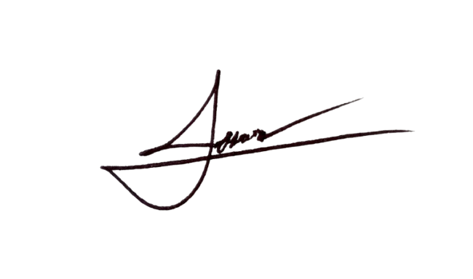

KEYAN ANDY DELGADO