Dear Volunteer,

Thank you for your very important ministry service. Volunteers like you are extremely important within your parish. As a volunteer within the Diocese of Phoenix, we ask that you complete safe environment training to help protect our community. Although the initial foundation class can only be done in person and is about 2.5 hours, all subsequent training can be completed online or in person, and takes less than an hour.

We are not asking you to complete this training because we think you are an offender, or want to harm children. Quite the opposite – we are asking for your help in protecting children and to be a part of the solution in preventing abuse! One of the main reasons all volunteers are required to complete safe environment training is so that we can have as many people as possible within our parishes be the eyes and ears of the most vulnerable within our communities. Bishop Olmsted asks each one of us to participate in a “Catholic Block Watch.” This can be accomplished by completing safe environment training, and maintaining awareness while we are serving in ministry.

It is up to each one of us to protect those within our community, whether that be children, vulnerable adults, or anyone in between. Each one of us is a child of God, no matter what age, and deserves to be protected. Although the safe environment training program is geared toward how we can protect children, the principles provided during the training can be applied to anyone, regardless of their age or situation.

In addition to learning how to protect those within our parish communities, safe environment training also provides tools on how we can protect our own children, grandchildren, nieces, nephews, and all others within our own families. The information provided during the trainings can be applied to anyone we interact with.
Encountering the Living Christ
Encountering the Living Christ
Encountering the Living Christ

Please feel free to contact me if you have any questions, or would like additional information on the safe environment training program.

Peace & Blessings,
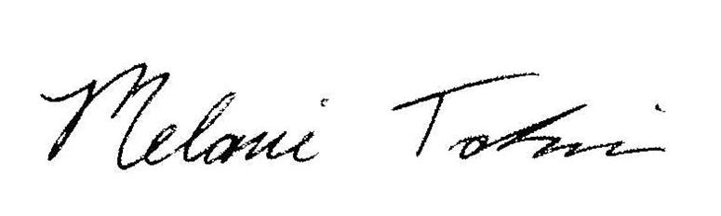

Melanie Takinen
Director, Safe Environment Training Office
Diocese of Phoenix
602-354-2208
mtakinen@diocesephoenix.org

