2009 Paper, Model Answers

1. A non-ferrous metal is one which contains no iron, for instance aluminium or copper.

*Note:* Many exam papers start with “What is the definition of…” type questions to settle you into the exam gently. They’re commonly to do with testing your resistant materials (wood, man-made boards, plastics, metals, etc) knowledge. Make sure you’ve been through your notes and know examples of each.

2. A thermoforming plastic is one which can be repeatedly re-formed when heated over and over. Examples include acrylic, HIPS and uPVC.

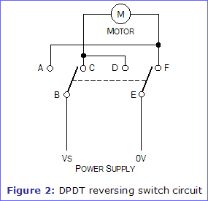3. A “double-pole, double-throw” switch is one which can be used to reverse the polarity of an output device connected to it (e.g. a DC motor). They are often configured as follows:

*Note:* Make sure you know the difference between SPST, SPDT and DPDT switches, along with examples of situations where they can be used.

4. A closed loop control system is one in which the output from the system serves as feedback which feeds the input. In an oven (for example), the heating element causes the temperature in the oven to rise. This is sensed by the thermostat, which turns off the element when the desired temperature is reached, and turns it back on when it falls.

*Note:* A central heating system is also a good example.

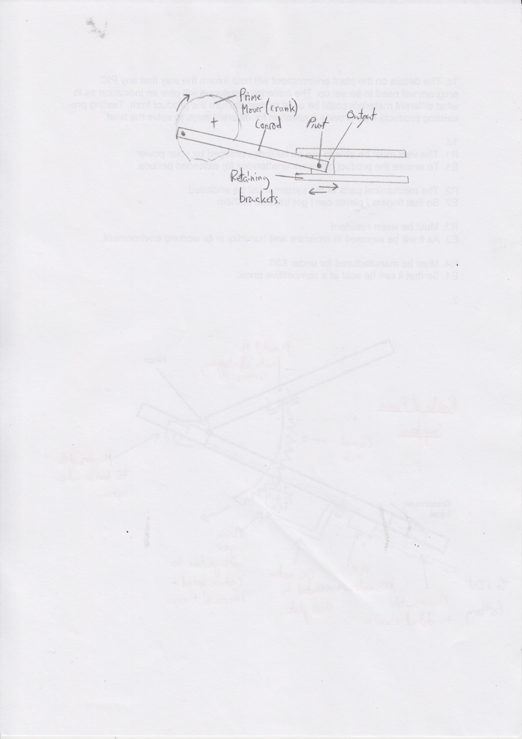5. A crank, link and slider will convert rotary to reciprocating motion.

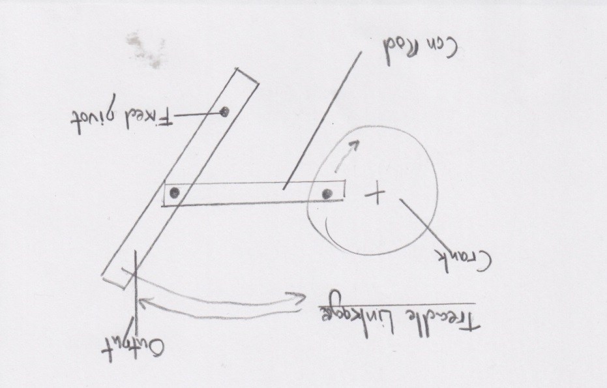

6. Either a “peg and slot”, or a “treadle” linkage will achieve this. The latter is shown here.

7a. One method of making a PCB is to use a chemical etch tank. To start, the artwork is placed into the UV light-box with an appropriately sized piece of photoboard on top of it for around 3 minutes. This causes the photoresist layer to soften on the parts of the PCB that the UV light can shine on. After this, the board is placed into the pre-heated developer tank for around 30 seconds. This serves to remove the softened photoresist and expose the copper on the board, leaving behind an impression of the PCB tracks. After rinsing this in water, the board is placed into the etch tank (containing ferric chloride), and air bubbles are passed over the board to accelerate the etching process. The unprotected copper is etched away, leaving tracks behind. After washing, the remaining photoresist can then be removed with a stripping solution, and the holes drilled on a precision drill ready for soldering. Optionally, the board can be placed in a tinning bath for 5 minutes to prevent the copper from oxidising.

*Note:* This is an 8 mark question, but I deliberately included lots of extra detail to avoid risking losing any of the marks.

7b. Solder can spit when soldering. To minimize the risk of injury, goggles should be worn at all times. Secondly, soldering irons are very hot and can cause burns. To reduce the risk of this, the soldering iron should be put into its holster in between uses. When etching, the developer and etchant solutions are hazardous. An apron, gloves and goggles are to be worn at all times when using them.

*Note:* I could also have discussed how the swarf (the residue drilling) is an irritant and that drill btis can snap off at speed, so to where goggles. The UV box is also dangerous to eyesight, so the lid should be kept shut while it is being operated.

7c. Breadboarding has the advantage that when made, one knows with confidence the circuit will work in the real World on a breadboard. Also, this can give an indication of the size and look of a finished PCB. The disadvantage is that large breadboards can be difficult to troubleshoot, and requires that the engineer has all the components in stock that they wish to use.

*Note:* Avoid using single-word answers like “cheaper”, and make sure you justify the points you make.

Simulation software allows for rapid prototyping to take place, and gives access to an enormous range of virtual parts. When troubleshooting, the software often gives access to virtual instruments to quickly identify any problems. The disadvantages are the initial cost to purchase the software can be prohibitive, and the simulations are only as accurate as the parameters built into the software by the developers.

*Note:* I wrote this up as two paragraphs, to make sure I said advantages and disadvantages of both.

8a. Friction is undesirable in the pistons in a car, where their rapid reciprocating strokes cause excess heat, part wear and a reduction in engine efficiency. This is minimized by lubricating the parts with oil that is pumped around the engine. Is it also undesirable in gearboxes, where the two surfaces rubbing together also causes noise, wear and heat. This can also be addressed by lubrication, or by using nylon gears which are self-lubricating.

*Note:* Conversely,friction is desirable with car tyres, where you want the best grip possible on the surface you’re driving on to avoid accidents and facilitate good braking. Car brakes also rely on friction to slow the speed of the vehicle quickly.

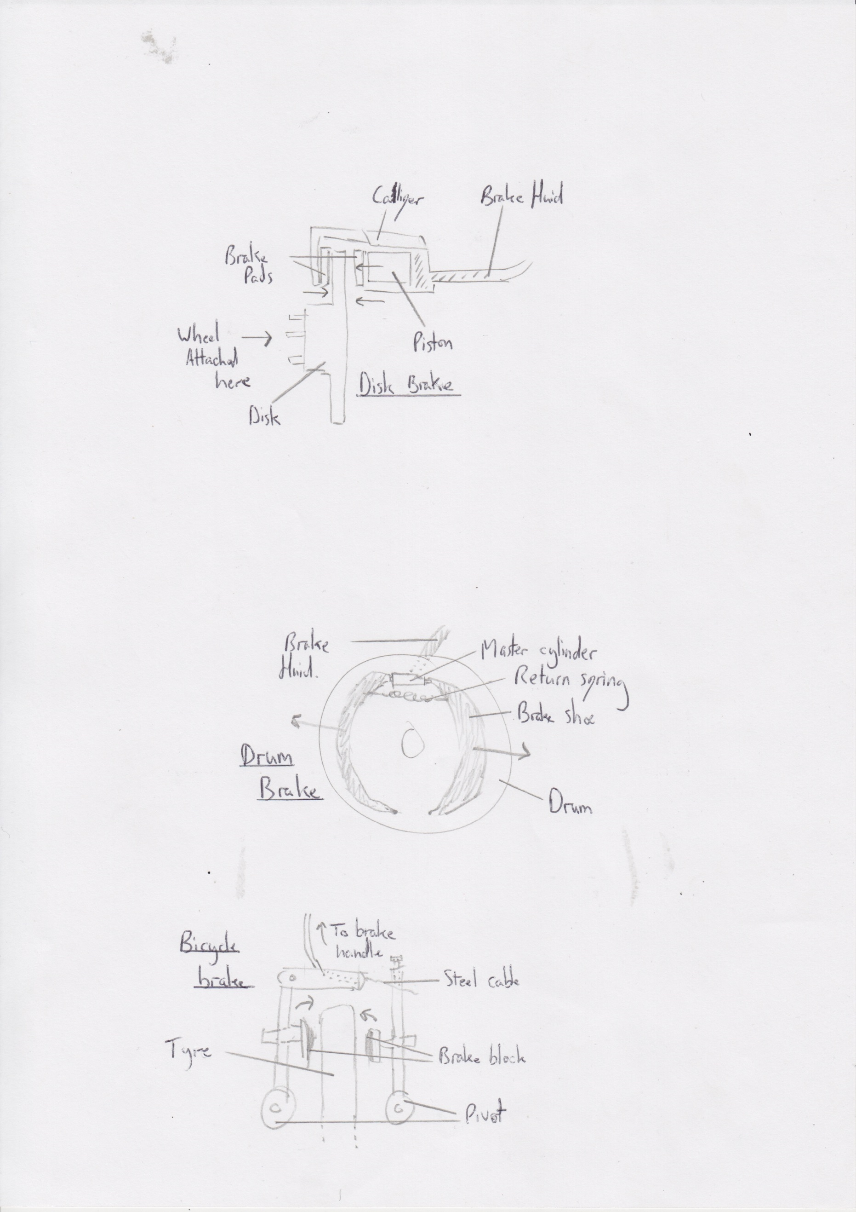8b.When the brake handle on the handlebars is pulled, the pivot at the bottom of the brake arms causes the two brake blocks to be pulled towards each other. They come into contact with the steel rim of the bike tyre, causing friction which slows the bike down. The harder the brake is pulled, the greater the exerted force on the tyre, and the faster the rate of deceleration.

*Note:* It’s a good idea to have basic knowledge of a couple of braking systems at AS level. Ultimately, most braking systems rely on a surface being pushed hard against the spinning surface in order to create friction and stop the moving object.

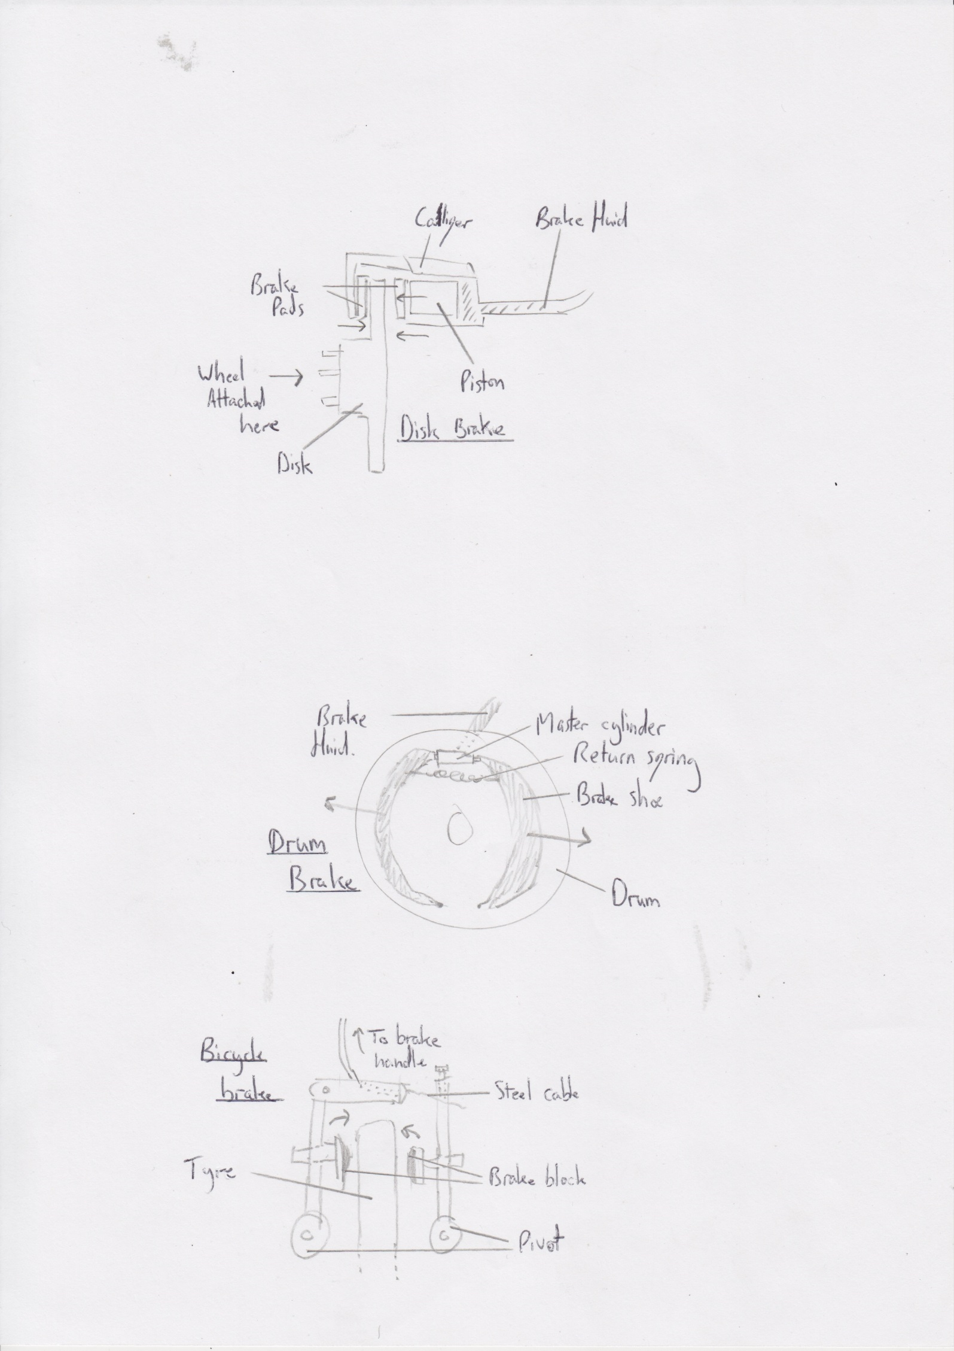

Disk brakes in a car use the same idea as above, but instead, brake fluid is pushed against the piston, causing the brake pads to pinch the disk with much greater force, causing friction which in turn slows the vehicle. When the pedal is released, the pads retract, ready for the next use.

8c. Force A x Distance A = Force B x Distance B

Force A = 48

Distance A = 50

Force B = ?

Distance B = 120

48 x 50 = Force B x 120 *Note:* A simple maths question. Ensure you get all the marks by 2400 = Force B x 120 showing lots of working out.

2400 / 120 = Force B

Force B = 20 N

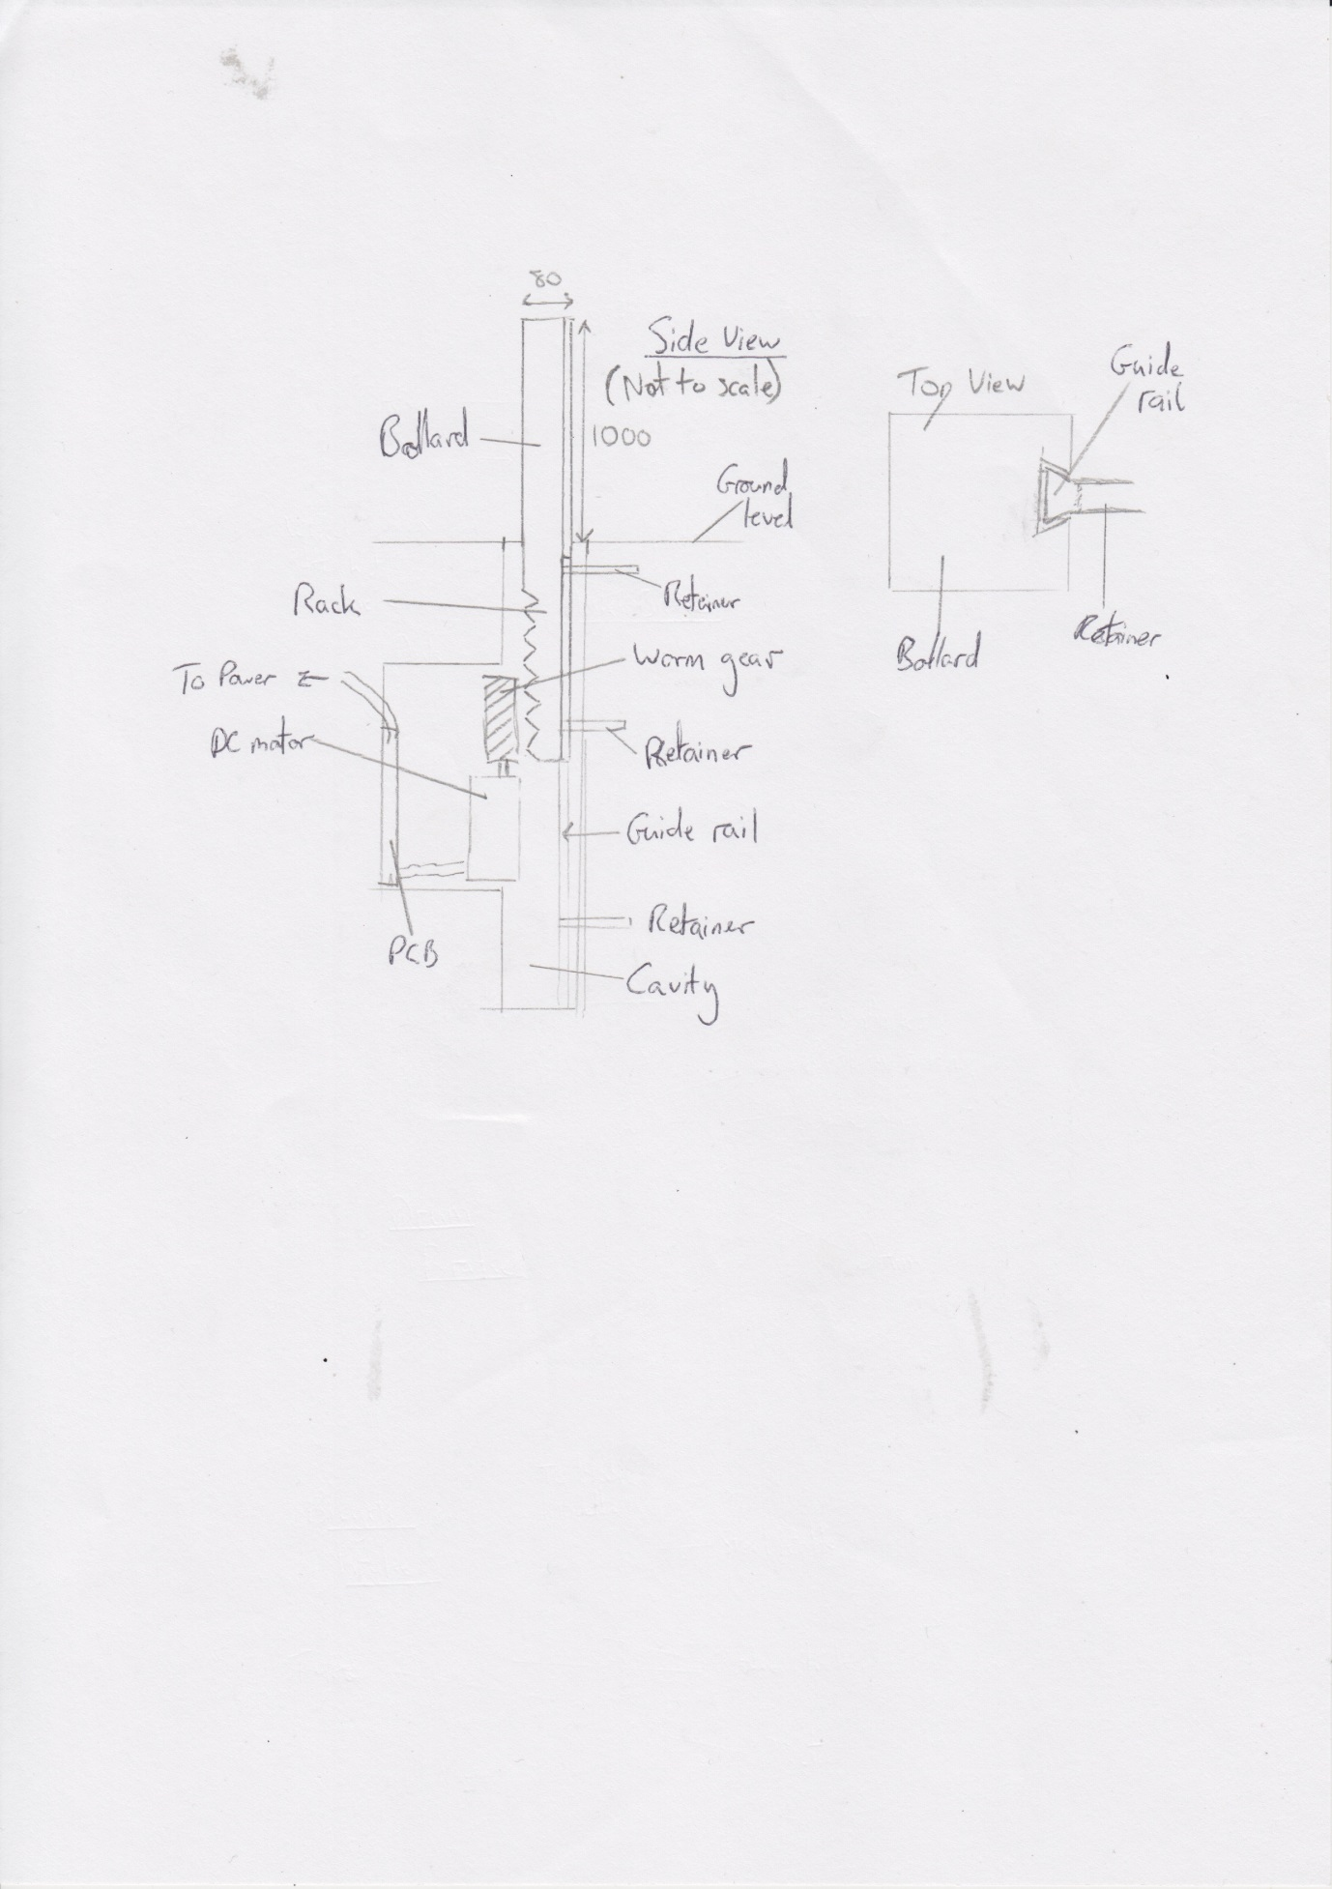

9a. In this design, a modified rack and pinion is used, using a worm gear in place of the spur gear. This is so that in the event of a power failure, the bollard will not fall into the ground and become damaged and also to reduce the output speed from the DC motor.

To prevent the rack from coming away from the worm gear, I have made a notch down the length of the bollard which I would slide a lubricated rail into, held in place with steel retainers.

The diagram is not to scale in the interests of fitting it on the page – the motor should be lower down, and the rack extended in order to bring the bollard down so it is flush with the ground.

*Note:* These type of questions always come up, and carry a large number of marks. Try to anticipate any problems that might occur with your design, and imagine yourself making it. Keep asking yourself what holds everything in position and stops the various parts from falling over. What powers your system? Where will the PCB go? Make sure you read ahead, to ensure you don’t answer the next question while answering the current one (i.e. look at question 9b and 9c first!)

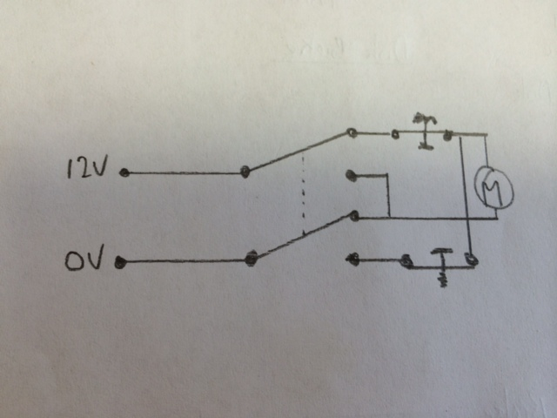

9b. The circuit uses a DPDT (Double pole, double throw) switch, with two PTB (push to break) microswitches at the top and bottom of the shaft that the bollard resides in. When they are opened, power is cut to the motor, stopping it from moving beyond its limits.

*Note:* This is a standard configuration for DPDT switches, and can be used in lifts and so on too.

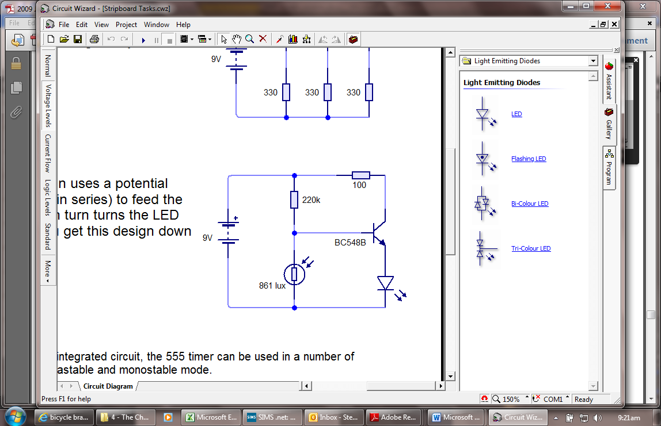

9c. In this circuit, the LDR and resistor act as a potential divider. When the light level falls sufficiently low, the resistance in the LDR becomes high enough that 0.7V can get to the base of the transistor. When this happens, current flows from the collected to the base the LED (which I would connect in parallel), and they illuminate. The 100Ω resistor limits the current to the LEDs, stopping them from blowing. (NOTE: I could have achieved the same result with an LDR going into an analogue input on a PIC chip).

x4

*Note:* You may feel that a simpler way to solve problems like these with a PIC circuit. If you go down this route, I’d encourage you to show a flowchart to accompany it.

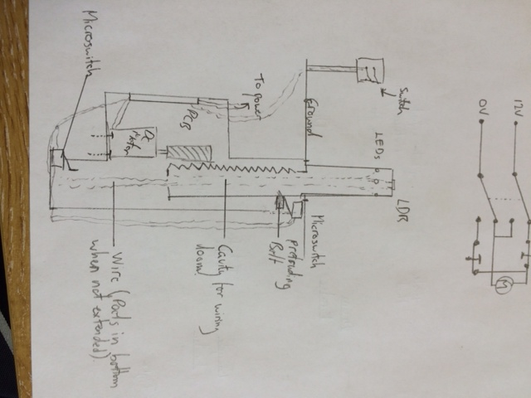

9d. The micro switch mounted at the top is triggered by the protruding bolt I have fitted to the bollard. At the bottom, another micro switch with its arm angled upwards will detect the bollard at the bottom of the hole in the ground. To simplify the wiring, I have decided to solder wires to all 6 pins of the DPDT switch, twist them together and run them through plastic trunking to the PCB, where they can be set up correctly in conjunction with the microswitches.

The middle of bollard will be hollow, allowing me to mount the LDR at the top of the bollard to detect light, and the LEDs into the 4 sides. By using a mains cable down the shaft, the weight of the cable will ensure that it drops neatly as the bollard moves up and down the shaft. I would secure the DC motor by making a bracket to hold it, lining the hole in the floor with concrete and using bolts to secure it.

*Note:* Questions like these are looking for your ability to combine different sub-systems together in an intelligent way. You need to ensure that all your constituent parts are present and presented in a way that they could work together. Remember that there are lots of different ways in which problems can be solved.

9e. With my system, I imagine that gaining access to the area where the PCB is to be kept once the hole is created might be difficult. I think that waterproofing would be an issue too, as the current design has no drainage for rainwater, so would cause problems over time. The weight of the bollard would increase with the addition of the rack, making the initial installation difficult too – I imagine that a high-power motor would be needed to handle the weight, even with the low gear ratio obtained by the worm gear. Making the bollard stay pushed up against the gear would need the retainer arrangement I describe in part a of this question. Finally, the calculations for the correct size of the worm gear to mesh into the rack would be challenging.

*Note:* Questions such as these rely on you demonstrating your understanding of how problems can occur between designing something on paper and coming to create it in real life. Issues such as where to run cables, how to get power and dealing with wet (or extreme) weather and what happens in the event of a power cut can all be explored here.

9f. The hole in the ground would be made from concrete. The worm gear and rack could be made from steel, or I could try using nylon (but I suspect it couldn’t bear the weight). The bollard itself could be made from aluminium, which would reduce the overall weight. If I used steel parts, they’d need to be greased to provide protection from corrosion; I could also paint the steel parts to help with this, or use galvanised steel.

I could secure the PCB using wall plugs and screws. The rack and bollard (if made as two pieces) could be welded together, or nuts, bolts and washers could be used.

*Note:* When considering a materials question, think about what all the component parts (i.e. Bollard, worm, gears, housing, etc) will be made from, then consider what fixings are to be used to hold them all together. Attaching motors to wood can be achieved with screws, metal can be welded (or bolted) to metal, plastics can use machine screws and nuts or use solvent adhesives, and [rawlplug](http://en.wikipedia.org/wiki/Wall_plug)s and screws/bolts can be used to fasten parts to concrete or brick surfaces.