Stephen Cardone

Module3 Assignment

See the screenshots for each question below. For larger screenshot, important items are highlighted in yellow. (I will also include vanilla screenshots in the submission in case some of these are hard to read)

1.

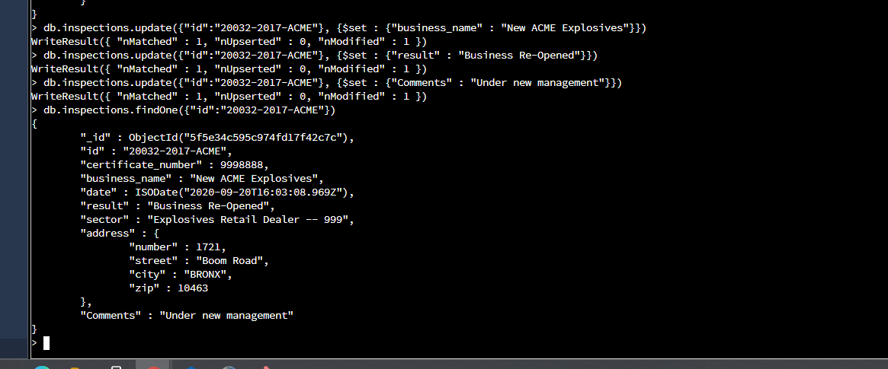

2.A (Ignore section crossed out in red)

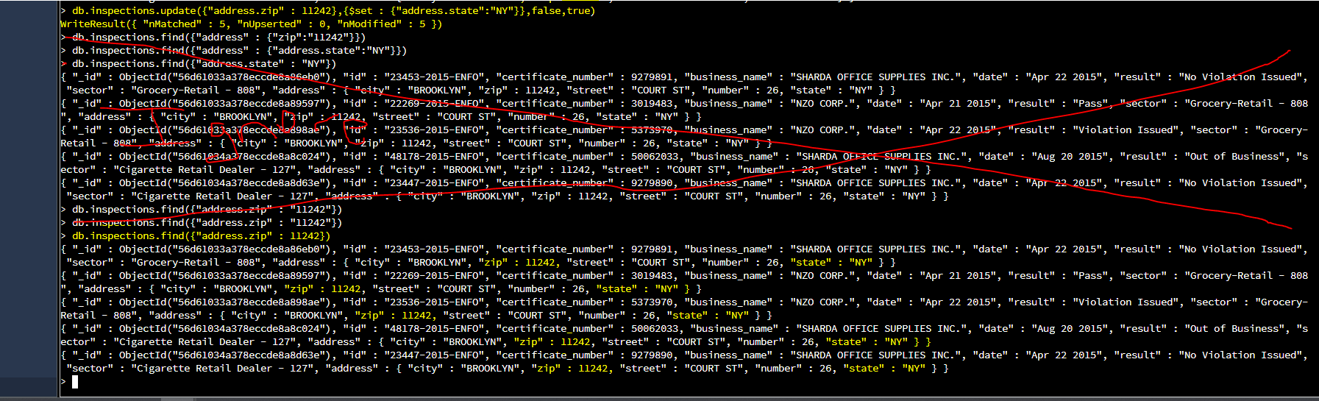

2.B

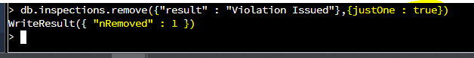

2.C ( Scanned objects goes from 81000 to 1 after indexing )

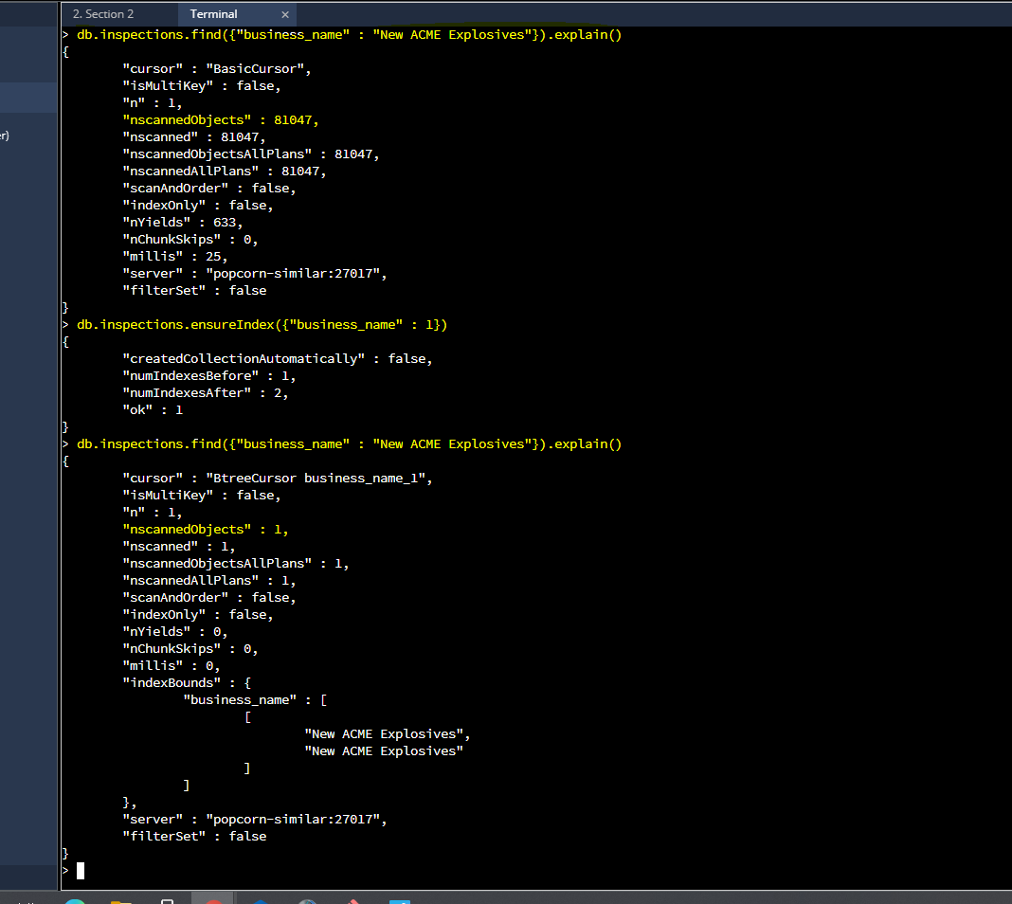

2.D

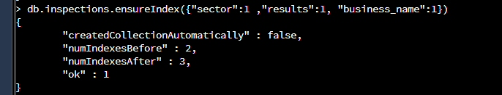

2.E ( after index, scanned items = items that meet criteria. Instead of scanning all 81000 items, we only scan 26000 because that’s how many matched )

