Stephen Cardone

Milestone 1

The goal of this assignment is to create functions in python to perform basic database CRUD (Create, Read, Update, Delete) functions with a mongodb database. The full .py script containing the implementation of these functions is a separate document (crud.py).

During development, I was testing my functions inside the python script itself with testing functions. Since running these test functions prove the CRUD functions behave as expected, I will include the python testing functions, as well as the output from the testing functions in this document.

The Test function definitions can be found in crud.py, and I will include them in a screenshot on the next page fore easy access.

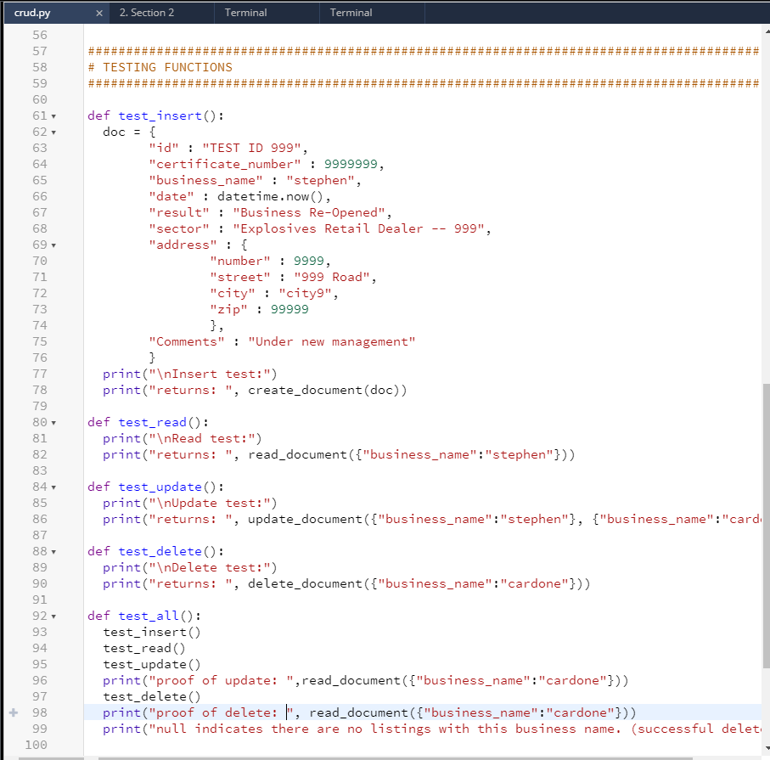

The next page contains output from running the test_all() function from the above screenshot

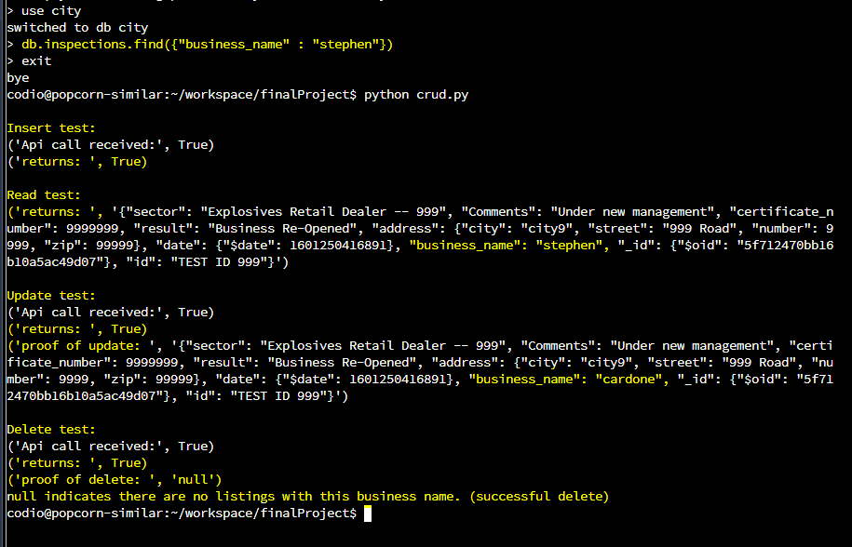

Description of test run:

**State before test:** Before executing the test, I run db.inspections.find({“business_name”:”Stephen”}) command. This proves that this business does **not** exist prior to the test is.

**Insert Test:** The value returned from the Insert function is “True” (highlighted in yellow). True indicates that the document was successfully inserted into the DB. (This is verified in the Read test)

**Read Test:** The read test returned the json data for “business_name”:”Stephen”. (This is the document that was created in the Insert Test which also verifies a successful insert.)

**Update Test:** The update test updates the “business_name”:”Stephen” to “business_name”:”cardone”. After the Update function is executed, I execute the read command. The “business_name” has changed to cardone (Highlighted in yellow) which indicates a successful update.

**Delete test:** I attempt to delete the document with “business_name”:”cardone”. The function returns “True” indicating a successful delete. For “Proof of Delete”, I attempt to read the document with business_name:cardone. The read command returns “null” which indicates that the document for business_name:cardone does not exist (was successfully deleted).