Stephen Cardone

Final Project Milestone2; REST API

**Pt1: Basic Rest API implementation**

Both the basic GET and POST requests are included here:

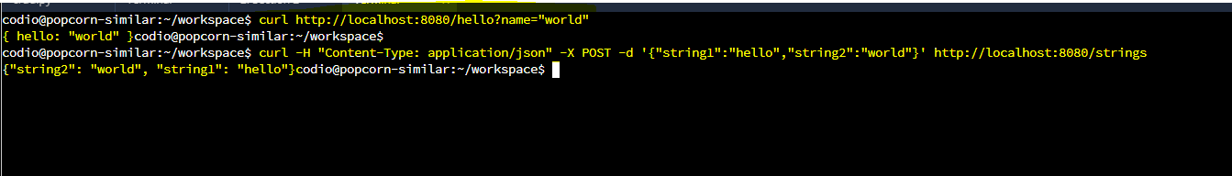

Screenshot of running server:  
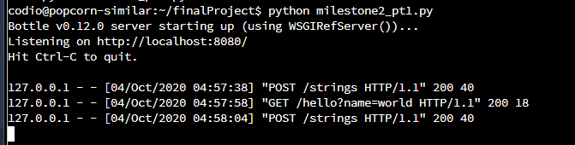

**Pt2: CRUD Rest API implementation**

Create: This screenshot shows a mongo session where the ACME TEST INC. business document originally does not exist. I use curl to hit my create POST api. Then re-enter mongo and the ACME TEST INC. business now exists.

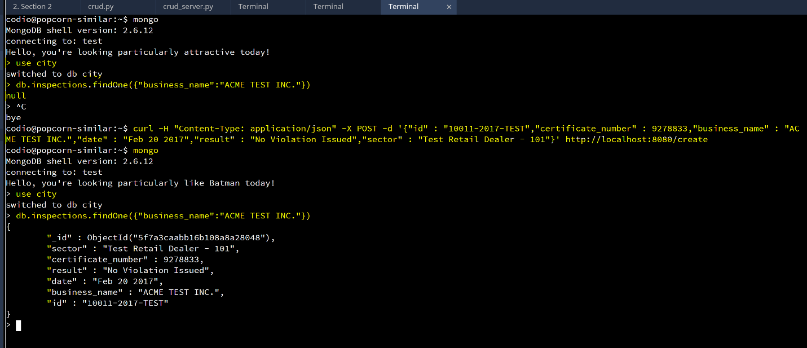

Read: When I query for the buesness called ACME TEST INC. via my /read GET api, the content of the correct document is output as JSON.

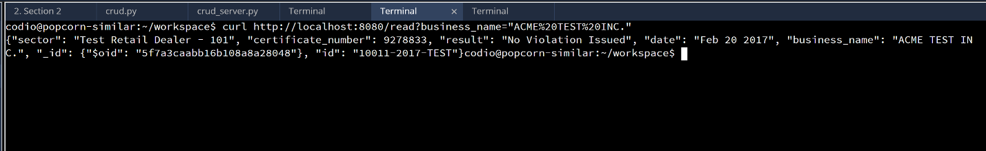

Update: Initially, the value of “result” in the ACME TEST INC. document is “No Violation Issued”. After I execute my /update REST API, I re-connect to mongo, and now, the value of “result” is “Violation Issued”

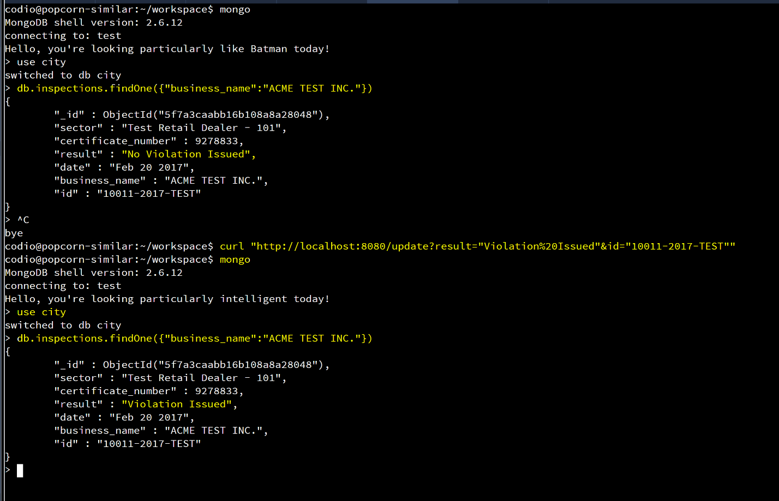

Delete on next page

Delete: I start in mongo and execute a findOne command for ACME TEST INC. which returns the document from the db. I then send a request to the /delete API. At this point, I re-connect to mongodb, and again execute a findOne for ACME TEST INC. Now, the document has been deleted by the api.

