CS340

Module 6 assignment

Stephen Cardone

Querying and creating Full-Text Indexes

1. Import and verification query screenshots:

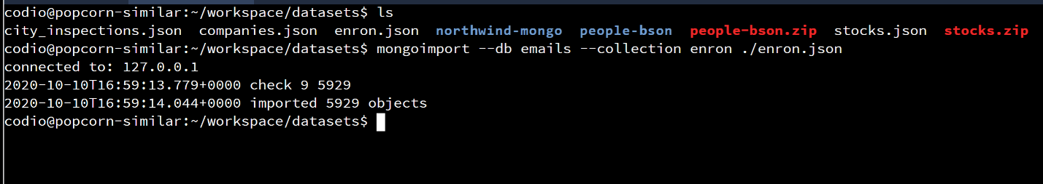

Confirmation:

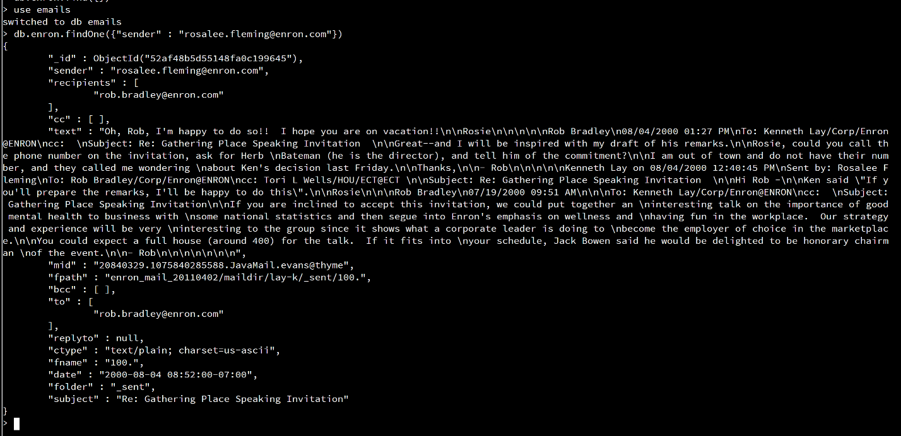

1. A: What is the size of the document from Q1: 1968  
   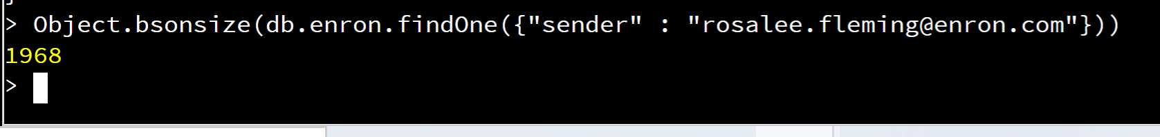

B: What is the size of the enron collection: 21878976

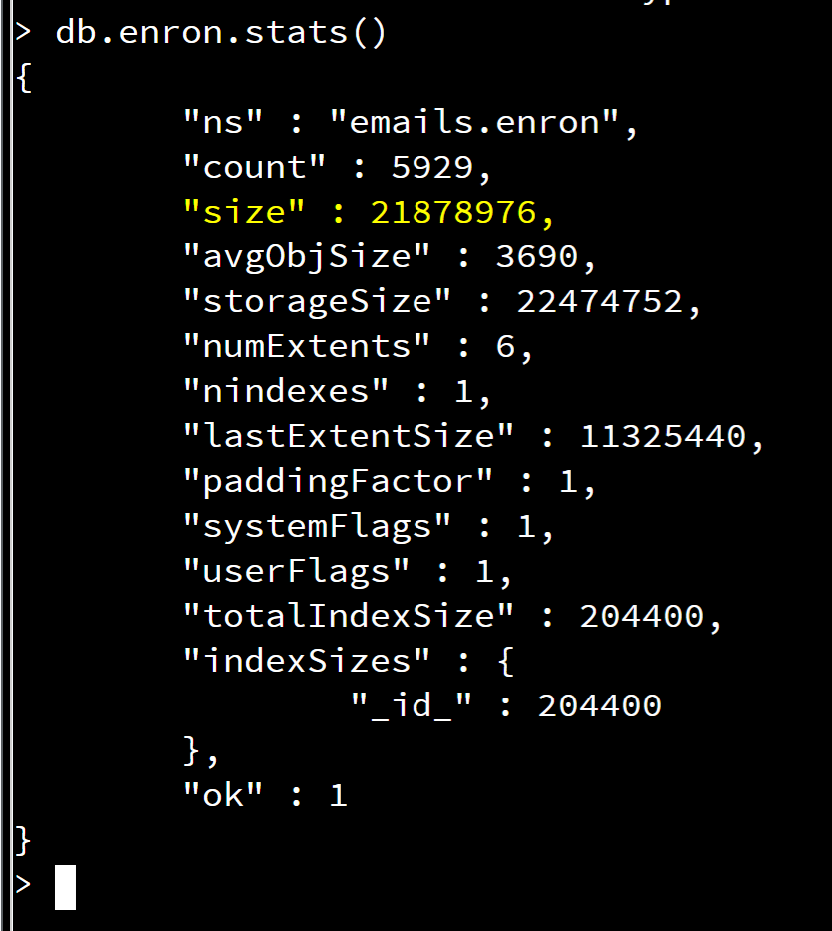

C: What is the size of the Emails DB: Data size is 21879232

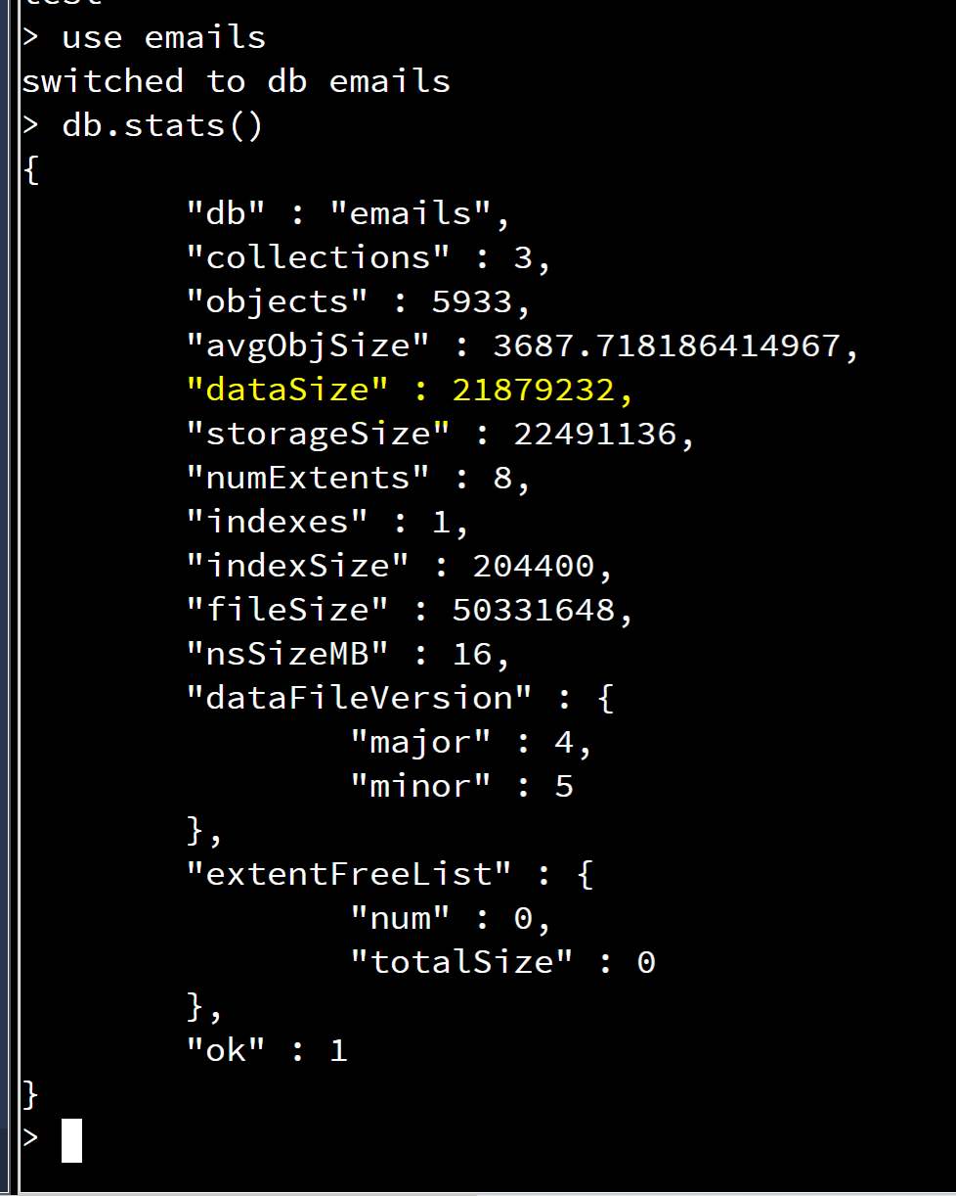

1. Crate full-text index:

See the screenshots where I enable the textSearch and then create the text index.

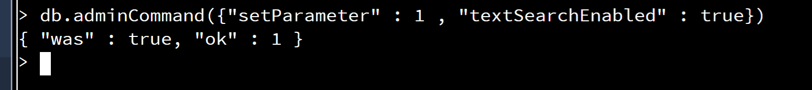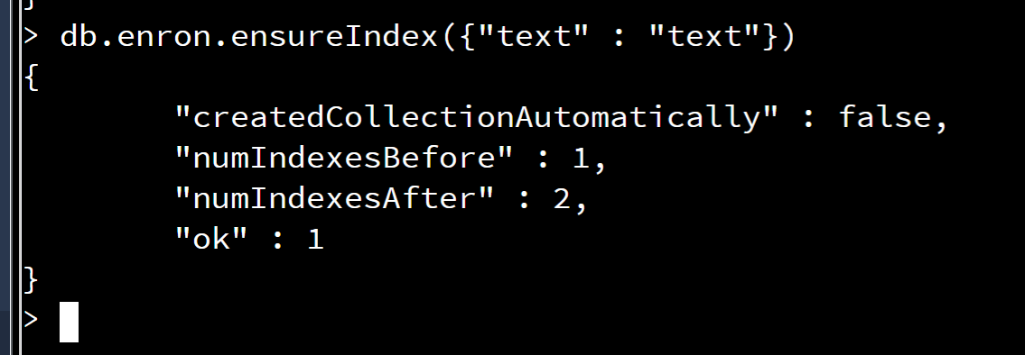

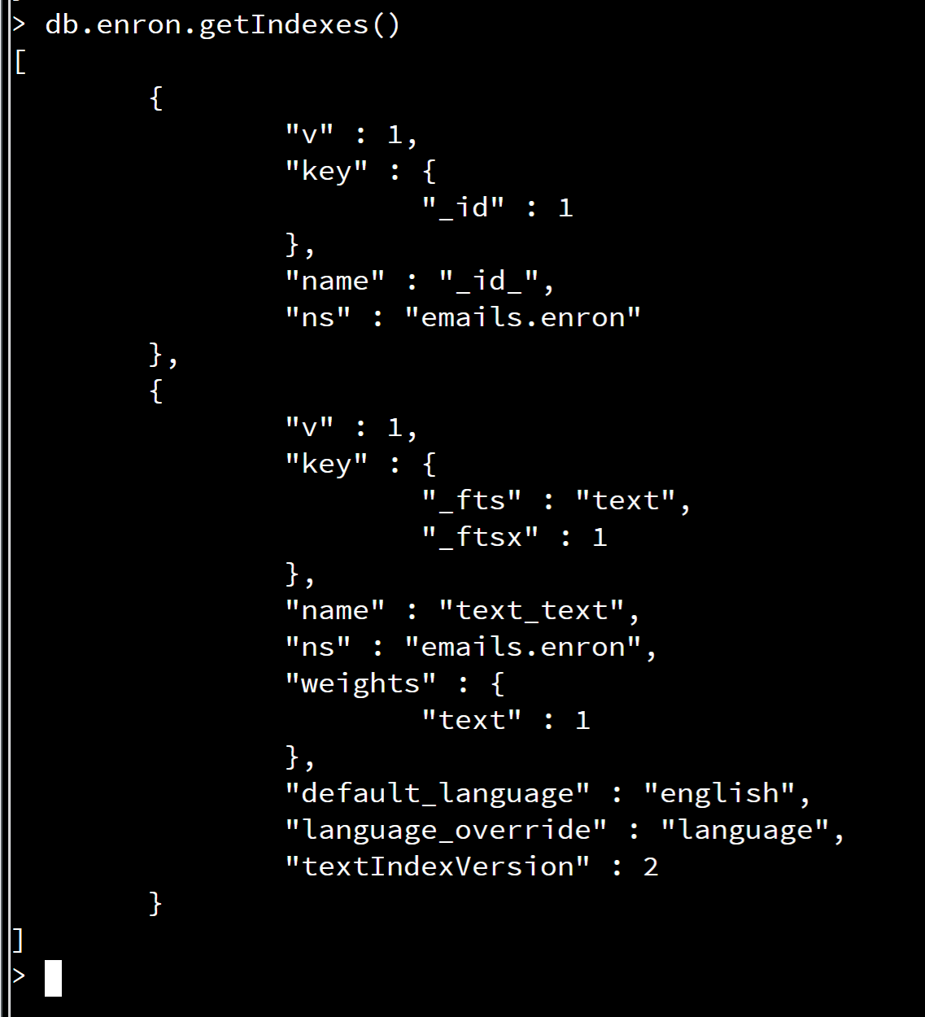

1. What percentage of Emails contain the string “Kenneth Lay”?

From the screenshot we can see that 6.65% of emails contain Kenneth Lay

