Stephen Cardone Module 1 Assignment UML Class Diagram

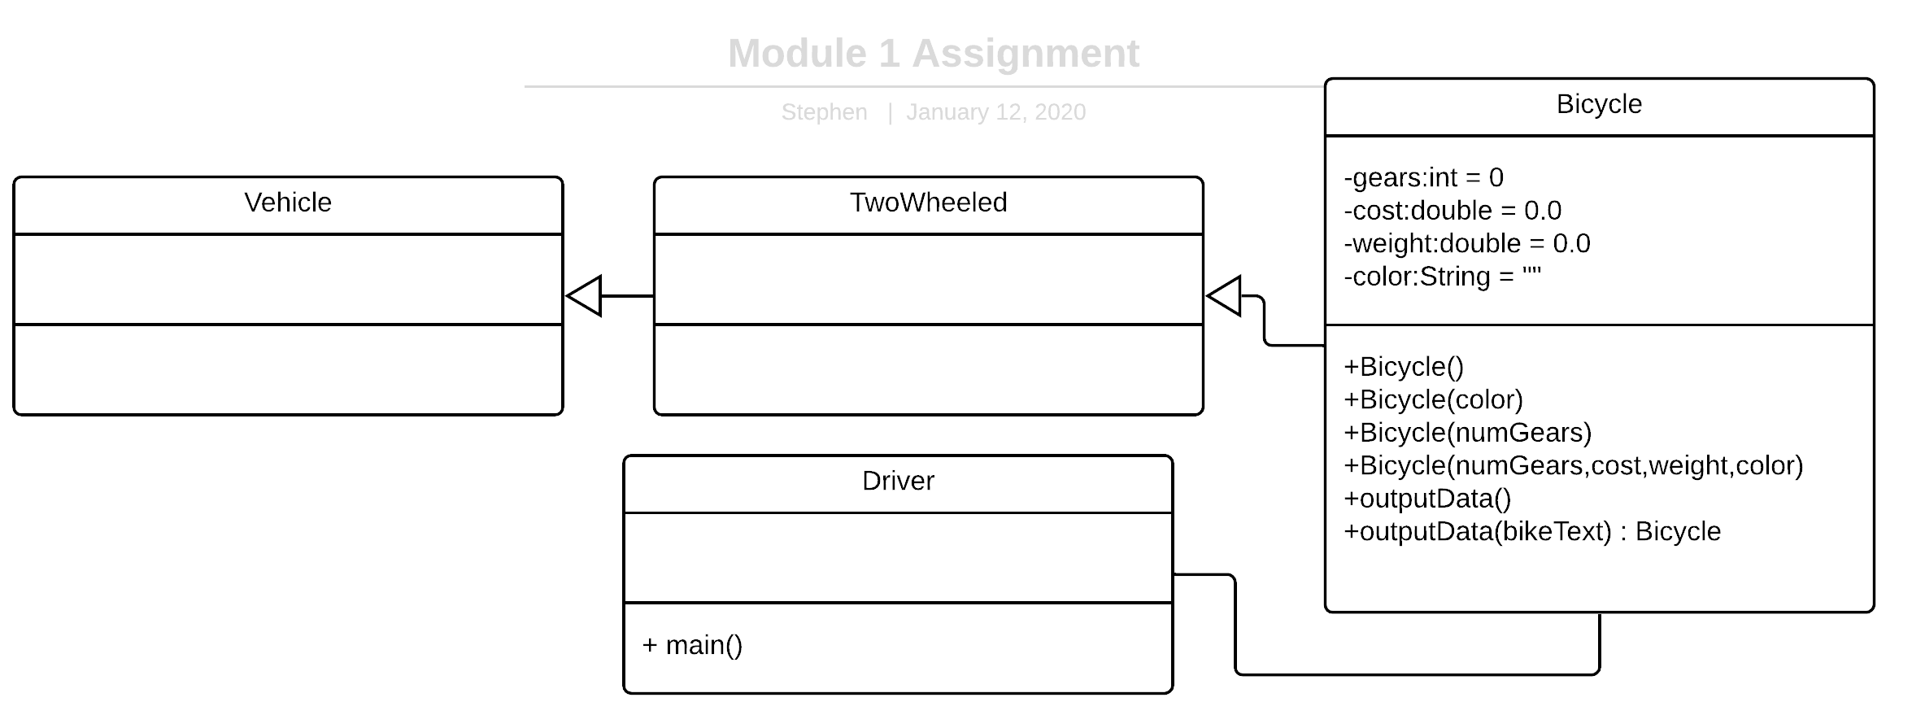

Description

Above is am example of a UML Class diagram for a bicycle inventory system. This UML diagram showcases inheritance and how it works. In this example, we can see that the Bicycle class inherits from the TwoWheeled class, and the TwoWheeled class inherits Vehicle. In this case it is interesting because the Vehicle, and TwoWheeled don’t have any attributes or functions, so the subclasses don’t inherit any behaviors.

Another OOP principal that is showcased in this example is polymorphism. As you can see in the Bicycle class, there are 4 Bicycle(), and 2 outputData() functions. This represents the overloading of the constructor and outputData classes.

The final item to take note of is the relationship between Driver and Bicycle. I wasn’t sure if Driver should be included as its only purpose is to serve as the start of the program. But since I decided to include it, it has a link to the Bicycle class as the bicycle class in instantiated in the Driver’s main method.