USAA Capstone Fall 2026 – Project Details and Expectations

General Information:
Company: USAA
Contact name(s): Dr. Steven Kirtzic, PhD; Sean McNulty, MS; Mohamed Meddouri, MS
Contact E-mail Address(es): steven.kirtzic@usaa.com, sean.mcnulty@usaa.com, mohamed.meddouri@usaa.com
Contact Phone Number(s): (Steven) 214-392-1971, (Sean) 406-396-6221, (Mohamed) 210-665-3624

Project Title:
“AIgents of Nvidia”

Project Description:
Nvidia has revolutionized the world of computing, starting with their GPUs and the development of the CUDA architecture, and finally leading to where we are now with AI, with Nvidia leading the industry in both AI hardware and software. One of their recent releases, the Agent Toolkit offers a host of software, models, and other tools designed to facilitate the creation of AI agents for a variety of purposes. The goal of this Capstone project is to explore the capabilities that the Agent Toolkit provides, and to determine whether this Toolkit is something that is viable for use at USAA and particularly how it compares to alternative options that have already been proven out.

To that end, this project will consist of two parts (and also a stretch goal), which include (1) creating an NemoClaw personal assistant and assessing its capabilities, and (2) creating two additional agents, one as a generic Nvidia agent and the other as a Cortex agent, which are both trained on the same data, and determining which comes out as better based on a variety of metrics.

Project Scope:
Given the above project description, the scope of this project is narrowed to the below defined specific data and functionality, considering the time constraints that a Capstone project presents. With that in mind, the goals of this project can be summarized as follows:
- Upskill in Nvidia Agent Toolkit and Snowflake Cortex agents
- Acquire IoT sample data (see below)
- Build a NemoClaw agent using the Agent Toolkit and evaluate its performance on a variety of IoT tasks
- Build two additional agent models, one as a generic Nvidia agent trained on IoT data, and another as a Cortex Search/Analyst model trained on the same IoT data
- Stretch goal 1: Provide an easy to use interface via Streamlit in Snowflake (SiS), Flask, or comparable service that displays the performance of the Nvidia agent vs. the Cortex agent
- Stretch goal 2: Automatically ingest IoT data into Snowflake rather than manually inserting the data.

Expected Outcomes:
- Create a NemoClaw agent that is capable of performing the functions of a “digital assistant” with incoming IoT data
- Create a separate Nvidia agent trained on the same IoT data
- Create a Cortex Search/Analyst agent trained on the same IoT data
- Compare the Nvidia and Cortex agents on both qualitative and quantitative metrics and produce a comprehensive report on the findings
- Create an LLM with/RAG for generating model training data of a comparable quality to real-world (ground truth) data
- Build a UI (Streamlit, Flask, etc.) to easily display the results of the above comparison (stretch goal)
- Automatically ingest IoT data into Snowflake (stretch goal)
Project Part 1: NemoClaw

Overview

Nvidia NemoClaw is an open-source reference stack that simplifies running OpenClaw always-on assistants. NemoClaw provides onboarding, lifecycle management, and OpenClaw operations within OpenShell containers. It incorporates policy-based privacy and security guardrails, giving you control over your agents’ behavior and data handling. This enables self-evolving claws to run more safely in clouds, on prem, RTX PCs and DGX Spark.
NemoClaw pairs open-source and hosted models (for example Nvidia Nemotron) with a hardened sandbox, routed inference, and declarative egress policy so deployment stays safer and more repeatable. The sandbox runtime comes from Nvidia OpenShell; NemoClaw adds the blueprint, NemoClaw CLI, onboarding, and related tooling as the reference way to run OpenClaw there.
Problem Statement

Autonomous AI agents like OpenClaw can make arbitrary network requests, access the host filesystem, and call any inference endpoint. Without guardrails, this creates security, cost, and compliance risks that grow as agents run unattended, and can even lead to potential malicious attacks such as prompt injections. As a result, agents like OpenClaw cannot be safely deployed in enterprise environments at USAA, such as Eagle, or even in research environments at USAA, such as Alpha, on their own natively. However, the potential benefits for utilizing such agents at USAA are considerable given their power and capabilities, if the appropriate guardrails can be applied and proven to be effective.

Proposed Solution

Nvidia recently released NemoClaw to address the above challenges that can arise from implementing OpenClaw in an enterprise environment without guardrails. The proposed solution is to implement NemoClaw as part of this Capstone project within an isolated environment where the agent’s access to internal resources (data, file systems, identifying/confidential information, tools/applications, etc.) as well as external online resources (websites, models, data, tools/applications, etc.) will be tightly controlled utilizing NemoClaw’s provided policy-based privacy and security guardrails. The benefits of these guardrails include sandboxed execution, routed inference, a declarative network policy, a single CLI, and blueprint lifecycle, among others. For more information on these benefits, see the following:
Benefit | Description
Sandboxed execution | Every agent runs inside an OpenShell sandbox with Landlock, seccomp, and network namespace isolation. No access is granted by default
Routed inference | Model traffic is routed through the OpenShell gateway to your selected provider, transparent to the agent. You can switch providers or models
Declarative network policy | Egress rules are defined in YAML. Unknown hosts are blocked and surfaced to the operator for approval
Single CLI | The Nemoclaw command orchestrates the full stack: gateway, sandbox, inference provider, and network policy
Blueprint lifecycle | Versioned blueprints handle sandbox creation, digest verification, and reproducible setup

Solution Approach

The proposed solution approach to this problem involves building an autonomous agent using NemoClaw that can successfully accomplish its goals without raising any security concerns. We want to use this project as a way to explore the capabilities of “Claws” within the NemoClaw framework and see how we may be able to utilize said capabilities within USAA. To that end, this is the following use case: Design an autonomous agent (claw) that can do the following:

- Monitor a Snowflake database which receives and stores Internet of Things (IoT) data
- If new IoT data has been added to the DB, the agent needs to be able to summarize the new data in the form of a report
- This report needs to be emailed to the business partners*
- A notification needs to be sent to the business partners that a new report is available via an instant messaging service*
- The report needs to be made available via an interactive UI frontend for easy consumption to the stakeholders*
- The UI should include the ability to drill down into the findings in the report performing computations on the fly as needed
- The report needs to be saved locally by the agent
- The results of the above IoT additions need to be logged and saved in a local file for auditing purposes
*Note: As this project will be a Capstone project completely outside of USAA, no actual business partners or stakeholders will be emailed or notified of anything. They will be simulated and the associated DB, email, and instant messaging accounts will be set up outside of USAA

Process Flow Diagram

Below is the proposed flow of processing for this part of the project:

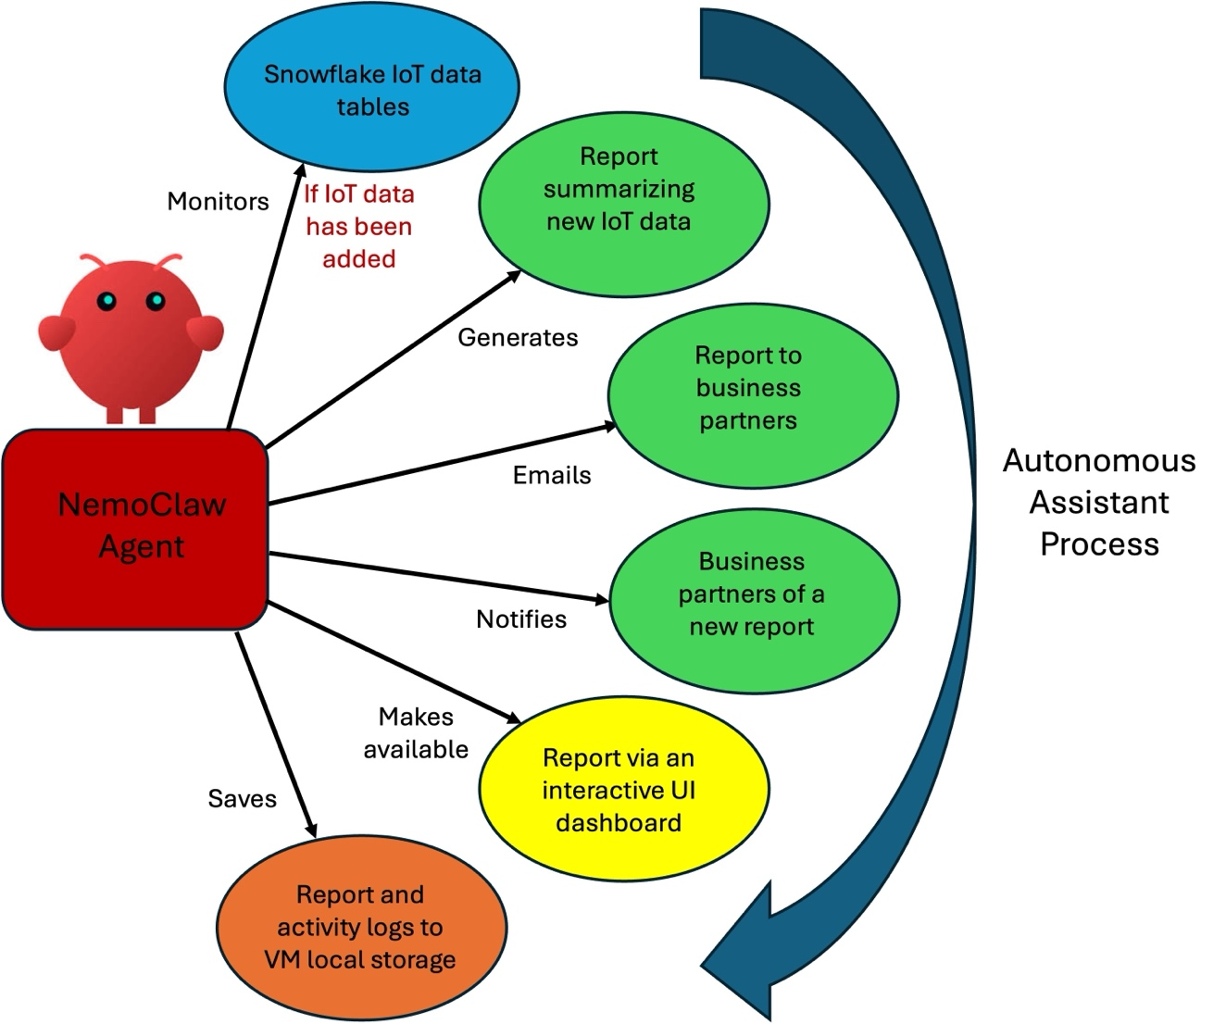

Solution Evaluation

At the conclusion of this part of the project, you should produce a report of your experience with NemoClaw, which includes the following:

- Ease of implementation of the agent
- Time required to implement the agent
- Resources required to implement the agent
- Impediments encountered in implementing the agent (if any)
- Additional evaluation metrics may be included as time allows

Part 2: Nvidia Agent vs. Cortex Agent

Overview

The Nvidia Agent Toolkit is an open, modular software stack designed for developers to build, secure, and optimize autonomous multi-agent AI systems in enterprise environments comprising models, tools, skills and a secure runtime. It acts as a foundation to connect AI agents to internal data sources and third-party frameworks, allowing them to autonomously determine how to complete assigned tasks.

Key Components of the Toolkit

- Nemotron Open Models: Fully customizable, open-weight foundation models designed to handle complex, long-running task inference and reasoning
- NemoClaw Blueprints & Framework Integration: Standardized behavior templates that work with major agent orchestration frameworks like LangChain, CrewAI, and Agno “free from vendor lock in”
- OpenShell Secure Runtime: A secure-by-design runtime that provides sandbox isolation, fine-grained permissions, and privacy guardrails so autonomous agents can safely execute inside corporate infrastructures
- NVIDIA Omniverse Libraries: Tools that grant AI agents the ability to perform physical AI simulations - like validating 3D assets or GPU-accelerated physics testing - before autonomous systems are used in the real world

Problem Statement

At USAA, we are actively working to research and develop agentic models from a variety of vendors and sources that we have vetted and deemed safe for use within our various development environments. To date, Nvidia products have not been cleared for active developmental use, how Snowflake Cortex LLM agents have proven themselves to be reliable and productive, especially as they have been utilized in previous Capstone projects, which essentially has established Cortex agents as a sort of “ground truth”. The goal, then, of the second part of this Capstone project is to prove out whether Nvidia’s Agent Toolkit can create agents that can be just as good, if not better, than Cortex agents, based on a variety of metrics.

Proposed Solution

The proposed solution is to utilize both the Agent Toolkit and Cortex to create “identical” agents using the same IoT data as described in Part 1 of this project to train the models. You will then compare the performance of the two models and produce a report of that comparison. If time allows, you will create a UI which allows for visualization of the results of the model comparison for easier consumption. At the end of the semester, the results of your research will be presented at a presentation for USAA shareholders.
Solution Approach

- Once you have set up the Snowflake DB and successfully ingested IoT data into it from the data sources identified below for the NemoClaw agent described in Part 1 of this project above, you will use that data to train both the Nvidia agent and the Cortex agent. You can think of it as the NemoClaw agent is bringing in the IoT data and processing it, and then making it available for the Nvidia agent and Cortex agent to be trained with. Once you have the data and can train both agents with a sufficient amount of data, you will then compare their respective performances and produce a report based on a variety of qualitative and quantitative metrics, including but not limited to:

- Ease of implementation of the agent
- Time required to implement the agent
- Resources required to implement the agent
- Impediments encountered in implementing the agent (if any)
- Performance metrics for trained agents on identical datasets which include metrics such as:
  - Precision
  - Accuracy
  - F1-score
  - Recall
- Additional evaluation metrics may be included as time allows

Final Deliverable

At the end of the semester, your final deliverable will include the two reports indicated above, the report on your overall conclusions with your experience with NemoClaw, and your conclusions on your comparisons between the Nvidia agent and the Cortex agent. This report should be in an easily consumable format (e.g., Word doc, .pdf, etc.).

Stretch Goals:

If you have the time, there is a “stretch goal” and then a “Reed Richards super stretch goal”

- Stretch goal: Create a frontend for displaying the results of your model comparisons in Part 2 via Streamlit in Snowflake (recommended), Flask, or other frontend in a using data visualizations such as charts, graphs, etc.

- Super stretch goal: Design and implement a process by with IoT data is automatically deposited into the Snowflake DB from another source on a regular basis, as opposed to you having to do it manually

Data Sources:
- Sample smart home IoT data at the following locations:
  - https://www.kaggle.com/datasets/pythonafroz/smart-home-dataset?select=preprocessed_dataset.csv
  - https://data.mendeley.com/datasets/t9n68ykfk3/1
  - https://ieee-dataport.org/documents/smart-home-energy-consumption-dataset-ai-driven-residential-load-forecasting-and-demand
  - https://data.mendeley.com/datasets/zgsw84b2ff/1
  - https://zenodo.org/records/16343844
  - https://github.com/TechnicalBuildingSystems/OpenSmartHomeData
  - https://www.kaggle.com/datasets/prince7489/household-water-consumption-dataset
  - https://openenergyhub.ornl.gov/explore/dataset/smart-data-set-for-sustainability/information/
  - https://www.nature.com/articles/s41597-024-03208-0
  - https://datashare.ed.ac.uk/items/15e82917-56ed-4282-99ef-7f211bf87f9d
  - https://www.kaggle.com/datasets/prince7489/smart-home-energy-usage-dataset
  - https://data.mendeley.com/datasets/pxnb7gh646/1
  - http://ampds.org/
  - https://vbn.aau.dk/en/publications/residential-household-dataset-occupancy-water-and-electricity-dat/
  - https://github.com/Water-End-Use-Dataset-Tools/WEUSEDTO
  - https://www.pecanstreet.org/2025/07/public-data/

Technical Resources Provided:
- UTD will provide the following technical resources:
  - A VM hosted at UTD
  - A Google Colab online development environment
  - A Google Drive storage environment
  - A Snowflake RDBMS environment (TBD)
  - An HPC (TBD)
- USAA will provide the following:
  - Weekly touchpoint meetings to discuss the project’s progress and provide direction
  - Full access to the project corporate sponsors (Steven, Sean, and Mohamed, as indicated above) via email and phone (if needed)
  - An external GitHub repo for the team’s use
- USAA will NOT provide the following:
  - Access to USAA’s hardware, software, network, or internal data

Team Roles & Responsibilities:
Suggested team roles:
- Project Manager: Oversee timeline, deliverables, and coordination
- Data Engineer: Prepare and enrich Snowflake datasets
- ML Engineer: Develop and fine-tune LLMs and embedding models
- Backend Developer: Implement Cortex workflows, stored procedures
- Frontend Developer: Build chat UI and integrate with backend
- QA Tester: Test system functionality and user experience
- Business Analyst: Define use cases, gather user feedback

Project Timeline:

Start Date: August 24th, 2026

Key Dates & Milestones:
- August 24th: First Day of Class

- August - September: Planning/Research Phase
  - January 28th: Meet & Greet with the student team at UTD
  - Upskilling with the needed technologies
  - Acquire IoT data

- October- November: Prototyping Phase
  - Have a working prototype for the NemoClaw model
  - October 17th: Midterm Grades Due
  - October 30th: Midterm Presentation to USAA (Tentative)
  - Begin work on the two remaining models

- November - December: Refinement Phase
  - Thanksgiving Break: 11/26 – 11/29

- December: Finalization Phase
  - Have finalized code for the NemoClaw agent
  - Have finalized code for the other Nvidia agent and Cortex agent
  - Have finalized report comparing the Nvidia agent and the Cortex agent
  - December 21st: Final Grades Due
  - TBD: Final Presentation to USAA
  - TBD: Technical Deep Dive for USAA
  - TBD: Project Final Deliverables Intake (i.e., code, documentation, etc.)

Skills Needed for the Project:
- Required skills:
  - Python
  - SQL
  - Relational database
  - Machine Learning background (preferably in Natural Language Processing (NLP))
  - Front-end development
  - Good communication and organizational skills

- Preferred skills/skills to be developed:
  - LLM with/RAG (Retrieval Augmented Generation) system design and development
  - Multimodal Gen AI model development
  - Prompt engineering
  - Use with specific libraries such as HuggingFace and OpenAI
  - Use with technologies such as transformers and LangChain
  - Use with front-end technologies such as Streamlit and Flask
  - Use with Agentic AI

Nvidia Training Material:
- https://openclaw.ai/
- https://clawhub.ai/
- https://docs.nvidia.com/nemoclaw/latest/get-started/quickstart.html
- https://developer.nvidia.com/nemo-agent-toolkit#:~:text=NVIDIA%20NeMo%E2%84%A2%20Agent%20Toolkit,%2C%20observability%2C%20and%20continuous%20learning
- https://www.nvidia.com/en-us/ai-data-science/foundation-models/nemotron/
- https://www.nvidia.com/en-us/ai/nemoclaw/#referrer=vanity
- https://nvidianews.nvidia.com/news/nvidia-announces-nemoclaw?ncid=em-even-503-en-us-1-l4&nvweb_e=3Nf7QTY-gAaFiCdcBIJOmeISsYUZtfs80X3TEGqYJrDnOKBXlyvL5Wls39__L32HP-nwVAubaVotcwDj1AXr1g&mkt_tok=MTU2LU9GTi03NDIAAAGgm8ehoxEOtwVT5-OcVAMYJR6UY_vbmoZu0MjduQlGGMSl5rOwlYwBI8HTUcuYGYwgJkBQ5snormqiFvjrTdZtejxuXFucXwRtN40HS1JBIZgLd8Ko-zfG
- https://www.nvidia.com/gtc/keynote/
- https://www.nvidia.com/gtc/training/build-a-claw/
- https://nvidianews.nvidia.com/news/ai-agents?ncid=em-anno-339007-1&mkt_tok=MTU2LU9GTi03NDIAAAGhF6P81jah_Dxq3ul2wUhN8u3pQKZHXUCfujwriDcw9b-VKTepPwI8e_ec0Q_8I9daZGAcphtw1LzBcxgThHJkvGuQciNRA73ov6MQO3LqFs5UWAIg5_1p3Au24E2ixUI
Snowflake Training Material:
- First you’ll need to create a Snowflake Community account, which will then allow you to create a trial SF account to do the actual work. There is no cost and they will give you 400 credits up front BUT it only lasts for 120 days. You can create your Snowflake Community account here: https://community.snowflake.com/s/login/?startURL=%2Fidp%2Flogin%3Fapp%3D0sp3r000000XZBA%26binding%3DHttpPost%26inresponseto%3D_a0f2e69699fe24f608b9e88da455d05a&ec=302
- Then you’ll have access to all the intro training material here: https://training.snowflake.com/lmt/clmsbrowsev2.prMain?in_sessionid=512528J4458J8J19&in_category_id=1687. There is an intro course which will take 6-8 hours to complete (if you choose to do the entire course), but you will receive a certification at the end of it. That can be found here: https://training.snowflake.com/lmt/clmsCourseDetails.prMain?in_sessionId=512528J4458J8J19&in_offeringId=98874317&in_from_module=LMTLOGIN.PRMENU (Note if that link doesn't take you directly to the course, once you log into Snowflake Community navigate to the Free On-Demand Training and look for the one entitled "Data Warehousing Workshop (Badge 1)"). If you don’t wish to complete the entire course, however, this is where you will find the information on setting up you Snowflake trial account
- Regarding creating a combined Cortex Search and Analyst agent, so far the best tutorial in doing so can be found here: https://quickstarts.snowflake.com/guide/getting_started_with_cortex_agents/index.html?index=..%2F..index&_ga=2.148336053.320475288.1756134461-358179241.1755212266#0.
- Other agent info: https://docs.snowflake.com/en/user-guide/snowflake-cortex/cortex-agents-manage#label-snowflake-agents-create
- https://medium.com/@paul.needleman/how-to-snowflake-cortex-agents-8e6c818b0e14
- https://docs.snowflake.com/en/user-guide/snowflake-cortex/cortex-agents-tutorials

General LLM Training Material:
- https://medium.com/data-science-at-microsoft/evaluating-llm-systems-metrics-challenges-and-best-practices-664ac25be7e5
- https://foundationcapital.com/foundation-model-ops-powering-the-next-wave-of-generative-ai-apps/
- https://huggingface.co/EleutherAI
- https://github.com/microsoft/promptbench
- https://www.coursera.org/learn/generative-ai-with-llms
- https://www.deeplearning.ai/short-courses/building-multimodal-search-and-rag/
- https://medium.com/@francesco.cozzolino/top-truly-free-and-open-source-vector-databases-2024-72d179e84277
- Finally, there are a TON of advanced ML/AI courses (as well as other topics) here: https://quickstarts.snowflake.com

