**BSAI-3B**

**Lab_Task_2**

**Syed Tahir Ali 103**

**(FizzBuzz Game)**

**Overview:**

**This is a Dynamic FizzBuzz Game built in Python.  
The twist in this version is that instead of simply counting numbers in sequence, the game adds a random number to the previous one and challenges the player to identify the correct output (Fizz, Buzz, FizzBuzz, or the number itself).**

**The goal is simple:**

* **One wrong guess and the game ends.**
* **Survive through the rounds to keep winning!**

**How It Works:**

**1. Player Setup**

* **The game welcomes the player and asks for their name.**
* **Rules are displayed so the player understands how to respond.**

**2. Random Number Generation**

* **Each round, the program generates a random number between 1 and 20.**
* **This number is added to the previously generated number to form a running total (t).**

**3. FizzBuzz Rules Applied on the Running Total**

* **If t is divisible by both 3 and 5, the correct answer is "FizzBuzz".**
* **If t is divisible by 3 only, the correct answer is "Fizz".**
* **If t is divisible by 5 only, the correct answer is "Buzz".**
* **Otherwise, the correct answer is simply the number itself (as a string).**

**4. Player Input & Checking**

* **The player must type their answer (Fizz, Buzz, FizzBuzz, or the number).**
* **The program checks the player’s guess against the correct result.**
* **If the guess is wrong, the game displays the correct answer and ends immediately.**

**5. Winning Condition**

* **The game continues indefinitely until the player makes a mistake.**
* **If the player survives all rounds, they are declared the winner (though realistically, the challenge goes as long as they can).**

**Example Run:**

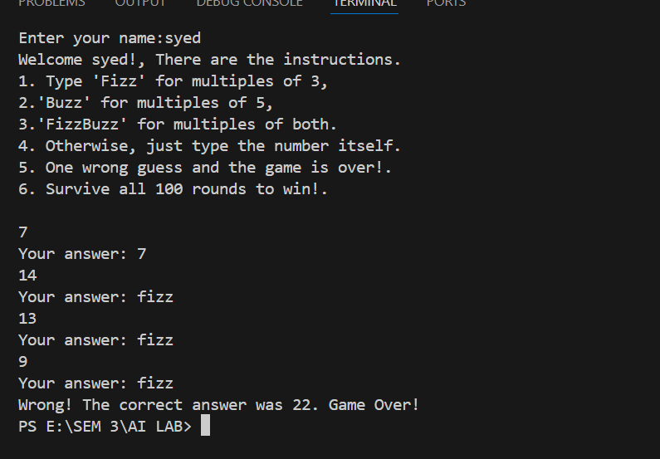

**Features:**

* **Randomized gameplay → makes every round unpredictable.**
* **Dynamic running total instead of simple counting.**
* **Strict FizzBuzz rules applied at each step.**
* **Instant feedback when the player makes a mistake.**
* **Replayability: outcomes change every time due to randomness**