**BSAI-3B**

**Lab_Task_2**

**Syed Tahir Ali 103**

**Movie Budget Project**

**Overview:**

This is a **Movie Budget Analysis Project** built in Python.  
The program stores a collection of movies and their budgets, calculates the **average budget**, and shows which movies are above that average.

The project is interactive, allowing users to:

* View all movies in the dataset.
* Add new movies and their budgets.
* Display the average budget and identify which movies exceed it.

**How It Works:**

**1. Initial Dataset**

* The program starts with a predefined list of movies, each paired with its budget (e.g., *Oppenheimer*, *Interstellar*, etc.).

**2. User Menu**  
The program runs continuously, presenting the user with the following options:

1. **Show All Movies** → Displays all movies and their budgets.
2. **Add Movies** → Allows the user to input new movies and budgets.
3. **Show Average and High Budget Movies** → Calculates the average and lists movies above it.
4. **Exit** → Ends the program.

**3. Adding Movies**

* The user chooses how many movies to add.
* For each, the program asks for the **name** and **budget**.
* These are added to the dataset dynamically.

**4. Calculating Average Budget**

* The program sums up all movie budgets.
* Divides the total by the number of movies.
* Displays the average as a whole number (no decimals).

**5. Movies Above Average**

* Each movie is compared against the average.
* If a movie’s budget is higher, it is displayed along with the difference.

**6. Displaying Results**

* A summary is shown with:
  + The average budget.
  + A list of movies above average (if any).
  + The total count of above-average movies.

**Example Run:**

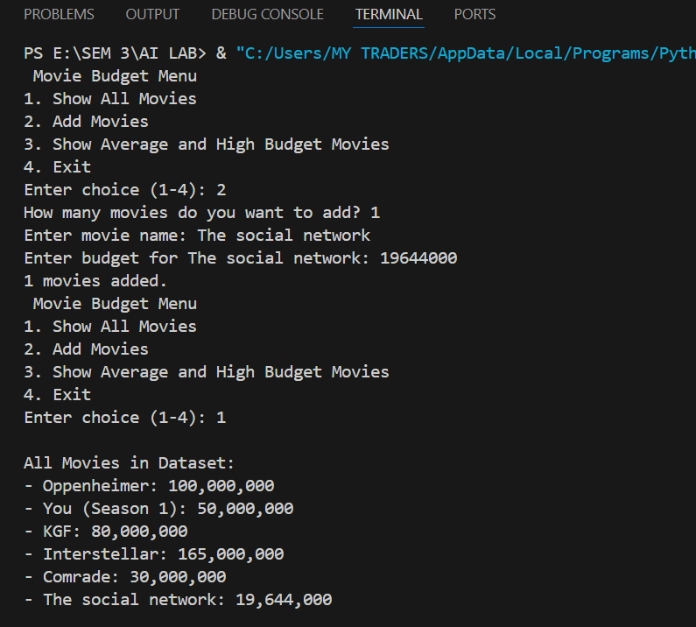

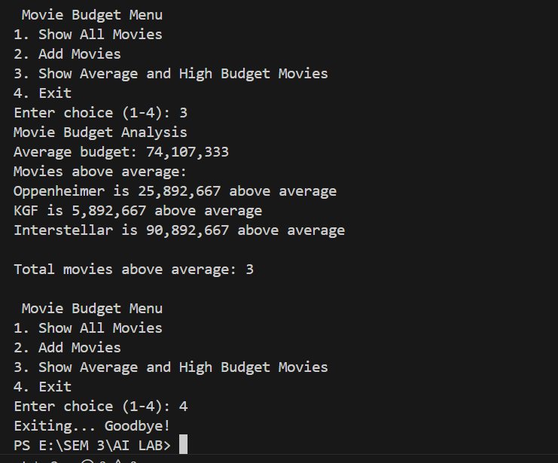

**Features:**

* **Interactive menu-driven interface.**
* **Dynamic dataset** – movies can be added anytime.
* **Accurate budget analysis** using averages.
* **Clear results** showing above-average movies with differences.
* **User-friendly design** with options to exit gracefully.