**Functionalities of the System - Modules**

**Home page** modules can see the front page of the website which the client suggest keep the design simple which they said the color theme is neutral colors which are brown white black and etc.

**Header (Projects/Details/Contact/Architects)**

Includes house type, details of the houses, contact to the admin of the website and the people who are working for the company and their contact infos.

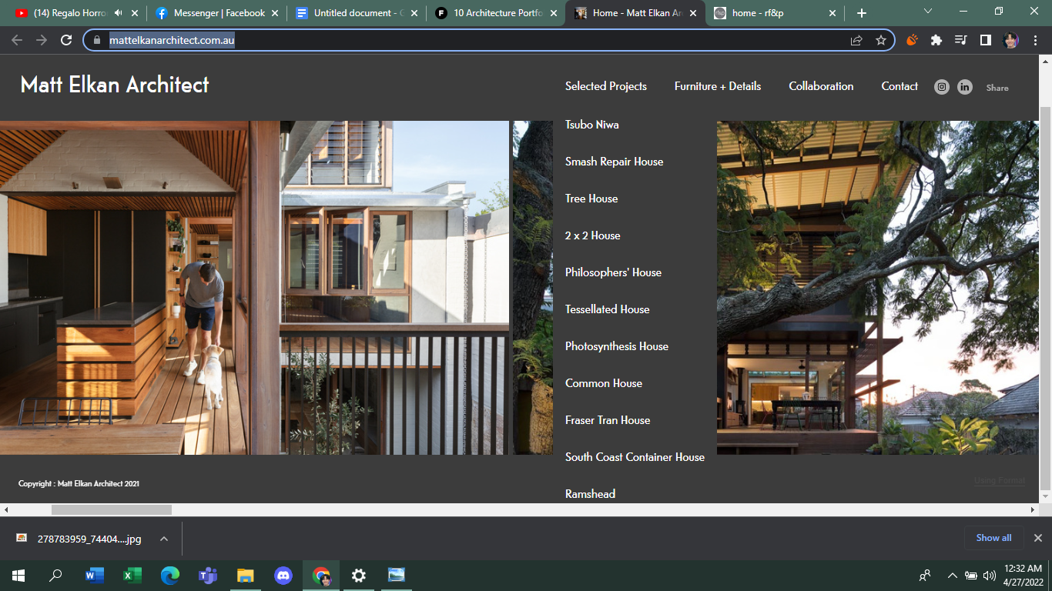

**Log in modules** -client side

Log in side of client which can include sign up, and sign in

**Admin Modules** - Admin side include upload of 3d model / Floorplans / House models / previous work model

**Upload modules** (admin side)

This page contains the file upload of the admin which may include previous works, archive and much more.

**REFERENCE**

<https://www.revelfox.co.za/>

<https://www.mattelkanarchitect.com.au/>