**Building 0 – Longitude using only WAPs**

Random Forest

RMSE Rsquared MAE

11.4955001 0.8139648 8.4716278

GBM

RMSE Rsquared MAE

14.7972344 0.8565039 11.2545421

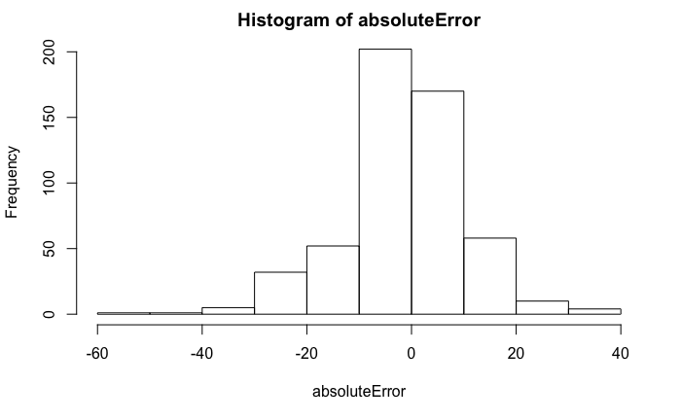

Building 1 – Longitude using only WAPs

Random Forest

RMSE Rsquared MAE

17.2281603 0.8827718 13.8483887

GBM

RMSE Rsquared MAE

25.0531938 0.8611451 21.4898421

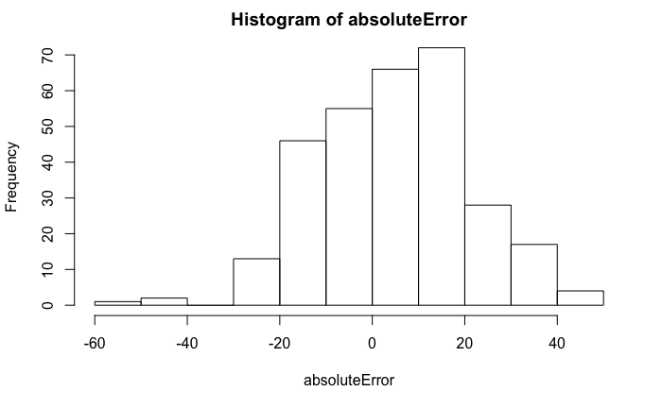

Building 2

Random Forest

RMSE Rsquared MAE

23.9917382 0.5544172 16.1967696

GBM

RMSE Rsquared MAE

25.8712090 0.6023656 19.2859512

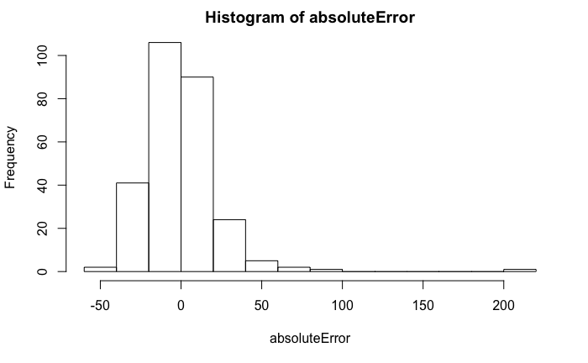

**Building 0 – Latitude using only WAPs**

Random Forest

RMSE Rsquared MAE

26.0308804 0.7284988 22.1296096

GBM

RMSE Rsquared MAE

16.7078182 0.7377273 10.2093539

