**React**

**Day 14th**

**JSX**

React element object consists of $$typeof, props, key, ref and type. $$typeof is a special property in react JS for safety and security purpose this was because can’t just put Symbols in JSON. Because JSON does not have a property called `**$$symbol**` but internally react uses JSON so we need this property coming from JSON.

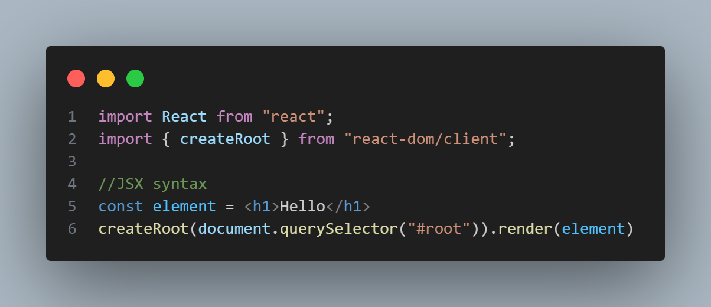**JSX syntax**

**JSX Rules**

1. JSX should be closed
   1. <h1> Hii </h1> ✅
   2. <h1> Hii <h1> ❌ (unterminated JSX contents)
2. Every self closing tag needs to be closed also. If it is void element it needs to be closed.
3. JSX expression must have a parent element
   1. <h1>Hello</h1>  
      <h1>Hello</h1>❌
   2. <div>  
      <h1>Hello</h1>  
      <h1>Hii</h1>  
      </div>✅