**React**

**Day 16th**

**JSX**

JSX is a JS syntax extension that looks similar to XML. You can use a simple JSX syntactic transform with react.

**Why JSX**

You don’t have to use JSX with React. You can just use plain JS. However, we recommend using JSX because it is a concise and familiar syntax for defining tree structures with attributes.

It’s more familiar for casual developers such as designers.

XML has the benefit of balanced opening and closing tags. This helps make large trees easier to read than function calls or object literals.

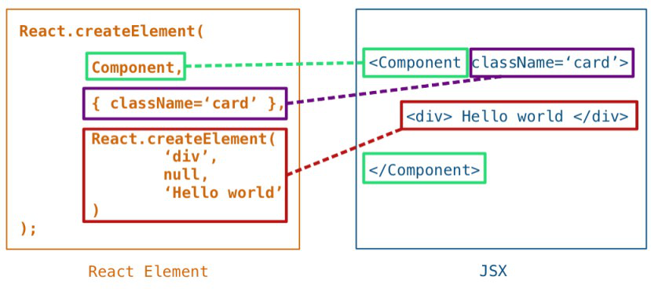It doesn’t alter the semantics of JavaScripts.

**Fragment**

If you add same level of elements react will not accept it because syntax wise it’s not correct you should wrap it with one parent element if you add a parent then DOM will create an extra node to the list so for optimization purpose it is not correct to overcome that issue instead of parent element you can go with fragments.

Document fragments are DOM Node objects which are never part of the main DOM tree. The usual use case is to create the document fragment, append elements to the document fragment and then append the document fragment to the DOM tree. In the DOM tree, the document fragment is replaced by all its children.

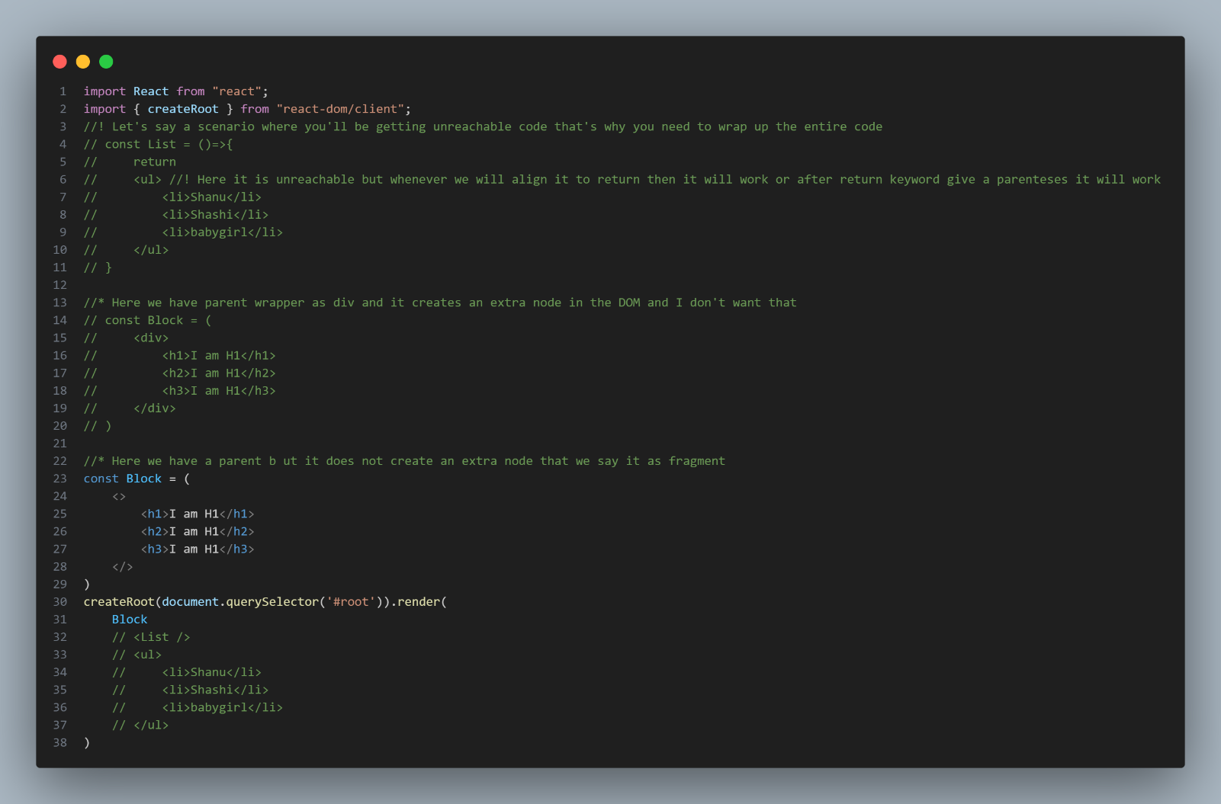**Fragment examples**

A common pattern in React is for a component to return multiple elements. Fragments let you group a list of children without adding extra nodes to the DOM. There is also a new short syntax for declaring them.

It is a react property you can access it like `**import React {Fragment} from “react”**` or you can also use it in the document wherever you don’t want to create an extra node as follows.

`**<React.Fragment>**

**<h1>Hello</h1>**

**<React.Fragment>**`

Fragment is a react property which is used to attach an element to the DOM without creating any extra node. It can accept only `**key**` prop except it, it won’t accept any other properties. Instead of the above syntax you can use shorthand as follows.

`**<>**

**<h1> Hii I am Shanu</h1>**

**</>**`

After using fragment like this you can’t even add any props even key.

**What is JSX expressions??**

With JSX you can write expressions inside curly braces { }.

The expression can be a react variable, or property or any other valid JS expression. JSX will execute the expression and return the result.

Inside JSX if you wanna give a class to an element then you need to go with `**className**` attribute.

If you wanna give label to an input you need to use `**htmlFor**` attribute.

Instead of lowercase here we use camel case.