**React**

**Day 24th**

**Props**

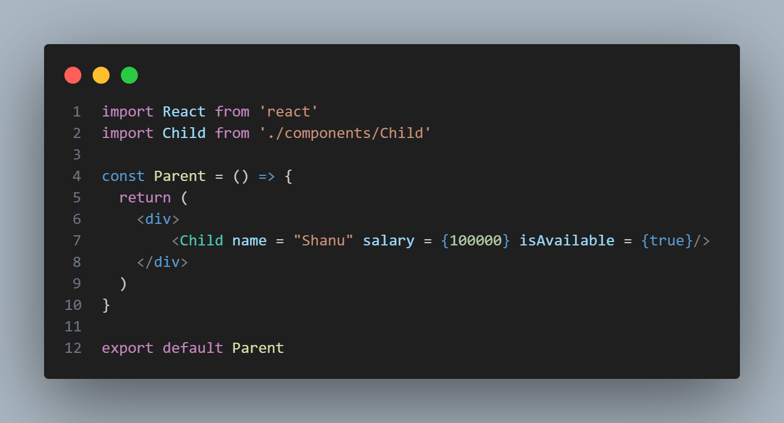In props you can’t send data directly except string you will need to send it inside an expression as follows.

You can’t print boolean value on the UI it is just for conditional purpose (true, false, undefined, null)

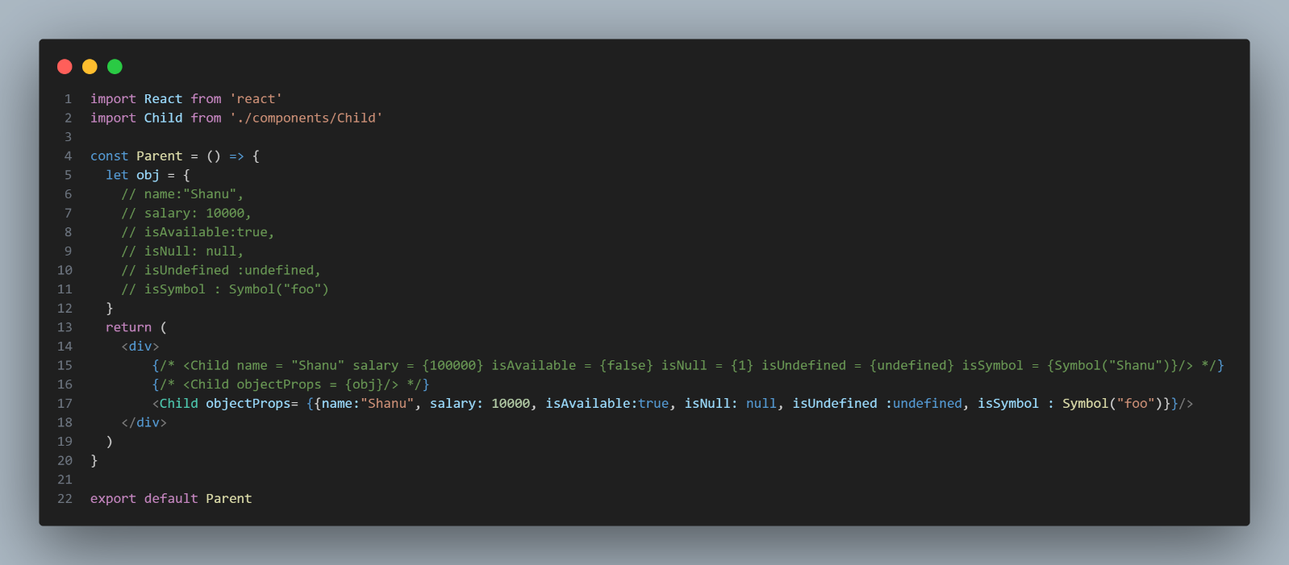If you wanna pass object directly as props you can but you need to wrap it into two Flower braces because the first one refers to expression and the second one is for object literals as follows.