**React**

**Day 25th**

**Props**

**What is props.children??**

`**props.children**` The important thing to note here is that children are a special prop that is used to pass the data from the parent component to the children component but this data must be enclosed within the parent’s opening and closing tag.

The concept of **children props** far less twisted than it sounds when placed within the context of React.js code.

The {props.children} property allows you to create a generic template component that can be modified by the parent when it is invoked. This means that the parent component can pass whatever is needed in the child component, even generated layout features that can then be rendered by the child.

**What even is `children`??**

The react docs say that you can use props.children on components that represents **generic boxes** and that don’t know their children ahead of time. For me that didn’t really clear things up. I am sure for some that definition makes perfect sense but it didn’t for me.

My simple explanation of what this.prop.children does is that it is used to display whatever you include between the opening and closing tags when invoking a component.

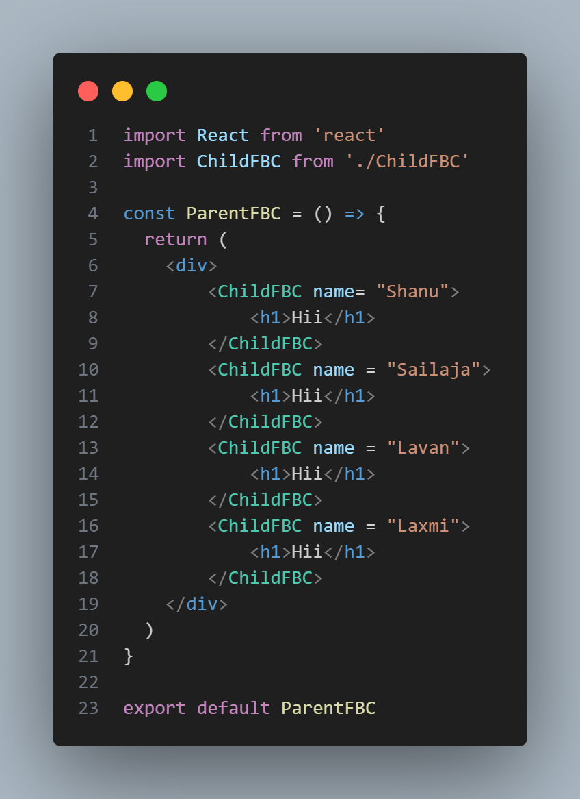Here is the uses (Functional Based Component)

**Parent Component**

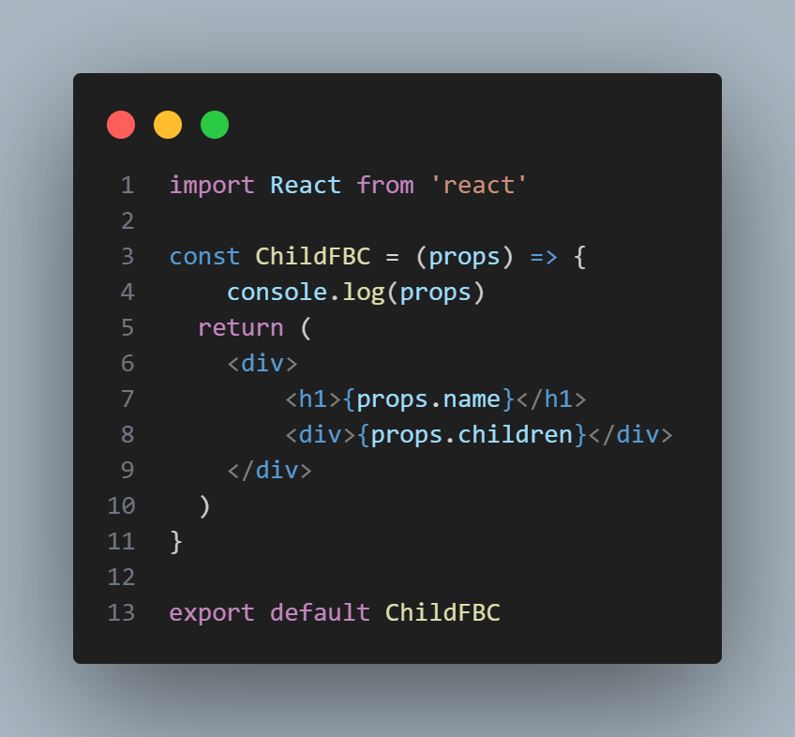**Child Component**

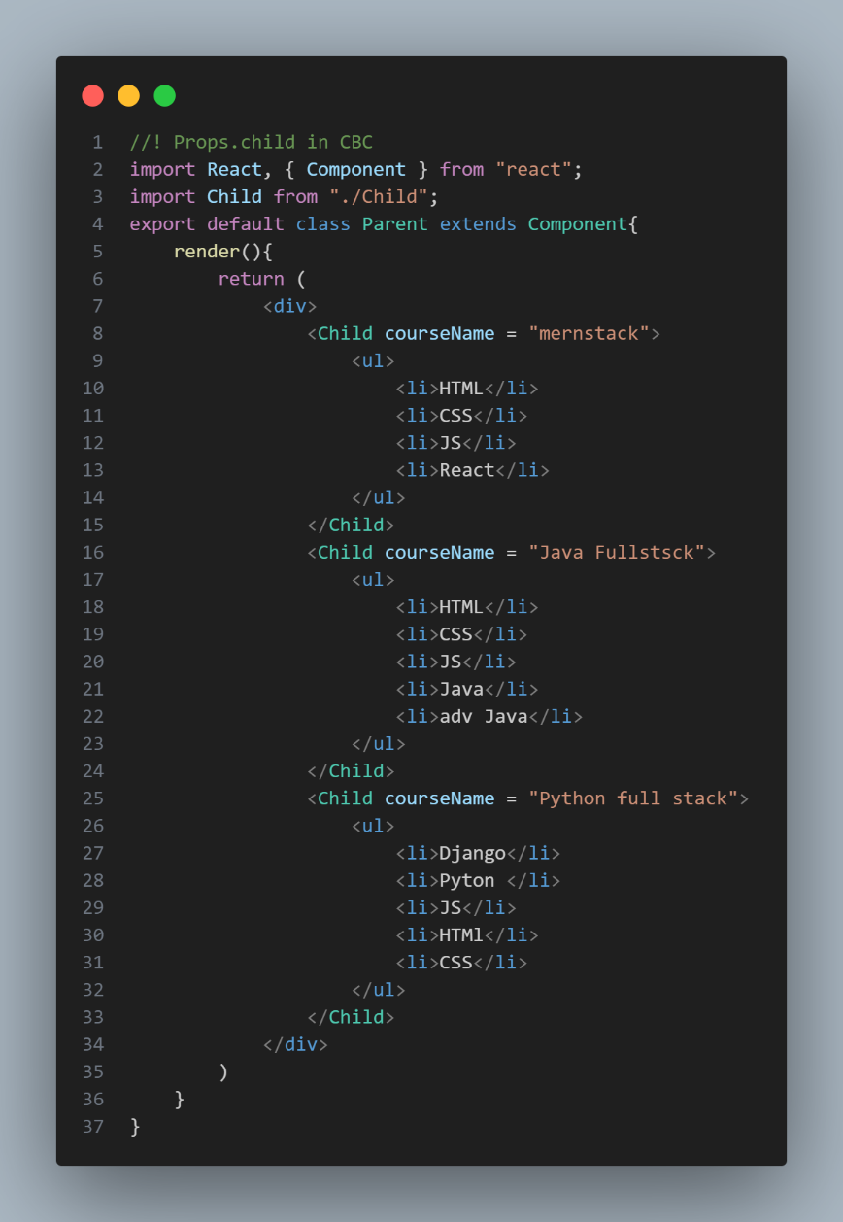Uses in class based Component

**Parent Component**

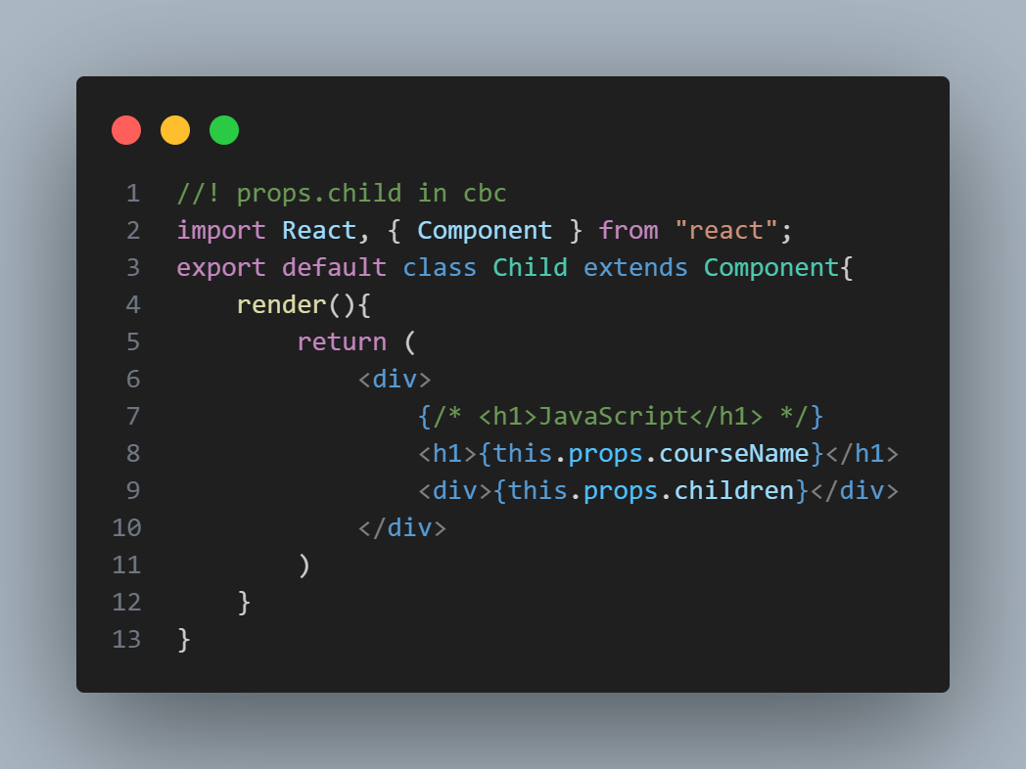**Child Component**

**Default Props**

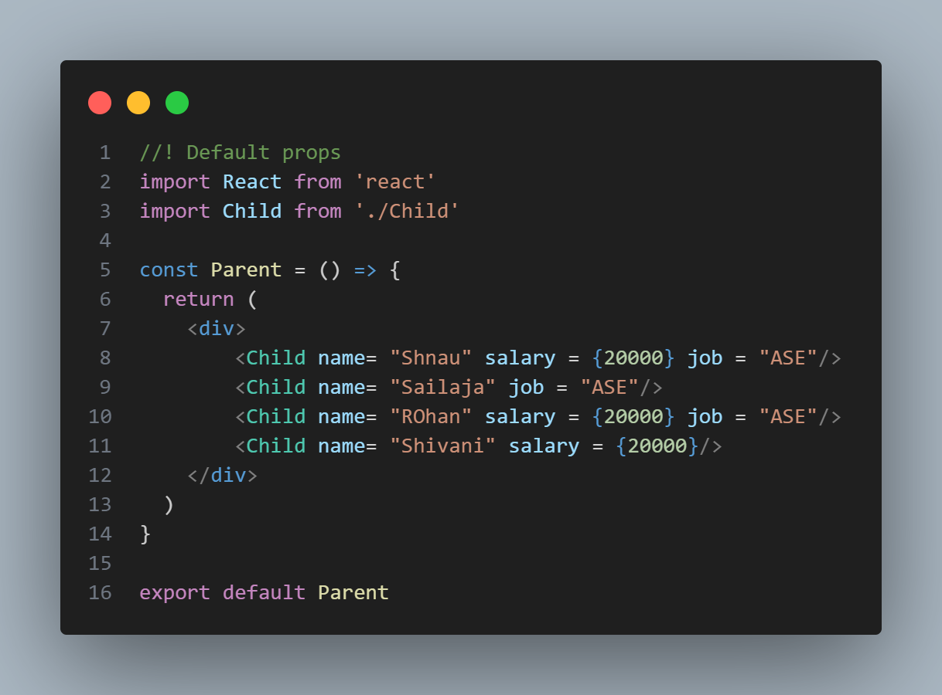The default props is a react component property that allows you to set default values for the props arguments. If the prop property is passed, it will be changed. The defaultProps can be defined as a property on the component class itself, to set the default props for the class.

Function based Component

**Parent Component**

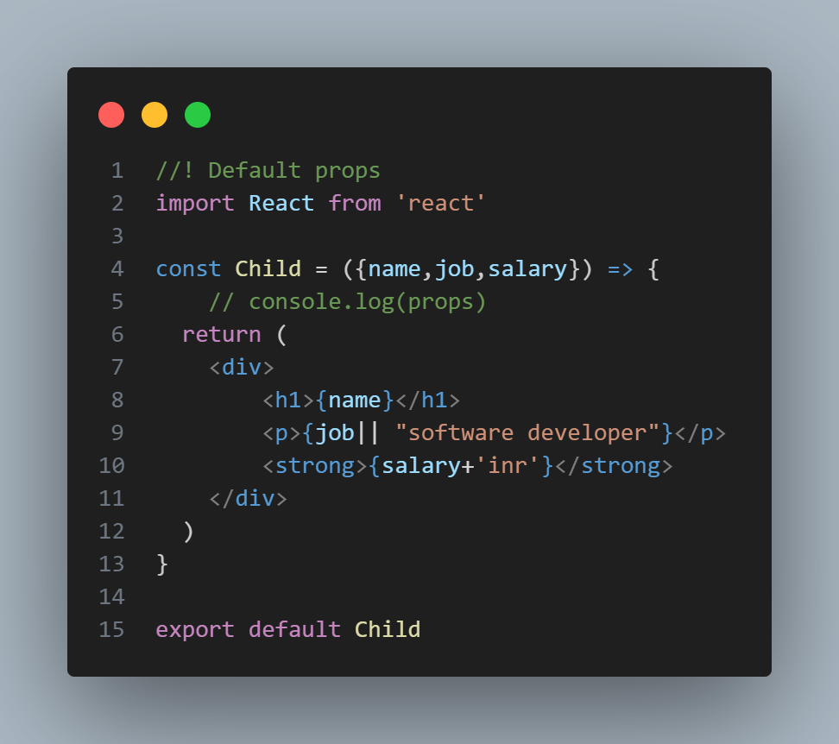

**Child Component**

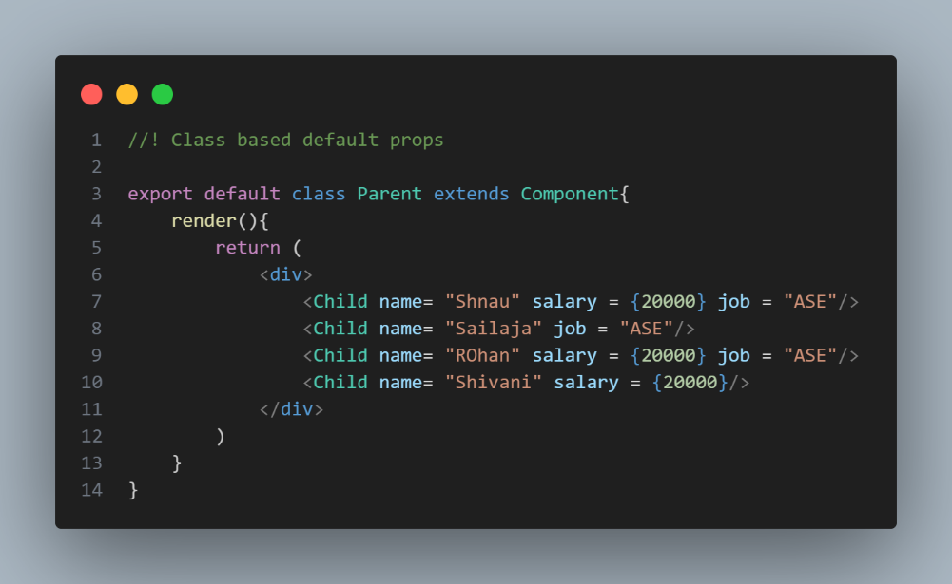**Class based Component**

**Parent Component**

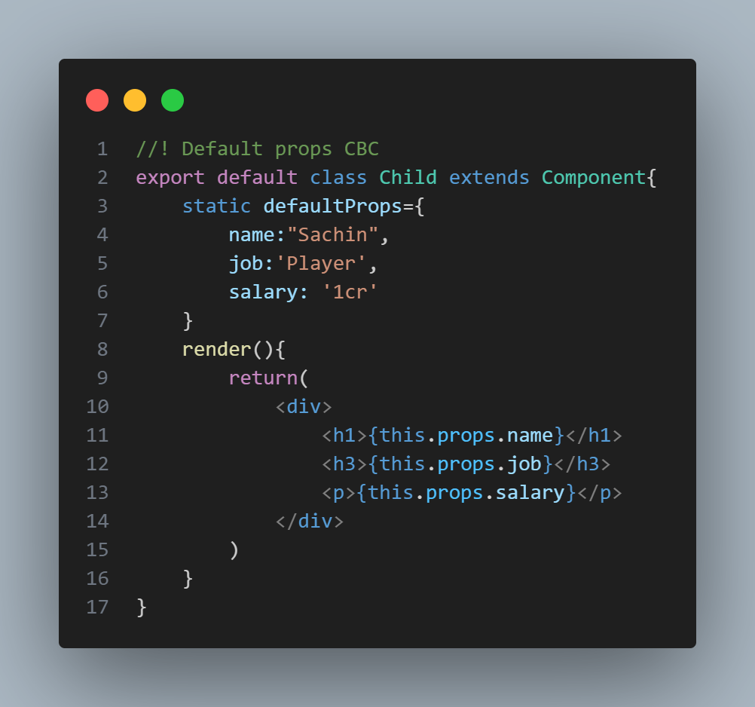**Child Component**