**React**

**Day 4th**

**ReactJS installation:**

There are many ways to install react JS:

React

Node JS

CLI

**CLI** stands for Command Line Interface. We have two CLI Create app and vite or another method we can create our own CLI.

Vite

Create React App

CDN way

Installation

**CDN** stands for Content Delivery Network. **It’s a group of geographically distributed servers that speed up your delivery of web content by bringing it closer to where user are. Data centers across the globe users caching a process that temporarily stored copy of files that you can access internet content from a web enabled devices like browsers. And it is much faster than your local installation most of the production application they use CDN.**

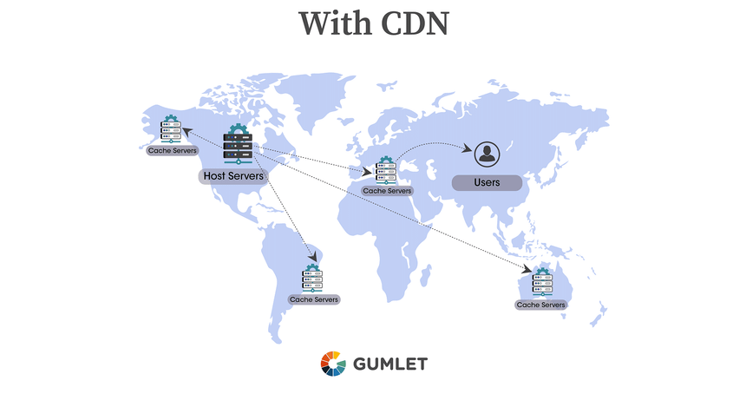

**Advantages of using CDN**

* Improving website load times
* Reducing bandwidth cost
* Increasing content availability and redundancy
* Improving website security

**What is CDN???**

A **CDN** Content Delivery Network is a geographically distributed group of servers that caches content close to end users. A CDN allows for the quick transfer of assets needed for loading internet content, including HTML pages JavaScript files, stylesheets, images and videos.

The popularity of CDN services continues to grow and today the majority of web traffic is served through CDNs, including traffic from major sites like Facebook, Netflix and amazon.

A properly configured CDN may also help protect websites against some common malicious attacks, such as Distributed Denial of Service (DDOS) attacks.

📝Next generation JavaScript like ES6, ES7, ES8, ES9, ES10 and ES22 but browser can understand ES5 and some modern browsers are understanding ES6 features but not all browsers are compatible.

**JSX (JavaScript and XML)**

It is a template language and used by react JS for rendering HTML but our browser does not understand JSX but react uses this template language. To convert it into JS we need transpiler called Babel JS (JS compiler use next generation JS today). It converts next generation JS to browser standard version.

**Babel**

Babel is a transpiler used to convert next generation JavaScript to browser standard JavaScript because our browser does not understand JSX directly.

It is a toolchain that is mainly used to convert ECMAScript 2015+ code into a backwards compatible version of JavaScript in current and older browsers or environments. Here are the main things Babel can do for you.

* Transform syntax
* Polyfill features that are missing in your target environment
* Source code transformations

**Installation of React using CDN**

1. For the very first time you need to create two files the first one is HTML and the second one is JavaScript.
2. Inside HTML you will require three CDN links the first one is **React**, the second one is **ReactDOM** and the third one is **standalone babel**.
3. Then inside JavaScript file you can access **react** and **reactDOM** then you need to write something like this
4. ReactDOM.render(<h1>Hii Shanu is here</h1>, document.getElementById('root'));
5. 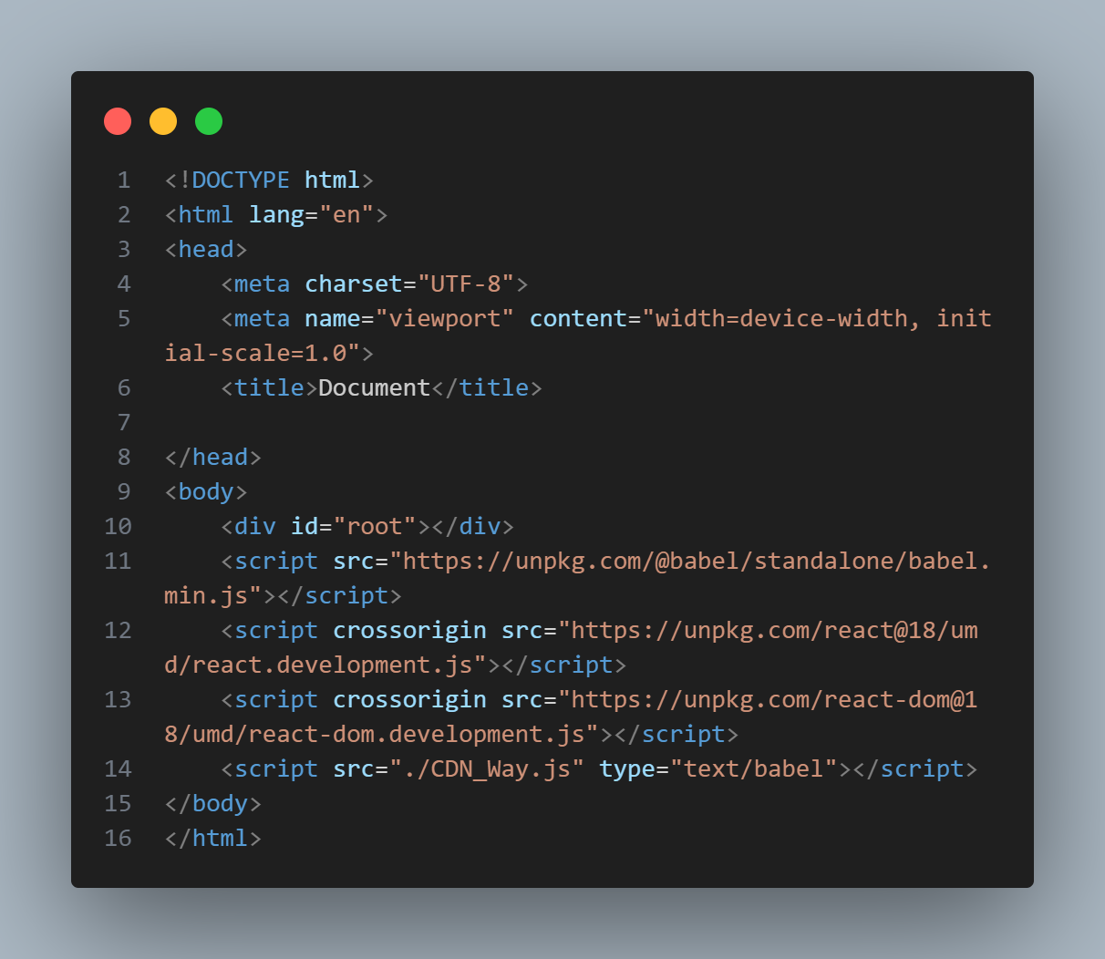Here the render is a method of ReactDOM used to render the file inside your browser.

HTML file

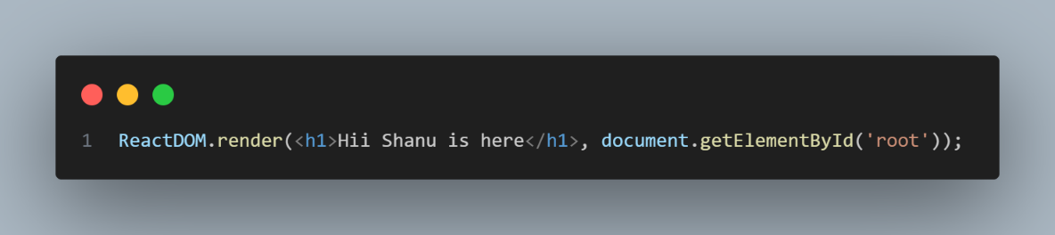

JavaScript File

Now you can able to see the text mentioned inside ‘h1’ tag.