**React**

**Day 6th**

**Webpack**

Webpack is a static module bundler for modern JavaScript applications when webpack browses your application it internally builds dependency graph from one or more entry points and it is combining every module your projects need into one or more bundles, which are static assets to serve your content from.

To get started you only need to understand its core concepts:

* Entry
* Output
* Loaders
* Plugins
* Mode
* Browser compatibility

**How to use this webpack**

The very first thing that we will need nodejs because it’s server page so we will need dependencies.

Just visit website Nodejs.org and download the lts file

**How to create nodeJS project How to create package.json**

Make folder and give it a name. Open it in CMD and run the first command `npm init` where npm stands for (Node Package Manager) and init which is initializing the package.json which is the art of Nodejs application. This Package.json holds the metadata of the application. Every Nodejs project the package.json is mandatory without this the node js application will not execute.

**What is package.json**

The package.json file contains descriptive and functional metadata about a project, such as a name, version and dependencies. The file provides the npm package manager with various information to help identify the project and handle dependencies.

**Usage of package.json**

The package.json file is the heart of any node project. It records important metadata about a project which is required before publishing to NPM and also defines functional attributes of a project that npm uses to install dependencies, run scripts and identify the entry point to our package.

**How to install webpack**

So finally we created our json file but there needs to be two more properties that is nothing but dependencies and dev dependencies. So installing a webpack we need to run the command **`npm install –save-dev webpack webpack-cli`** here we are using a flag –save-dev which means we are installing it for development purpose.

**Configuring your webpack**

So for this we need to create a file at the root folder as **`webpack.config.js`** inside this file we need to write configuration like entry point output and mode as follows.

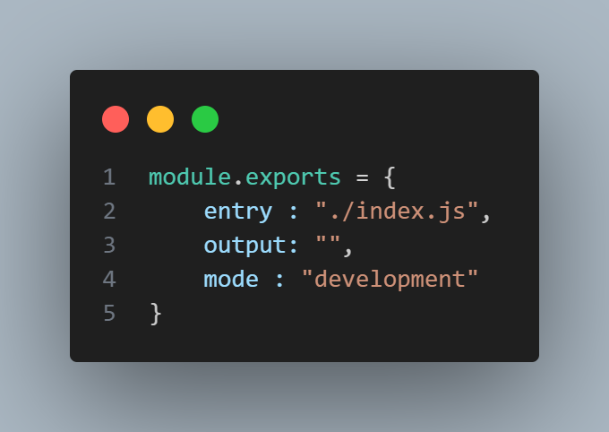Then we need to create a folder at the root named dist which will be containing all bundle file for production. Which is dynamically done by webpack .