**React**

**Day 61st**

**Styled Component**

**What is CSS-in-JS**

CSS-in-JS refers to a collection of ideas to solve complex problems with CSS. Since it is NOT a particular library, different libs might solve a different subset of problems and use different approaches, depending on their implementation details.

However, all implementations have in common that they tackle the problems using APIs instead of convention and they leverage JavaScript as a language for styles authoring.

You may already know this, but there’s a slight difference between CSS-in-JS and inline styles, you write your code in a JS object, then attach it to the pseudo selectors, media queries, keyframes,etc.

CSS-in-JS is different from inline styles. We still write all our CSS in JS, but instead of passing it to the style attribute, we take those styles and inject an actual string of CSS in a <style> tag into the DOM. By having all your CSS in JS and using CSS and using CSS-in-JS , you can have separate folders to organize your styles in a better way and have files to different React components, eliminating that whole mess that you have in one single .css file.

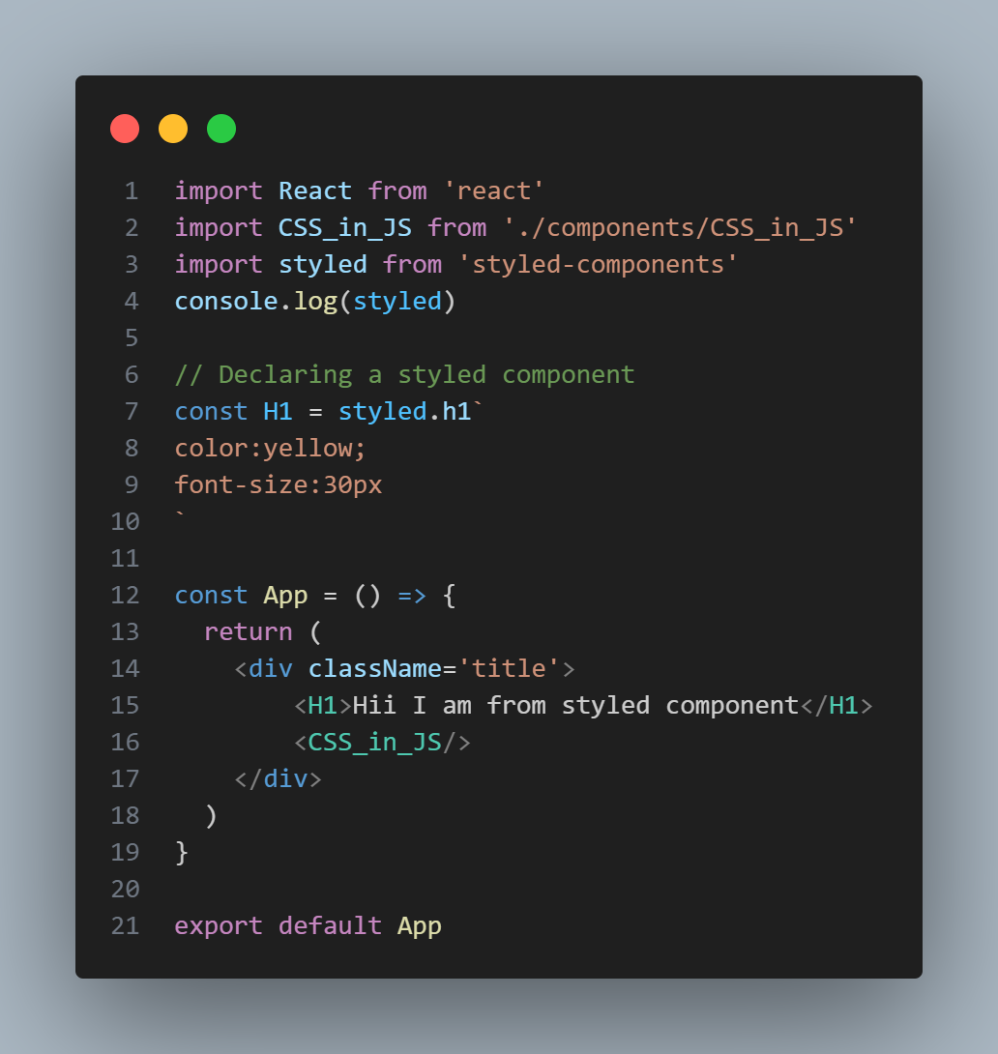**How to use styled component**

As styled component is a component itself so whenever we are dealing with styled component we need to store the styles in a variable starting with upper case and use this as tag. You need to import styled component first then whichever tag you wanna design go with the name you have imported with followed by dot and actual tag.