**React**

**Day 62nd**

**Tailwind CSS**

This is third party CSS library

**Installation process of tailwind**

1. Run the command prompt and enter the very first command
   1. `npm install -D tailwindcss` here D stands for development
2. Then go for configuration
   1. 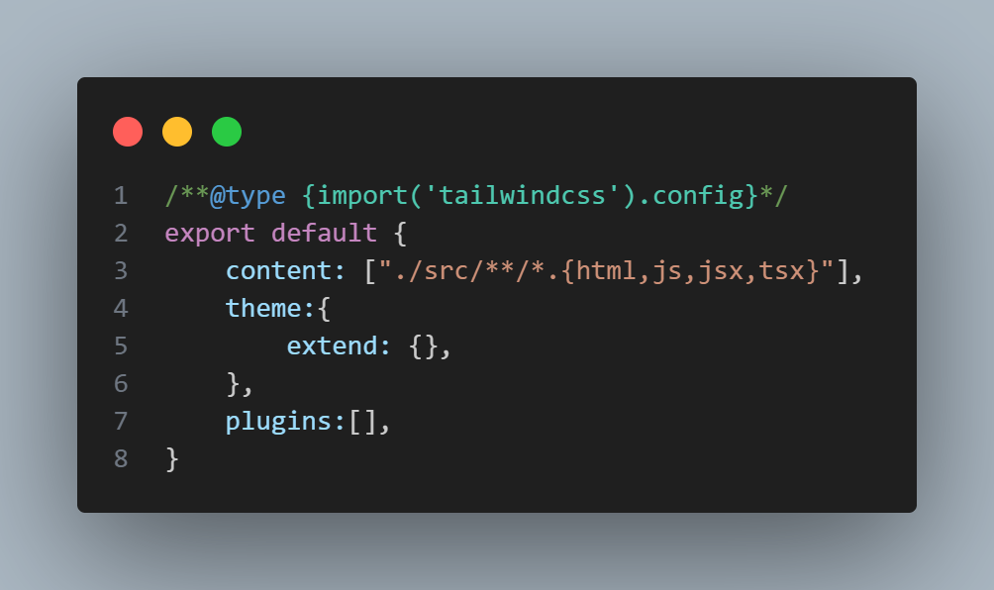Run the command `npx tailwindcss init` to get tailwind.config.js file. If it is not working then create a file manually with the name `tailwind.config.js` and paste the code as follows.
3. 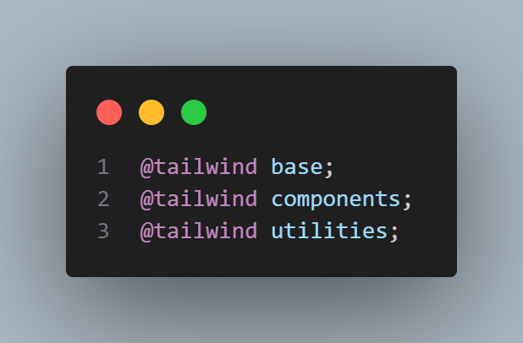Now you’ll need a global css file create it with any name e.g. `style.css` and paste the code as follows.
4. Import the created CSS file in your root file `main.jsx or App.jsx`

These things we were doing for create React App method which is based on Class based components so it won’t work with vite as it is. We have some changes in vite that we need to apply.

So here is the process of installing tailwind in vite.

1. For the very first time you need to open command prompt and you need to run the command as follows.
   1. `**npm install -D tailwindcss postcss autoprefixer**`
2. After this you need to create a config file for tailwind using the following command
   1. `**npx tailwind css init -p**`
3. After this you need to work in config file you need to customize it as follows.

**Is it possible to use tailwind css along with styled component**

Yes by using twin we can do the same. (twin macro) but it’s quite difficult.