**React**

**Day 72nd**

**Nav and NavLink**

In this documentation we gonna discuss about what is Link Component and what is NavLink Component.

**NavLink**

A NavLink is a special kind of <Link> tha knows whether or not it is ‘active’, ‘pending’ or ‘transitioning ’. This is useful in a few different scenarios.

* When building a navigation menu, such as breadcrumb or a set of tabs where you’d like to show which of them is currently selected.
* It provides useful context for assistive technology like screen readers.
* It provides a transitioning value to give you finer grained control over view transitions.

**Query Params string**

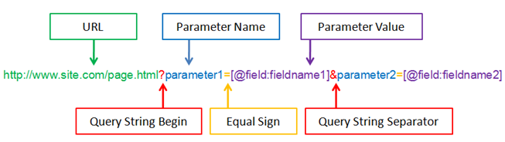What are the query string parameters? Query string parameters are extensions of a website’s base Uniform Resource Locator loaded by a web browser or client application. Originally query strings were used to record the content of an HTML form or web form on a given page.