Information – For Work Order Creation
Running Sheet Information for the screen
Date | WO# | Site ID | Site Name | Type | Priority | Assigned To | Logged By | Value | Status

- Date
- WO #
- Site ID – This is generated from S3. We will get it merged with the software.
- Site Name – Again will be picked up from S3
- Type
  - Static Guarding – Permanent [ This will be recurring]
  - Patrols – Permanent [ This will be recurring]
  - Patrols – Ad hoc & Alarm Response
  - Alarm Response
  - ESD
  - Remote Access and Monitoring
  - Key Management
- Priority –
  - Low,
  - Medium and
  - Urgent
- Assigned To
- Logged By
- Status
  - In Progress [This is when the job is in progress]
  - Completed by Cont [ This when a Services Provider completes the job]
  - Await Invoice [This is when admin closes the job as complete and Services Provide can upload the invoice]
  - Await Aprvl [ This is when Work Order is approved for payment once invoice is uploaded]
  - Req attention – This is when an invoice is uploaded and is incorrect and Services Provider needs to readdress.
- Dollar Value of the Work Order

Sender Details
- Site Name & Address
- Contact Name: Name of the person who raises the work order
- Contact Number: Contact Number of the person who raises the work order
- Contact Email: Contact email of the person who raises the work order
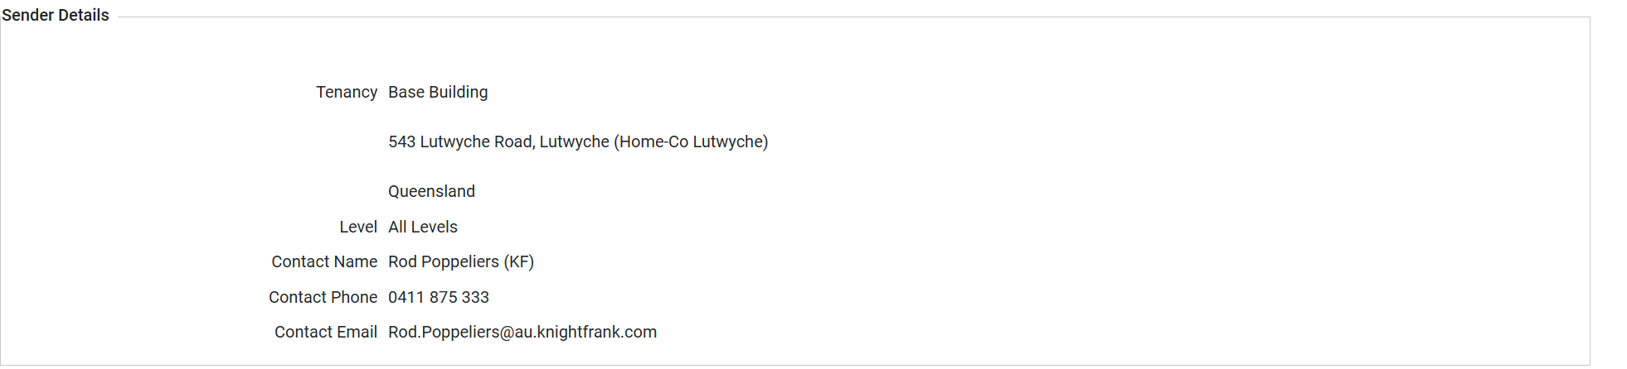

Invoicing Details
- Billing Details – Please invoice to – Sec QLD, GPO Box 389 Brisbane Markets QLD 4106
- Request Issued To ABN: Details of the Service Provider [Company Name]
- Quote Work order No [Work Order Number to be mentioned] on your invoice for prompt payment.
- Notes [ In red – This can be updated and information added from Admin Access]
- The invoices must be uploaded directly to the work order, as they should not be sent via post or email.
- You will receive notification when it is time to upload your invoice.
- Work Order Amount
Work costs are not to exceed $300.00 (excluding GST) without obtaining prior approval from the Sec QLD

Job Details
- Work Order Number
- Site Reference Number
- Date / Time Logged
- Priority
- Type
- Job Description
- Download – [If we can have a facility for Admin to upload documents that can be downloaded – This function is used by Admin or the person who create the work order to upload document for Services Provider to download. File Types to Support – Excel, JPG, PNG and PDF]
- Attachments
  - Attach files for this request [Not for Invoices]
  - Attach files for this request [Hidden]
  - Upload any document that is related to work order – Like Risk assessment, Site visit monitoring
- Status –
  - In Progress
  - On Hold
  - Completed [ Once this selected then the Options for – Invoice No, Work Began, Actual Completion is open to be added in]
  - Completed No Charge
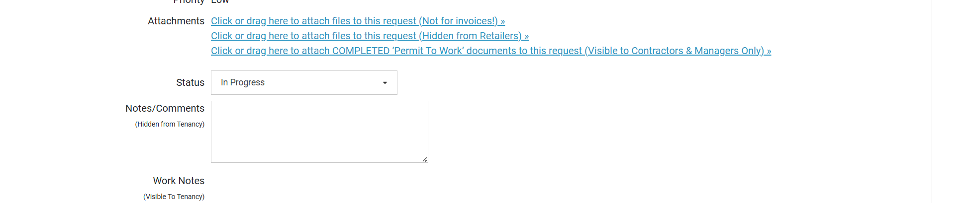
- Notes / Results
- Invoice No
- Work Begin – Date to be selected
- Expected Completion – [This is entered by Admin / Work Order Creator]
- Actual Completion – Date to be selected
- Amount – [ To be only visible once Status is Completed. The value should be equivalent too or less than the approved value of the work order].

Workflow for Recurring
When a site is selected for recurring work [ Type] order the following will apply
- Static Guarding – Permanent
- Patrols – Permanent
We need the ability to choose
- Start Date
- Finish Date
- Frequency
  - Weekly
  - Fortnightly
  - Monthly
  - Quarterly
- If a contract tend to be terminated during the middle of the cycle – Ability to cancel the recurring work Order.
Add the following information
- Depending on the cycle – The Dollar Value
- Annual Value – This will be based on the yearly value of the Site for Services
  - For Example – If the frequency is Weekly and the dollar value is $1000.00 Work order raised will be for $1000.00 value for every work order.
  - The annual value will be $1000.00 *52 weeks [This amount can only be seen by Admin and Managers]
  - So, if you are selecting a site and choose the Type of Services you should be able to see the graph at the top of the page with
    - Total Value
    - Work Order billed till date
    - Balance
    - If the graph is in Red – Then the total value allocated has been surpassed and services provider is being paid more than what was approved.
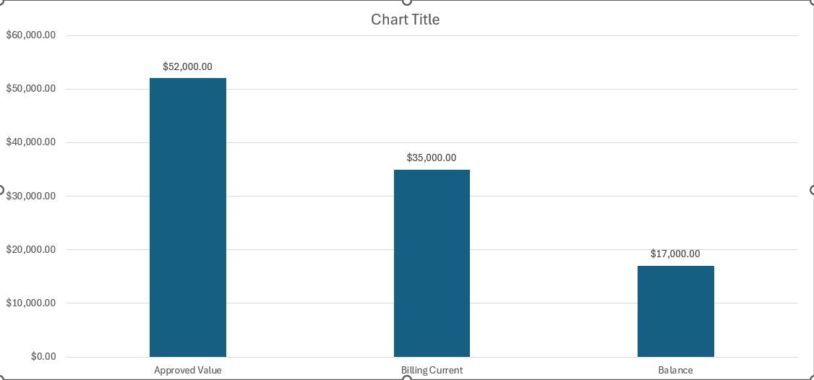

Annual Value | $52,000.00 | Current Billing | $35,000.00
Weekly Value | $1000.00 | Balance | $17,000.00
Site | McWhirter’s Carpark [ Guarding] | Address | Brunswick St & Wickham St Fortitude Valley QLD 4006

Date | Wo# | Site ID | Site Name | Type | Priority | Assigned To | Logged By | Value | Status
28/07/2025 | W00101 | SID00031 | McWhiters Carparking [ Guarding] | Static Guarding – Permanent | Medium | Jay | Simar Bajwa | $1000.00 | Completed
21/07/2025 | W00095 | SID00031 | McWhiters Carparking [ Guarding] | Static Guarding – Permanent | Medium | Jay | Simar Bajwa | $1000.00 | Completed
14/07/2025 | W00081 | SID00031 | McWhiters Carparking [ Guarding] | Static Guarding – Permanent | Medium | Jay | Simar Bajwa | $1000.00 | Completed
07/07/2025 | W00075 | SID00031 | McWhiters Carparking [ Guarding] | Static Guarding – Permanent | Medium | Jay | Simar Bajwa | $1000.00 | Completed
30/06/2025 | W00070 | SID00031 | McWhiters Carparking [ Guarding] | Static Guarding – Permanent | Medium | Jay | Simar Bajwa | $1000.00 | Completed
23/06/2025 | W00065 | SID00031 | McWhiters Carparking [ Guarding] | Static Guarding – Permanent | Medium | Jay | Simar Bajwa | $1000.00 | Completed
16/06/2025 | W00061 | SID00031 | McWhiters Carparking [ Guarding] | Static Guarding – Permanent | Medium | Jay | Simar Bajwa | $1000.00 | Completed
09/06/2025 | W00055 | SID00031 | McWhiters Carparking [ Guarding] | Static Guarding – Permanent | Medium | Jay | Simar Bajwa | $1000.00 | Completed
02/06/2025 | W00040 | SID00031 | McWhiters Carparking [ Guarding] | Static Guarding – Permanent | Medium | Jay | Simar Bajwa | $1000.00 | Completed
26/05/2025 | W00039 | SID00031 | McWhiters Carparking [ Guarding] | Static Guarding – Permanent | Medium | Jay | Simar Bajwa | $1000.00 | Completed
19/05/2025 | W00031 | SID00031 | McWhiters Carparking [ Guarding] | Static Guarding – Permanent | Medium | Jay | Simar Bajwa | $1000.00 | Completed

- Other facilities – Filter in ascending or descending order.
- Download in Excel Format
When work order value exceeds from Annual approved figures

Annual Value | $52,000.00 | Current Billing | $60,000.00
Weekly Value | $1000.00 | Balance | $8000.00
Site | McWhirter’s Carpark [ Guarding] | Address | Brunswick St & Wickham St Fortitude Valley QLD 4006

Date | Wo# | Site ID | Site Name | Type | Priority | Assigned To | Logged By | Value | Status
28/07/2025 | W00101 | SID00031 | McWhiters Carparking [ Guarding] | Static Guarding – Permanent | Medium | Jay | Simar Bajwa | $1000.00 | Completed
21/07/2025 | W00095 | SID00031 | McWhiters Carparking [ Guarding] | Static Guarding – Permanent | Medium | Jay | Simar Bajwa | $1000.00 | Completed
14/07/2025 | W00081 | SID00031 | McWhiters Carparking [ Guarding] | Static Guarding – Permanent | Medium | Jay | Simar Bajwa | $4000.00 | Completed
07/07/2025 | W00075 | SID00031 | McWhiters Carparking [ Guarding] | Static Guarding – Permanent | Medium | Jay | Simar Bajwa | $1000.00 | Completed
30/06/2025 | W00070 | SID00031 | McWhiters Carparking [ Guarding] | Static Guarding – Permanent | Medium | Jay | Simar Bajwa | $4000.00 | Completed
23/06/2025 | W00065 | SID00031 | McWhiters Carparking [ Guarding] | Static Guarding – Permanent | Medium | Jay | Simar Bajwa | $1000.00 | Completed
16/06/2025 | W00061 | SID00031 | McWhiters Carparking [ Guarding] | Static Guarding – Permanent | Medium | Jay | Simar Bajwa | $4000.00 | Completed
09/06/2025 | W00055 | SID00031 | McWhiters Carparking [ Guarding] | Static Guarding – Permanent | Medium | Jay | Simar Bajwa | $1000.00 | Completed
02/06/2025 | W00040 | SID00031 | McWhiters Carparking [ Guarding] | Static Guarding – Permanent | Medium | Jay | Simar Bajwa | $1000.00 | Completed
26/05/2025 | W00039 | SID00031 | McWhiters Carparking [ Guarding] | Static Guarding – Permanent | Medium | Jay | Simar Bajwa | $1000.00 | Completed
19/05/2025 | W00031 | SID00031 | McWhiters Carparking [ Guarding] | Static Guarding – Permanent | Medium | Jay | Simar Bajwa | $1000.00 | Completed

