StackFix — User Flow Diagrams
StackForge AI · Ace Repairs Kigali · Phase 6.3
Visual reference for authentication, roles, repair lifecycle, invoicing, and team flows. Companion to docs/USER_FLOW.md (markdown + Mermaid source).

Demo test accounts
Role | Email | Password | Access
Super Admin | kevin@stackfix.app | StackFix2026! | Full CRUD
Admin | admin@stackfix.app | Admin2026! | Create + read
Technician | eric@stackfix.app | Tech2026! | Own tickets only

Role permissions matrix
Action | Super Admin | Admin | Technician
Create ticket | Yes | Yes | Yes
View all tickets | Yes | Yes | Own only
Update ticket status | Yes | No | Own only
Edit / delete ticket | Yes | No | No
Create invoice | Yes | Yes | No
View invoices / payments | Yes | Yes | No
Mark invoice paid | Yes | No | No
Manage team | Yes | View only | No
Filter tickets by user | Yes | Yes | No
In-app messaging | Yes | Yes | Send requests

Repair status unlock rules
Completed and Picked Up are not selectable from Pending. Follow: Pending → Under Repair → Completed → Picked Up.
Current status | Completed available? | Picked Up available?
Pending | No — mark Under Repair first | No
Under Repair | Yes | No — mark Completed first
Completed | Yes (current) | Yes
Picked Up | No (terminal) | Yes (current)

1. Authentication & Session
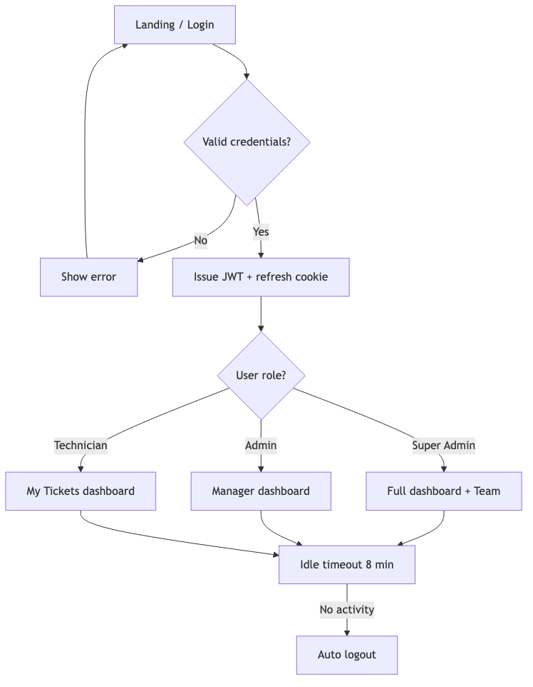

2. Repair Ticket Lifecycle
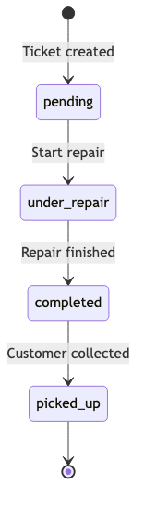

3. New Repair Ticket Flow

4. Invoice & Payment Flow
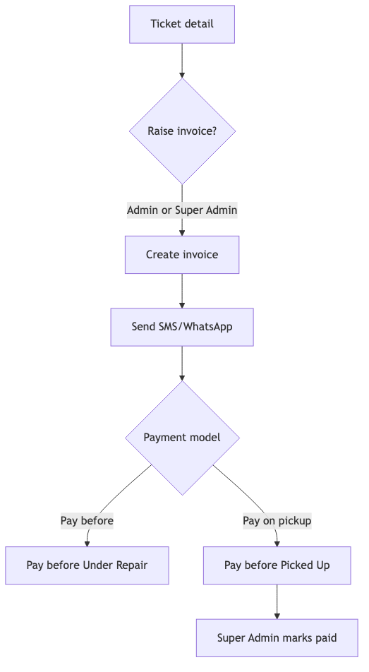

5. Team Management
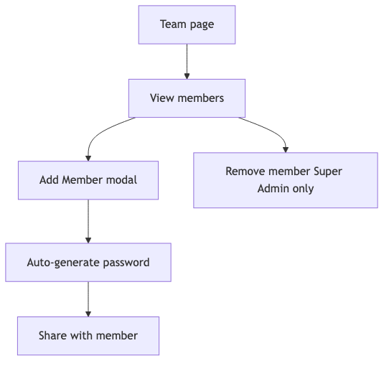

6. In-App Messaging
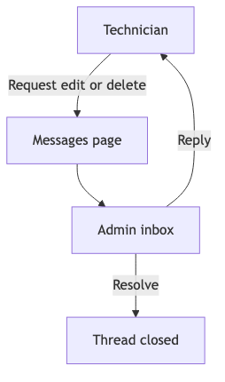

Phase roadmap (upcoming)
- Phase 7: OpenAPI docs, PDF invoices
- Phase 8: MTN MoMo auto-payment
- Phase 9: WhatsApp/SMS webhooks
- Phase 10: Mobile app
- Phase 11: Playwright E2E
- Phase 12: Production deploy
- Phase 13: Beta shop onboarding

hello@stackforgeai.africa · Generated from StackFix monorepo

