

Stackla for SFRA

*Version 20.1.0*



Table of Contents

**Summary** **3**

**Component Overview** **3**

*Functional Overview*3

*Use Cases*4

*Limitations, Constraints*5

*Compatibility*5

*Privacy, Payment*5

**Implementation Guide** **6**

*Setup of Business Manager*6

*Configuration*6

**Testing** **7**

**Operations, Maintenance** **7**

*Data Storage*7

*Availability*7

*Failover/Recovery Process*7

*Support*7

**User Guide** **8**

*Roles, Responsibilities*8

*Business Manager*8

*Storefront Functionality*11

**Known Issues** **12**

**Release History** **12**

# Summary

This document describes how to integrate the int_stackla cartridge into the Salesforce B2C Commerce SFRA (Storefront Reference Architecture) reference application.

The int_stackla cartridge supports the following Stackla visual content engine features:

* Tracking Pixel
* Product Detail Page Widget
* Product Feed

# Component Overview

## 2.1 Functional Overview

Stackla enables User-Generated Content from social media to be curated and displayed in a Salesforce B2C Commerce site. The following social networks are currently supported:

* Instagram
* Facebook
* YouTube
* Twitter
* Flickr
* Weibo
* Pinterest
* Stackla
* WordPress
* RSS
* Tumblr
* Vimeo
* Hootsuite
* Dailymotion
* Spotify
* Soundcloud
* Linkedin
* Amazon
* Youku
* Brightcove
* Wistia
* Snapchat
* Imgur
* Livestream
* Foursquare
* Twitch.tv

## 2.2 Use Cases

2.2.1 Tracking Pixel

The Stackla Tracking Pixel monitors customer activity on a Salesforce B2C Commerce site. The following events are tracked in this cartridge:

|  |  |  |
| --- | --- | --- |
| Event Name | Description | Event Parameters |
| product_page_view | Record an event each time an end-user views a specific Product Page after interacting with a Stackla Widget | product_id |
| add_to_cart | Record an event each time an end-user adds a particular Product to their Cart | product_id  currency  ext_quantity  ext_price |
| payment_info | Record an event when the user reaches the Payment Information Page / Starts the Checkout | product_id  ext_currency  ext_quantity  ext_price |
| purchase | Record an event when the user has completed a Purchase | product_id  ext_currency  ext_quantity  ext_price |
| add_to_wishlist | Record an event each time an end-user adds a particular Product to their Wishlist | product_id  ext_currency  ext_quantity  ext_price |

Stackla also supports tracking for the following events that are not included in this cartridge:

|  |  |  |
| --- | --- | --- |
| Event Name | Description | Event Parameters |
| donation | Record an event when the user has successfully made a Donation | product_id  ext_currency  ext_quantity  ext_price |
| subscribe | Record an event when the user has successfully registered/subscribed to a service. | product_id |

2.2.2 PDP Widget

User-Generated content from social media is displayed in a Salesforce B2C Site in the form of a widget. The widget is available on the Product Detail Page. The Product Details Page widget renders UGC content tagged in Stackla for that unique Product ID. Tags are generated or created in Stackla based on the Product Feed included in the int_stackla cartridge.

Widget settings and appearance may be customized in the Stackla Dashboard. A widget’s appearance may be further customized by adding Javascript and CSS in the widget’s Custom Code Editor.

2.2.3 Product Feed

This cartridge includes a job step for generating a product feed from the site catalog to be ingested by Stackla.

The product feed requires the following elements:

**<id>** - String: Between 1 - 50 Characters.

**<title>** - String: Between 1 - 150 Characters

**<description>** - String: Between 1 - 1024 Characters

**<link>** - URL: Between 1 - 250 Characters

**<image_link>** - URL: Between 1 - 250 Characters

**<availability>** - Options: 'in stock', 'out of stock', 'preorder'

**<price>** - String: Between 3 - 20 Characters

The Export Product Feed job step may be modified to include the following optional elements:

**<condition>** - Options: 'new', 'refurbished', 'used'

**<shipping>** - SubElements: 'country', 'service', 'price'

**<expiration_date>** - dateTime

**<brand>** - String: Between 1 - 70 Characters

**<gtin>** - String: Between 1 - 50 Characters

**<mpn>** - String: Between 1 - 50 Characters

**<product_category**> - String: Between 1 - 250 Characters

**<product_type>** - String: Between 1 - 250 Characters

**<additional_image_type>** - String: Between 1 - 250 Characters

**<gender>** - Options: 'Male', 'Female', 'Unisex'

**<age_group>** - Options: 'Newborn', 'Infant', 'Toddler', 'Kids', 'Adult'

**<color>** - String: Between 1 - 25 Characters

**<size>** - String: Between 1 - 25 Characters

**<item_group_id>** - String: Between 1 - 50 Characters

**<sale_price>** - String: Between 3 - 20 Characters

**<sale_price_start_date>** - dateTime

**<sale_price_end_date>** - dateTime

## 2.3 Limitations and Constraints

This cartridge is only available for SFRA (Storefront Reference Architecture). This cartridge works with all locales.

## 2.4 Compatibility

This cartridge has been tested with SFRA 5.0.1 and compatibility mode 19.10.

## 2.5 Privacy, Payment

Customer order details are sent to Stackla. No customer payment data is processed or stored.

# Implementation Guide

## 3.1 Setup of Business Manager

To install the cartridge:

1. Compile the Javascript (run the command “npm run compile:js”) and upload the cartridge.
2. Add the cartridge to the beginning of the site’s cartridge path, i.e., "int_stackla:app_storefront_base”.
3. Import the metadata.
4. Configure the site preferences.
5. Configure the job settings.

## 3.2 Configuration

3.2.1 Import Metadata

In Business Manager, navigate to **Administration > Site Development > Site Import & Export**. Upload and import metadata.zip.

3.2.2 Configure Site Preferences

|  |  |  |
| --- | --- | --- |
| Name | ID | Description |
| Stackla Tracking Enabled | stacklaTrackingEnabled | Enable tracking |
| Stackla Tracking Pixel URL | stacklaTrackingPixelUrl | The tracking pixel image URL |
| Stackla Widget ID | stacklaWidgetId | The PDP widget ID  * You can find the widget ID in the Stackla Dashboard > Engage > Widgets |
| Stackla Widget Available Products Only | stacklaWidgetAvailableProductsOnly | Don't show product information for unavailable products |
| Stackla Widget Filter | stacklaWidgetFilter | The filter/segment of content to show |
| Stackla Widget Tag Group | stacklaWidgetTagGroup | Show Products for a specific locale |
| Stackla Widget Tags Grouped As | stacklaWidgetTagsGroupedAs | Apply 'AND'/'OR' grouping to Tags |
| Stackla PDP Widget Enabled | stacklaWidgetEnabled | Enable PDP widget |

3.2.3 Configure Job Settings

The Stackla-ProductFeed job builds and exports a product feed from the site catalog. By default, the job is scheduled to run every 24 hours. Configure the parameters of the custom.stackla.ExportProductFeed job step.

Specific product IDs (separated by commas) may be entered for the “Products” parameter. If no product IDs are specified, all products assigned to the current site will be exported to the product feed.

The default value for the “TargetFolder” parameter is “default/feeds," and the default value for the "Filename" parameter is “stackla_product_feed”.

The scope of the custom.stackla.ExportProductFeed job step must be set to “Specific Sites”. Assign to the appropriate site(s).

## 3.3 Custom Code

In order to enable the tracking pixel “add_to_wishlist” event for use with the “plugin_wishlists” cartridge, uncomment the lines containing “processInclude(require('./product/wishlist'))” in the productDetail.js, productTile.js, and search.js files located in the “cartridge/client/default/js” directory.

In the main.js file located in the same directory, change the path for miniCart to “./components/miniCart”.

In the “paths” property of the package.json file located in the top level of the cartridge, add a “wishlists” property with a path to your “plugin_wishlists” cartridge.

# Testing

Integration tests for the Cart-AddProduct route and the optional Wishlist-AddProduct route have been included in the cartridge.

# Operations, Maintenance

## 5.1 Data Storage

Product feed XML files will be generated by the Stackla-ProductFeed job and stored in the assigned site’s catalog content library. The files can be manually deleted.

## 5.2 Availability

Cartridge functionality is dependent on the availability of the Stackla service.

## 5.3 Failover/Recovery Process

When the Stackla service is down, customer activity will not be tracked, and widgets will not appear. Contact Stackla support.

## 5.4 Support

*<CONTACT EMAIL IN CASE DEFECT FIXES OR IMPROVEMENTS FOR COMPONENT ARE REQUIRED>*

# User Guide

## 6.1 Roles, Responsibilities

The product feed generated by the Stackla-ProductFeed job needs to be imported into Stackla.

1. The product feed can be found in the site’s catalog content library. Go to **Merchant Tools > Products and Catalogs > Import & Export > Product Images**.
2. Select the site catalog ID.
3. Find the product feed XML file and copy the URL, i.e., {domain}/on/demandware.static/-/Sites-storefront-catalog-m-en/default/feeds/productfeed.xml.
4. Go to the Stackla Dashboardand navigate to **Settings > Product Feed**.
5. Add the URL of the product feed XML file from the Salesforce B2C Commerce site.

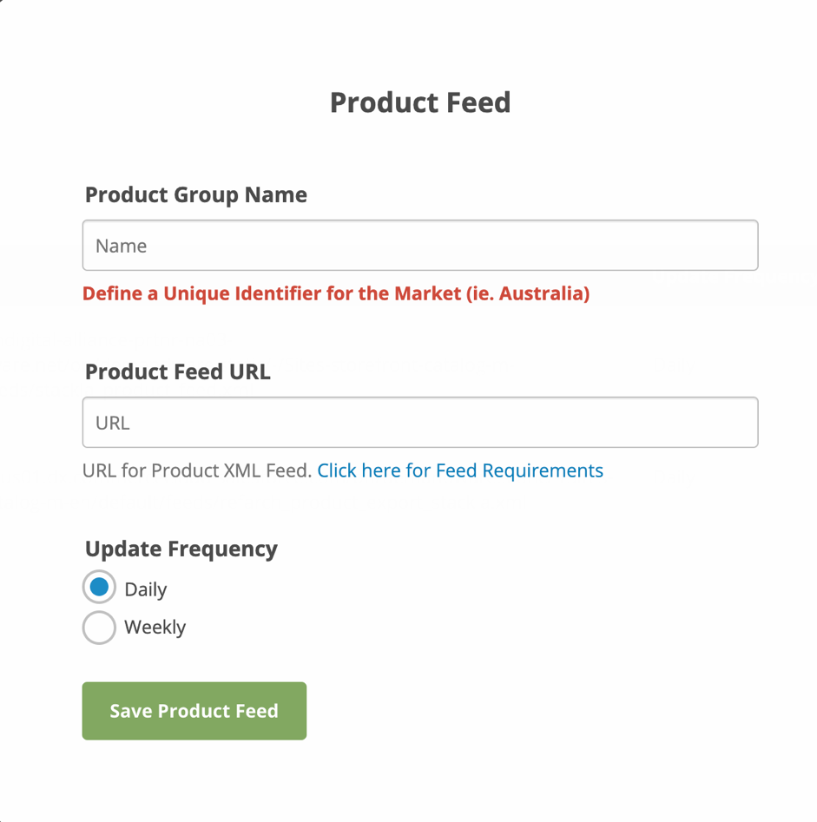

## 6.2 Business Manager

6.2.1 Export Product Feed Job

The job is configured in Business Manager in **Administration > Operations > Jobs**.

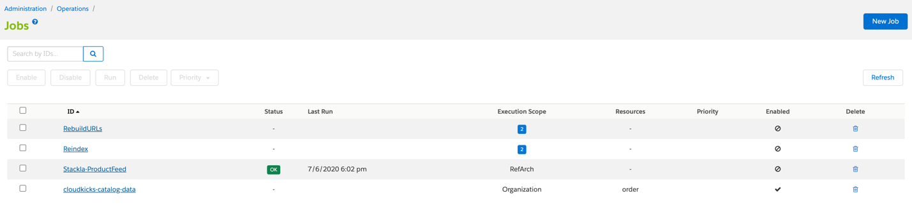

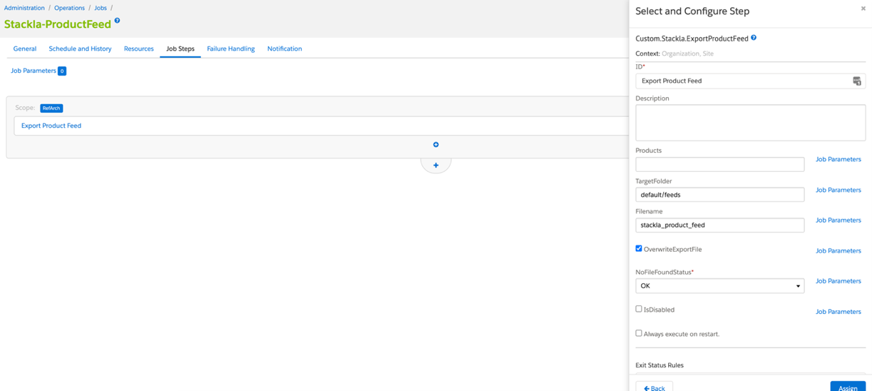

­­­­­­­

## 6.3 Storefront Functionality

The widget appears on the Product Detail Page. The productDetails.isml template may be modified to change the position of the widget.

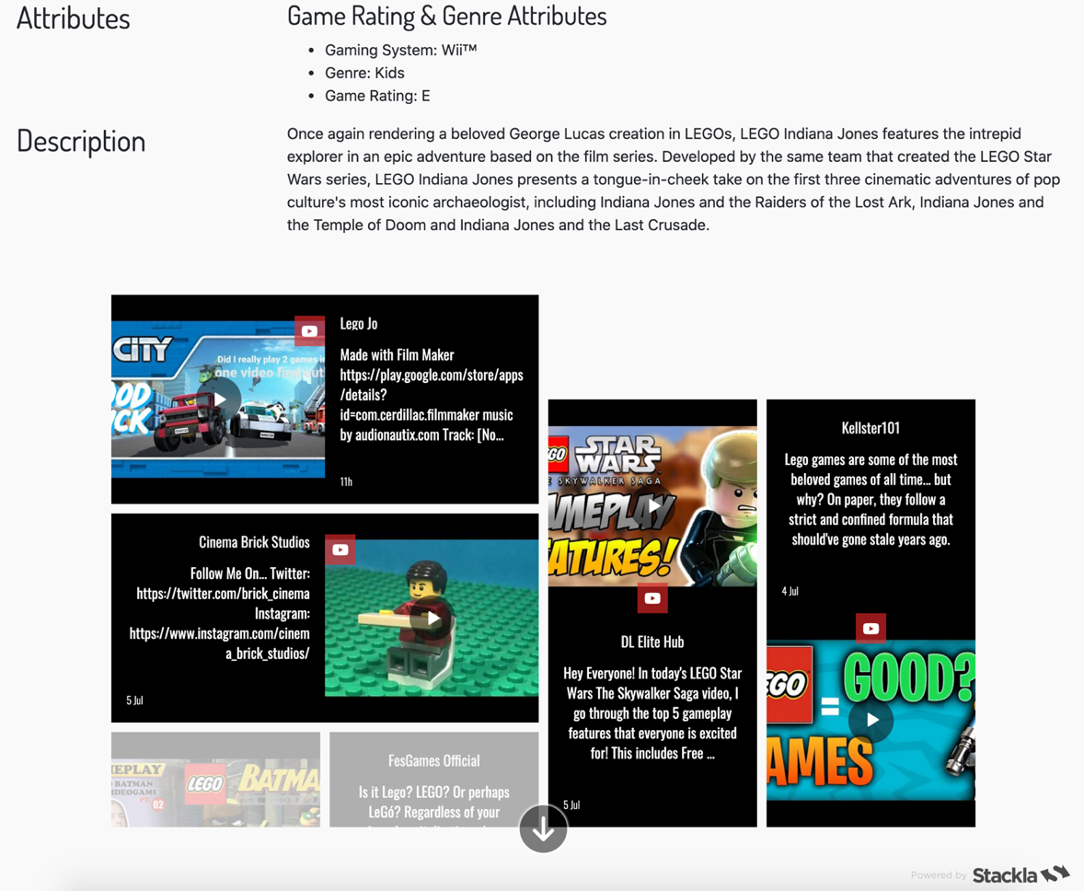

The Stackla tracking pixel can be viewed by checking the source code of the page. For example, the ‘product_page_view’ tracking event pixel should be visible when inspecting the rendered Product Detail Page code.

# Known Issues

There are no known existing issues.

# Release History

|  |  |  |
| --- | --- | --- |
| **Version** | **Date** | **Changes** |
| 20.1.0 | TBD | Initial release |