Notes
Output Created |  | 21-OCT-2022 09:34:19
Comments
Input | Data | C:\Users\stacy\OneDrive\Documents\Assignment.sav
Input | Active Dataset | DataSet7
Input | Filter | <none>
Input | Weight | <none>
Input | Split File | <none>
Input | N of Rows in Working Data File | 10
Missing Value Handling | Definition of Missing | User-defined missing values are treated as missing.
Missing Value Handling | Cases Used | Statistics are based on all cases with valid data.
Syntax |  | FREQUENCIES VARIABLES=Gender  /BARCHART FREQ  /ORDER=ANALYSIS.
Resources | Processor Time | 00:00:00.59
Resources | Elapsed Time | 00:00:00.70

Notes
Output Created |  | 21-OCT-2022 09:34:57
Comments
Input | Data | C:\Users\stacy\OneDrive\Documents\Assignment.sav
Input | Active Dataset | DataSet7
Input | Filter | <none>
Input | Weight | <none>
Input | Split File | <none>
Input | N of Rows in Working Data File | 10
Missing Value Handling | Definition of Missing | User-defined missing values are treated as missing.
Missing Value Handling | Cases Used | Statistics are based on all cases with valid data.
Syntax |  | FREQUENCIES VARIABLES=Gender  /BARCHART FREQ  /ORDER=ANALYSIS.
Resources | Processor Time | 00:00:00.55
Resources | Elapsed Time | 00:00:00.90

Frequencies

Notes
Output Created |  | 21-OCT-2022 09:36:23
Comments
Input | Data | C:\Users\stacy\OneDrive\Documents\Assignment.sav
Input | Active Dataset | DataSet7
Input | Filter | <none>
Input | Weight | <none>
Input | Split File | <none>
Input | N of Rows in Working Data File | 10
Missing Value Handling | Definition of Missing | User-defined missing values are treated as missing.
Missing Value Handling | Cases Used | Statistics are based on all cases with valid data.
Syntax |  | FREQUENCIES VARIABLES=Gender  /BARCHART FREQ  /ORDER=ANALYSIS.
Resources | Processor Time | 00:00:00.55
Resources | Elapsed Time | 00:00:00.54

Statistics
The gender of the respondent
N | Valid | 10
N | Missing | 0

The gender of the respondent
 |  | Frequency | Percent | Valid Percent | Cumulative Percent
Valid | Female | 5 | 50.0 | 50.0 | 50.0
Valid | Male | 5 | 50.0 | 50.0 | 100.0
Valid | Total | 10 | 100.0 | 100.0

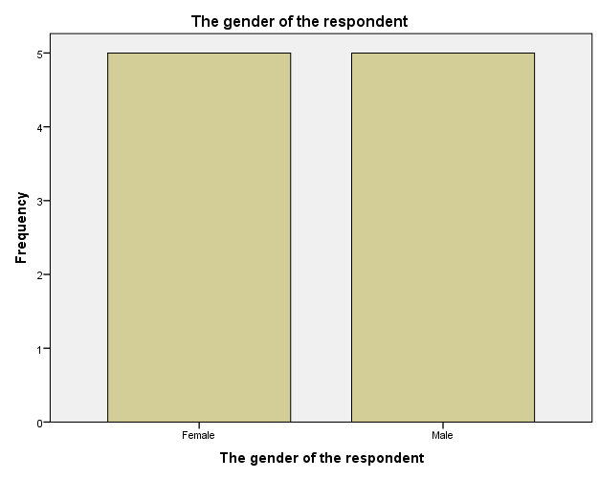

Notes:
50% of the respodents were female and 50% of the respondents were male.
All data points had no missing values.

Notes
Output Created |  | 21-OCT-2022 09:37:44
Comments
Input | Data | C:\Users\stacy\OneDrive\Documents\Assignment.sav
Input | Active Dataset | DataSet7
Input | Filter | <none>
Input | Weight | <none>
Input | Split File | <none>
Input | N of Rows in Working Data File | 10
Missing Value Handling | Definition of Missing | User-defined missing values are treated as missing.
Missing Value Handling | Cases Used | Statistics are based on all cases with valid data.
Syntax |  | FREQUENCIES VARIABLES=Age Occupation Relationship_to_contributor  /BARCHART FREQ  /ORDER=ANALYSIS.
Resources | Processor Time | 00:00:01.49
Resources | Elapsed Time | 00:00:01.49

Frequencies

Notes
Output Created |  | 21-OCT-2022 09:39:27
Comments
Input | Data | C:\Users\stacy\OneDrive\Documents\Assignment.sav
Input | Active Dataset | DataSet7
Input | Filter | <none>
Input | Weight | <none>
Input | Split File | <none>
Input | N of Rows in Working Data File | 10
Missing Value Handling | Definition of Missing | User-defined missing values are treated as missing.
Missing Value Handling | Cases Used | Statistics are based on all cases with valid data.
Syntax |  | FREQUENCIES VARIABLES=Age  /BARCHART FREQ  /ORDER=ANALYSIS.
Resources | Processor Time | 00:00:00.48
Resources | Elapsed Time | 00:00:00.59

Statistics
The age of the respondent
N | Valid | 10
N | Missing | 0

The age of the respondent
 |  | Frequency | Percent | Valid Percent | Cumulative Percent
Valid | 18-24 | 2 | 20.0 | 20.0 | 20.0
Valid | 25-34 | 2 | 20.0 | 20.0 | 40.0
Valid | 35-44 | 2 | 20.0 | 20.0 | 60.0
Valid | 45-54 | 2 | 20.0 | 20.0 | 80.0
Valid | 55+ | 2 | 20.0 | 20.0 | 100.0
Valid | Total | 10 | 100.0 | 100.0

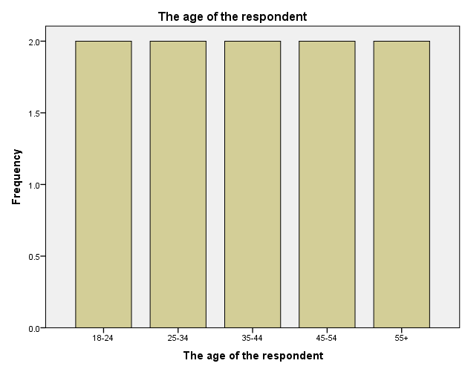

Notes:
1. 20% of the respondents are in the age bracket 18-24, 20% of the respondents are in the age bracket 25-34, 20% of the respondents are in the age bracket 35-44, 20% of the respondents are in the age bracket 45-44, 20% of the respondents are in the age bracket 55+.
2. All data points had no missing values.

Notes
Output Created |  | 21-OCT-2022 09:40:13
Comments
Input | Data | C:\Users\stacy\OneDrive\Documents\Assignment.sav
Input | Active Dataset | DataSet7
Input | Filter | <none>
Input | Weight | <none>
Input | Split File | <none>
Input | N of Rows in Working Data File | 10
Missing Value Handling | Definition of Missing | User-defined missing values are treated as missing.
Missing Value Handling | Cases Used | Statistics are based on all cases with valid data.
Syntax |  | FREQUENCIES VARIABLES=Occupation  /BARCHART FREQ  /ORDER=ANALYSIS.
Resources | Processor Time | 00:00:00.61
Resources | Elapsed Time | 00:00:00.76

Frequencies

Notes
Output Created |  | 21-OCT-2022 09:41:44
Comments
Input | Data | C:\Users\stacy\OneDrive\Documents\Assignment.sav
Input | Active Dataset | DataSet7
Input | Filter | <none>
Input | Weight | <none>
Input | Split File | <none>
Input | N of Rows in Working Data File | 10
Missing Value Handling | Definition of Missing | User-defined missing values are treated as missing.
Missing Value Handling | Cases Used | Statistics are based on all cases with valid data.
Syntax |  | FREQUENCIES VARIABLES=Occupation  /BARCHART FREQ  /ORDER=ANALYSIS.
Resources | Processor Time | 00:00:00.64
Resources | Elapsed Time | 00:00:00.69

Statistics
The occupation of the respondent
N | Valid | 10
N | Missing | 0

The occupation of the respondent
 |  | Frequency | Percent | Valid Percent | Cumulative Percent
Valid | Claimant | 2 | 20.0 | 20.0 | 20.0
Valid | Employed | 5 | 50.0 | 50.0 | 70.0
Valid | Unemployed | 3 | 30.0 | 30.0 | 100.0
Valid | Total | 10 | 100.0 | 100.0

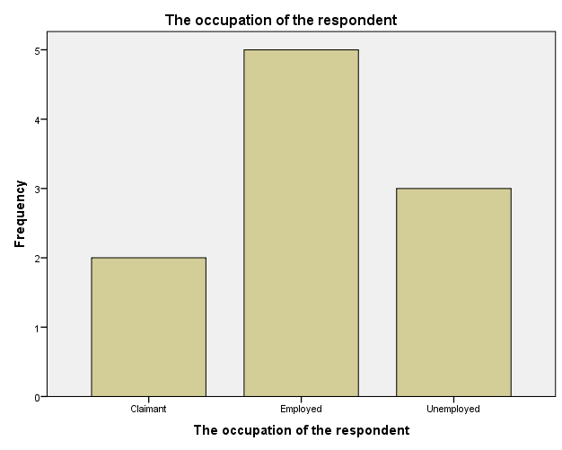

Notes:
1. 20% of the respondents are claimants, 50% of the respondents are employed, 30% of the respondents are unemployed.
2. All data points had no missing values.

Frequencies

Notes
Output Created |  | 21-OCT-2022 09:42:42
Comments
Input | Data | C:\Users\stacy\OneDrive\Documents\Assignment.sav
Input | Active Dataset | DataSet7
Input | Filter | <none>
Input | Weight | <none>
Input | Split File | <none>
Input | N of Rows in Working Data File | 10
Missing Value Handling | Definition of Missing | User-defined missing values are treated as missing.
Missing Value Handling | Cases Used | Statistics are based on all cases with valid data.
Syntax |  | FREQUENCIES VARIABLES=Relationship_to_contributor  /BARCHART FREQ  /ORDER=ANALYSIS.
Resources | Processor Time | 00:00:00.58
Resources | Elapsed Time | 00:00:00.75

Statistics
Relationship the respondent has with the contributor/claimant
N | Valid | 10
N | Missing | 0

Relationship the respondent has with the contributor/claimant
 |  | Frequency | Percent | Valid Percent | Cumulative Percent
Valid | Family member | 3 | 30.0 | 30.0 | 30.0
Valid | Friend | 2 | 20.0 | 20.0 | 50.0
Valid | Self | 5 | 50.0 | 50.0 | 100.0
Valid | Total | 10 | 100.0 | 100.0

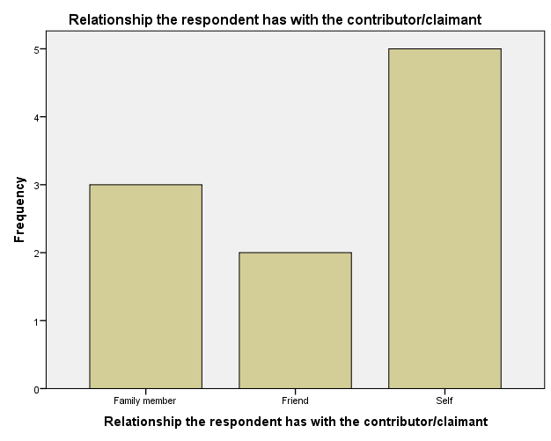

Frequencies

Notes
Output Created |  | 21-OCT-2022 09:43:33
Comments
Input | Data | C:\Users\stacy\OneDrive\Documents\Assignment.sav
Input | Active Dataset | DataSet7
Input | Filter | <none>
Input | Weight | <none>
Input | Split File | <none>
Input | N of Rows in Working Data File | 10
Missing Value Handling | Definition of Missing | User-defined missing values are treated as missing.
Missing Value Handling | Cases Used | Statistics are based on all cases with valid data.
Syntax |  | FREQUENCIES VARIABLES=Region  /BARCHART FREQ  /ORDER=ANALYSIS.
Resources | Processor Time | 00:00:00.61
Resources | Elapsed Time | 00:00:00.66

Statistics
The location of the respondent
N | Valid | 10
N | Missing | 0

The location of the respondent
 |  | Frequency | Percent | Valid Percent | Cumulative Percent
Valid | Central | 1 | 10.0 | 10.0 | 10.0
Valid | Coast | 1 | 10.0 | 10.0 | 20.0
Valid | Eastern | 1 | 10.0 | 10.0 | 30.0
Valid | Nairobi | 3 | 30.0 | 30.0 | 60.0
Valid | North Eastern | 1 | 10.0 | 10.0 | 70.0
Valid | Nyanza | 1 | 10.0 | 10.0 | 80.0
Valid | Rift Valley | 1 | 10.0 | 10.0 | 90.0
Valid | Western | 1 | 10.0 | 10.0 | 100.0
Valid | Total | 10 | 100.0 | 100.0

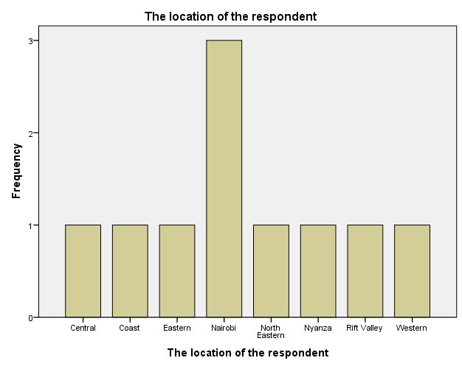

Notes:
1. 10% of the respondents are located in central, 10% of the respondents are located in Coast, 10% of respondents are located in Eastern, 30% of respondents are located Nairobi, 10% of respondents are located in North Eastern, 10% of respondents are located in Nyanza, 10% of respondents are located in Rift Valley, 10% of respondents are located in Western.
2. All data ponts had no missing values.

Frequencies

Notes
Output Created |  | 21-OCT-2022 09:44:47
Comments
Input | Data | C:\Users\stacy\OneDrive\Documents\Assignment.sav
Input | Active Dataset | DataSet7
Input | Filter | <none>
Input | Weight | <none>
Input | Split File | <none>
Input | N of Rows in Working Data File | 10
Missing Value Handling | Definition of Missing | User-defined missing values are treated as missing.
Missing Value Handling | Cases Used | Statistics are based on all cases with valid data.
Syntax |  | FREQUENCIES VARIABLES=Station  /BARCHART FREQ  /ORDER=ANALYSIS.
Resources | Processor Time | 00:00:00.53
Resources | Elapsed Time | 00:00:00.61

Statistics
The station chosen by the respondent
N | Valid | 10
N | Missing | 0

The station chosen by the respondent
 |  | Frequency | Percent | Valid Percent | Cumulative Percent
Valid | NSSF branch | 6 | 60.0 | 60.0 | 60.0
Valid | Sub branch | 4 | 40.0 | 40.0 | 100.0
Valid | Total | 10 | 100.0 | 100.0

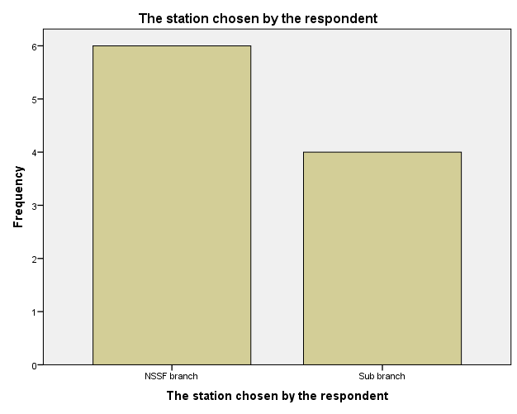

Notes:
1. 60% of the respondents chose NSSF branch while 40% of the respondents chose the sub branch.
2. All data points have no missing values.

Notes
Output Created |  | 21-OCT-2022 09:48:06
Comments
Input | Data | C:\Users\stacy\OneDrive\Documents\Assignment.sav
Input | Active Dataset | DataSet7
Input | Filter | <none>
Input | Weight | <none>
Input | Split File | <none>
Input | N of Rows in Working Data File | 10
Missing Value Handling | Definition of Missing | User-defined missing values are treated as missing.
Missing Value Handling | Cases Used | Statistics are based on all cases with valid data.
Syntax |  | FREQUENCIES VARIABLES=Radio Tv Newspaper Friends_Relatives_Colleagues Publicity_boards Employer Visiting_their_premises Other Retirement_benefit Survival_benefit  /BARCHART FREQ  /ORDER=ANALYSIS.
Resources | Processor Time | 00:00:04.72
Resources | Elapsed Time | 00:00:05.17

Multiple Response

Notes
Output Created |  | 27-OCT-2022 21:40:34
Comments
Input | Data | C:\Users\stacy\OneDrive\Documents\Stacy_data.sav
Input | Active Dataset | DataSet4
Input | Filter | <none>
Input | Weight | <none>
Input | Split File | <none>
Input | N of Rows in Working Data File | 10
Missing Value Handling | Definition of Missing | User-defined missing values are treated as missing.
Missing Value Handling | Cases Used | Statistics for each table are based on all the cases with valid data in the specified range(s) for all variables in each table.
Syntax |  | MULT RESPONSE GROUPS=$Benefit_awareness 'Benefit awareness' (retirement_benefit survival_benefit invalidity_benefit funeral_grant emigration_benefit withdrawal_benefit (0))  /FREQUENCIES=$Benefit_awareness.
Resources | Processor Time | 00:00:00.05
Resources | Elapsed Time | 00:00:00.06

[DataSet4]

Case Summary
 | Cases
 | Valid |  | Missing |  | Total
 | N | Percent | N | Percent | N | Percent
$Benefit_awarenessª | 10 | 100.0% | 0 | 0.0% | 10 | 100.0%

a. Dichotomy group tabulated at value 0.

Multiple Response

Notes
Output Created |  | 03-NOV-2022 13:52:42
Comments
Input | Data | C:\Users\stacy\OneDrive\Documents\Stacy_data_1.sav
Input | Active Dataset | DataSet6
Input | Filter | <none>
Input | Weight | <none>
Input | Split File | <none>
Input | N of Rows in Working Data File | 10
Missing Value Handling | Definition of Missing | User-defined missing values are treated as missing.
Missing Value Handling | Cases Used | Statistics for each table are based on all the cases with valid data in the specified range(s) for all variables in each table.
Syntax |  | MULT RESPONSE GROUPS=$NSSF_awareness 'NSSF awareness' (radio tv newspaper friends_relatives_colleagues publicity_boards employer visiting_their_premises other (0))  /FREQUENCIES=$NSSF_awareness.
Resources | Processor Time | 00:00:00.02
Resources | Elapsed Time | 00:00:00.03

Case Summary
 | Cases
 | Valid |  | Missing |  | Total
 | N | Percent | N | Percent | N | Percent
$NSSF_awarenessª | 10 | 100.0% | 0 | 0.0% | 10 | 100.0%

a. Dichotomy group tabulated at value 0.

$Benefit_awareness Frequencies
 |  | Responses |  | Percent of Cases
 |  | N | Percent | Percent of Cases
Benefit awarenessª | Respondents who are aware of the retirement benefit | 10 | 22.7% | 100.0%
Benefit awarenessª | Respondents who are aware of the survival benefit | 7 | 15.9% | 70.0%
Benefit awarenessª | Respondents who are aware of the invalidity benefit | 2 | 4.5% | 20.0%
Benefit awarenessª | Respondents who are aware of the funeral grant | 8 | 18.2% | 80.0%
Benefit awarenessª | Respondents who are aware of the emigration benefit | 10 | 22.7% | 100.0%
Benefit awarenessª | Respondents who are aware of the withdrawal benefit | 7 | 15.9% | 70.0%
Total |  | 44 | 100.0% | 440.0%

a. Dichotomy group tabulated at value 0.
Notes:
1. 100% of the respondents are aware of the retirement benefit.
2. 70% of the respondents are aware of the survival benefit.
3. 20% of the respondents are aware of the invalidity benefit.
4. 80% of the respondents are aware of the funeral grant.
5. 100% of the respondents are aware of the emigration benefit.
6. 70% of the respondents are aware of the withdrawal benefit.

$NSSF_awareness Frequencies
 |  | Responses |  | Percent of Cases
 |  | N | Percent | Percent of Cases
NSSF awarenessª | Respondents who knew about NSSF through radio | 5 | 12.8% | 50.0%
NSSF awarenessª | Respondents who knew about NSSF through Tv | 9 | 23.1% | 90.0%
NSSF awarenessª | Respondents who knew about NSSF through newspaper | 5 | 12.8% | 50.0%
NSSF awarenessª | Respondents who knew about NSSF through friends/relatives/colleagues | 10 | 25.6% | 100.0%
NSSF awarenessª | Respondents who knew about NSSF through publicity boards | 6 | 15.4% | 60.0%
NSSF awarenessª | Respondents who knew about NSSF through employer | 3 | 7.7% | 30.0%
NSSF awarenessª | Respondents who knew about NSSF through visiting their premises/NSSF staff | 1 | 2.6% | 10.0%
Total |  | 39 | 100.0% | 390.0%

a. Dichotomy group tabulated at value 0.

Notes:
1.50% of the respondents knew about NSSF through radio.
2.90% of the respondents knew about NSSF through tv.
3. 50% of the respondents knew about NSSF through newspaper.
4. 100% of the respondents knew about NSSF through friends/relatives/colleauges.
5. 60% of the respondents knew about NSSF through publicity boards.
6. 30% of the respondents knew about NSSF through employer.
7. 10% of the respondents knew about NSSF through visiting their premises/NSSF staff.

Frequencies

Notes
Output Created |  | 03-NOV-2022 14:00:01
Comments
Input | Data | C:\Users\stacy\OneDrive\Documents\Stacy_data_1.sav
Input | Active Dataset | DataSet6
Input | Filter | <none>
Input | Weight | <none>
Input | Split File | <none>
Input | N of Rows in Working Data File | 10
Missing Value Handling | Definition of Missing | User-defined missing values are treated as missing.
Missing Value Handling | Cases Used | Statistics are based on all cases with valid data.
Syntax |  | FREQUENCIES VARIABLES=Distribution_of_NSSF_offices Registration_process Mode_of_contribution Affordability_of_contribution Ability_contribution_to_make_sufficient_income Safety_of_contributions NSSF_investments NSSF_benefits Decision_and_rules  /BARCHART FREQ  /ORDER=ANALYSIS.
Resources | Processor Time | 00:00:04.98
Resources | Elapsed Time | 00:00:05.97

Statistics
 |  | your level of satisfaction with distribution of NSSF offices | Your level of satisfaction with registration process | Your level of satisfaction with mode of contribution | Your level of satisfaction with affordability of contribution | Your level of satisfaction with ability of contributions to make sufficient income in the end
N | Valid | 10 | 10 | 10 | 10 | 10
N | Missing | 0 | 0 | 0 | 0 | 0

Statistics
 |  | Your level of satisfaction with safety of contributions | Your level of satisfaction with NSSF investments | Your level of satisfaction with NSSF benefits | Your level of satisfaction with decision and rules
N | Valid | 10 | 10 | 10 | 10
N | Missing | 0 | 0 | 0 | 0

Frequency Table

your level of satisfaction with distribution of NSSF offices
 |  | Frequency | Percent | Valid Percent | Cumulative Percent
Valid | Satisfied | 7 | 70.0 | 70.0 | 70.0
Valid | Neutral | 1 | 10.0 | 10.0 | 80.0
Valid | Dissatisfied | 2 | 20.0 | 20.0 | 100.0
Valid | Total | 10 | 100.0 | 100.0

On the level of satisfaction with distribution of NSSF offices;
70% of the respondents are satisfied
10% of the respondents are recorded neutral
20% of the respondents are dissatisfied

Your level of satisfaction with registration process
 |  | Frequency | Percent | Valid Percent | Cumulative Percent
Valid | Very satisfied | 1 | 10.0 | 10.0 | 10.0
Valid | Satisfied | 4 | 40.0 | 40.0 | 50.0
Valid | Neutral | 2 | 20.0 | 20.0 | 70.0
Valid | Dissatisfied | 2 | 20.0 | 20.0 | 90.0
Valid | Very dissatisfied | 1 | 10.0 | 10.0 | 100.0
Valid | Total | 10 | 100.0 | 100.0

On the level of satisfaction with registration process;
10% of the respondents are very satisfied
40% of the respondents are satisfied
20% of the respondents recorded neutral
20% of the respondents are dissatisfied
10% of the respondents are very dissatisfied

Your level of satisfaction with mode of contribution
 |  | Frequency | Percent | Valid Percent | Cumulative Percent
Valid | Satisfied | 7 | 70.0 | 70.0 | 70.0
Valid | Neutral | 2 | 20.0 | 20.0 | 90.0
Valid | Dissatisfied | 1 | 10.0 | 10.0 | 100.0
Valid | Total | 10 | 100.0 | 100.0

On the level of satisfaction with mode of contribution;
70% of the respondents are satisfied
20% of the respondents recorded neutral
10% of the respondents are dissatisfied

Your level of satisfaction with affordability of contribution
 |  | Frequency | Percent | Valid Percent | Cumulative Percent
Valid | Satisfied | 4 | 40.0 | 40.0 | 40.0
Valid | Neutral | 3 | 30.0 | 30.0 | 70.0
Valid | Dissatisfied | 2 | 20.0 | 20.0 | 90.0
Valid | Very dissatisfied | 1 | 10.0 | 10.0 | 100.0
Valid | Total | 10 | 100.0 | 100.0

On the level of satisfaction with affordability of contribution;
40% of the respondents are satisfied
30% of the respondents recorded neutral
20% of the respondents are dissatisfied
10% of the respondents are very dissatisfied

Your level of satisfaction with ability of contributions to make sufficient income in the end
 |  | Frequency | Percent | Valid Percent | Cumulative Percent
Valid | Satisfied | 7 | 70.0 | 70.0 | 70.0
Valid | Neutral | 3 | 30.0 | 30.0 | 100.0
Valid | Total | 10 | 100.0 | 100.0

On the level of satisfaction with ability of contributions to make sufficient income in the end;
70% of the respondents are satisfied
30% of the respondents recorded neutral

Your level of satisfaction with safety of contributions
 |  | Frequency | Percent | Valid Percent | Cumulative Percent
Valid | Satisfied | 7 | 70.0 | 70.0 | 70.0
Valid | Neutral | 3 | 30.0 | 30.0 | 100.0
Valid | Total | 10 | 100.0 | 100.0

On the level of satisfaction with safety of contributions;
70% of the respondents are satisfied
30% of the respondents recorded neutral.

Your level of satisfaction with NSSF investments
 |  | Frequency | Percent | Valid Percent | Cumulative Percent
Valid | Satisfied | 7 | 70.0 | 70.0 | 70.0
Valid | Neutral | 3 | 30.0 | 30.0 | 100.0
Valid | Total | 10 | 100.0 | 100.0

On the level of satisfaction with NSSF investments;
70% of the respondents are satisfied.
30% of the respondents recorded neutral.

Your level of satisfaction with NSSF benefits
 |  | Frequency | Percent | Valid Percent | Cumulative Percent
Valid | Very satisfied | 4 | 40.0 | 40.0 | 40.0
Valid | Satisfied | 5 | 50.0 | 50.0 | 90.0
Valid | Don't know | 1 | 10.0 | 10.0 | 100.0
Valid | Total | 10 | 100.0 | 100.0

On the level of satisfaction with NSSF benefits;
40% of the respondents are very satisfied
50% of the respondents are satisfied
10% of the respondents don't know

Your level of satisfaction with decision and rules
 |  | Frequency | Percent | Valid Percent | Cumulative Percent
Valid | Satisfied | 5 | 50.0 | 50.0 | 50.0
Valid | Neutral | 2 | 20.0 | 20.0 | 70.0
Valid | Dissatisfied | 2 | 20.0 | 20.0 | 90.0
Valid | Don't know | 1 | 10.0 | 10.0 | 100.0
Valid | Total | 10 | 100.0 | 100.0

On the level of satisfaction with decision and rules;
50% of the respondents are satisfied
20% of the respondents recorded neutral
20% of the respondents are dissatisfied
10% of the respondents don't know

Bar Chart

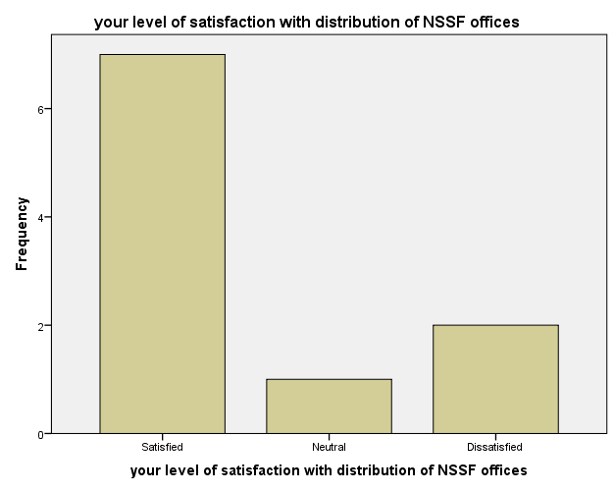

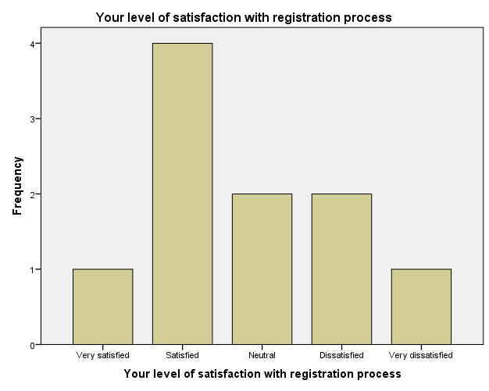

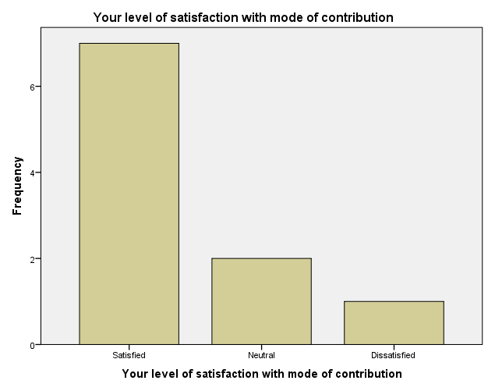

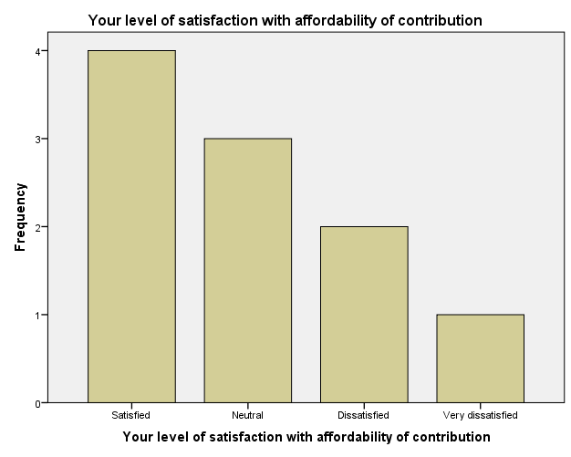

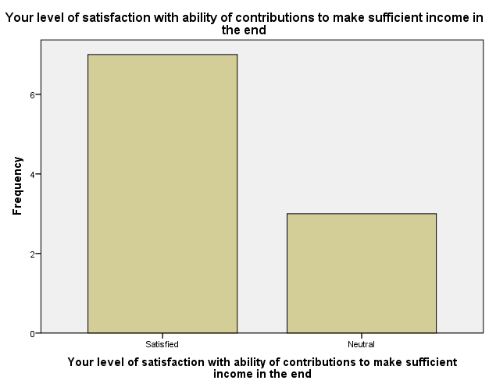

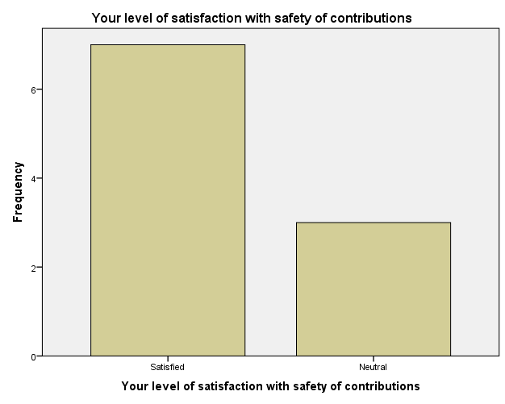

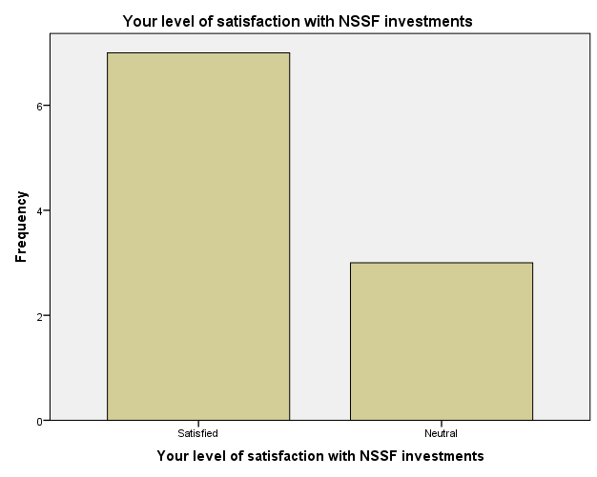

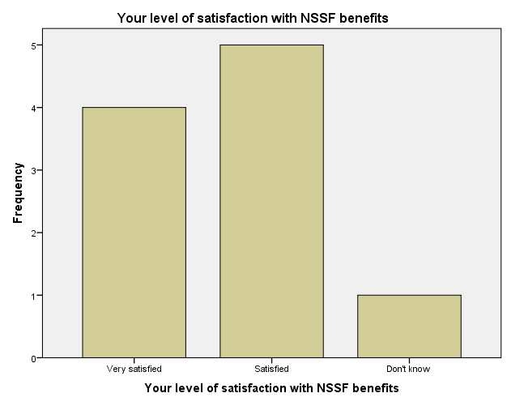

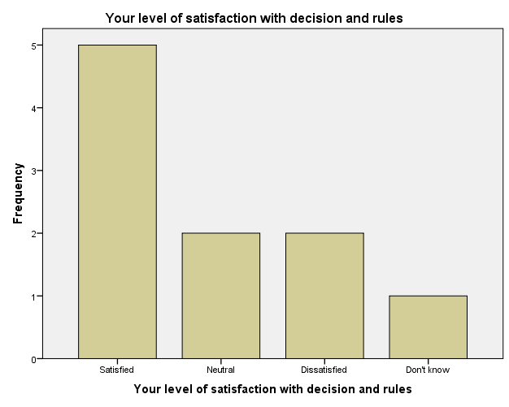

Frequencies

Notes
Output Created |  | 03-NOV-2022 14:01:02
Comments
Input | Data | C:\Users\stacy\OneDrive\Documents\Stacy_data_1.sav
Input | Active Dataset | DataSet6
Input | Filter | <none>
Input | Weight | <none>
Input | Split File | <none>
Input | N of Rows in Working Data File | 10
Missing Value Handling | Definition of Missing | User-defined missing values are treated as missing.
Missing Value Handling | Cases Used | Statistics are based on all cases with valid data.
Syntax |  | FREQUENCIES VARIABLES=Does_not_tolerate_corrupt_activities New_or_better_ways_of_delivering_services Act_responsibly_and_openly Work_together_when_necessary_to_meet_clients_needs  /BARCHART FREQ  /ORDER=ANALYSIS.
Resources | Processor Time | 00:00:02.08
Resources | Elapsed Time | 00:00:02.54

Statistics
 |  | Your extent of agreement with NSSF does not tolerate corrupt activities | Your extent of agreement with new or better ways of delivering services | Your extent of agreement with NSSF staff act responsibly and openly | Your extent of agreement with NSSF staff work together to meet client needs
N | Valid | 10 | 10 | 10 | 10
N | Missing | 0 | 0 | 0 | 0

Frequency Table

Your extent of agreement with NSSF does not tolerate corrupt activities
 |  | Frequency | Percent | Valid Percent | Cumulative Percent
Valid | Strongly agree | 2 | 20.0 | 20.0 | 20.0
Valid | Agree | 6 | 60.0 | 60.0 | 80.0
Valid | Disagree | 2 | 20.0 | 20.0 | 100.0
Valid | Total | 10 | 100.0 | 100.0

Your extent of agreement with new or better ways of delivering services
 |  | Frequency | Percent | Valid Percent | Cumulative Percent
Valid | Strongly agree | 10 | 100.0 | 100.0 | 100.0

Your extent of agreement with NSSF staff act responsibly and openly
 |  | Frequency | Percent | Valid Percent | Cumulative Percent
Valid | Strongly agree | 8 | 80.0 | 80.0 | 80.0
 | Agree | 2 | 20.0 | 20.0 | 100.0
 | Total | 10 | 100.0 | 100.0

Your extent of agreement with NSSF staff work together to meet client needs
 |  | Frequency | Percent | Valid Percent | Cumulative Percent
Valid | Strongly agree | 4 | 40.0 | 40.0 | 40.0
 | Agree | 2 | 20.0 | 20.0 | 60.0
 | Neutral | 1 | 10.0 | 10.0 | 70.0
 | Strongly disagree | 3 | 30.0 | 30.0 | 100.0
 | Total | 10 | 100.0 | 100.0

Bar Chart

