DSA3050A: E-Commerce Customer & Sales Intelligence
Section 9: Dashboard Pages Documentation
The Power BI report is structured into two core pages designed to provide executive leadership with high-level macro metrics alongside deep-dive operational and logistics insights. Below is the complete walkthrough and analytical breakdown of each dashboard page.

9.1 Page 1: Executive Sales Dashboard
This page provides executive leadership with a consolidated overview of macro-level sales performance, regional revenue distribution, top-performing product categories, and overall historical sales growth trends.
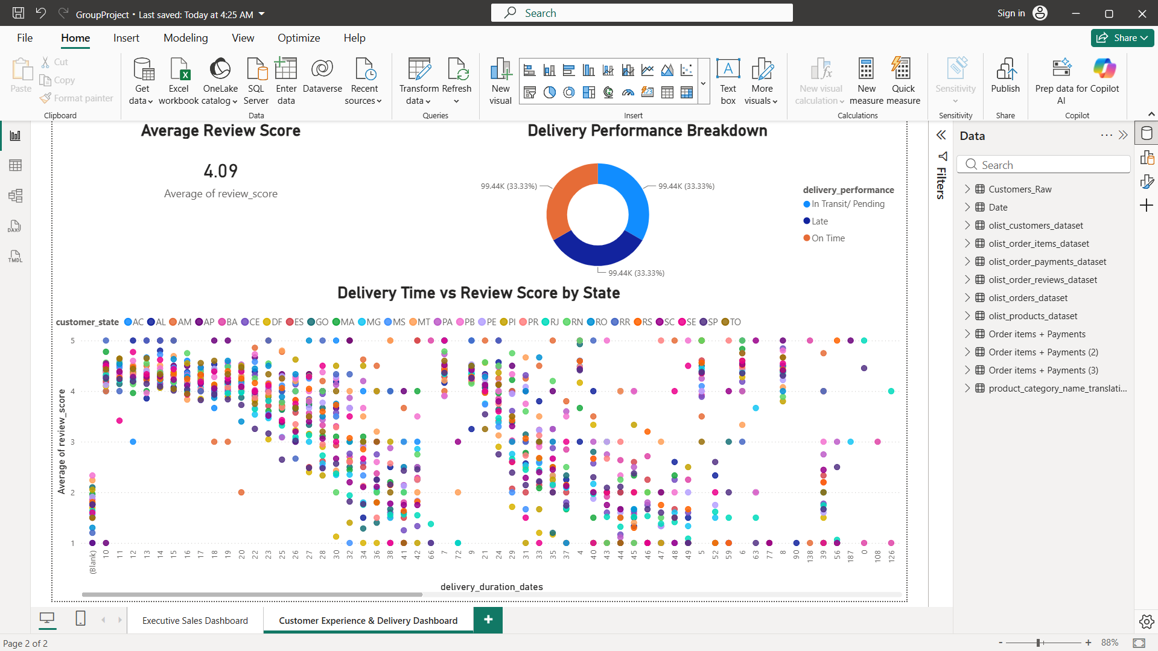

Key Components & Visualizations:
- Key Performance Indicators (KPI Cards):
- Total Orders: 98.67K total orders processed across the Brazilian marketplace network.
- Total Revenue: R$ 13.59M total gross sales generated (Sum of item price).
- Average Order Value (AOV): R$ 120.65 average spend per order item.
- Geographic Analysis (Map – Revenue by State): A spatial map visualization displaying revenue density and order distribution across Brazilian states, highlighting sales concentration in key economic hubs (such as São Paulo and Rio de Janeiro).
- Category Performance (Horizontal Bar Chart – Revenue by Product Category): Ranks product categories by overall revenue generation. Top performing categories include:
- 1. beleza_saude (Health & Beauty)
- 2. relogios_presentes (Watches & Gifts)
- 3. cama_mesa_banho (Bed, Bath & Table)
- 4. esporte_lazer (Sports & Leisure)
- 5. informatica_acessorios (Computers & Accessories)
- Temporal Growth & Interactivity:
- Revenue Trend Over Time: Line chart mapping monthly revenue trajectory from 2017 through 2019 to track seasonal peaks, holiday spikes, and multi-year trajectory.
- Year Slicer: Interactive checkbox slicer allowing stakeholders to isolate and filter performance across specific years (2017, 2018, 2019).

9.2 Page 2: Customer Experience & Delivery Dashboard
This page focuses on customer satisfaction, logistics and fulfillment efficiency, and analyzing the direct correlation between delivery lead times and customer review ratings across different Brazilian geographic regions.
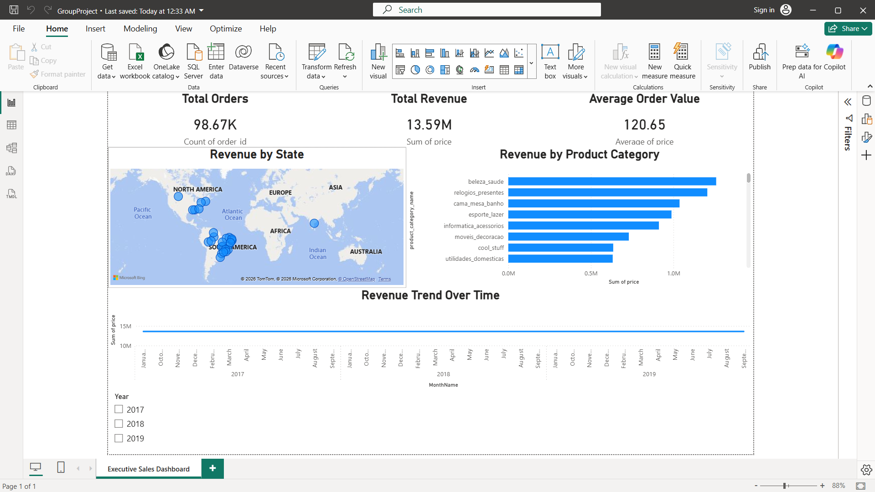

Key Components & Visualizations:
- Customer Satisfaction & Fulfillment KPIs:
- Average Review Score: 4.09 / 5.00 overall satisfaction rating across all fulfilled customer orders.
- Delivery Performance Breakdown (Donut Chart): Visualizes the proportional distribution of order status categories (On Time, Late, and In Transit / Pending).
- Fulfillment Efficiency vs. Satisfaction (Scatter Plot – Delivery Time vs Review Score by State):
- X-Axis: delivery_duration_dates (Total shipping fulfillment duration in days).
- Y-Axis: Average of review_score (Customer rating scale from 1 to 5).
- Legend / Color Context: customer_state (Color-coded across all Brazilian state regions).
- Key Analytical Insight: Reveals a strong inverse relationship between shipping duration and review scores across all regions; as delivery lead times exceed 15–20 days, average review scores decline steeply from 4–5 star levels down to 1–2 star ratings.

