WSU CPTS 411 Project 2 – Calculating Network Buffer, Bandwidth, and Latency
Stacy Schauls
11460535
Experiment:

For this experiment, the Pleiades cluster on the Tri-City WSU campus was used to estimate the network latency, bandwidth and network buffer size of this cluster. To do this, 10 sets of MPI_Send and MPI_Recv messages were called. The average time delta between the send/recv were calculated and plotted. From these graphs and data, an overall latency between send and receive was calculated, as well as the network bandwidth of the cluster. This procedure was done for sizes of messages, from 1 byte to 4MB.

Figure 1: Send time vs Message size.
In figure one, we can see that the time stays relatively flat, until the message size increases to 2²⁰ bytes, or 1MB. At this point, a more linear trend is observed. We expect this curve to be linear as the message size increases passed the size of the network buffer.

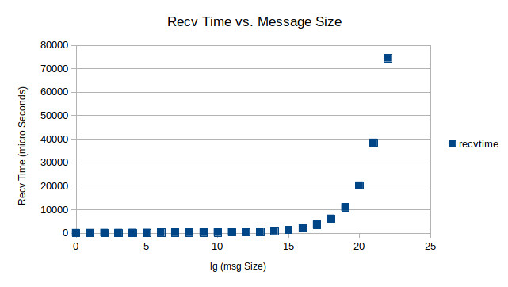Figure 2: Receive Time vs Message Size
From figure two we again see the flat results until we reach a size of 2²⁰, or 1MB, at which the trend starts to become linear.

Results:
To calculate latency, network bandwidth and a network buffer size, the data from figure two was used. First, the slope between each point, starting at a message size of 8KB was calculated. The average of this was then taken, providing a μ value of 0.020 microseconds. The network bandwidth is given by:

Thus the average calculated bandwidth was 50.11 MB/sec. From this data, we can see that our network buffer is 1MB. The value was chosen because at 1MB we can start to see a linear trend in our receive time data. Finally, the latency of our network was calculated using the average send time from where the data points are flat: 1 byte to 8KB. The latency is estimated to be 45.85 microseconds.

