- Course: CSC340.02  
- Student: <Xiaoqian> <Yang>, SFSU ID: <920294060>  
- Assignment Number: 02  
- Assignment Due Date & Time: 06-29-2020 at 11:55PM

- Part A - TIC TAC TOE, 10 points

The program works fine and meets the requirements.

1. The screen shots of PA_Run1:

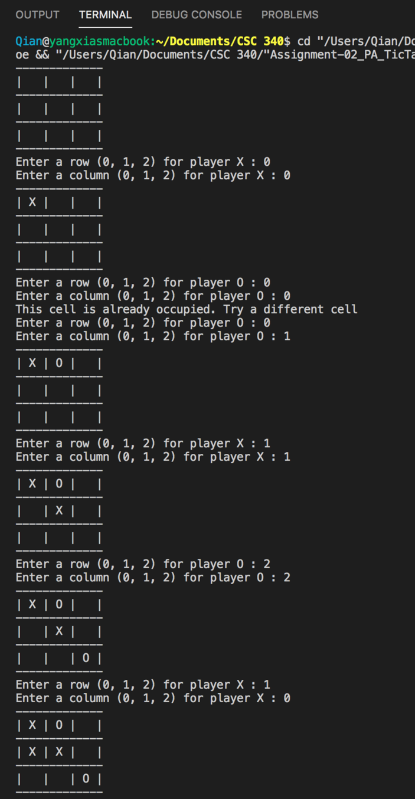

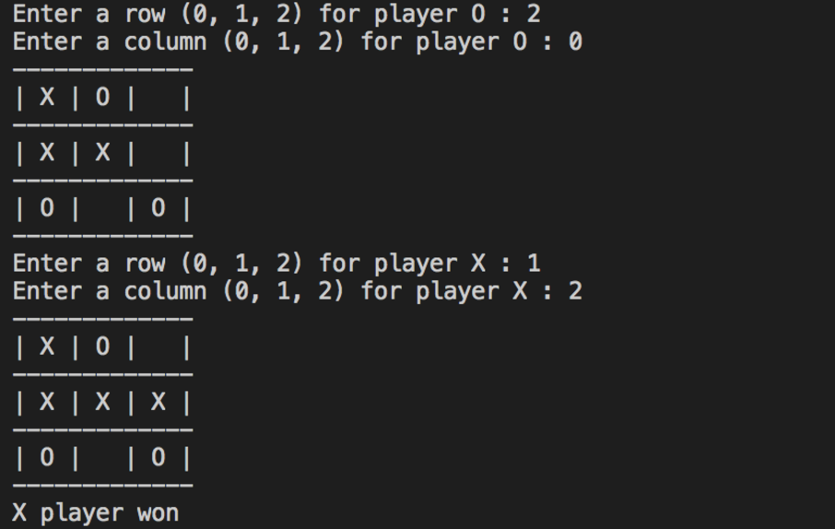

1. The screen shots of PA_Run2:

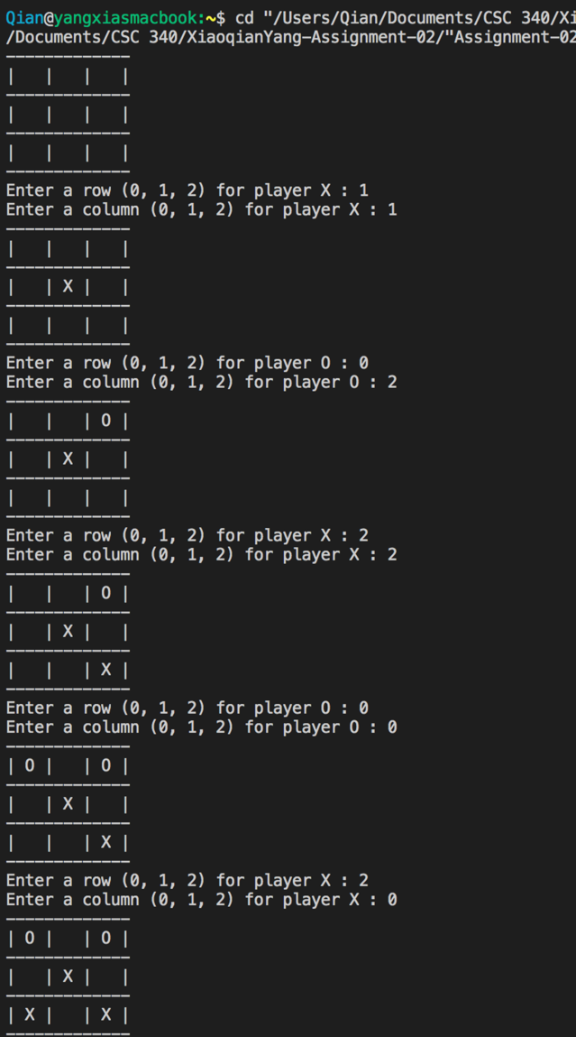

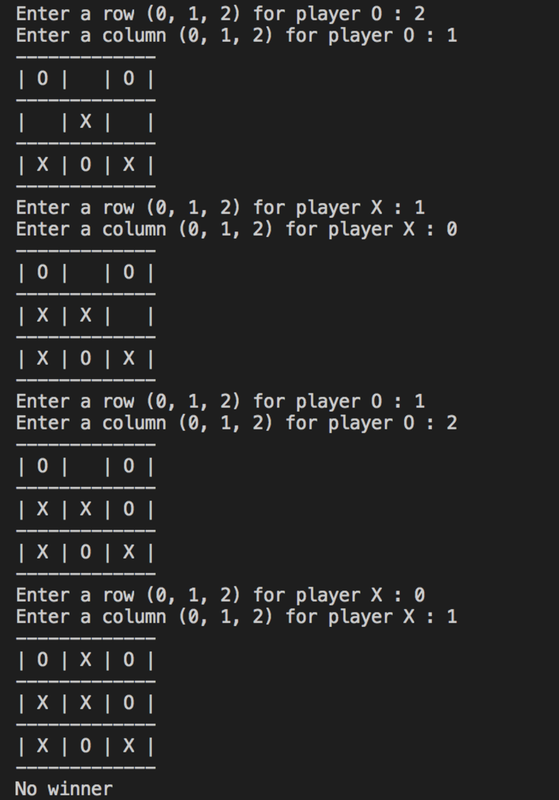

Part B– Credit Card Number Validation

The code works fine and meets all requirements.

I’m using Visual Studio Code on Mac, when run the code, first use command “g++ -std=c++11 Assignment-02_PB_CCNumberValidation.cpp”, then run a.out file. Or use the command “g++ -std=c++11 Assignment-02_PB_CCNumberValidation.cpp && ./a.out”.

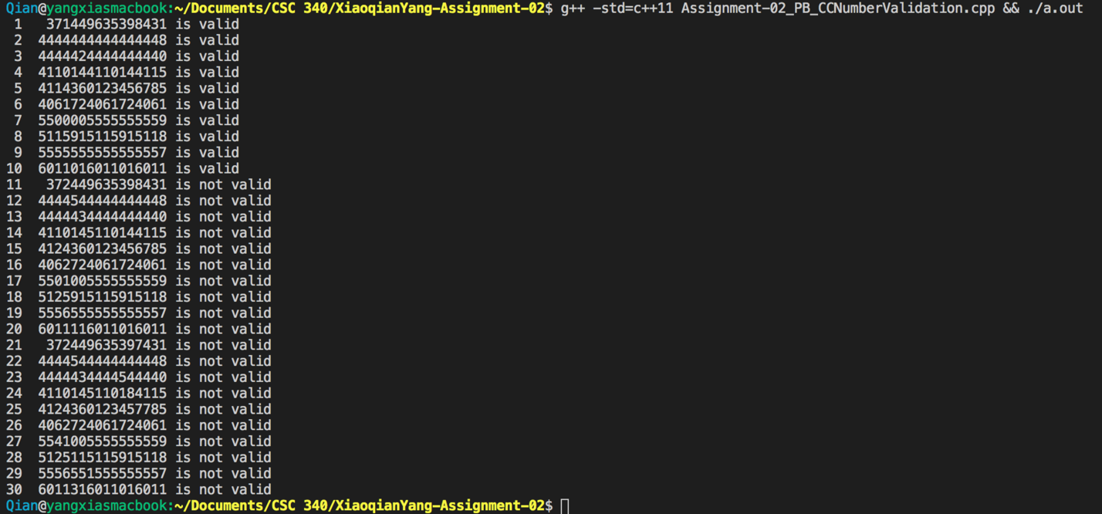

Part C – Dictionary 340 C++

The code works fine and meets all requirements.

I’m using Visual Studio Code on Mac, when run the code, first use command “g++ -std=c++11 Assignment-02_PC_Dictionary.cpp”, then run a.out file. Or use the command “g++ -std=c++11 Assignment-02_PC_ Dictionary.cpp && ./a.out”.

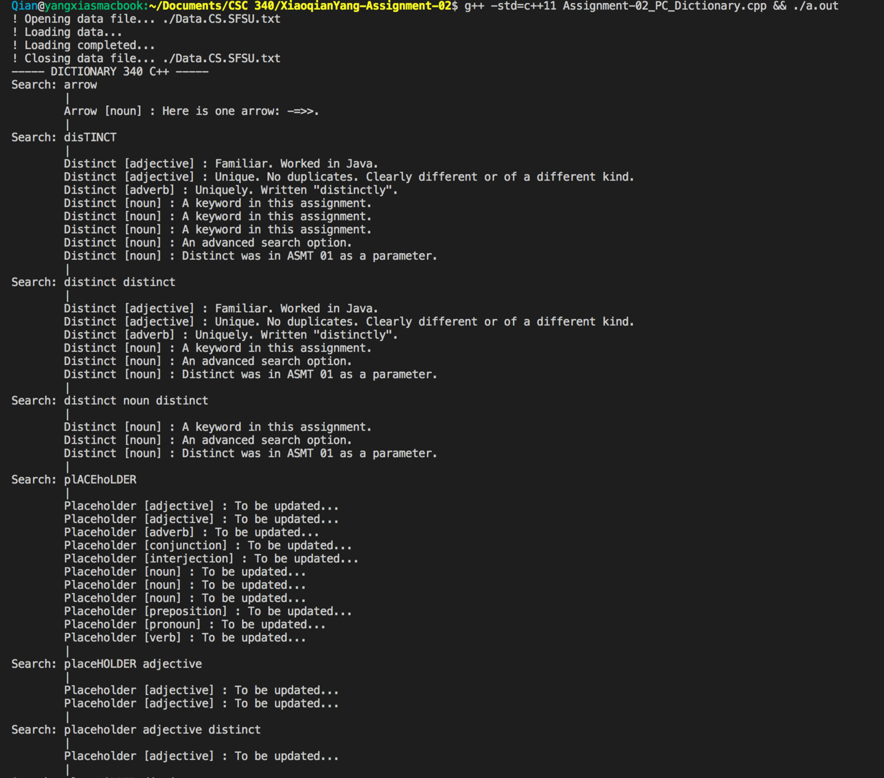

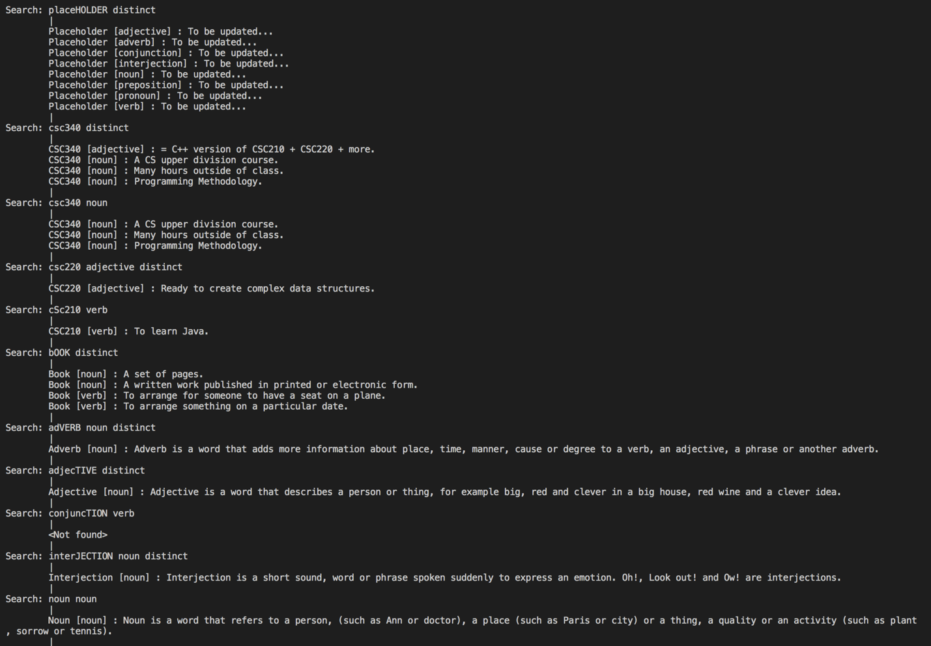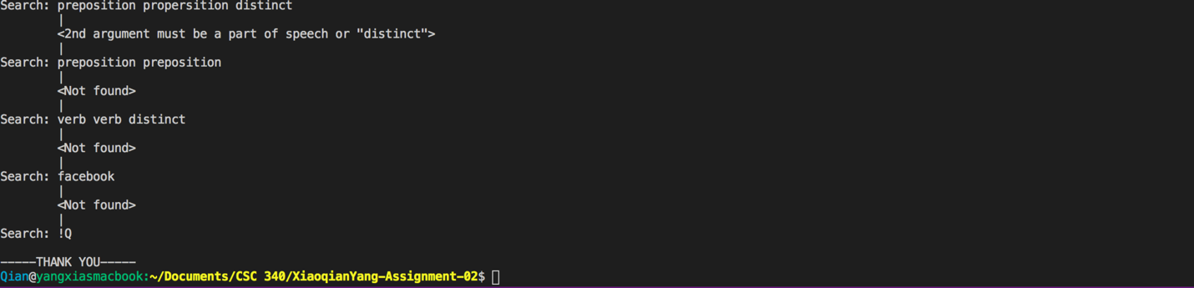

1. Program Analysis to Program Design.
2. Your analysis of the provided information and the provided sample output. Compare to the ASMT 01 Java version.

First of all, we can’t force the results as in we should be able to get the correct result when input in the right pattern. Second, use iofile fstream to load all data into the program as vs. use enum as a database to store all the original data in ASMT 01 Java version. And then use multimap<string, vector<string>> to store all the data. Third, users are allowed to input search keys and before user can search any words, data loading must be completed. And we when code, we must follow the lead of the sample output.

1. What problem you are solving. How it is different from that of ASMT 01. Problem formulation and problem solving.

We are creating a data structure that maps keys to values, and allow users to find values through keys. The most important and different thing from ASMT 01 is that we are required to load all the data from a separate file instead of typing them in manually.

1. How you load data from the data source. What the steps are. Why these steps? Can you do better?

First use fstream ioFile to load the file in the program, then use getline to get every line of the file. Then use getline and stringstream to separate line into part of speech and definitions. Last store them into a multimap.

I think I can do better as we learn c++ this summer. I’ll get more comfortable with c++ and it’s functions and syntax.

1. Which data structure(s) you use/create for your dictionary.And why. Think Data structures and think Data Design.

I used a multimap<string, vector<string>> to create my dictionary. Because in our program, we are required to store the same key with multiple values and the element order matters.

1. Program Implementation.
2. Does your program work properly?

Yes, right now my program works properly and meets all the requirements the instructor asked.

1. How will you improve your program?

Although the program meets all the requirements now, there are still a few places that could be improved.

First of all, without knowing c++ very well, I think the search multiple map and print all the values are a little bit long. Second, the logic for search part can be simpler if more thinking is done here.