**Team name**: Luna R

**Team members:** Xinghai Nian, Bingzhen Chen, Xiaoqian Yang(current leader)

**Project title:** Flashcards to learn a foreign language

**Description:** Users can learn different kinds of languages using flashcards. Users are required to log in or sign up for new accounts, then they can choose between study mode and quiz mode. And in quiz mode, users’ scores and quiz time will be recorded, which is visible to all users on the scoreboard.

**Github:** <https://github.com/StacyYang/Flashcards-to-learn-a-foreign-language>

**Job assignments:**

| **Xinghai Nian:** study mode design, flashcards design, scoreboard design  **Bingzhen Chen:** study mode design, flashcards design, scoreboard design  **Xiaoqian Yang:** home page, sign in/up, log out, study mode/quiz mode choices page/ user accounts, create a database, connect database to the website, administer account design  Everyone will do a little bit of everything, we will function as a team.  **Milestones:**   |  | Description | Date | | --- | --- | --- | | Milestone 1 | * Setup Github repo & work environment * Research on tech skills to learn * Website structure design | week 2: 02/09/2023 | | Milestone 2 | * Frontend/backend development (home page, register, login) | week 4: 02/23/2023 | | Milestone 3 | * Frontend/backend development (study mode design) | week 6: 03/09/2023 | | Milestone 4 | * Frontend/backend development (quiz mode design) | week 8: 03/23/2023 | | Milestone 5 | * Frontend/backend development (scoreboard design) * Test website, possibly deploy the website. * Supervisor account | week 10: 4/15/2023 | |
| --- | --- | --- | --- | --- | --- | --- | --- | --- | --- | --- | --- | --- | --- | --- | --- | --- | --- | --- |

**Technologies involved:**

Frontend: HTML, CSS, JavaScript

Backend: Flask/Jinja, Python, SQLite for Database

The activity/progress/update shown in GitHub repository since last week:

**List the milestones that have been accomplished as a team.**

Milestone 1, 2, 3, 4 are accomplished.

**Task accomplished by the team this week**

* Modified github's README about instructions on how to repopulate the database.
* Finished scoreboard frontend and backend design, allowing users to check the total score rank and individual score history.

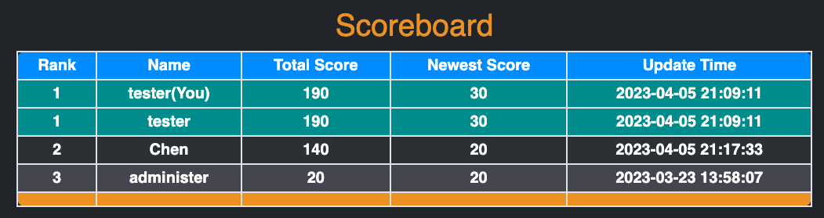

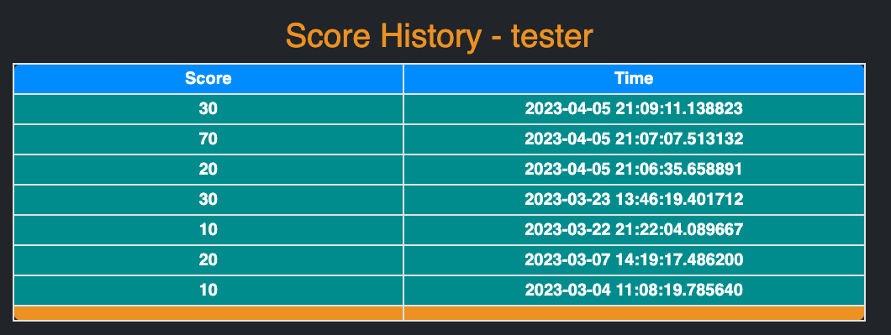

**The next task to do (or current task to be continued).**

Implement more functions for administer account

* possibly allow administer to add new questions and flashcards

Allowing users to reset passwords.

**Provide instructions for expert users to verify your finished work:**

* View GitHub commits ([Link](https://github.com/StacyYang/Flashcards-to-learn-a-foreign-language/commits/main))
* Follow the instruction to setup our project ([Link](https://github.com/StacyYang/Flashcards-to-learn-a-foreign-language/blob/main/README.md))
* Check the login and registration page
* Login the admin account and check the status.
* Login the user account to check the study and quiz mode.